

Energy Poverty, Energy Affordability, and Demand Modelling

by:
African Energy Research (AER)

Research Team

Date: March, 2026

Executive Summary
Energy poverty remains a critical structural constraint on global oil and gas demand growth, with 730 million people worldwide lacking electricity access as of 2024 declining by only 11 million from 2023, a pace slower than pre-pandemic levels . Sub-Saharan Africa accounts for 80% of the global access deficit, where population growth continues to outpace electrification despite record solar PV imports and grid expansion1 .
From a demand modelling perspective, developing economies exhibit income elasticities of 1.2–1.9 for total energy demand significantly higher than OECD ranges of 0.8–1.1, indicating that GDP growth in emerging markets drives disproportionately higher energy consumption. OPEC's latest World Oil Outlook projects non-OECD oil demand to increase by 26.1 mboe/d by 2050, with Africa contributing 4.1 mboe/d of incremental demand. However, affordability constraints persist: household energy bills in emerging markets are projected to rise 80% by 2050, outpacing disposable income growth1
Key Investment Implication: The divergence between high income elasticity in developing markets and stagnating access rates creates a bifurcated demand outlook robust long-term growth potential constrained by near-term affordability barriers and sovereign debt burdens.

Background and Context
Energy poverty defined as lack of access to modern energy services or excessive energy expenditure relative to income represents both a humanitarian challenge and a market structural factor. The IEA estimates that 730 million people lacked electricity access in 2024, with sub-Saharan Africa hosting 600 million of this population. Despite universal access achievements in India and Indonesia, progress has stalled in Pakistan, Afghanistan, and across much of Africa due to elevated debt burdens, high borrowing costs, and declining development finance1.
The energy affordability crisis extends beyond access to include "hidden" energy poverty where households maintain grid connections but reduce consumption below essential levels due to cost constraints. In emerging market and developing economies, energy expenditure often exceeds 10% of household income, the threshold commonly cited for energy poverty, though systematic cross-country data remains limited
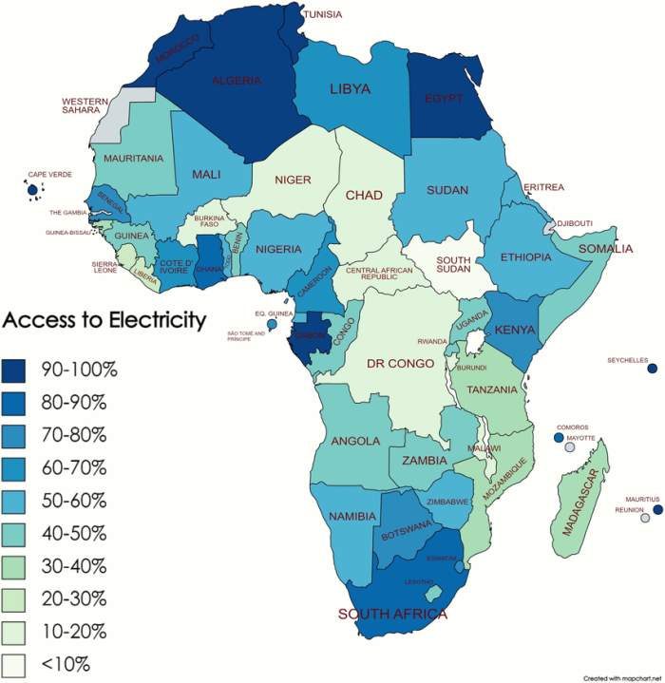

Figure 1: Electricity access rates across Africa, showing significant regional disparities (Source: Economist/World Bank data)

Key Findings and Data Insights
Electricity Access Stagnation
- Global Access Gap: 730 million people without electricity in 2024 (down from 750 million in 2023)
- Sub-Saharan Africa: 80% of global deficit; only 4 million reduction in unconnected population in 2024 due to population growth offsetting 6.8 million new connections
- Grid vs. Off-Grid: Grid expansion and mini-grids drove 90% of new connections in sub-Saharan Africa in 2024, with grid connections rising 11% year-on-year
- Solar Home Systems: Global sales grew 4% in 2024, with sub-Saharan Africa recording 26% increase in new primary users, though mostly Tier 1 systems (basic lighting/phone charging only)
Energy Demand Projections
OPEC's World Oil Outlook 2050 projects3:
- Primary Energy Demand: Global increase from 308 mboe/d (2024) to 378 mboe/d (2050), with non-OECD countries accounting for nearly all growth
- Regional Growth: India (+21.6 mboe/d), Other Asia (+15.3 mboe/d), Africa (+4.1 mboe/d)
- Oil Demand: Non-OECD increase of 26.1 mboe/d by 2050, reaching 81.3 mboe/d
- Natural Gas: Non-OECD demand rising from 40 mboe/d (2024) to 60.7 mboe/d (2050)
Affordability Constraints
- Household Energy Bills: In emerging markets, projected 80% increase by 2050 under stated policies scenario, exceeding disposable income growth
- Vulnerability to Price Shocks: A fossil fuel price shock scenario (using 2010–2020 peak prices) would increase household energy costs by 35% in emerging markets vs. 25% in advanced economies
- Electricity Share: By 2050, electricity projected to account for 90% of household energy bills in emerging markets (vs. 30% in 2020)
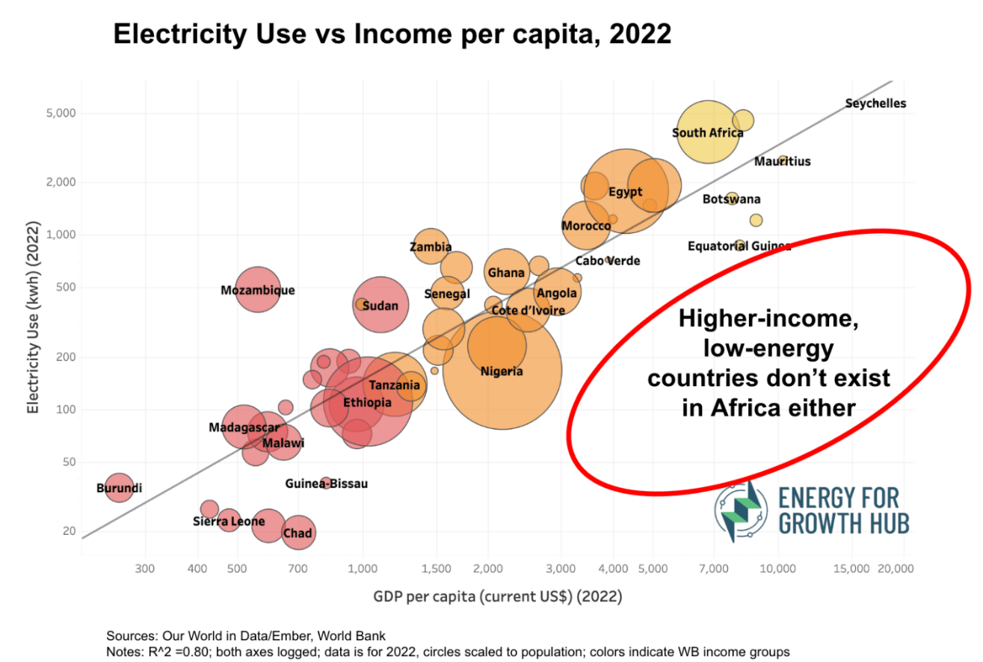
Figure 2: Relationship between electricity use and income per capita, highlighting that higher-income, low-energy countries do not exist in Africa (Source: Energy for Growth Hub)

Demand Modelling Implications for Energy Markets
Econometric Approaches
Energy demand modelling employs three primary methodological frameworks:
1.Econometric Elasticity Models
The standard approach estimates long-run relationships using the form:
ln(E) = α + β₁ln(GDP) + β₂ln(Price) + ε
Recent panel data studies utilizing 65 countries (1960–2016) confirm income elasticities vary significantly by development stage
- OECD/High-Income: Income elasticity ~0.6–0.7; Price elasticity ~-0.2 to -0.3
- Middle-Income/Non-OECD: Income elasticity ~0.8–1.25; Price elasticity ~-0.1 to -0.08 (often statistically insignificant)
- Oil-Exporting Developing Economies: Income elasticity substantially above unity
2. Scenario Modelling
Integrated assessment models (IAMs) and energy system models (e.g., IEA's World Energy Model, OPEC's World Oil Model) project demand under alternative policy scenarios. These incorporate:
- Macroeconomic growth trajectories
- Technology cost curves (particularly renewables)
- Policy constraints (carbon pricing, access targets)
- Demographic and urbanization trends
3. Sectoral Decomposition
Disaggregated models estimate demand by end-use sector:
- Residential: Income elasticity 0.4–1.4; Price elasticity -0.3 to -1.0
- Transport: Gasoline demand income elasticity 0.7–1.2; Price elasticity -0.2 to -1.5
- Industry: Output elasticity 0.6–1.0; Price elasticity -0.3 to -0.8 2

Critical Modelling Insights
- Asymmetric Responses: Price elasticity in developing countries is typically lower than in OECD markets due to limited substitution options and essential demand characteristics
- Saturation Effects: High-income countries show declining income elasticities as energy service demands saturate; developing markets remain on the steep portion of the energy-GDP curve
- Structural Change: Industrialization shifts in developing economies contribute to greater-than-unitary income elasticities as energy-intensive sectors expand

Policy and Investment Risks
Sovereign Debt and Fiscal Constraints
Elevated post-pandemic debt burdens in sub-Saharan Africa constrain public investment in grid infrastructure. The IEA notes that cuts in international aid and high borrowing costs are weighing on electrification progress, with 27 countries in the region still lagging pre-pandemic connection rates
.
Affordability-Access Trade-offs
Mini-grid and off-grid solar solutions (Tier 1–2) provide basic access but limit demand growth potential. Tier 1 systems (12 Wh/day) support only lighting and phone charging, while Tier 3+ systems (>800W) enabling productive uses remain unaffordable for most rural households
. This creates a "low-energy trap" where access gains do not translate to significant demand growth.

Fuel Substitution Risks
- LPG for Biomass: Rising energy access supports LPG demand growth, particularly in sub-Saharan Africa, as households transition from traditional biomass
- Coal-to-Gas Switching: Natural gas demand growth in non-OECD Asia is policy-dependent; China and India's coal phase-out policies will determine gas import requirements
- Electrification vs. Liquid Fuels: Transport electrification in emerging markets remains limited by infrastructure constraints, preserving oil demand growth in the commercial vehicle sector
Investment Requirements
OPEC estimates $18.2 trillion in cumulative energy investments needed globally through 2050, including $14.9 trillion for upstream oil and gas. However, affordability constraints may delay demand materialization, creating stranded asset risks if supply investments precede demand growth.

Conclusion
Energy poverty and affordability constraints remain critical structural factors shaping global energy demand. While developing economies exhibit high income elasticities, stagnant electrification rates, high household energy burdens, and elevated sovereign debt limit the immediate realization of this demand. Sub-Saharan Africa, home to the majority of the unconnected population, exemplifies the persistent “low-energy trap,” where access gains do not translate into significant consumption growth. From a policy and investment perspective, bridging the gap between access and affordability is essential to unlock sustainable demand expansion, mitigate supply stranded risks, and support long-term economic development. Targeted investments in Tier 3+ off-grid solutions, grid expansion, and supportive fiscal mechanisms are critical to ensure that rising energy demand in non-OECD countries translates into real market opportunities rather than structural underconsumption.

IEA (2025), Access to electricity stagnates, leaving globally 730 million in the dark, IEA, Paris https://www.iea.org/commentaries/access-to-electricity-stagnates-leaving-globally-730-million-in-the-dark, Licence: CC BY 4.0
Choe, B. J. (1981). Energy demand elasticities: Concept, evidence and implications. World Bank, Development Policy Staff, Economic Analysis and Projections Department.
Organization of the Petroleum Exporting Countries (OPEC). (2024). World oil outlook 2050. OPEC.
Jiti Gao., Bin Peng., & Russell Smyth. (2021). On income and price elasticities for energy demand: A panel data study. Energy Economics, 96, 105168. https://doi.org/10.1016/j.eneco.2021.105168
Hillard G. Huntington. (2015). Prices, income and energy demand. Stanford University, Energy Modeling Forum. https://web.stanford.edu/group/emf-research/docs/occasional_papers/op73.pdf
African Energy Chamber. (2025, September 29). AEW: OPEC highlights Africa’s rising oil demand, calls for realistic energy pathways. AEC Week. https://aecweek.com/aew-opec-highlights-africas-rising-oil-demand-calls-for-realistic-energy-pathways/

