Oil and Gas Block Commercialization

INTELLIGENCE NOTE

BY

AFRICAN ENERGY RESEARCH

Executive Summary

The transition of an upstream oil and gas asset from a geologically promising discovery to a commercially viable producing block is fraught with technical, regulatory, and financial complexities. This intelligence note assesses the principal drivers, constraints, and operational pathways required to successfully commercialize hydrocarbon blocks in the contemporary energy landscape. While initial exploration success dictates resource volume, ultimate commercialization is heavily dependent on infrastructure access, the stability and progressivity of the fiscal regime, and deliberate host-government alignment.
Analysis indicates that isolated or marginal discoveries—particularly natural gas—face acute monetization hurdles. Successful commercialization depends on block quality, infrastructure access, balanced licensing design, clear and attractive licensing terms, and the ability to optimize infrastructure and unitization (World Bank, Licensing). This assessment underscores the critical distinction between subsurface potential and above-ground commercial execution, providing actionable recommendations for government policymakers and upstream investors.

Key Commercialization Drivers

The velocity and success rate of bringing a block to market are dictated by several interdependent above-ground factors. Chief among these is the regulatory and fiscal architecture established by the host nation. Fiscal design matters deeply: predictable revenue, progressivity, neutrality, flexibility, simplicity, equitable risk sharing, and regime stability are central to investment decisions and development pace (World Bank, Fiscal Systems for Hydrocarbons). A fiscal regime that aggressively front-loads government take without accounting for capital recovery will inevitably stall development, particularly in frontier basins.
Furthermore, strategic alignment between the state and the operator is critical. Guyana's draft strategy, for example, emphasizes transparency, contract stability, clear roles, government alignment, third-party access rules, and rapid gas infrastructure development to unlock upstream commercialization (Government of Guyana, Draft Gas Monetization Strategy). Clear rules governing unitization the joint development of a reservoir that straddles multiple license areas prevent operational paralysis and maximize ultimate resource recovery (World Bank, Licensing).

Decision Matrix: Core Commercialization Criteria

Factor | Optimal Condition for Commercialization | Risk Indicator
Fiscal Regime | Progressive, flexible, stable, allows rapid cost recovery. | Regressive, retroactive tax changes, high upfront bonuses.
Infrastructure | Proximity to existing pipelines/terminals; clear third-party access. | Stranded/remote location; lack of evacuation routes.
Regulatory | Transparent licensing, streamlined FID approvals. | Bureaucratic delays, unclear unitization laws.

Principal Risks and Constraints

Despite favorable geology, numerous blocks become "stranded" assets due to compounding constraints. Marginal or stranded gas fields are often blocked by small scale, remoteness, limited infrastructure, and lack of technical skills, political risk, and slow administration (World Bank, Commercialization of Marginal Gas Fields). For offshore environments, the sheer capital intensity required for platforms, subsea tie-backs, and evacuation logistics poses a massive barrier to entry for all but the largest capitalized operators.
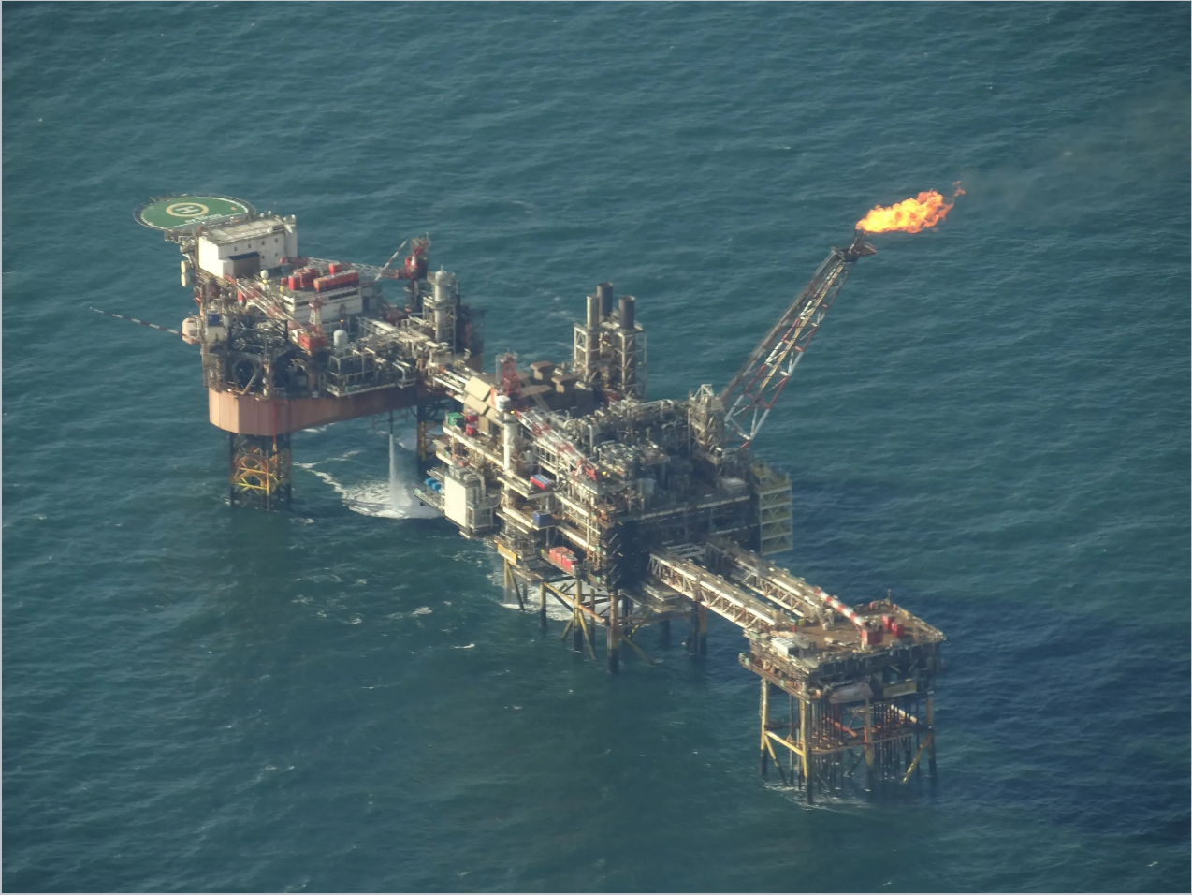
Offshore platform complex illustrating capital intensity and evacuation dependency.
Source: Wikimedia Commons, 'Douglas Complex platforms UK 2013 B'.

Gas developments face a particularly stringent set of prerequisites compared to oil. Because natural gas is difficult and expensive to store and transport, gas commercialization requires complete government agreements, finalized fiscal terms, enabling legislation, land access, financing, reserve certification, and locked-in market offtake agreements long before a Final Investment Decision (FID) can be reached (U.S. DOE, Understanding Natural Gas and LNG Options). Furthermore, political risk and changing energy transition policies threaten the long-term viability of multi-decade payback projects.

Commercialization Pathways for Oil and Gas

The strategic pathways for monetizing hydrocarbons diverge significantly depending on whether the primary resource is crude oil or natural gas. Planners must evaluate local demand, export logistics, and processing requirements.

Oil Commercialization Pathways

Oil is inherently fungible and relatively easy to transport via tanker, giving operators more flexibility. The primary pathways include:
- Direct Export via FPSO: For offshore deepwater blocks, Floating Production Storage and Offloading (FPSO) vessels remain the most agile commercialization route, circumventing the need for expensive subsea pipelines to shore.
- Pipeline to Terminal: Onshore or shallow-water fields typically rely on trunk pipelines connected to coastal export terminals. This requires securing right-of-way and tariff agreements.
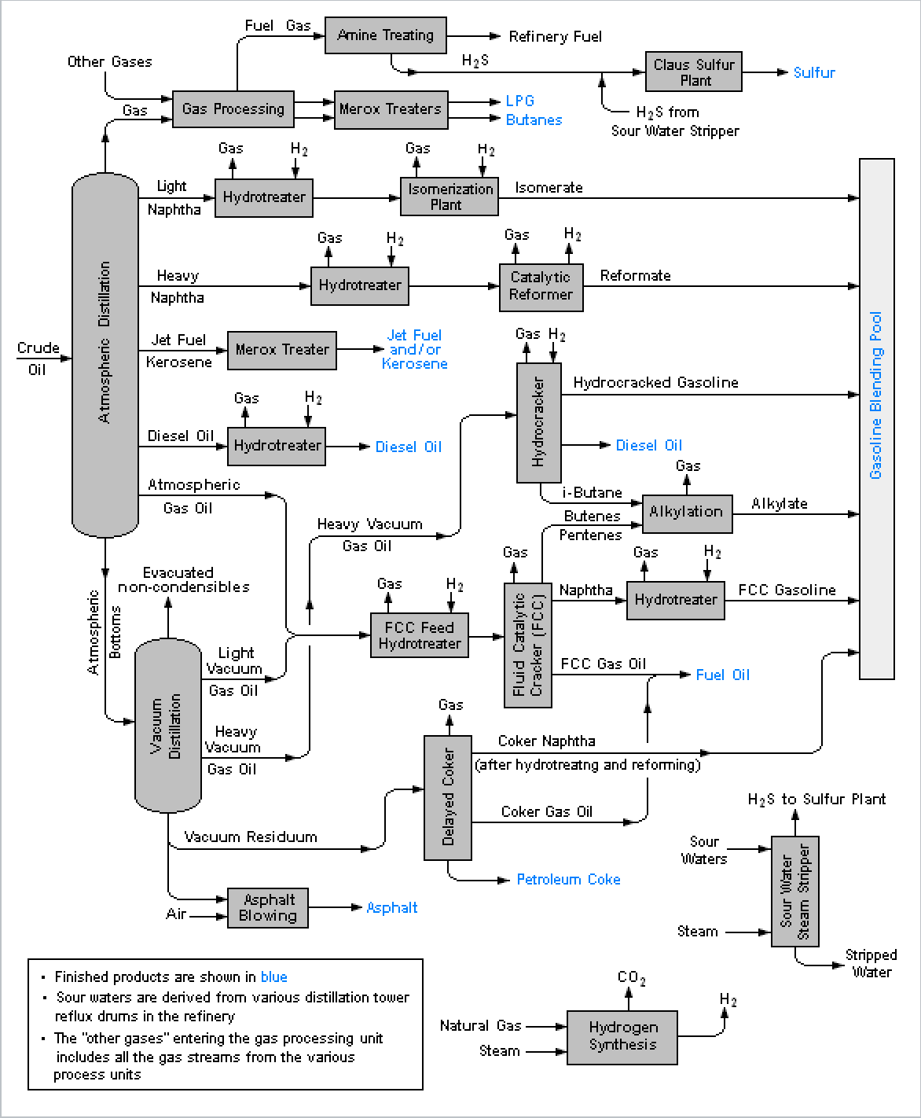
- Domestic Refining: Supplying local refineries can secure long-term domestic energy stability, though it often requires host-government subsidies or mandated domestic supply obligations within the licensing terms.

Simplified refinery/process flow image showing downstream integration opportunities.
Source: Wikimedia Commons, 'RefineryFlow.png'.

Gas Commercialization Pathways

Natural gas monetization is highly infrastructure-dependent. Without an established evacuation route, associated gas is often flared or reinjected, while non-associated gas fields remain undeveloped. Pathways include:
- Liquefied Natural Gas (LNG): For massive reserves, LNG provides access to global markets. However, it requires billions in upfront capital, certified reserves of at least 15-20 years, and complex international off-take contracts (U.S. DOE, Understanding Natural Gas and LNG Options).
- Domestic Power Generation: Routing gas to domestic power plants is a primary catalyst for industrialization in emerging markets, as highlighted by Guyana’s focus on rapid gas infrastructure development to unlock broader economic benefits (Government of Guyana, Draft Gas Monetization Strategy).
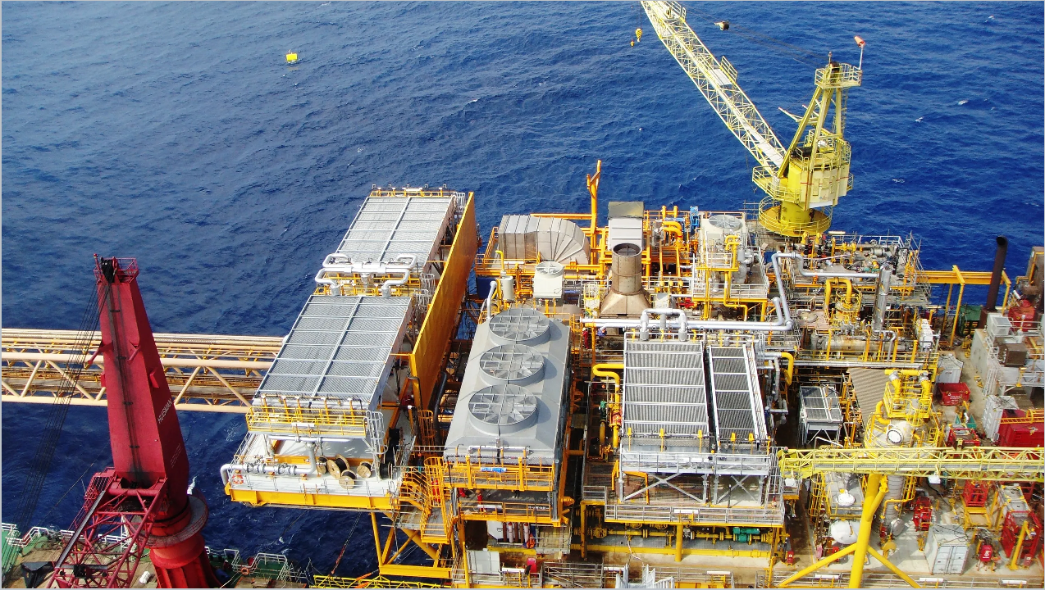
- Alternative Monetization for Marginal Fields: When reserves are too small for LNG, commercialization can improve through Gas-to-Liquids (GTL), methanol production, carbon black/hydrogen generation, floating LNG/methanol solutions, and industrial clusters with shared infrastructure (World Bank, Commercialization of Marginal Gas Fields).

Gas compression and processing infrastructure underpinning monetization options. Source: Wikimedia Commons, 'Rong Doi Booster Compressor project aerial view'.

Conclusion and Recommendations

A fundamental distinction exists between a geologically promising block and a commercially executable one. Geologic promise is defined by reservoir porosity, permeability, and hydrocarbon volumes in place. Commercial executability, however, is determined entirely by above-ground factors: fiscal stability, infrastructure proximity, regulatory transparency, and market access. A world-class geological discovery can remain stranded indefinitely if the fiscal regime is punitive or if infrastructure bottlenecks are not resolved.

Recommendations for Government Decision-Makers:

  - Implement progressive, flexible fiscal regimes that automatically adjust to commodity price fluctuations, thereby ensuring a stable investment climate without requiring constant contract renegotiation.
  - Facilitate the rapid deployment of shared processing and evacuation infrastructure, particularly for natural gas, to prevent smaller blocks from becoming stranded assets.
  - Establish clear, standardized frameworks for unitization and third-party infrastructure access to lower the barrier to entry for mid-sized operators.

Recommendations for Upstream Investors:

  - Prioritize blocks not just on seismic data, but on proximity to existing infrastructure and the historical stability of the host country's fiscal framework.
  - For marginal gas discoveries, aggressively evaluate alternative commercialization technologies—such as small-scale GTL or floating methanol—rather than relying solely on traditional pipeline or LNG pathways.
  - Engage in early-stage alignment with host governments on domestic supply obligations to secure political goodwill and expedite FID approvals.

Sources and References:

- World Bank Group. Licensing. Documentation on upstream oil and gas licensing phases and area selection strategies.
- World Bank Group. Fiscal Systems for Hydrocarbons. Analysis of tax neutrality, stability, and government take.
- U.S. Department of Energy (U.S. DOE). Understanding Natural Gas and LNG Options. Guidance on global LNG commercialization and FID prerequisites.
- World Bank Group / ESMAP. Commercialization of Marginal Gas Fields. Technical viability of GTL, methanol, and industrial clusters for stranded resources.
- Government of Guyana. Draft Guyana Gas Monetization Strategy. Strategic roadmap for gas infrastructure, state alignment, and third-party access.

