Country Briefing
Ghana’s Oil and Gas Sector

Introduction
Ghana is a politically stable Gulf of Guinea producer whose offshore petroleum industry has become an important element of West Africa’s energy landscape since first oil from Jubilee in 2010. The sector is concentrated in the Tano–Cape Three Points Basin and is anchored by three producing assets, Jubilee, TEN, and OCTP/Sankofa-Gye Nyame, supported by a comparatively mature legal framework and a visible state role through GNPC and the Petroleum Commission. In regional terms, Ghana is best understood as a medium-sized but institutionally significant offshore producer with growing relevance for gas-to-power supply. (Sources: GNPC overview; Petroleum Commission; GNPC 2024 Annual Report)

Sector Overview
At end-2024, Ghana’s remaining gross 2P reserves stood at 860 million barrels of oil equivalent, comprising 649.3 million barrels of oil/condensate and about 1,223 bcf of natural gas, while contingent resources were estimated at 1,390 MMboe. Total crude oil production in 2024 was 48.24 million barrels, equivalent to about 131,803 barrels per day. Output remains dominated by Jubilee, which contributed 31.85 million barrels (66%), followed by Sankofa-Gye Nyame with 9.61 million barrels (20%) and TEN with 6.78 million barrels (14%). Natural gas production reached 280,511 MMscf in 2024, of which 115,455 MMscf was exported for domestic use. Figure 1 shows that oil output has trended downward since 2019, while Figure 3 highlights the continued dominance of Jubilee. (Sources: GNPC 2024 Annual Report; PIAC 2024 Annual Report)
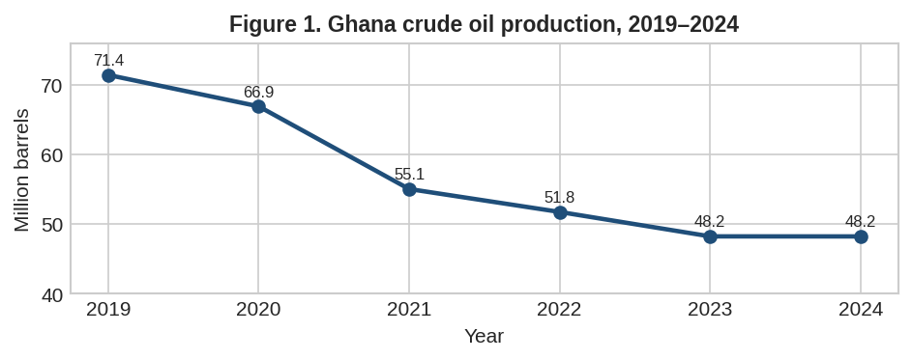
Figure 1. Ghana crude oil production declined from 71.4 million barrels in 2019 to 48.2 million barrels in 2024.
Source: PIAC Annual Report 2024, Table 3 (2019–2024 annual crude oil production).

Regulatory Framework
The core upstream statute is the Petroleum (Exploration and Production) Act, 2016 (Act 919), which governs licensing, petroleum agreements, operational rights, and state participation. Institutional oversight is shared across GNPC, the Ministry responsible for energy policy, the Petroleum Commission, and the Bank of Ghana/Ghana Revenue Authority for revenue administration. The Petroleum Commission Act, 2011 (Act 821) created the sector regulator for efficient, safe, and sustainable development, while the Petroleum Revenue Management Act, 2011 (Act 815) established the Petroleum Holding Fund and the Ghana Stabilisation and Heritage Funds to govern collection, savings, and budget use. Local participation is driven by the Petroleum (Local Content and Local Participation) Regulations, 2013 (L.I. 2204), later amended to broaden partnership models. (Sources: Petroleum Commission Act 821; Petroleum Revenue Management Act 815; GNPC overview; 2025 Upstream Business Outlook Report)

Key Industry Players
GNPC is the national oil company and a partner in petroleum agreements, while Tullow Ghana operates Jubilee and TEN and Eni leads the OCTP/Sankofa development. Other major participants include Kosmos Energy, PetroSA, Vitol, Jubilee Oil Holdings, Springfield Exploration & Production, Pecan Energies, and Explorco, GNPC’s exploration and production subsidiary. The operator mix underscores Ghana’s hybrid model: strong state participation combined with foreign capital, technology, and offshore project management expertise. (Sources: Petroleum Commission upstream operators page; GNPC 2024 Annual Report)
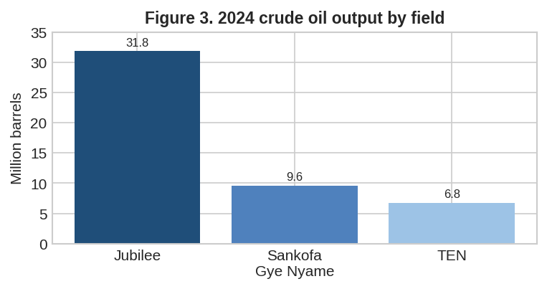
Figure 2. Jubilee remained the dominant producing field in 2024.
Source: GNPC Annual Report 2024, crude oil production by field.

Economic Contribution
The sector’s macroeconomic importance lies more in exports, foreign exchange, and fiscal revenue than in broad-based GDP dynamism. In 2024, crude oil export earnings rose modestly to US$3.87 billion and were one of the main contributors to Ghana’s improved current account and balance-of-payments position. Total petroleum revenue reached US$1.36 billion, up 27.8% year on year, with carried and participating interest, corporate income tax, and royalties accounting for most receipts. Real GDP growth was 5.7% including oil and 6.0% excluding oil, indicating that petroleum supported the headline economy but was not the fastest-growing component. Employment effects are relatively narrow in direct terms but meaningful in high-skill segments: Petroleum Commission material reported 4,147 upstream jobs, of which 3,759 were held by Ghanaians, while 339 roles had been localised since 2018. PIAC also reported that Indigenous Ghanaian Companies received about 20% of service value in 2024. Figure 2 shows the volatility of petroleum receipts relative to production trends. (Sources: Bank of Ghana 2024 Annual Report; PIAC 2024 Annual Report; Petroleum Commission local content publication)
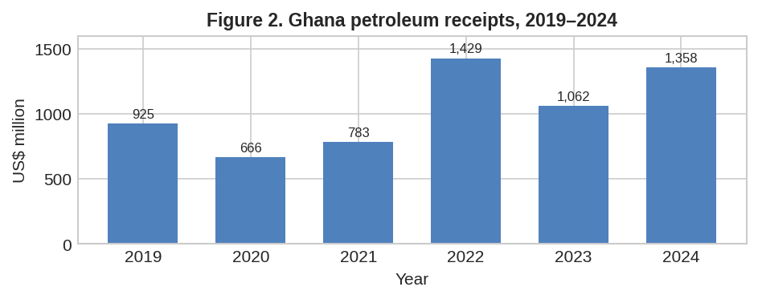
Figure 3. Petroleum receipts recovered in 2024 but remained volatile over the period 2019–2024.
Source: PIAC Annual Report 2024, annual petroleum receipts.

Challenges and Issues
Ghana’s petroleum industry faces four structural constraints. First, field maturity has driven a prolonged production decline from the 2019 peak, raising pressure for reserve replacement. Second, infrastructure bottlenecks have reduced gas efficiency: PIAC reported forfeited make-up gas from SGN because it could not be recovered within the contractual window. Third, governance concerns persist around unpaid proceeds, stabilisation-fund capping, and the absence of new petroleum agreements since 2018. Fourth, the sector remains exposed to oil-price volatility and to tightening global finance for hydrocarbons. Environmental pressures are also increasing as Ghana seeks to reconcile offshore development, gas monetisation, and decarbonisation commitments. (Sources: PIAC 2024 Annual Report; 2025 Upstream Business Outlook Report; Ghana National Energy Transition Framework)

Recent Developments
Recent activity suggests a renewed effort to stabilize and extend the upstream portfolio. The Petroleum Commission’s 2025 outlook projected baseline upstream investment of about US$1.2 billion, with upside to US$2.8 billion. Pecan remains the main undeveloped growth project, with its plan of development approved earlier and key engineering letters of intent in place while investors worked toward FID. In 2025 the Commission also issued Strategic Alliance and Channel Partnership guidelines and prepared a Common Qualification System to widen local participation pathways. Most significantly, Ghana’s Parliament ratified licence extensions for the Jubilee and TEN petroleum agreements in February 2026, extending them to 2040; Kosmos stated that the extensions could unlock up to US$2 billion of incremental investment and support additional gas supply for domestic power. (Sources: 2025 Upstream Business Outlook Report; Kosmos Energy, 20 Feb 2026)

Future Outlook
The medium-term outlook is cautiously positive. Production growth is not guaranteed, but the Jubilee/TEN extensions, new drilling, and the possible sanctioning of Pecan improve the odds of arresting decline. Ghana’s gas position is strategically important because policy now treats natural gas as a transition fuel for electricity, industry, and transport, implying continued investment in domestic gas infrastructure even as the country pursues net-zero ambitions by 2070. The most plausible scenario is therefore not a dramatic oil boom, but a gradual repositioning toward a more gas-centered, fiscally disciplined, and locally embedded hydrocarbons sector. Ghana’s comparative advantage in West Africa will depend less on sheer scale than on regulatory credibility, project execution, and its ability to align upstream development with the energy transition. (Sources: Ghana National Energy Transition Framework; 2025 Upstream Business Outlook Report; Kosmos Energy 2026 release)

Conclusion
Ghana’s oil and gas industry has moved from discovery-led optimism to a consolidation phase. The sector remains economically important through exports, public revenue, and gas supply, but it is constrained by declining mature-field output and the need for new investment. If Ghana can convert current licence extensions, local content reforms, and gas-transition policy into bankable projects, it should retain a meaningful—if moderate—strategic role in West Africa’s energy system. (Sources: GNPC 2024; PIAC 2024; Bank of Ghana 2024; Petroleum Commission 2025; Kosmos 2026)

References
GNPC. 2024 Annual Report. https://www.gnpcghana.com/download/ar/annual_report2024.pdf
Public Interest and Accountability Committee (PIAC). 2024 Annual Report. https://www.piacghana.org/wp-content/uploads/2025/04/Final-2024-PIAC-Annual-Report-28-04-2025-1.pdf

Bank of Ghana. Annual Report and Financial Statements 2024. https://www.bog.gov.gh/wp-content/uploads/2025/07/2024-Annual-Report-and-Financial-Statements.pdf

Petroleum Commission. Ghana Upstream Petroleum Business Outlook Report 2025. https://petrocom.gov.gh/wp-content/uploads/2025/05/Final-2025-Ghana-Upstream-Petroleum-Business-Outlook-Report-GUPBO-.pdf

Petroleum Revenue Management Act, 2011 (Act 815). https://petrocom.gov.gh/wp-content/uploads/2024/01/petroluem-revenue-management-act815-2011-.pdf
GNPC Overview. https://www.gnpcghana.com/about-us/overview

Petroleum Commission, Upstream Operators. https://petrocom.gov.gh/upstream-operators-3/
Petroleum Commission local content publication. https://petrocom.gov.gh/wp-content/uploads/2024/04/LCG-2024-1-pdf.io_.pdf

Kosmos Energy. Ghana License Extensions ratified by Parliament, 20 Feb 2026. https://investors.kosmosenergy.com/news-releases/news-release-details/kosmos-energy-announces-ratification-ghana-license-extensions

Ministry of Energy. Ghana National Energy Transition Framework. https://www.energymin.gov.gh/sites/default/files/2023-09/FINAL%20GHANA%27S%20NATIONAL%20ENERGY%20TRANSITION%20FRAMEWORK_2023_compressed%20%281%29_compressed%20%282%29.pdf

