Nigeria Investment Pipeline Update

1. Introduction
Nigeria’s investment environment is improving in transaction volume and reform activity, but long-term project execution remains uneven. The macro backdrop is more market-oriented, supported by foreign-exchange liberalisation, fuel-subsidy removal, a new Investment and Securities Act (2025), and an ongoing banking recapitalisation cycle intended to deepen domestic financing capacity. However, the quality of inflows matters: Reuters reports that total capital inflows rose to $23.22 billion in 2025, but about 85% was portfolio money, while FDI reached only $923 million evidence that real-asset commitments remain selective and risk-priced.
Tracking the investment pipeline is therefore important for distinguishing headline announcements from bankable, executable projects. In Nigeria, this is particularly relevant because large projects rely on mixed structures state-led capex, PPPs, multilateral programmes, and corporate JV spending each with different delivery risks and timelines.

2. Overview of the Investment Pipeline
Nigeria’s formal pipeline is broad. The ICRC publishes 77 federal projects eligible for PPP procurement across 16 sectors, while its registry of FEC-approved PPP projects lists 103 projects through 2023, covering ports, roads, rail, dams, airports, gas infrastructure, ICT and social infrastructure. The current live pipeline is concentrated in five clusters: gas and power, strategic roads and logistics, agro-industrial platforms, digital backbone build-out, and a smaller but growing set of value-add manufacturing projects such as fertilizer and lithium processing.
The most visible projects are in energy and transport, but the fastest expansion in project-preparation activity is arguably in blended-finance programmes: off-grid electrification, agro-processing zones, and open-access broadband. These projects are increasingly designed to crowd in private capital rather than rely solely on budget funding.

Figure 1. Selected pipeline value by sector
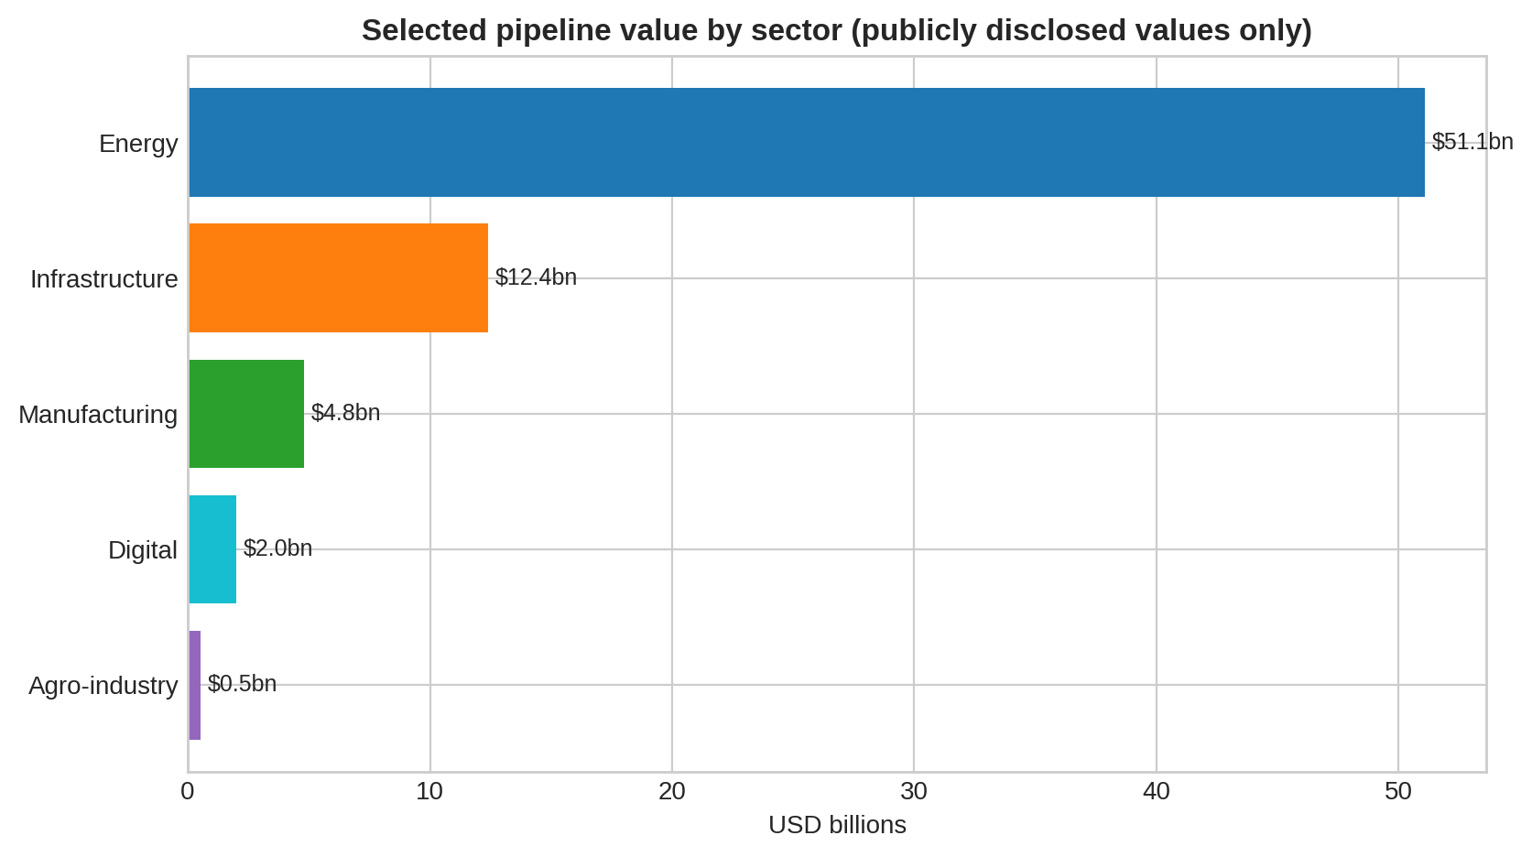

3. Sectoral Analysis
Energy. Gas remains the deepest project pool. Train 7 is the clearest near-term milestone: the $10 billion NLNG expansion is reported at roughly 80% complete and targets commercial operations by June 2026. Upstream support projects include the Ubeta gas development and local-operator reinvestment by Renaissance and Seplat. The AKK pipeline remains strategically important for domestic gas transmission but still has timetable uncertainty. Longer-dated optionality comes from the Nigeria–Morocco gas pipeline, a $25 billion regional project now past FEED and awaiting its intergovernmental phase.
Power and renewables. Two themes dominate: grid strengthening and distributed energy. The Siemens-backed Presidential Power Initiative is advancing substations and transmission equipment, while the $750 million DARES programme extends the earlier Nigeria Electrification Project model and aims to mobilise over $1 billion in private capital for mini-grids and solar systems. In practical terms, Nigeria’s power pipeline is becoming more dual-track: central grid reinforcement plus off-grid scale-up.
Infrastructure. Transport remains road-heavy but is broadening into ports and regional corridors. The Lagos-Calabar Coastal Highway now has a landmark $747 million syndicated facility for an initial phase, against an estimated total cost of about $11 billion. Ondo Deep Sea Port illustrates the renewed use of concession structures and external lenders, while the Abidjan-Lagos Corridor is progressing institutionally through its corridor authority and could become a major regional trade asset if financing closes.
Manufacturing and industry. Nigeria’s industrial pipeline is still narrower than energy and infrastructure, but it is shifting toward domestic value addition. Two Chinese-backed lithium processing plants worth a combined $800 million are near commissioning, showing a move away from raw mineral exports. Ondo State’s proposed $4 billion fertilizer project would deepen gas-based manufacturing if it reaches financial close. The recently launched Nigeria Industrial Policy 2025 provides the policy frame for this pivot, emphasising value chains, industrial competitiveness, and alignment of energy and logistics with production.
Agro-industry and digital. The $538 million SAPZ Phase I programme is one of the most bankable diversification platforms in the pipeline because it combines state-level location logic, multilateral backing, and private-sector mobilisation. In parallel, Project BRIDGE / D-VIBE is moving digital infrastructure from policy aspiration to structured project finance, with a $2 billion financing architecture designed around a PPP SPV and nationwide open-access fibre rollout.

Figure 2. Distribution of selected projects by stage
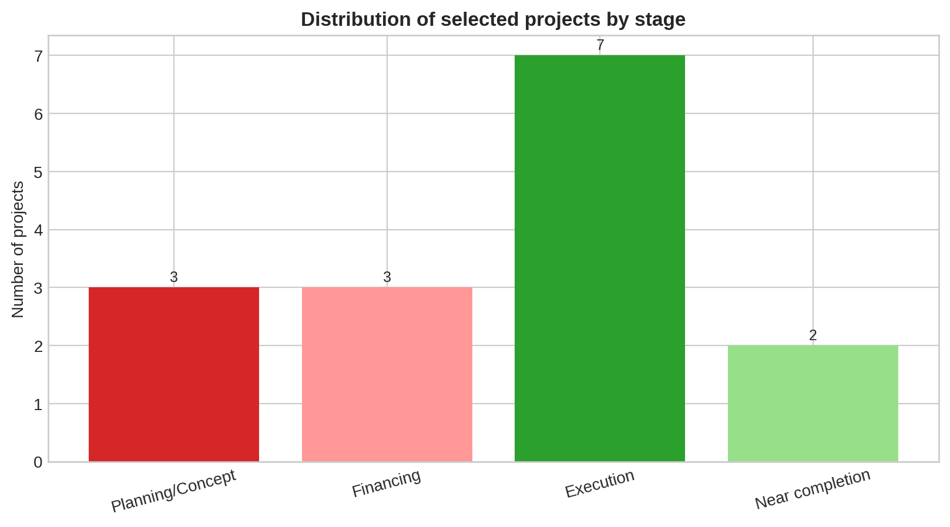

4. Project Status Classification
The current pipeline is best described as “front-loaded in execution, back-loaded in value.” A relatively high number of projects are already under execution—especially energy expansions, road works, SAPZ launch sites and corporate capex programmes. Yet some of the largest headline values, notably the Nigeria–Morocco pipeline and the Ondo fertilizer proposal, are still at concept or structuring stage. This means the visible pipeline is larger than the near-term delivered pipeline.
Near-completion assets are concentrated in LNG and mineral processing, where counterparties, offtake logic and export channels are clearer. By contrast, regional infrastructure and complex PPPs remain more dependent on governance milestones, regulatory coordination and multi-source financing closure.

Figure 3. Funding structure of selected projects
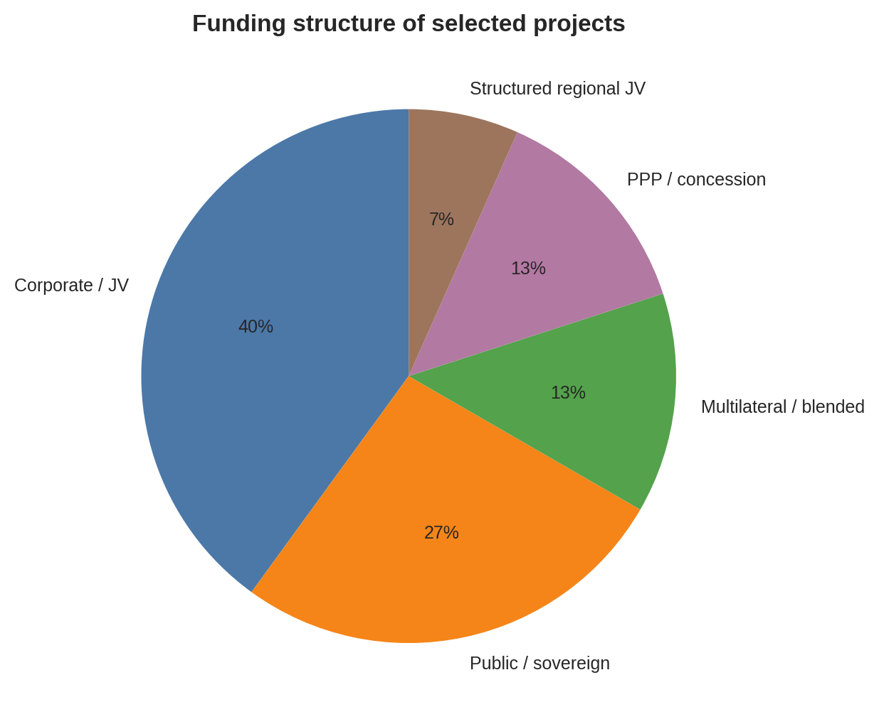

5. Funding Sources and Structures
Funding structures are increasingly diversified. Corporate and JV finance still dominates upstream energy and export-oriented processing. Public and sovereign-backed structures remain central for strategic roads, transmission upgrades and certain gas backbones. PPPs are re-emerging in ports and digital infrastructure, where a concession or SPV model can allocate construction and operating risks more clearly. Multilateral-backed blended finance is especially prominent in electrification and agro-industrial platforms, where development lenders are helping create investable ecosystems rather than funding a single asset in isolation.
A financing bottleneck nevertheless remains. Nigeria’s domestic capital market is deeper than before, but long-duration naira funding is still limited for very large infrastructure. The CBN-directed recapitalisation of commercial banks should strengthen underwriting capacity over time, yet foreign-currency liquidity, hedging cost and tariff bankability continue to constrain project closure.

6. Key Stakeholders
The stakeholder map is highly layered. Federal actors include NNPC Ltd, FGN Power Company, the ICRC, line ministries, and the Ministry of Finance. State governments are increasingly important in ports, industrial zones and SAPZ sites. Development partners especially the World Bank, African Development Bank, IsDB, IFAD and JICA play a catalytic role in early-stage structuring and de-risking. International corporates such as Siemens Energy, TotalEnergies, Shell and Chinese processing investors remain central in sectors where technical complexity or export channels matter. Domestic private firms are becoming more prominent, particularly in onshore oil and gas redevelopment and local industrial partnerships.

7. Key Challenges and Risks
Five recurring risks cut across the pipeline. First, financing risk: several projects have announced values but incomplete debt or equity closure. Second, macro risk: inflation, exchange-rate volatility and high local interest rates can undermine project economics. Third, execution risk: right-of-way, land acquisition, procurement discipline, and contractor performance remain variable. Fourth, operating risk: power shortages, oil theft, vandalism and broader security threats raise lifecycle cost. Fifth, regulatory risk: investors still cite policy inconsistency, customs inefficiency and cumbersome administrative processes as constraints to long-term commitments.

8. Recent Developments
Recent developments are broadly supportive. The first phase of the National Single Window went live in March 2026, improving trade facilitation and port efficiency. Nigeria Industrial Policy 2025 was formally launched in February 2026, providing a stronger framework for value-add manufacturing and coordinated industrial execution. The Nigeria–Morocco gas pipeline moved into an intergovernmental agreement phase, while Ondo Deep Sea Port reported FEC revalidation and Afreximbank-backed financing commitments. In programme finance, AfDB approved a further $200 million first tranche for SAPZ Phase II, indicating scale-up momentum beyond the pioneering states.

9. Conclusion
Nigeria’s investment pipeline is real, diverse and expanding, but it is not uniform in quality. Energy still anchors the value pool; transport and logistics dominate strategic public works; and the strongest diversification stories now sit in agro-industry, distributed renewables, broadband and minerals processing. The critical distinction is not between “announced” and “not announced” projects, but between projects that are financed, governed and execution-ready, and those that remain politically important but commercially immature.
Overall, the outlook is constructive. The pipeline is becoming more structured, more blended in its financing, and more focused on domestic value addition. If Nigeria can sustain reform credibility, improve execution discipline, and convert more portfolio confidence into long-horizon project capital, the current pipeline could translate into a stronger multi-sector investment cycle over the next three to five years.

Appendix A. Selected project pipeline tracker
All values in USD billions where publicly disclosed. “n/d” = no public value identified in reviewed sources.
Sector | Project | Stage | Value | Funding model | Lead stakeholders / latest update
Energy | AKK Gas Pipeline | Execution | n/d | Public / state-led energy infrastructure | NNPC Ltd; ICRC; federal authorities. Under construction; EIA says completion date remains unclear.
Energy | NLNG Train 7 | Near completion | $10bn | Corporate JV / project finance | NLNG; NNPC Ltd; Shell; TotalEnergies; Eni. Reported at 80%+ complete; commercial operations targeted by June 2026.
Energy | Ubeta Gas Development | Execution | n/d | Corporate JV | TotalEnergies; NNPC Ltd. FID taken in 2024; 6-well cluster tied back to Obite facilities; start-up expected 2027.
Energy | Nigeria-Morocco Gas Pipeline | Planning/Concept | $25bn | Phased equity + debt (to be raised) | NNPC; ONHYM; ECOWAS; 13 participating countries. IGA expected in 2026; FEED completed; first gas for initial phases targeted for 2031.
Energy | DARES Distributed Renewable Energy Programme | Financing | $0.75bn | Multilateral + private leverage | World Bank; Federal Government; REA; private mini-grid / solar firms. $750m IDA credit approved; expected to leverage $1bn+ private capital and parallel financing.
Energy | Presidential Power Initiative (Siemens) | Execution | n/d | Government-to-government / vendor-supported | FGN Power Company; Siemens Energy; TCN; Governments of Nigeria and Germany. Acceleration agreement targets grid modernization and expansion over 18–24 months.
Infrastructure | Lagos-Calabar Coastal Highway | Execution | $11bn | Sovereign-backed syndicated debt + public works budget | Federal Government; Deutsche Bank-led syndicate; Afreximbank; FAB; EBID; Zenith Bank. $747m syndicated loan secured for first phase; total project cost estimated around $11bn.
Infrastructure | Abidjan-Lagos Corridor Highway | Planning/Concept | n/d | Regional public + multilateral mobilization | ECOWAS; AfDB; ALCoMA; five corridor countries incl. Nigeria. Management authority operationalized; feasibility and structuring near completion.
Infrastructure | Ondo Deep Sea Port | Financing | $1.4bn | PPP / private capital | Ondo State; ONDIPA; MITARK; NPA; Afreximbank; ICRC. Phase 1 capex of $1.4bn to be fully privately financed; FEC revalidation reported for Dec. 2025.
Digital | Project BRIDGE / D-VIBE Fibre Backbone | Financing | $2bn | PPP + sovereign + multilaterals + private investors | Federal Government; AfDB; World Bank; EBRD; private SPV investors. AfDB approved $200m as part of a $2bn plan to expand fibre to 120,000 km and all 774 LGAs.
Agro-industry | SAPZ Phase I | Execution | $0.538bn | Blended public + multilateral + private-sector-led | Federal Government; AfDB; IsDB; IFAD; participating states; ARISE IIP. Groundbreakings began in 2025; Phase I covers Kaduna, Kano, Kwara, Cross River, Imo, Ogun, Oyo and FCT.
Manufacturing | Ondo Integrated Fertilizer Plant | Planning/Concept | $4bn | Private industrial investment | Ondo State; ONDIPA; Resident Fertilizer and Petrochemical Plc. Proposed 2MMTPA urea complex with captive power, gas pipeline and export jetty.
Manufacturing | Chinese-backed Lithium Processing Plants | Near completion | $0.8bn | Foreign private investment + local equity | Chinese investors incl. Jiuling Lithium Mining and Canmax; Three Crown Mines; state governments. A $600m plant near Kaduna-Niger border and a $200m refinery near Abuja were due for commissioning in 2025.
Energy | Renaissance Africa Energy upstream program | Execution | $15bn | Local private / corporate investment | Renaissance Africa Energy. Company plans to invest $15bn over five years to raise oil and gas output.
Energy | Seplat Energy 2025 capex & ANOH completion | Execution | $0.32bn | Corporate balance sheet / capex | Seplat Energy. 2025 spending plan of up to $320m covers new wells, infrastructure and completion of ANOH gas plant.

Reference
ICRC published PPP pipeline (77 projects across 16 sectors): https://www.icrc.gov.ng/projects/published-ppp-projects-pipeline/
ICRC FEC-approved PPP registry (103 projects through 2023): https://www.icrc.gov.ng/projects/fec-approved-ppp-projects/
U.S. State Department investment climate statement: https://www.state.gov/reports/2025-investment-climate-statements/nigeria
Reuters: capital inflows in 2025: https://www.reuters.com/world/africa/nigerias-capital-inflows-jump-90-2025-foreign-investors-chase-high-returns-2026-03-26/
Reuters: bank recapitalisation plans: https://www.reuters.com/world/africa/nigerian-lenders-submitting-recapitalisation-plans-central-bank-says-2024-06-04/
World Bank: DARES project: https://www.worldbank.org/en/news/press-release/2023/12/15/nigeria-to-expand-access-to-clean-energy-for-17-5-million-people
World Bank: mini-grid market expansion: https://www.worldbank.org/en/news/feature/2025/03/07/expanding-nigeria-s-mini-grid-market
TotalEnergies: Ubeta gas development: https://totalenergies.com/news/press-releases/nigeria-totalenergies-launches-ubeta-gas-development-supply-nigeria-lng
NLNG Train 7 project page: https://www.nlng.com/operations/train-7
EIA country analysis: Nigeria: https://www.eia.gov/international/content/analysis/countries_long/Nigeria/Nigeria-2025.pdf
AfDB: Project BRIDGE / D-VIBE: https://www.afdb.org/en/news-and-events/press-releases/african-development-bank-group-approves-200-million-nigerias-digital-value-chain-infrastructure-project-bridge-expand-fibre-backbone-92278
AfDB: SAPZ groundbreaking: https://www.afdb.org/en/news-and-events/press-releases/nigerias-agro-revolution-construction-special-agro-industrial-processing-zones-sapz-begins-82556
AfDB: SAPZ programme financing: https://www.afdb.org/en/sapz-nigeria/programme
AfDB: Abidjan-Lagos corridor update: https://www.afdb.org/en/news-and-events/press-releases/mega-abidjan-lagos-corridor-project-enters-operational-phase-launch-governing-board-91138
Reuters: Lagos-Calabar financing: https://www.reuters.com/world/africa/nigeria-secures-747-million-deutsche-bank-led-syndicated-loan-coastal-highway-2025-07-10/
FMINO: Ondo port and fertilizer projects: https://fmino.gov.ng/government-clarifies-structure-and-financing-of-1-4-billion-deep-sea-port-and-4-billion-fertilizer-plant-projects/
Reuters: lithium processing plants: https://www.reuters.com/business/energy/nigeria-open-two-chinese-backed-lithium-processing-plants-this-year-2025-05-26/
Reuters: Renaissance and local energy investments: https://www.reuters.com/business/energy/local-firms-drive-new-growth-phase-nigerias-oil-sector-2025-06-03/
Reuters: Seplat 2025 capex: https://www.reuters.com/business/energy/nigerias-seplat-plans-up-320-million-spending-new-assets-drive-production-2025-03-04/
State House: Siemens PPI acceleration: https://statehouse.gov.ng/nigeria-and-germany-sign-agreement-to-accelerate-siemens-power-project-implementation/
State House: Nigeria Industrial Policy 2025 launch: https://statehouse.gov.ng/president-tinubu-unveils-nigeria-industrial-policy-2025-demands-speedy-implementation/
Reuters: National Single Window launch: https://www.reuters.com/world/africa/nigeria-launch-trade-platform-ports-part-reform-push-2026-03-25/
Reuters: Nigeria-Morocco pipeline: https://www.reuters.com/sustainability/boards-policy-regulation/intergovernmental-deal-25-billion-nigeria-morocco-gas-pipeline-due-this-year-2026-04-13/

