The Growing Role of FLNG in Unlocking Stranded Gas Resources
Executive Summary
Floating Liquefied Natural Gas (FLNG) technology has rapidly matured from an experimental solution into a mainstream commercialisation pathway for stranded offshore gas reserves. Driven by post-2022 global energy security mandates, volatile onshore geopolitical environments, and a structural shift toward capital discipline, FLNG is increasingly enabling the commercialization of significant volumes of previously stranded offshore gas resources across frontier and mature basins. Stranded natural gas reserves that are economically challenging to develop due to their remote location, offshore setting, small reserve size, or lack of supporting infrastructure have historically remained untapped despite growing global demand for cleaner-burning fuels. FLNG technology is changing this dynamic by enabling operators to process, liquefy, store, and export natural gas directly at sea, eliminating the need for costly onshore liquefaction facilities and extensive pipeline networks.
What Is FLNG and Why Does It Matter?
Floating Liquefied Natural Gas (FLNG) facilities are offshore vessels or platforms that process, liquefy, store, and transfer natural gas directly at sea. Unlike conventional LNG infrastructure which requires extensive onshore processing plants, pipelines, and port facilities, FLNG units can be deployed directly above or near a gas field, eliminating the need for costly land-based infrastructure.
The strategic significance of FLNG lies in its ability to monetise stranded gas: reserves that are economically or technically unviable to develop through traditional onshore means. These include offshore fields in remote deepwater environments, gas reserves in politically complex or environmentally sensitive regions, and smaller accumulations that cannot justify the capital expenditure of a conventional LNG train. By bringing liquefaction infrastructure directly to the resource, FLNG transforms previously uneconomic reserves into commercially viable export opportunities.

Core Drivers of FLNG Growth
- Rising Global LNG Demand and Supply Diversification
Global LNG demand continues to be underpinned by energy security imperatives among importing nations, particularly in Europe and Asia following the Russian supply shock of 2022. The IEA's World Energy Outlook 2025 notes that final investment decisions for new LNG projects surged in 2025, adding to an expected wave of new gas supply of new annual LNG export capacity scheduled to come online by 2030, a 50% increase in available global LNG supply. Within this wave, FLNG is emerging as a differentiated, faster-to-market solution.

- Improving Economics and Utilisation Rates
The economics of FLNG have improved materially over the past five years. Recent operating performance indicates that leading FLNG facilities are achieving utilization rates increasingly comparable to conventional onshore LNG plants. The chart below illustrates how FLNG utilisation rates have converged with onshore benchmarks.
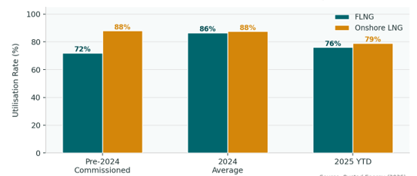
Figure 1 FLNG vs Onshore LNG Utilisation Rate Comparison
- Favourable Positioning in the Energy Transition
FLNG can reduce certain environmental and social impacts associated with large-scale onshore developments, particularly land disturbance, resettlement requirements, and extensive pipeline construction. By operating offshore, FLNG facilities minimize land disturbance, reduce the need for extended pipeline networks, and in projects such as Congo LNG, target zero routine gas flaring. Modern FLNG designs incorporate advanced emissions management technologies, aligning with tightening ESG requirements from international financiers and offtakers.

Key Projects and Regional Landscape
The FLNG sector has evolved from a handful of pioneering installations to a globally distributed portfolio of operational, under-construction, and advanced-development projects. The chart below profiles selected major FLNG projects across key regions.
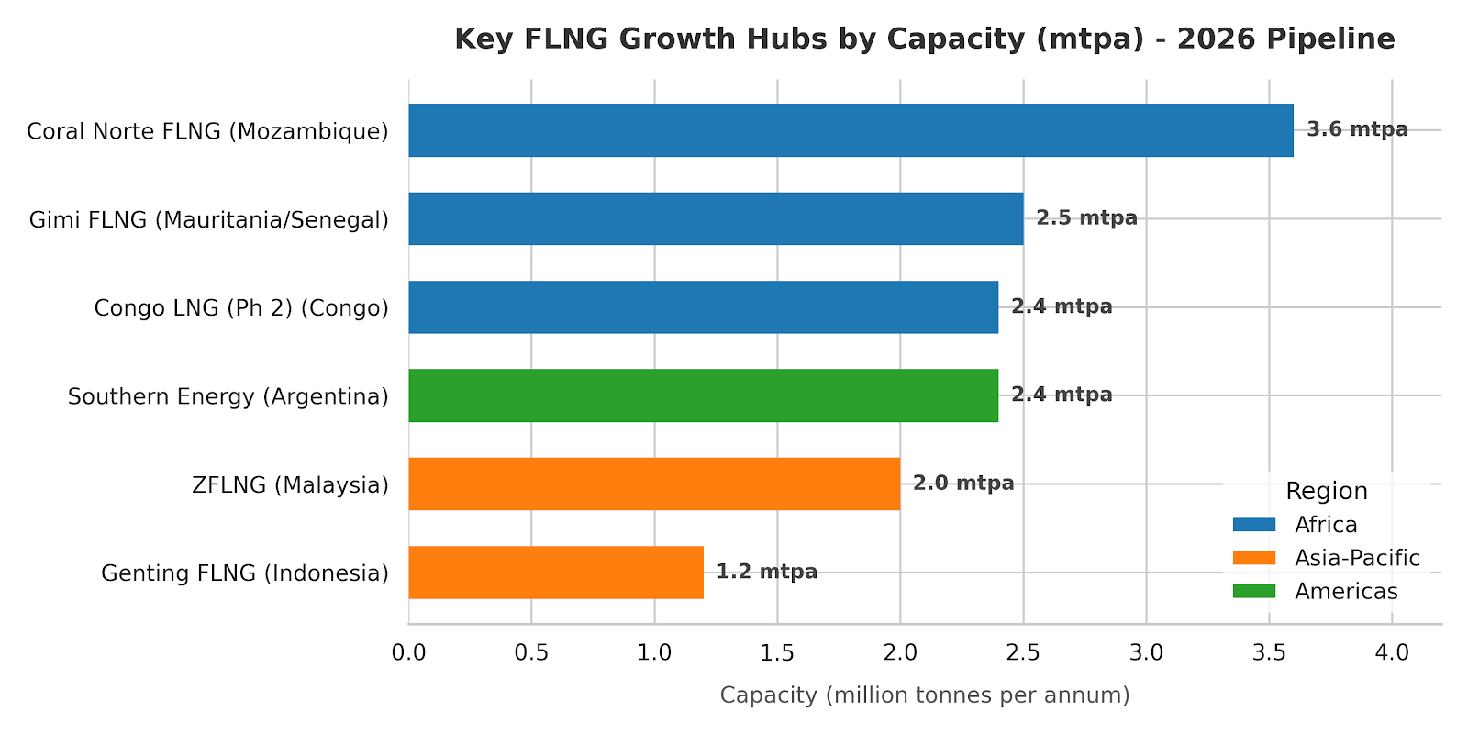
Figure 2 FLNG projects across key regions
Challenges and Risk Factors
Despite the sector's rapid maturation, FLNG projects continue to face a range of structural, regulatory, and market risks. The chart below presents an analyst-weighted breakdown of the key risk categories, followed by a detailed assessment of each.
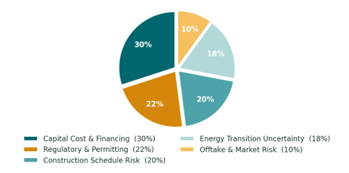
Figure 3 FLNG Project Risk Distribution
- Capital Cost and Financing
Despite improvements, FLNG projects remain capital-intensive undertakings. Large-scale units such as Prelude FLNG (Shell) have been associated with significant cost overruns, and the complexity of marrying a full LNG processing train with a floating hull in a marine environment imposes engineering risks not present in onshore facilities. Securing project financing requires robust long-term offtake agreements, creditworthy counterparties, and increasingly, alignment with lender ESG frameworks.
- Regulatory and Permitting Risk
Regulatory environments for offshore LNG can be uncertain. In a notable case in 2024, Grand Isle LNG withdrew its deepwater port license application in the Gulf of Mexico, effectively terminating the project after regulatory, financial, and logistical hurdles proved insurmountable. This episode underscores that regulatory risk remains non-trivial, particularly in jurisdictions with active competing LNG infrastructure and evolving environmental regulations.
- Construction Timelines and Schedule Risk
While recent projects have demonstrated improved schedule adherence, extended construction timelines remain a risk that delays revenue generation and amplifies cost overrun exposure. In the current market environment characterised by tightening, LNG supply-demand balances but a risk of oversupply post-2027 as onshore projects from the US and Qatar also come online speed to first production is commercially critical. Schedule slippage can materially erode a project's competitive positioning.
- Long-Term Energy Transition Uncertainty
The global energy transition presents a structural uncertainty for all LNG investments. The IEA and other forecasters note that under ambitious climate scenarios, LNG demand could decline well below current export capacity projections by the 2030s, raising the risk that some FLNG assets could become stranded in a net-zero trajectory. However, the redeployable nature of FLNG units and their faster capital recovery profile (relative to onshore facilities) provide partial mitigation against this terminal risk.

Recommendations
- For Upstream Operators: Portfolio strategies must be reassessed to include marginal or previously discounted offshore blocks. Tie-ins with mid-scale FLNG technology providers should be explored as an alternative to lengthy pipeline infrastructure negotiations.
- For Infrastructure Investors: In selected offshore developments, standardized FLNG solutions may offer attractive risk-adjusted returns and shorter development timelines compared to conventional onshore LNG infrastructure. Focus investments on modular units ranging between 1.5 to 3.5 mtpa, as this represents the sweet spot for capital efficiency and redeployability.
Conclusion
The growing adoption of FLNG is transforming stranded gas from a dormant asset into a commercially viable resource. Most industry forecasts project continued LNG demand growth through the 2030s, although long-term demand trajectories remain uncertain under accelerated decarbonization scenarios. For investors, operators, and host governments, FLNG represents both a strategic opportunity and a competitive advantage in the evolving global gas market.

