The Strategic Implications of Rising Global LNG Demand and the Emerging Supply Wave
Executive Summary
Global liquefied natural gas (LNG) demand is entering a new growth cycle driven by energy security concerns, coal-to-gas switching, rapid industrialization in emerging economies, and the growing role of natural gas as a transition fuel. Recent projections suggest that global LNG demand could increase substantially through the 2030s, with Asia remaining the primary growth engine while Europe continues to secure long-term supply diversification following disruptions to traditional pipeline gas flows.
This demand expansion is reshaping global energy trade patterns, accelerating investment in liquefaction and regasification infrastructure, and intensifying competition among exporters. The strategic implications extend beyond energy markets, influencing geopolitical relationships, upstream investment decisions, shipping capacity, and energy transition pathways.

DEMAND TRAJECTORY AND SUPPLY DYNAMICS
Global natural gas consumption has posted strong sequential growth over the past two years, with the LNG segment increasingly central to the market balance. The IEA's latest data point to a clear inflection: tighter conditions in H1 2025 are giving way to a substantially larger and more liquid market in 2026.

Global Demand Growth
- Global natural gas consumption rose by over 2.8% in 2024, exceeding 4,200 billion cubic metres (bcm), with Asia-Pacific accounting for nearly 45% of the incremental growth due to industrial expansion and decarbonisation efforts.
- Demand growth is forecast to slow to approximately 1.3% in 2025 reflecting tighter market conditions and macro uncertainty before re-accelerating to around 2% in 2026 as a considerable increase in LNG supply eases market fundamentals.
- Emerging Asian markets and China are expected to be the primary drivers of the 2026 acceleration, as falling spot prices stimulate demand in price-sensitive markets.

Supply Wave: North America Leads
- Global LNG supply rose by almost 7% in 2025, with around three-quarters of this growth concentrated in the second half of the year. New LNG capacity coming online in North America was by far the largest driver.
- Global LNG supply growth is expected to accelerate further in 2026 to more than 7%, its fastest pace since 2019 as US terminals ramp up and new trains come online.
- More than 90 bcm/year of LNG liquefaction capacity reached final investment decision in 2025, the second-highest annual amount on record with the United States accounting for over 80 bcm of approved capacity, reinforcing its position as the world's largest LNG supplier.
- Upcoming 2026 US additions include Corpus Christi Stage 3 (Trains 5–7), Golden Pass LNG (first two trains), Port Arthur LNG Phase 1, and Rio Grande LNG Trains 1 and 2.
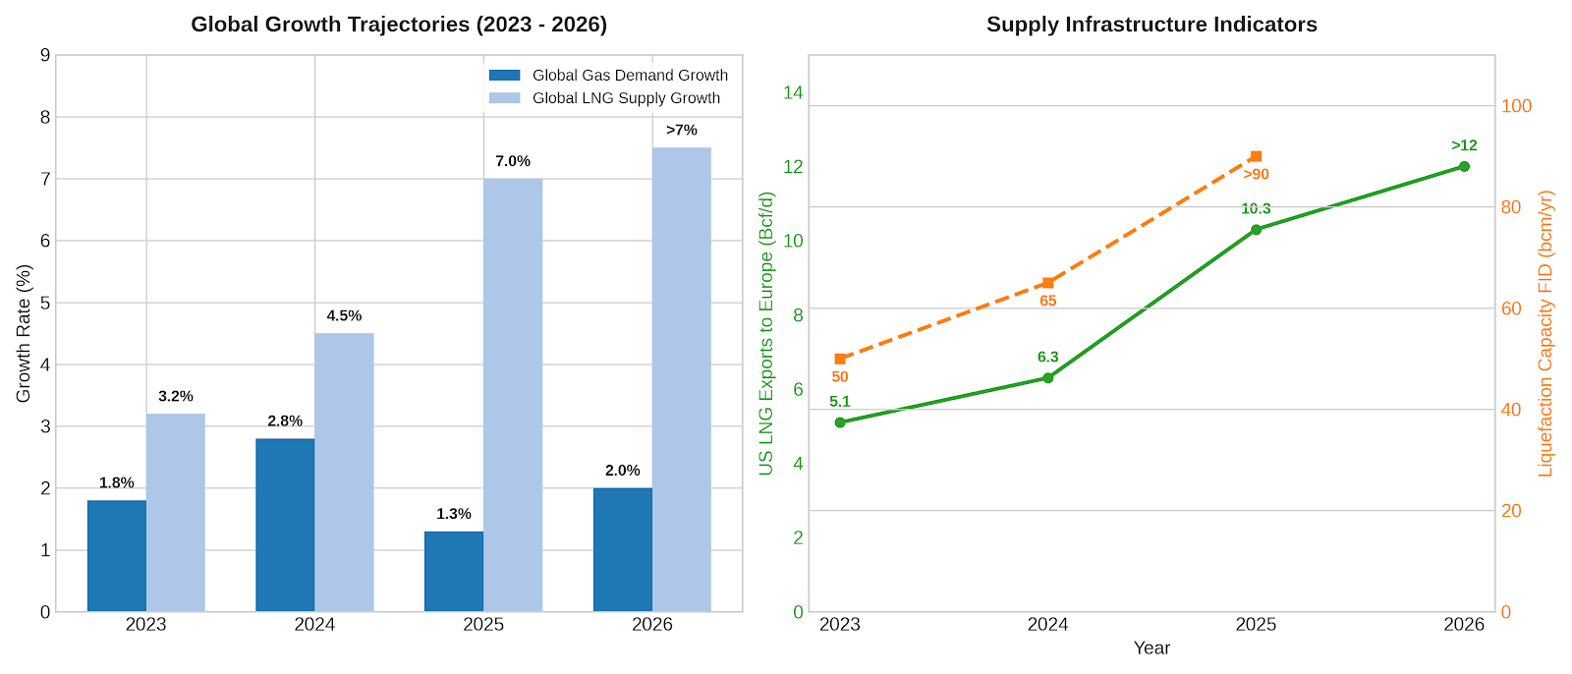
Figure 1: Global Growth Trajectories & Supply Infrastructure Indicators.
Core Drivers of the Demand Acceleration

Accelerated Decarbonization and Coal-to-Gas Substitution
Across South and Southeast Asia, policy mandates are driving structural fuel-switching. Power sector modernization and industrial emissions targets have cemented LNG as the primary bridging fuel to backstop intermittent renewable energy grids, providing critical dispatchable power.

Permanent European Disconnection from Russian Piped Gas
Following the European Union’s historic regulatory mandate to completely phase out all Russian natural gas imports by November 2027, Europe has emerged as a structurally important LNG import market following its strategic diversification away from Russian pipeline gas, although competition from Asian buyers will continue to influence cargo flows and prices. Europe is expected to maintain historically high LNG import requirements through the latter half of the decade as Russian gas is phased out.

- Rebound of the Asian Engine
Despite localized price shocks, Asian demand is rising, led by price-elastic buying and expanding gas storage infrastructure in China and India. Chinese imports are recovering, aiming toward a historic milestone of 100 million tonnes per annum (mtpa) by the late 2020s.
Key Strategic Implications

Intensified Competition for Supply Security

Acceleration of Upstream Investment

Growing Strategic Importance of Africa

Expansion of LNG Infrastructure

Increased Geopolitical Influence of LNG Exporters

Impact on the Energy Transition

Risk

Infrastructure Interdiction and Geopolitical Chokepoints
The vulnerability of centralized liquefaction hubs (e.g., Ras Laffan) and maritime bottlenecks (the Strait of Hormuz, Bab-el-Mandeb) means that supply resilience is now valued above low-cost production. Maritime freight rates and war-risk insurance premiums will remain highly volatile.

Upstream Feedgas Squeezes
As liquefaction capacity rapidly builds out along the US Gulf Coast, intense competition for domestic feedgas is narrowing export margins. Analysts must closely monitor the pricing spread between local benchmarks (Henry Hub) and international markers (Title Transfer Facility (TTF) and Japan Korea Marker (JKM)).

Infrastructure Constraints
Downstream regasification and pipeline infrastructure must expand rapidly enough to absorb shifting trade routes. Delays in engineering, procurement, and construction (EPC) frameworks driven by labor constraints or supply chain bottlenecks represent the primary execution risk for next-wave projects.

Outlook
The global LNG market is entering a period of sustained strategic importance. Demand growth across Asia, continued energy security concerns in Europe, and increasing gas utilization in emerging economies are likely to support robust LNG trade expansion over the coming decade. As a result, LNG will remain a central pillar of global energy systems, driving investment decisions, geopolitical alignments, and infrastructure development.
For energy stakeholders, the key challenge will be balancing the opportunities created by rising LNG demand with the long-term requirements of decarbonization and energy transition policies. Those capable of securing competitive supply positions, managing emissions, and integrating LNG into broader energy strategies will be best positioned to capture value in the evolving global gas landscape.

