Africa’s New Oil Producers: Assessing the Economic and Geopolitical Implications of First Oil in Senegal and Upcoming Production in Namibia

Senegal has already crossed the political and technical threshold from discovery to production. Woodside achieved first oil at Sangomar in June 2024, bringing online a deepwater FPSO with nameplate capacity of 100,000 barrels per day and 1.3 million barrels of storage. Senegal’s hydrocarbon complex then broadened in April 2025 when bp completed loading the first LNG cargo from GTA Phase 1. This sequence materially improved the external accounts and lifted headline growth, even while debt sustainability and the recent fiscal transparency reset kept sovereign risk elevated.
Namibia remains pre-first-oil, but it has moved from pure exploration enthusiasm into a more demanding phase of concept selection, ESIA work, fiscal preparation, and local-content design. Official and industry signals point to a Venus final investment decision window in 2026 and first oil around 2029/2030, while TotalEnergies and Galp are positioning Venus and Mopane as the basis for a future Orange Basin production hub. The key question is no longer whether Namibia has discovered hydrocarbons, but whether it can convert ultra-deepwater resources into competitive barrels at scale while preserving policy credibility.
The core contrast between the two countries is timing. Senegal’s immediate policy problem is how to translate first oil and first LNG into durable fiscal, industrial, and diplomatic gains without overheating expectations or worsening debt vulnerabilities. Namibia’s immediate policy problem is pre-revenue statecraft: locking in bankable project economics, a credible petroleum fiscal regime, workable local-content rules, and transparent institutions before major rents arrive.
Geopolitically, both countries matter because they widen Atlantic African supply options for Europe and other importers, deepen supermajor interest in the region, and increase the strategic importance of local ports, logistics corridors, and maritime governance. Yet neither case fits the old oil-state template. Senegal enters production with a parallel gas-to-power and LNG agenda; Namibia enters with stronger geological upside but also higher technical complexity, limited domestic market depth, and intense scrutiny over how rents should be shared.

Comparative snapshot
Dimension | Senegal | Namibia
Status | First oil June 2024; first GTA LNG cargo April 2025 | Pre-production; Venus FID targeted 2026; first oil expected 2029/2030
Anchor project metric | Sangomar FPSO 100 kb/d; storage 1.3 mmbbl; water depth ~780 m | Venus concept includes ~160 kb/d FPSO; ultra-deepwater around 3,000 m
Headline macro issue | Growth uplift with debt overhang and transparency shock | Pre-revenue opportunity with fiscal-space and capability constraints
Institutional lever | PETROSEN participation; FONSIS; Petroleum Code 2019 | Welwitschia Fund; local-content policy; petroleum fiscal competitiveness
Geopolitical signal | Atlantic hydrocarbons plus gas-to-power relevance | Orange Basin becoming a major frontier for global majors
Table 1. Comparative snapshot compiled from cited public sources.

Senegal country briefing: first oil as a macro and strategic inflection point

Sangomar is Senegal’s first offshore oil development and the clearest proof that the country can move from discovery to commercial operation. Woodside states that the field achieved first oil in June 2024 and that Phase 1 is built around a stand-alone FPSO with 100,000 barrels per day nameplate capacity. The vessel stores 1.3 million barrels, sits in approximately 780 metres of water, and supports 23 wells in the first phase, including production, water-injection, and gas-injection wells. These are the hard technical facts that matter because they frame the pace at which Senegal’s oil economy can convert offshore output into exports, revenues, and operating experience.
Senegal’s hydrocarbon story is not only oil. bp’s GTA Phase 1 exported its first LNG cargo in April 2025, with phase-one capacity expected around 2.4 million tonnes per year once fully commissioned. That gives Senegal a dual hydrocarbon narrative: Sangomar creates crude-export capability, while GTA creates a gas-and-LNG axis with both export and prospective domestic gas implications. This broadens the strategic use of hydrocarbons beyond pure fiscal extraction and gives Dakar more room to integrate energy policy with industrial and power-sector planning.
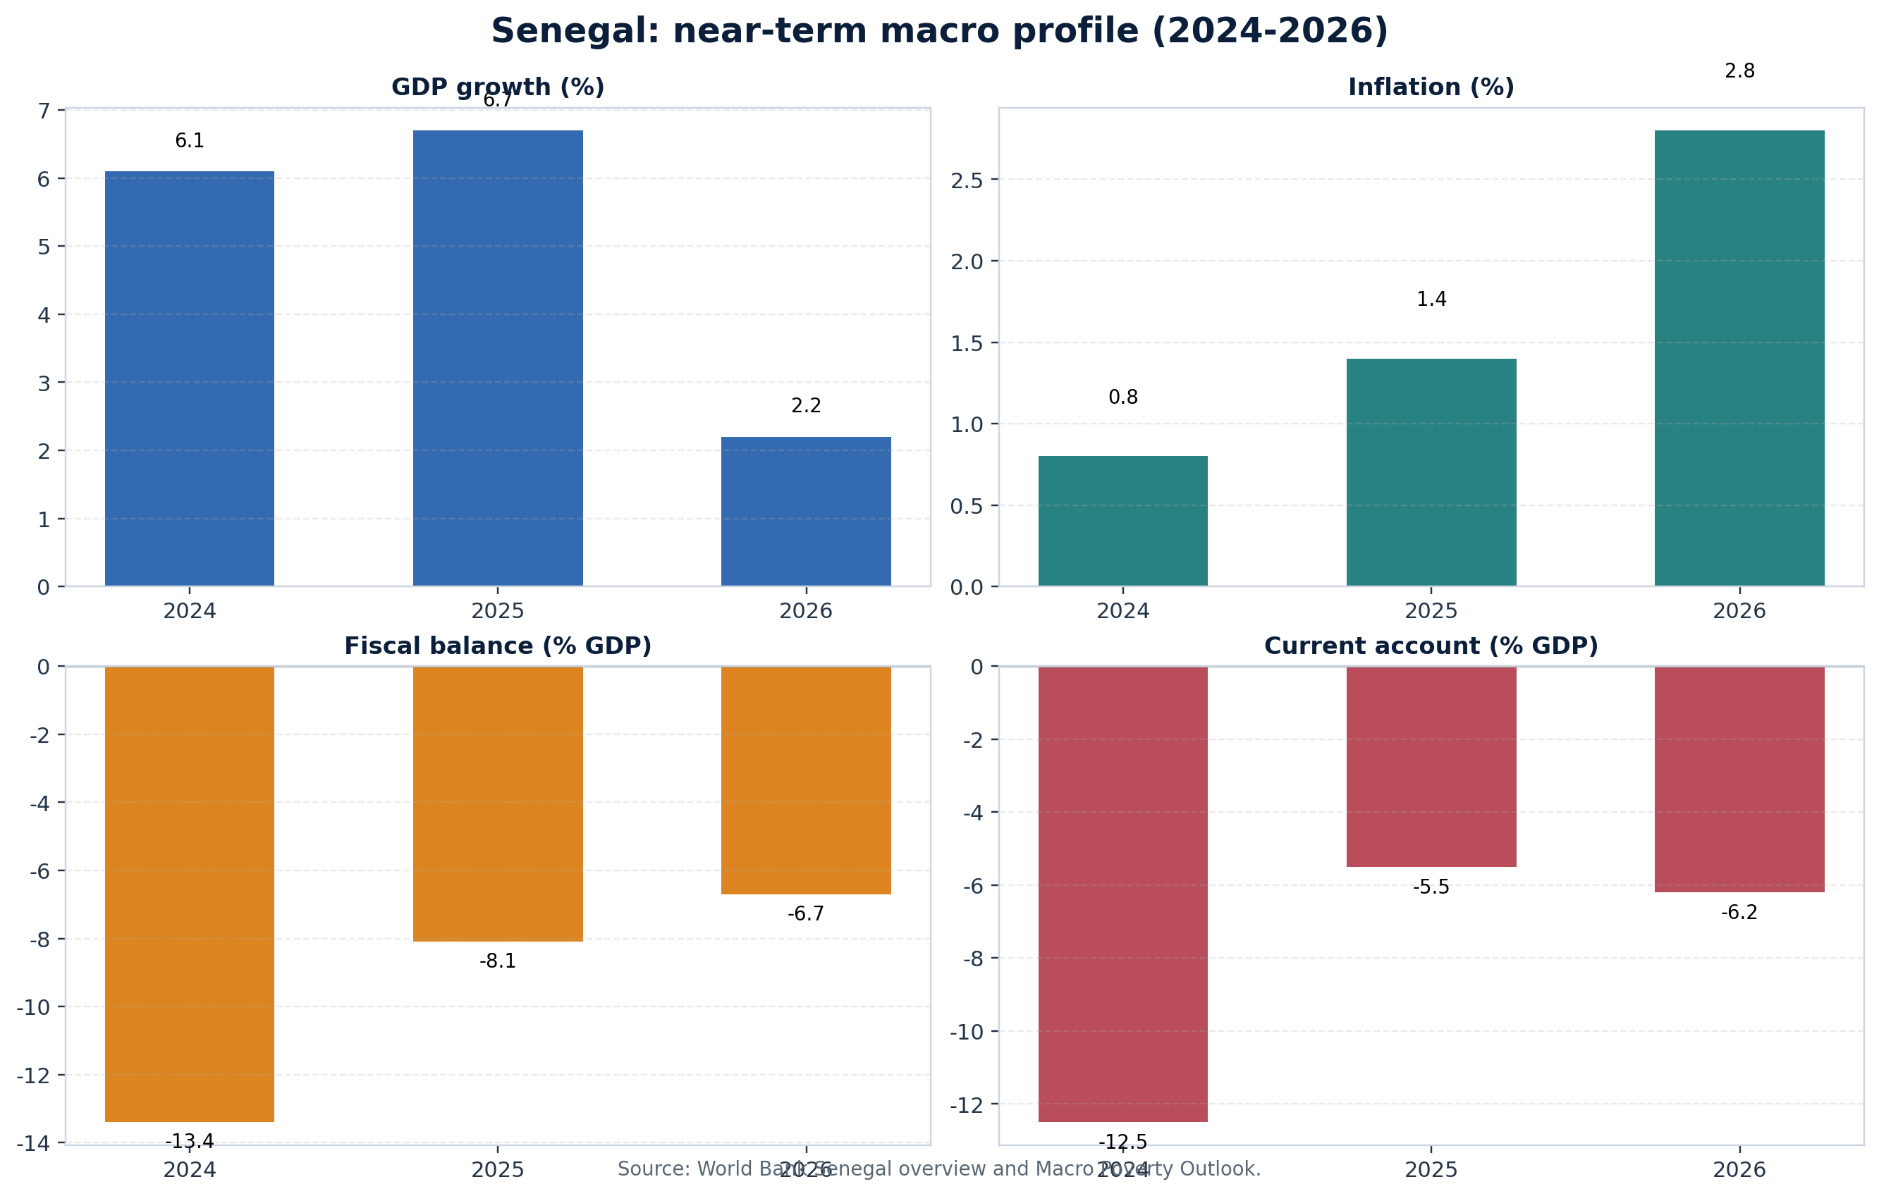
Figure 2. Senegal macro profile, 2024-2026
Based on World Bank Senegal overview and Macro Poverty Outlook.
The macro numbers show why first oil mattered immediately. The World Bank reports GDP growth of 6.1% in 2024 and 6.7% in 2025, while the current account deficit narrows from 12.5% of GDP to 5.5% over the same period. Hydrocarbon exports are the main reason. Inflation remains low, but the broader sovereign picture is less comfortable: the fiscal deficit and public debt ratios remain exceptionally high following the revelation of previously unreported debt and expenditure for 2019-2023. In other words, oil improved flow variables quickly, but it did not erase stock vulnerabilities.
That asymmetry is central to policy risk. Hydrocarbon revenues can support confidence only if they are embedded in a transparent fiscal consolidation strategy. Senegal therefore faces a “credibility premium” challenge: first oil has increased the country’s medium-term financing promise, but not yet reduced the need for tough debt management, better reporting, and spending discipline. The AfDB and World Bank both continue to frame diversification, macro stability, and the quality of public investment as the crucial filters through which hydrocarbon gains must pass.
Operationally, Senegal also gained an important data point in 2025. Reuters reported that the Ministry of Energy raised the Sangomar field’s 2025 output forecast to 34.5 million barrels from 30.53 million barrels, and said that production from January through August had already exceeded 24 million barrels. This matters for two reasons: it suggests stronger early field performance than initially expected, and it increases the salience of revenue-management institutions while public expectations are still being formed.
Selected Senegal technical and policy metrics
Metric | Value
First oil | June 2024
Sangomar FPSO nameplate capacity | 100,000 b/d
Gas processing capacity | 130 million scf/d
Water injection capacity | 145,000 b/d
Storage capacity | 1.3 million barrels
Water depth | Approx. 780 m
Well count in Phase 1 | 23 wells; 24th approved
JV structure in exploitation area | Woodside 82%, PETROSEN 18%
Project cost estimate | US$4.9-5.2 billion
GTA Phase 1 milestone | First LNG cargo in April 2025
GTA Phase 1 capacity | Approx. 2.4 mtpa LNG when fully commissioned
Table 2. Senegal technical profile.
Institutionally, Senegal has more than a project story. The 2019 Petroleum Code codifies that petroleum belongs to the Senegalese people, confirms the state’s sovereign rights, and gives PETROSEN at least a 10% stake in all contracts while setting transparency, local-content, and environmental requirements. The U.S. Commercial Service also notes that PETROSEN may hold up to 30% in development and exploitation phases and that companies are required to source some labor and materials locally and contribute to workforce training. This is a stronger state-participation and local-benefit framework than a purely enclave model.
Revenue management remains a live question rather than a settled architecture. NRGI reports that Senegal has considered saving a fixed share of hydrocarbon revenues via an intergenerational fund managed by FONSIS and a separate stabilization fund, with the remainder entering the general budget. FONSIS itself is a state strategic investment fund established in 2012 and aligned with Santiago Principles. That direction is positive, but the larger issue is execution: the fiscal rule, fund governance, and integration with the budget process matter more than the existence of funds alone.
Geopolitically, Senegal’s emergence as an exporter slightly enlarges the Atlantic supply map at a time when European buyers continue to value diversified crude and LNG sources. The crude quality from Sangomar is marketed as roughly 31° API and in demand in Europe and Asia, while GTA offers a West African LNG option that is strategically useful even at modest scale. Dakar therefore gains external relevance not by being large, but by being timely, reliable, and integrated into a broader regional gas narrative with Mauritania.
The main downside risks are now clear. First, debt sustainability concerns can dilute the sovereign credit benefit of first oil if investors conclude that revenue gains will be absorbed by financing gaps rather than productivity-enhancing investment. Second, public expectations for jobs and lower energy costs can outrun the realistic domestic-employment intensity of offshore projects. Third, any contract or governance controversy would carry disproportionate political weight because the hydrocarbon era is still institutionally new. Senegal’s challenge is therefore one of disciplined normalization: make first oil look boring, rules-based, and bankable.

Namibia country briefing: from frontier excitement to pre-first-oil statecraft

Namibia has not yet produced commercial oil, but it is already living through the political economy of expectation. The Orange Basin discoveries have attracted supermajor capital and global attention, yet the country’s next steps are more technical than celebratory: design a field concept that works in ultra-deepwater conditions, secure fiscal and regulatory clarity, scale logistics and skills, and preserve investor confidence through the FID window.
For the lead project, public reporting indicates a fairly clear directional timeline. Reuters cited Namibia’s petroleum commissioner in saying that TotalEnergies was on track for a Venus FID in the fourth quarter of 2026 and that Namibia expected first oil in 2029-2030. Galp’s official Namibia page says TotalEnergies is progressing a Venus development concept including a 160 kb/d FPSO with FID expected in 2026. These signals matter because they frame Namibia’s current policy horizon: the next 12-24 months are the window in which the state can still shape local-content design, gas-handling choices, and enabling infrastructure before path dependency hardens.
Namibia’s technical challenge is materially tougher than Senegal’s. Reuters quotes TotalEnergies describing the gas as remote, under 3,000 metres of water and about 300 kilometres from the coastline; Wood Mackenzie similarly emphasizes the frontier complexity of water depths above 2,000 metres, deep reservoirs, flow-assurance issues, and uncertain gas monetization pathways. This is why cost competitiveness, not just resource size, dominates the pre-first-oil debate. TotalEnergies has signaled that keeping production costs under US$20 per barrel is an important viability threshold.
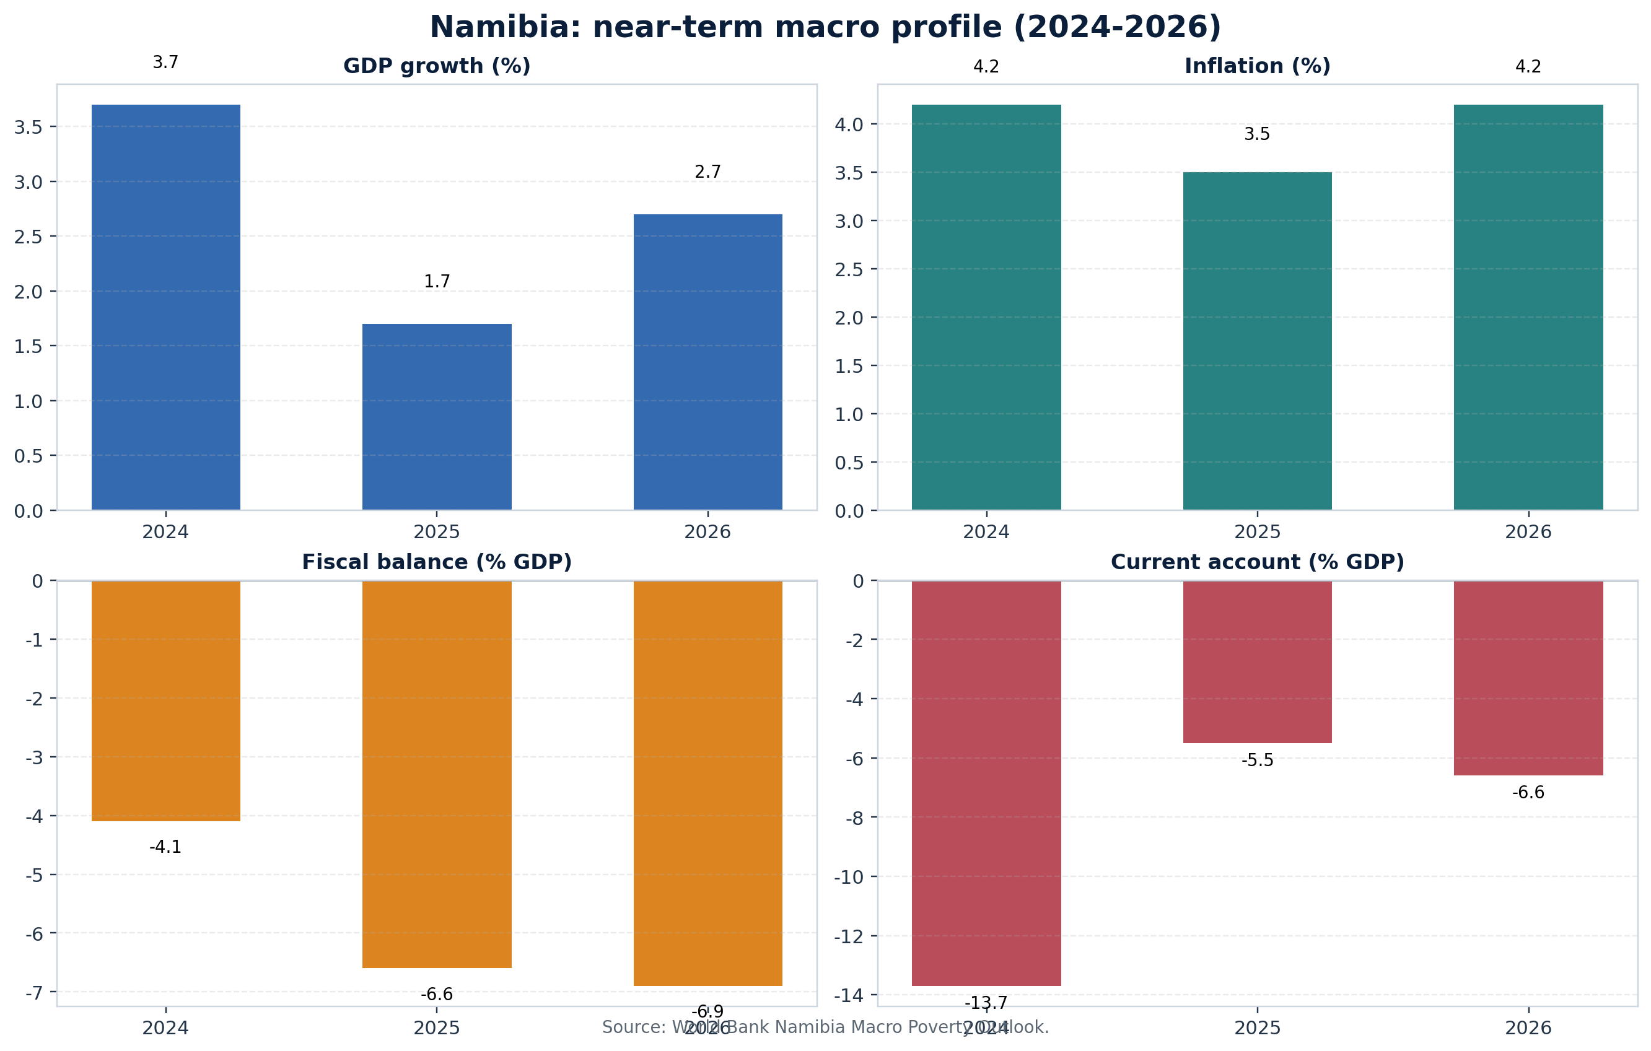
Figure 3. Namibia macro profile, 2024-2026
Based on World Bank Namibia Macro Poverty Outlook.
Unlike Senegal, Namibia’s macro data do not yet show petroleum production benefits. The World Bank estimates growth slowed from 3.7% in 2024 to 1.7% in 2025, with the fiscal deficit widening to 6.6% of GDP and public debt remaining around 71.7% of GDP. The current account improved from a very wide 13.7% deficit in 2024 to 5.5% in 2025, but this did not reflect oil exports; it sat alongside a US$750 million Eurobond repayment and continued structural fiscal stress. The same World Bank outlook notes that major petroleum and green hydrogen projects, if they proceed, could raise FDI and GDP over the next five years, but warns that job creation impacts are uncertain.
That distinction is essential. Namibia’s oil boom, for now, is a capital-markets and expectations story rather than a revenue story. The near-term gains are exploration spend, service-sector demand, port and logistics activity, and a rise in strategic visibility. The near-term risks are policy overreach, capability gaps, and disappointment if project economics weaken. Put differently, the opportunity is very large, but it is not yet banked.
Selected Namibia technical and institutional metrics
Metric | Value
Status | Pre-production; no first oil yet
Venus FID signal | Targeted in 2026
Venus first oil expectation | 2029/2030
Venus development concept | Approx. 160 kb/d FPSO
Ultra-deepwater reference | Around 3,000 m water depth; ~300 km offshore
Mopane appraisal | At least three wells over next two years; first well planned in 2026
Mopane setting | Approx. 200 km offshore; water depths 1,200-1,900 m
Indicative fiscal terms | 5% royalty, 35% petroleum income tax, excess profit tax, NAMCOR stake
SWF status | Welwitschia Fund launched 2022; ~N$460m assets as of Mar 2025; no governing legislation yet
Local content policy signal | Draft March 2025; local company definition 51% Namibian ownership and 30% previously disadvantaged ownership
Table 3. Namibia project and institutional profile.
Namibia’s institutional posture is promising but unfinished. The Bank of Namibia says the Welwitschia Fund is designed to insulate the socio-economic structure against cyclical shocks and promote intergenerational prosperity. The U.S. State Department’s 2025 investment climate statement adds that the fund had roughly N$460 million in assets by March 2025, but also notes that it still lacked governing legislation and was being administered by the Bank of Namibia. In a resource-governance context, that means Namibia already understands the importance of stabilization and savings, but still needs to harden the legal architecture before large petroleum inflows arrive.
Local content is the second institutional frontier. Namibia’s March 2025 draft National Upstream Petroleum Local Content Policy aims to maximize Namibian participation, workforce development, procurement localization, technology transfer, and reporting obligations. It defines a local company as one with at least 51% Namibian ownership and 30% ownership by previously disadvantaged persons. The direction is politically understandable and economically important, but the implementation challenge is real: overly rigid requirements before supply chains are mature could raise costs in exactly the pre-FID period when project bankability is being tested.
On the investor side, Namibia still looks competitive. Wood Mackenzie argues that the country’s tax terms are favorable and progressive for a frontier province, highlighting a 35% petroleum income tax rate, a 5% royalty, state participation through NAMCOR, and an excess-profit mechanism. The broader claim is that if appraisal and flow testing meet expectations, Namibia could exceed 500,000 barrels per day within a decade with upstream investment reaching as much as US$4 billion per year in the early 2030s. That upside is not a forecast certainty, but it captures why majors are competing to build long-run positions there.
Geopolitically, Namibia’s value comes from optionality. It offers global firms a large, non-OPEC, Atlantic-basin growth province; it offers southern Africa a potential new energy and logistics hub; and it offers Western governments another example of a rules-based African producer that could emerge outside the more politically crowded Gulf of Guinea. Yet the same strategic premium raises the stakes of governance. If Namibia mismanages expectations or investors conclude that fiscal or local-content terms may turn unstable after discovery, the frontier premium could compress quickly.

Comparative assessment: what first oil changes, and what it does not

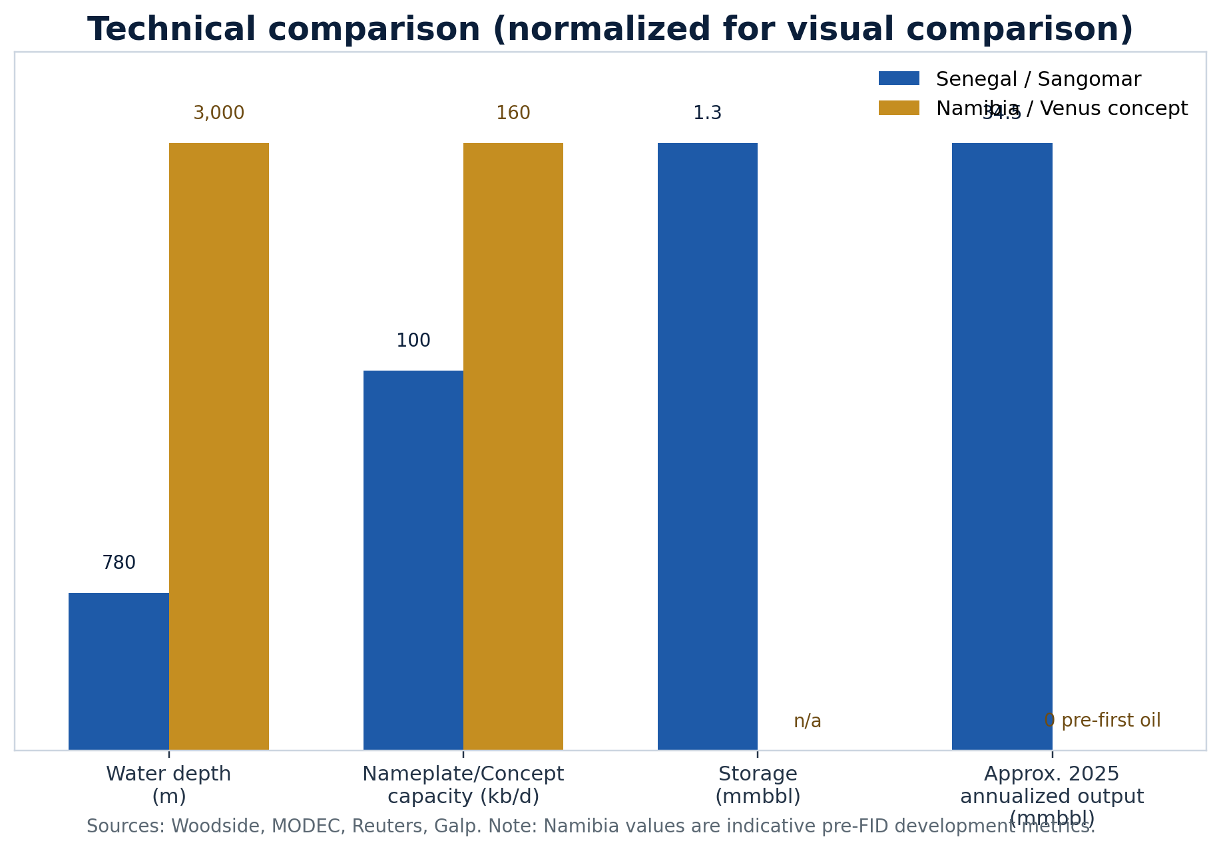
Figure 4. Technical comparison of Senegal’s operating system and Namibia’s lead concept
Normalized visual; values annotated directly on bars.
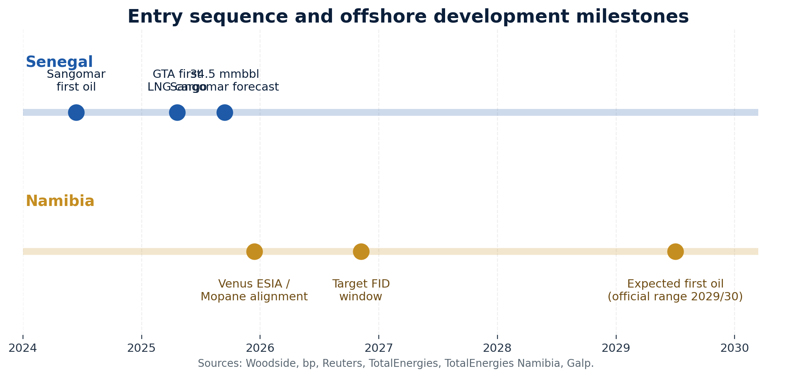
Figure 5. Entry sequence and offshore development milestones
Milestones compiled from official company disclosures and Reuters reporting.
Senegal demonstrates that even a relatively modest deepwater oil project can alter macro narratives quickly. The gains appear first in exports, current-account dynamics, and sovereign storytelling. They do not automatically appear in debt metrics, industrial competitiveness, or employment outcomes. Namibia should learn from that sequencing. First oil, when it comes, will likely improve external and fiscal indicators before it materially transforms the broader labor market. Planning should reflect that lag.
The two countries also highlight different versions of resource nationalism. In Senegal, the immediate emphasis is on ensuring that state participation, budgeting, and revenue-management mechanisms are credible after production has begun. In Namibia, the emphasis is on pre-production bargaining over local content, fiscal competitiveness, and infrastructure burden-sharing. One country is managing realization risk; the other is managing conversion risk.
From an energy-security perspective, Senegal is already part of the diversification map, while Namibia is still part of the optionality map. Senegal can offer actual cargoes. Namibia offers the prospect of future barrels from a highly attractive frontier basin. Investors and policymakers should therefore avoid over-comparing current macro outcomes: Senegal is being measured on operational delivery, whereas Namibia is being measured on the credibility of its runway to delivery.
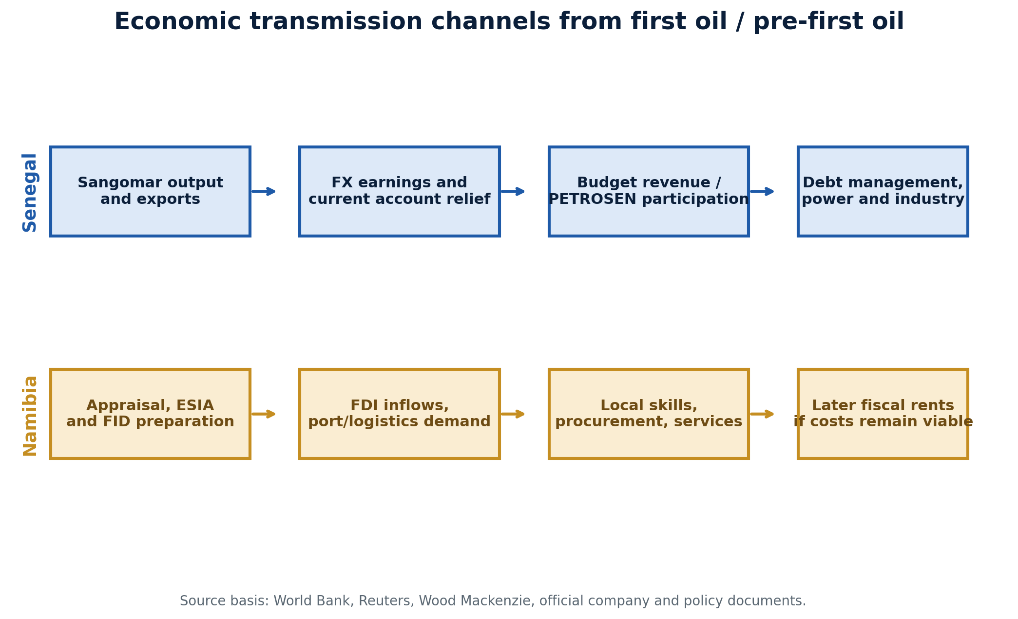
Figure 6. Economic transmission channels
Framework illustration based on cited sources; boxes are analytic synthesis.
A final difference is the gas question. In Senegal, gas is a complementary policy asset with direct relevance to LNG exports and domestic power. In Namibia, gas is partly a development constraint because handling and monetization are technically difficult in ultra-deepwater settings, increasing the importance of reinjection and shared infrastructure options. This means Namibia’s route to first oil depends more heavily on disciplined engineering simplification than Senegal’s did.

Risk dashboard and watch points
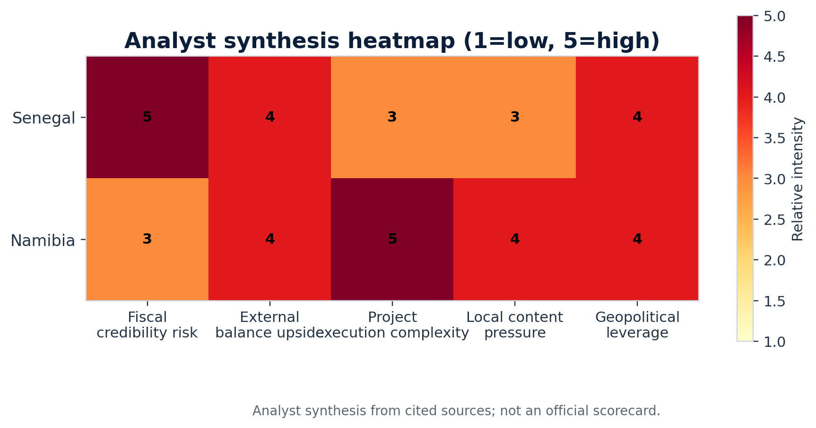
Figure 7. Analyst synthesis heatmap
This scorecard is an analytical synthesis rather than an externally published ranking.
The highest Senegal risk is fiscal credibility. The country now has hydrocarbon inflows but also a more difficult debt narrative after the fiscal transparency review. The key watchpoint is whether oil and gas receipts become a platform for repairing sovereign confidence or merely a cushion for legacy imbalances.
The highest Namibia risk is execution complexity. Ultra-deepwater development, gas handling, cost control, and local-content calibration all sit directly in the path to FID. The key watchpoint is whether the government and operators can keep the political ambition of local participation aligned with the commercial discipline needed for sanctioning.
Priority watchpoints by country
Country | Near-term watchpoint | Why it matters
Senegal | Budget integration of hydrocarbon revenues | Determines whether first oil improves creditworthiness and investment quality
Senegal | Domestic gas monetization and power linkages | Shapes whether hydrocarbons reduce energy costs and support industry
Senegal | Operational consistency at Sangomar | Keeps the first-production story bankable and politically defensible
Namibia | Venus FID conditions in 2026 | The commercial gate between discovery and future revenue
Namibia | Gas-handling / shared infrastructure decisions | Affects cost structure and development concept
Namibia | Legal hardening of SWF and local-content framework | Signals whether pre-revenue institutions are being built fast enough
Table 4. Priority watchpoints.

Conclusions for policymakers, investors, and lenders

For policymakers, the briefing’s main conclusion is straightforward: first oil is not the same thing as transformation. Senegal’s experience shows that hydrocarbons can quickly improve growth and the external account, but they do not remove the need for hard institutional choices on debt, budgeting, and domestic value creation. Namibia should use its pre-first-oil window to make those choices before rents arrive.
For investors and lenders, Senegal and Namibia should be read as adjacent but not identical opportunities. Senegal offers evidence that West African offshore projects can come onstream and broaden the state’s policy toolkit. Namibia offers much larger frontier upside, but only if costs, governance, and local participation can be stabilized through sanctioning. One is a producing case that still needs fiscal normalization; the other is a frontier case that still needs institutional consolidation.
For geopolitical analysis, the rise of both producers reinforces a broader pattern: Atlantic Africa is becoming more important as a diversified supply and investment corridor. The countries that will benefit most are not necessarily those with the largest discoveries, but those that can combine credible institutions, reliable project execution, and a realistic social contract around what hydrocarbons can and cannot deliver.

Appendix A. Chart data tables
Table A1. Senegal macro data used in figures
Year | GDP growth | Inflation | Fiscal balance | Current account | Debt
2024 | 6.1 | 0.8 | -13.4 | -12.5 | 122.7
2025 | 6.7 | 1.4 | -8.1 | -5.5 | 118.9
2026 | 2.2 | 2.8 | -6.7 | -6.2 | 118.7
Source: World Bank Senegal overview and Macro Poverty Outlook.
Table A2. Namibia macro data used in figures
Year | GDP growth | Inflation | Fiscal balance | Current account | Debt
2024 | 3.7 | 4.2 | -4.1 | -13.7 | 71.7
2025 | 1.7 | 3.5 | -6.6 | -5.5 | 71.7
2026 | 2.7 | 4.2 | -6.9 | -6.6 | 74.8
Source: World Bank Namibia Macro Poverty Outlook.

