The Expansion of Regional Cross-Border Pipelines: Africa's Bid for a Unified Energy Market
Executive Summary
Africa's hydrocarbon investment landscape is undergoing a structural shift. While upstream exploration and field development remain critical, an increasing share of capital is flowing into regional cross-border pipeline infrastructure that connects multiple producing nations, industrial centers, and export terminals. The investment thesis is straightforward: pipelines provide lower sensitivity to price, but still volume-dependent on upstream production and demand , long-duration cash flows through transportation tariffs and throughput agreements, often underwritten by government-backed commitments and long-term ship-or-pay contracts.
Three projects anchor this thesis at different points on the risk-and-maturity curve: the East African Crude Oil Pipeline (EACOP), now approximately 82% complete and approaching first oil, the West African Gas Pipeline (WAGP) and its proposed extension into the African Atlantic Gas Pipeline (AAGP); and the Trans-Saharan Gas Pipeline (TSGP), which has just restarted construction after a year of Sahelian political disruption. The success of the East African Crude Oil Pipeline (EACOP) demonstrates how large-scale transnational infrastructure can unlock stranded reserves while creating predictable revenue streams independent of short-term commodity price volatility. Figure 1 illustrates a Scale comparison across the four flagship cross-border projects.

The Shift to Trans-Boundary Infrastructure
Historically, sub-Saharan asset monetization has suffered from the "stranded reserve" dilemma where highly commercially viable oil and gas deposits remained locked in landlocked or infrastructure-starved jurisdictions. Traditional domestic-only pipelines often lacked the localized industrial demand or financial scalability required to generate acceptable internal rates of return (IRRs). That model is giving way to a corridor logic, in which pipelines are conceived from the outset as multi-country systems linking stranded reserves to either a coastal export hub or an industrial demand centre in a neighbouring state. This shift is driven by three reinforcing factors:

- Geology
reserves of scale in Uganda, Niger and the wider Sahel are landlocked, so monetisation is structurally impossible without crossing at least one border;
- Policy
The African Continental Free Trade Area and ECOWAS/EAC energy-integration agendas have pushed governments to co-sponsor multi-state agreements rather than compete for stand-alone projects; and
- Risk diversification
Regional pipelines spread political and counterparty risk across several sovereigns and several offtake markets, which is more financeable than a single-country exposure, particularly for DFIs and risk-averse lenders.

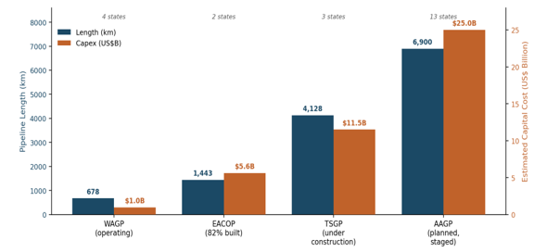
Figure 1 Cross-boarder Pipeline Scale Comparison
Case Studies

EACOP

The East African Crude Oil Pipeline is the most advanced and most cited example of the trans-boundary model: a 1,443-km, heated 24-inch line running from Hoima in Uganda's Lake Albert basin to the Chongoleani Marine Terminal near the Port of Tanga in Tanzania. It is being built in parallel with, but is contractually separate from, the upstream Tilenga (TotalEnergies) and Kingfisher (CNOOC) developments, and is designed to carry up to 246,000 barrels per day once ramped.

Parameters | Details
Route | Hoima (Uganda) → Tanga (Tanzania), 1,443 km
Capacity | Up to 246,000 bbl/d design capacity
Capex | Originally $4.0bn (2016), now reported at $5.6bn (2026), +40%
Ownership | TotalEnergies, CNOOC, UNOC (Uganda), TPDC (Tanzania)
Completion | Approximately 82% complete as of April 2026

For investors, EACOP demonstrates both sides of the toll-road thesis simultaneously. The tariff and throughput economics are increasingly bankable as completion nears — Tanzania stands to collect transit fees, employment, and corridor infrastructure spillovers regardless of which upstream field is producing in a given year. But the financing experience also shows that ESG pressure can functionally privatise a “government-backed” project's risk back onto its sponsors: project leads have reportedly had to self-fund roughly 90% of costs as international banks and insurers exited under activist and reputational pressure. Figure 2 shows how EACOP's capital cost has risen 40% from its original 2016 budget, while construction has accelerated sharply since late 2025, closing in on the H2 2026 first-oil target.
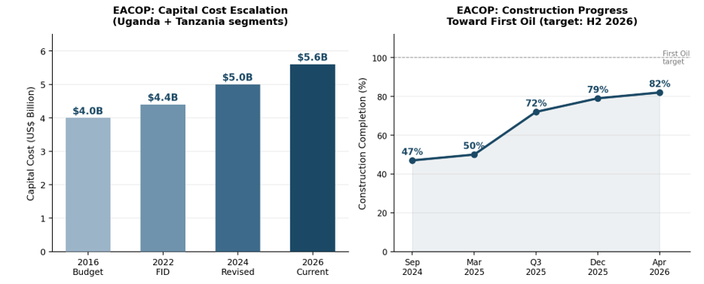
Figure 2 EACOP's Capital Cost Rise
- WAGP / WAGP Extension
Where EACOP is a single corridor under construction, WAGP is the model already in commercial operation, a 678-km subsea and onshore system moving Nigerian gas to Benin, Togo and Ghana since 2011. Nigeria supplies more than 68% of total volumes, and the project is governed by a dedicated treaty-based authority (WAGPA) rather than a single host government.
The proposed extension, also referenced as the Nigeria–Morocco Gas Pipeline would scale this same architecture dramatically: a planned 6,900-km system intended to connect Nigeria to as many as 13 coastal West and North African states en route to Morocco and, ultimately, European buyers, with an estimated capacity of 30 billion cubic metres per year and a cost estimated near $25 billion staged over roughly 25 years. The first phase under discussion would extend WAGP from Takoradi (Ghana) to San-Pédro (Côte d'Ivoire) and link Kayar (Senegal) to Morocco.

Parameter | WAPG (Operating) | AAGP (Planned)
Length | 678 km | 6,900 km
Countries involved | 4 (Nigeria, Benin, Togo, Ghana) | Up to 13, plus Morocco/EU linkage
Capacity | 5 bcm/year | Approximately 30 bcm/year
2025 throughput | Approximately 80 million MMBtu (record year) | N/A — pre-construction
Capex | Approximately $0.97bn (1990s–2011 build) | Approximately $25bn estimated, staged to ~2046
2025 fiscal yield | Approximately $32.8m in member-state corporate tax | N/A

- TSGP
The Trans-Saharan Gas Pipeline connects Nigeria's stranded gas reserves, via landlocked Niger, to Algeria's Hassi R'Mel hub and onward into the existing Trans-Mediterranean, Maghreb-Europe, Medgaz and Galsi pipeline network feeding Europe. At 4,128 km and an estimated $10–13 billion, it is roughly three times the length and twice the cost of EACOP, but touches only three sovereigns versus EACOP's two and AAGP's prospective thirteen.
The project gained real momentum in early 2025 with fresh ministerial agreements among Algeria, Nigeria and Niger, only to stall when Algeria shot down a Malian drone in April 2025, triggering ambassador recalls across the Alliance of Sahel States (Mali, Niger, Burkina Faso) and casting doubt on Niger's continued participation. A diplomatic reset in February 2026 revived the project, and preparatory engineering works and renewed intergovernmental discussions have intensified in 2025–2026, with phased development scenarios under review. By linking Niger’s prolific Agadem Basin with Atlantic shipping lanes, the project introduces clear, long-term tariff structures. This infrastructure transforms previously restricted upstream assets into highly scalable, liquid international commodities.

Comparative Project Mapping
The table below provides a comparative operational and financial analysis of the leading trans-boundary midstream pipeline projects defining the African continent's current infrastructure deployment cycle.

Project name | Participating nations | Length (km) | Resource type | Estimated CAPEX | Function
EACOP (East  African Crude Oil  Pipeline) | Uganda, Tanzania | 1,443 | Crude Oil | $5.6  Billion | Monetizes stranded Albertine  Graben fields via Tanga Port.  Fully insulated/heated line.
WAGP | Niger, Benin | 1,980 | Natural Gas | $4.5  Billion | Bypasses landlocked limits to link  Agadem fields with Sèmè-Kpodji  ocean terminal.
WAGP Extension  (West African Gas) | Nigeria, Benin, Togo,  Ghana (Ext. to Côte  d'Ivoire) | 678+ | Natural Gas | $2.5  Billion | Links structural gas oversupply in  Nigeria to industrial generation  hubs across ECOWAS.
TSGP (Trans-  Saharan Gas  Pipeline) | Nigeria, Niger, Algeria | 4,128 | Natural Gas | $13.0  Billion | Mega-project linking sub-Saharan  supply fields directly into the  European gas grid.

Investor Recommendations
For energy firms and long-horizon institutional investors looking to deploy capital efficiently into the African upstream space, the following steps are recommended:
- Prioritize Midstream over Pure Upstream Asset Plays
- Enforce Sovereign Cross-Collateralization
- Structure Investments Around Take-or-Pay Tariff Models

Conclusion
The expansion of regional cross-border pipelines represents one of the most significant structural developments in Africa's energy landscape. As governments seek to monetize stranded reserves, strengthen energy security, and accelerate industrialization, pipeline infrastructure is emerging as the backbone of a more integrated continental energy market.
For investors, the appeal lies not merely in transporting hydrocarbons but in owning strategic infrastructure that functions as a long-term toll road connecting resources, industries, and export markets. Projects such as EACOP, WAGP expansions, the Nigeria-Morocco Gas Pipeline, and Trans-Saharan Gas Pipeline illustrate how capital is increasingly shifting toward assets that provide predictable tariffs, multi-country risk diversification, and decades of cash-flow visibility. Over the next decade, regional pipeline corridors are expected to become one of the most resilient and strategically important investment themes across Africa's upstream and midstream energy sectors.

