Ghana Energy Country Briefing
Executive Summary
Following several years of production decline, Ghana's energy sector is evolving into one of West Africa's most diversified energy markets, combining a mature hydrocarbon sector with one of the continent's most ambitious energy transition programs. The government’s 2026 strategy, centered on "resetting" the upstream petroleum landscape and aggressive natural gas commercialization, aims to position the nation as a regional industrial and energy hub. The government has struck roughly $3.5 billion in fresh investment commitments to revive the Jubilee, TEN, and Sankofa fields, while simultaneously pursuing a $60 billion downstream refining and petrochemical hub that, if built as announced, could position Ghana among Africa's largest refining and petrochemical hubs if developed as planned. While the power sector remains thermally reliant, the integration of LNG imports and domestic gas expansion is critical to meeting a projected 7.3% year-on-year increase in electricity demand during 2026 .

Country Energy Snapshot
Indicator | Value
Electricity Access | >88%
Installed Power Capacity | Approximately 5.7 GW
Peak Electricity Demand | Approximately 4.0 GW
Crude Oil Production | Approximately 130,000–140,000 bpd
Natural Gas Production | Approximately 250–300 MMscfd
Renewable Energy Share (excluding large hydro) | <5%
Major Export | Crude Oil
Key Energy Hub | Takoradi

Power Sector Overview
Ghana's National Interconnected Transmission System recorded a coincident peak demand of 3,952 MW on December 19, 2024 a 9.2% jump over the prior year's peak. Demand has more than tripled since 2000, and the trend shows no sign of plateauing as rural electrification, industrial expansion (notably aluminium smelting and emerging data-centre interest), and urban growth all add load. Ghana’s electricity generation for 2026 is forecasted to be heavily dominated by thermal and hydro sources. With peak demand projected to reach 4,581 MW, system stability depends on reliable gas throughput.
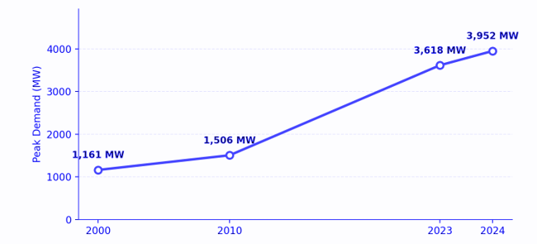
Figure 1 Ghana System Peak Electricity Demand, 2000-2024

Natural Gas
Unlike crude oil, Ghana's natural gas position has been comparatively resilient, and gas remains the single most strategically important hydrocarbon the country produces not for export revenue, but because it now fuels roughly 70% of domestic electricity generation. Current gas supply averages approximately 250–300 mmscfd, sourced from Jubilee, TEN, and Sankofa, plus pipeline imports via the West African Gas Pipeline (WAGP) and from Nigeria. Some facts about Ghana’s natural gas sector are as follows:
- Raw gas production rose 10% in 2024 on higher output across Jubilee, TEN, and OCTP, even as oil volumes fell, a divergence that reflects gas's status as a byproduct stream from fields whose primary economics are oil-driven.
- Nigeria has agreed to increase gas supply to Ghana from 70 to 100 mmscfd, with discussions underway to scale this to 150 mmscfd, while ENI agreed a separate 30 mmscfd supply top-up effective July 2025.
- Energy Minister Jinapor has cited $2 billion in Jubilee-partner commitments and $1.5 billion in Sankofa-partner commitments as expected to reduce gas prices and increase consumption, alongside a planned second domestic gas processing plant approved by Cabinet.

Generation Mix
Thermal plants fired predominantly by domestic and imported natural gas, with light crude or diesel as backup now account for 66% of Ghana's generation mix, with hydropower (Akosombo, Kpong, and Bui) supplying 33% and utility/embedded solar contributing roughly 1%. This is a marked structural shift from the era when the Akosombo dam alone could carry the bulk of national demand.
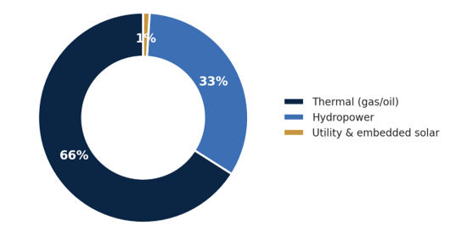
Figure 2 Ghana Installed Generation Mix 2024
Following exceptionally high inflows into the Akosombo reservoir in 2023 that forced precautionary water spillage, inflows have normalized and hydro output is projected to fall from an estimated 9,943 GWh in 2024 to 8,561 GWh in 2025 a 13.9% decline. Thermal generation, by contrast, rose from about 13.0 TWh (Jan–Nov 2023 basis) to an estimated 14,580 GWh for full-year 2024, a 2.7% increase, and is expected to absorb most of the incremental demand growth that hydro cannot meet.

Upstream
Ghana's three producing fields, Jubilee, TEN (Tweneboa-Enyenra-Ntomme), and Sankofa-Gye Nyame (SGN) have seen combined output fall every year since output peaked at 71.44 million barrels in 2019. The Public Interest and Accountability Committee (PIAC), presenting its 2025 Annual Report in April 2026, confirmed a sixth straight annual decline, with full-year 2025 production of 37.3 million barrels, representing an average compound annual decline of approximately 9% since 2019 and leaving output nearly 48% below its peak level.

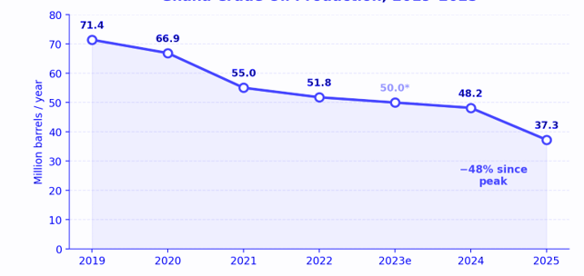
Figure 3 Ghana Crude Oil Production, 2019-2025
The decline is uneven across fields. Jubilee, still the largest producer, fell hardest in percentage terms in 2025 down 30.3% year-on-year to 22.21 million barrels (63,280 bpd) while Sankofa-Gye Nyame proved comparatively resilient, down just 3.6% to 9.26 million barrels, and TEN fell 14.0% to 5.83 million barrels.
Why the decline
- PIAC attributes the trend to natural reservoir depletion and field maturation, compounded by scheduled shutdowns that have cut yields by as much as 32% since 2019, and by the absence of any new petroleum agreement since 2018 a near-decade drought in fresh licensing that starved the basin of new exploration capital.
- Energy Minister John Jinapor has pointed to protracted licensing processes, ambiguous fiscal policy, legal disputes over field unitization, and high operating costs as the structural deterrents that pushed investors elsewhere in the region.

Downstream
Ghana currently imports more than 80% of the refined petroleum products it consumes, at a cost the government puts at roughly $3 billion a year, despite being a crude producer, an anomaly the government's downstream strategy is explicitly designed to close.
- The Jomoro Petroleum Hub
The centrepiece is the Petroleum Hub Development Corporation's (PHDC) Jomoro project in the Western Region, conceived as a full industrial free zone rather than a single refinery. Phase 1 alone a 300,000 bpd integrated refinery, a 90,000 bpd petrochemical plant, 3 million m³ of storage, and marine/port infrastructure is costed at $12 billion and is being developed by the TCP-UIC Consortium (Touchstone Capital Group, UIC Energy Ghana, and Chinese EPC contractors China Wuhan Engineering and China Construction Third Engineering Bureau). At full build-out across three phases through 2036, the hub envisages three refineries totalling 900,000 bpd (expandable toward 1.5 million bpd) and five petrochemical plants, at an estimated all-in cost of $60 billion and a projected 780,000 direct and indirect jobs.

Tema Oil Refinery (TOR) expansion
In parallel, state-owned Tema Oil Refinery announced in January 2026 a new 100,000 bpd processing unit alongside its existing 45,000–45,000+ bpd plant, which would lift TOR's total capacity to 160,000 bpd with its own dedicated petrochemical plant. Though no financing structure, EPC contractor, or firm timeline has yet been disclosed.

Legal and Regulatory Framework
Ghana's upstream sector is governed by the Petroleum Act, 2016 (Act 919), covering exploration, development, production, and decommissioning, with the Petroleum Commission Act, 2011 (Act 821) establishing the Petroleum Commission as upstream regulator. Petroleum revenue management runs through the PRMA (2011, as amended), administered jointly by the Ministry of Finance and the Bank of Ghana, with independent oversight from PIAC.
- Parliament is considering a new National Petroleum Authority Bill (2025) intended to strengthen downstream licensing oversight relevant to how TOR's expansion and the Jomoro Hub's product offtake will eventually be regulated.
- PIAC has recommended amendments addressing the gap exposed by the Explorco accounting failure, alongside calls for a clear GNGLC debt-repayment plan and reform of domestic gas pricing policy.
- No new petroleum exploration agreement has been signed since 2018 a regulatory and licensing-process bottleneck the Energy Ministry has identified as a direct driver of the production decline, and one that any vendor or new-field interest will need to test going forward.

Key Risks
- Continued upstream production decline
- Delays in Jomoro Petroleum Hub financing
- Gas supply disruptions from Nigeria
- Electricity sector debt accumulation
- Currency depreciation and fuel import costs
- Climate-related hydrology risks affecting Akosombo generation

Outlook
Ghana's medium-term energy outlook will be shaped by two competing trends: declining crude oil production from mature offshore fields and rapid growth in natural gas utilization, power demand, and downstream industrial ambitions. While upstream output is likely to continue its gradual decline absent major new discoveries, increased investment in Jubilee, TEN, and Sankofa could slow production losses and sustain gas availability. The successful execution of the Jomoro Petroleum Hub and Tema Oil Refinery expansion plans would significantly strengthen Ghana's downstream position, although financing and execution risks remain substantial. Combined with growing renewable energy deployment and a stable regulatory environment, Ghana remains one of the most attractive energy investment destinations in West Africa.

