The Brownfield-First Investment Shift: Why Industry Leaders are Prioritizing Brownfield Tie-backs over Frontier Exploration
Executive Summary
Capital allocation across the global upstream sector is increasingly shifting from high-risk frontier exploration toward brownfield tie-backs, infrastructure-led developments, and near-field opportunities that leverage existing production systems and export infrastructure. Following a decade characterized by volatile commodity prices, increasing investor scrutiny, energy transition pressures, and higher financing costs, major operators are increasingly favoring brownfield developments and infrastructure-led exploration (ILX) over traditional frontier exploration campaigns. Wood Mackenzie's 2026 outlook names brownfield rejuvenation as one of the year's defining upstream themes, alongside a second consecutive year of industry-wide spending cuts. This Brownfield-First strategy offers several advantages:
- Lower capital expenditure (CAPEX)
- Faster time-to-first-oil/gas
- Reduced technical and geological risk
- Lower carbon intensity per barrel
- Improved project economics under volatile price environments
- Stronger shareholder returns
The trend is reshaping global upstream portfolios, influencing exploration budgets, offshore development strategies, and long-term reserve replacement approaches. Figure 1 is an Illustrative comparison of project economics between frontier developments and brownfield tie-backs.
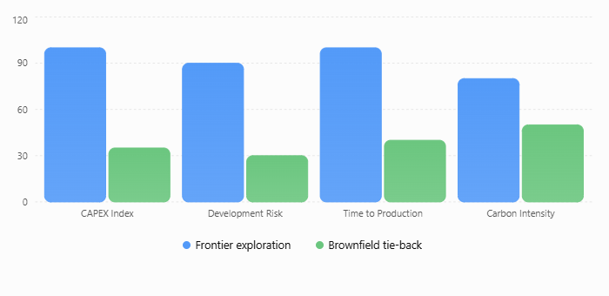

Figure 1 Brownfield vs Frontier Development Economics
Comparative Analysis
Features | Frontier Exploration | Brownfield Tie-backs
CAPEX Risk | High (Uncertain) | Low (Predictable)
Time-to-First Oil | 5-10+ years | 1-3 years
Regulatory Approval | Complex/Stringent | Streamlined/Existing
Resource Certainty | Speculative | Discovered / Appraised
Avg Breakeven Price | USD 50–80+/bbl | USD 25–45/bbl

Key Drivers
The move away from frontier exploration is primarily driven by three core pressures:
- Capital Discipline
Since the 2014 oil price collapse, investors have prioritized cash flow generation, return on capital employed (ROCE), debt reduction, and dividend sustainability. Shareholders are demanding rigorous capital discipline and consistent returns, as a result, exploration budgets have declined substantially while development spending around existing assets has increased. Brownfield projects offer higher IRR and faster payback periods compared to the speculative nature of frontier assets.

- Energy Transition Ambiguity
As the global energy landscape transitions, companies are wary of "stranded asset" risks. Tie-back projects have shorter investment horizons, reducing exposure to potential long-term demand declines.
- Operational Efficiency
Utilizing existing pipelines, platforms, and processing facilities significantly lowers the incremental CAPEX required to bring new production online, maximizing the utility of sunk infrastructure costs.
- Lower Carbon Intensity
Brownfield developments leverage existing infrastructure, reducing the need for new platforms, pipelines, and processing facilities. This lowers embedded construction emissions and generally produces a smaller carbon footprint per barrel than greenfield developments.

Brownfield Tie-Back Projects, 2025-2026
Operators | Projects | Region | What it does
Chevron | Ballymore | Gulf of Mexico | Subsea tie-back bringing an estimated 150 million boe of resource on stream through existing Gulf infrastructure; supports a push toward 300,000 net b/d gulf-wide by 2026.
Eni | Cronos | Cyprus / East Med | Fast-track gas tie-back into Egypt's existing Zohr and Damietta LNG infrastructure; roughly 3 Tcf discovered, targeting about 500 MMscf/d at plateau.
Shell | Bonga North | Nigeria | Subsea tie-back into the Shell-operated Bonga FPSO, adding an estimated 300 million boe of reserves without a new floating facility.
Eni | Sabratha compression / BESS tie-back | Libya | Compression plus a new exploration tie-back extended output from the Bahr Essalam field, sustaining Libya's principal gas hub.
Equinor / Aker BP-led cluster | Troll & Johan Castberg-area tie-backs | Norwegian Continental Shelf | Anchor roughly 15% of all 2026-28 base-case subsea tie-back awards on a low-carbon-intensity, electrified shelf.
Petrobras | Pre-salt satellite tie-backs | Brazil (Santos & Campos) | Connects smaller satellite discoveries to existing FPSOs, contributing to the +113% regional tie-back production growth forecast for South America.

Brownfield Operational and Strategic Risks
- Infrastructure Aging
Legacy assets often require extensive maintenance, leading to higher operational expenditures as systems reach the end of their design life.
- Capacity Constraints
As production from multiple tie-backs is funneled through existing infrastructure, capacity bottlenecks can occur, limiting the ability to process additional volumes effectively.
- Asset Integrity Issues
Operating beyond original design parameters increases operational risk, including heightened potential for mechanical failure, corrosion, and associated environmental or safety hazards.
- Over-reliance on Mature Fields
This creates strategic concentration risk, where a firm’s production and cash flow become overly dependent on aging basins, leaving it highly vulnerable to localized regulatory changes, regional infrastructure failures, or accelerated geological depletion.

Outlook
The brownfield-first investment philosophy is expected to dominate upstream investment decisions over the next decade. Elevated capital costs, decarbonization pressures, and investor demands for disciplined spending will continue to favor projects that maximize value from existing infrastructure.
However, a complete withdrawal from frontier exploration is unlikely. The industry will likely adopt a hybrid model, where selective frontier exploration targets only world-class discoveries while the majority of capital is directed toward brownfield optimization and infrastructure-led developments.

