Country Briefing: Foreign Direct Investment Trends in Nigeria’s Oil and Gas Sector

Executive summary
- Nigeria remains one of Africa’s largest hydrocarbon markets, with 37.5 billion barrels of proven crude oil reserves and 211.1 trillion cubic feet of proved natural gas reserves in 2024. Crude oil and lease condensate production averaged about 1.5 million barrels per day in 2024, while crude and condensate exports were about 1.3 million barrels per day.
- At the economy-wide level, Nigeria’s annual FDI inflows have fallen sharply from historical highs above US$8 billion in the late 2000s/early 2010s. Official World Bank data show FDI net inflows of US$3.31 billion in 2021, -US$0.19 billion in 2022, US$1.87 billion in 2023, and US$1.08 billion in 2024.
- High-frequency National Bureau of Statistics (NBS) capital-importation data indicate that foreign capital entering the oil and gas sector remained very weak through 2024: US$2.04 million in Q4 2023, US$0.00 million in Q1 2024, US$5.00 million in Q2 2024, and US$0.00 million in Q3 2024. Over the same quarters, total FDI into Nigeria ranged from US$29.83 million to US$183.97 million.
- The medium-term project pipeline improved in 2025. NUPRC reported that 43 approved field development plans could unlock 1.7 billion barrels of oil and 7.7 trillion cubic feet of gas, backed by more than US$20 billion in committed capital. However, execution risk remains high because of oil theft, vandalism, aging infrastructure, regulatory uncertainty, and financing constraints.

Country and sector snapshot
Indicator | Latest value | Why it matters
Proven crude oil reserves (2024) | 37.5 bn barrels | Confirms Nigeria’s scale as a long-life upstream market.
Proved natural gas reserves (2024) | 211.1 Tcf | Large gas resource base supports LNG, domestic gas and transition-linked investments.
Crude oil + lease condensate production (2024) | ~1.5 mb/d | Production remains material, but below Nigeria’s potential.
Crude oil + condensate exports (2024) | ~1.3 mb/d | Shows strong export orientation and continued dependence on hydrocarbon receipts.
FDI net inflows (2024) | US$1.08 bn | Marks a decline from US$1.87 bn in 2023 and remains far below historical peaks.
Nigeria total FDI, Q3 2024 | US$103.82 m | Illustrates weak near-term foreign direct investment momentum.

1. Long-run FDI trend: Nigeria has not returned to pre-2015 inflow levels
Nigeria’s FDI story is best understood as a long decline from earlier highs. According to the World Bank API series for FDI net inflows (BoP, current US$), inflows reached US$8.84 billion in 2011 and remained above US$4.6 billion as recently as 2014. Since then, inflows have weakened structurally, affected by slower upstream investment, lower risk appetite, foreign-exchange frictions, and domestic security constraints. The latest annual data show a brief rebound from a negative outturn in 2022 to US$1.87 billion in 2023, followed by a decline to US$1.08 billion in 2024.
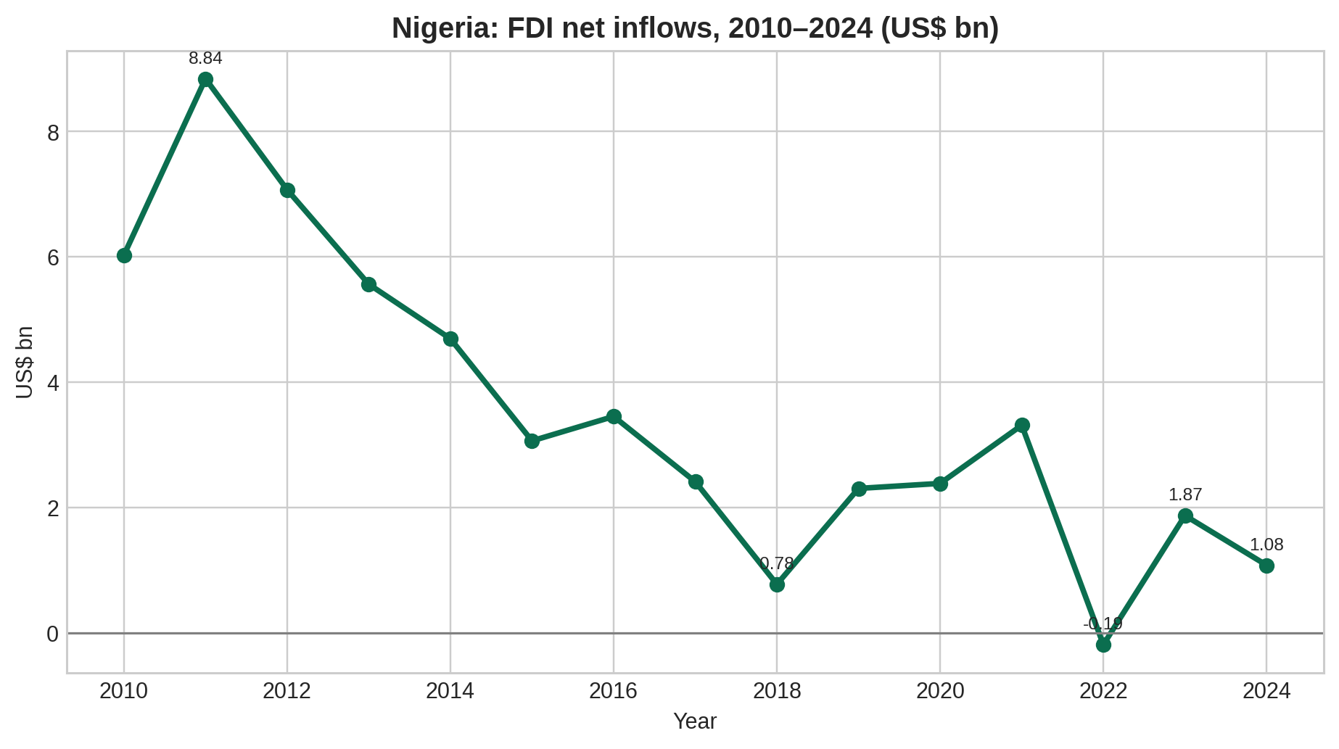
Figure 1. Nigeria FDI net inflows, 2010–2024. Source: World Bank indicator BX.KLT.DINV.CD.WD (API).

2. What the high-frequency data say about oil and gas investment
Quarterly NBS capital-importation releases provide the most useful high-frequency proxy for foreign capital entering individual sectors. These data are not identical to greenfield FDI or final investment commitments, but they help show whether foreign capital is actually arriving in-country by sector.
Quarter | Oil & gas sector capital importation (US$ m) | Total FDI into Nigeria (US$ m) | Total capital importation (US$ m)
Q4 2023 | 2.04 | 183.97 | 1088.48
Q1 2024 | 0.00 | 119.18 | 3376.01
Q2 2024 | 5.00 | 29.83 | 2604.50
Q3 2024 | 0.00 | 103.82 | 1252.66
The signal from these quarterly data is weak. Oil and gas capital importation was only US$2.04 million in Q4 2023, fell to zero in Q1 2024, recovered modestly to US$5.00 million in Q2 2024, and returned to zero in Q3 2024. This suggests that, despite Nigeria’s resource depth and policy attention to the sector, realized foreign capital inflows into oil and gas remained thin through most of 2024.
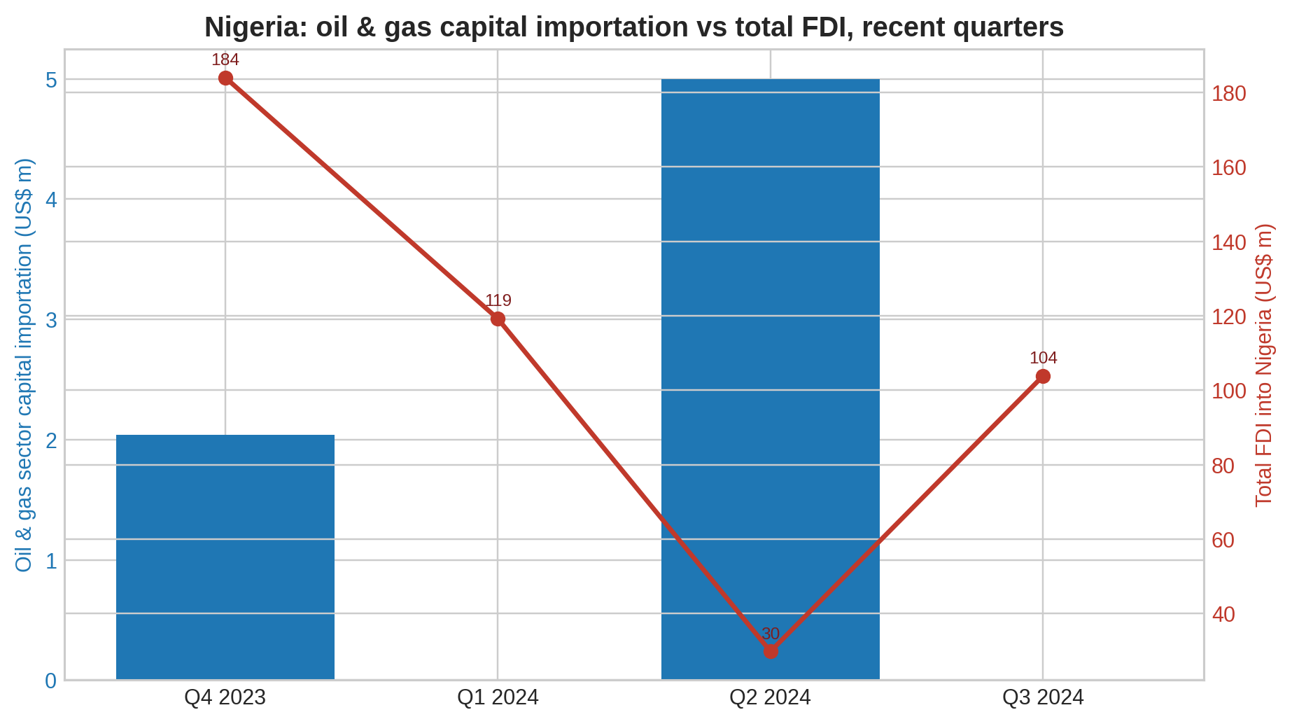
Figure 2. Oil & gas sector capital importation versus total FDI into Nigeria. Source: NBS capital importation reports.

3. Structural strengths of the investment case
Nigeria’s oil and gas investment proposition remains strong on geology and market scale. It is one of the largest hydrocarbon holders in Africa, with sizable crude and gas reserves that can support upstream, gas-processing, LNG, domestic power, and petrochemical investment over a long horizon.
The downstream story has also improved. The U.S. State Department notes that the 650,000-barrel-per-day Dangote Refinery ramped up in 2024, adding a potentially transformative refining anchor to the country’s hydrocarbons value chain and improving prospects for related logistics, storage, and domestic-products markets.
In gas, Nigeria’s large reserve base and the policy emphasis on flare reduction, gas commercialization, and domestic gas use create a stronger medium-term case than the recent flow data alone would suggest.

4. Why realized FDI remains below potential
The gap between Nigeria’s resource endowment and actual foreign-investment inflows reflects persistent execution risk. The EIA highlights reduced upstream investment since 2020, crude theft, pipeline vandalism, mature fields, and aging infrastructure as key reasons production has underperformed potential.
The U.S. State Department adds that investor confidence is still weakened by regulatory uncertainty, infrastructure bottlenecks, and security concerns. Illegal bunkering and theft in the Niger Delta remain recurring operational risks, while financing and gas-transport constraints continue to delay or shrink projects.
These constraints matter because large project announcements and final investment decisions often take years to convert into recorded capital inflows. In Nigeria’s case, the policy direction has improved, but the recorded disbursement picture still looks fragile.

5. Policy reforms and forward pipeline
Nigeria’s policy framework has become more investment-focused since the Petroleum Industry Act and subsequent regulatory implementation. NUPRC says it is pursuing continuous acreage licensing, upgraded data systems, deepwater cluster development, gas-flare commercialization, and “Project One Million Barrels” to restore and grow daily production.
As a forward indicator, NUPRC stated in November 2025 that 43 field development plans approved in 2025 could unlock 1.7 billion barrels of crude and 7.7 trillion cubic feet of gas, backed by more than US$20 billion in committed capital. It also cited major FIDs such as US$5 billion for Bonga North, US$500 million for Ubeta Gas, and US$2 billion for Shell’s HI Gas project.
If these commitments are executed, Nigeria’s oil and gas FDI outlook could improve materially over the medium term. The key question for investors is not project availability, but conversion: whether approvals, financing, security, and infrastructure can turn commitments into sustained inflows.

6. Bottom line for investors and policymakers
Nigeria’s oil and gas sector still offers one of Africa’s deepest resource opportunities, especially in gas, selective upstream brownfield optimization, deepwater development, and downstream value-chain buildout. However, the country’s recent recorded inflows show that market potential has not yet translated into strong realized foreign investment.
The near-term reading is therefore mixed: weak disbursed inflows in 2024, but a stronger 2025 project pipeline. A durable upswing in FDI will depend on continued regulatory credibility, better foreign-exchange liquidity, improved evacuation and gas-capture infrastructure, and measurable progress on security in producing regions.

References and source links
- World Bank API – Foreign direct investment, net inflows (BoP, current US$), Nigeria: https://api.worldbank.org/v2/country/NGA/indicator/BX.KLT.DINV.CD.WD?format=json&per_page=70
- UNCTAD country profile for Nigeria: https://unctadstat.unctad.org/CountryProfile/GeneralProfile/en-GB/566/index.html
- NBS Nigeria Capital Importation Q4 2023: https://www.nigerianstat.gov.ng/pdfuploads/Capital%20importation%20Q4%202023.pdf
- NBS Nigeria Capital Importation Q3 2024: https://microdata.nigerianstat.gov.ng/index.php/catalog/143/download/1064/Capital_importation_Q3_2024.pdf
- NBS Nigeria Capital Importation Q1 2024 summary: https://nigerianstat.gov.ng/elibrary/read/1241527
- NBS Nigeria Capital Importation Q2 2024 summary: https://www.nigerianstat.gov.ng/elibrary/read/1241568
- U.S. Energy Information Administration – Nigeria country analysis brief: https://www.eia.gov/international/content/analysis/countries_long/Nigeria/Nigeria-2025.pdf
- U.S. Department of State – 2025 Investment Climate Statement: Nigeria: https://www.state.gov/reports/2025-investment-climate-statements/nigeria
- NUPRC – Approved FDPs can unlock 1.7bn barrels, 7.7tcf of gas: https://www.nuprc.gov.ng/approved-fdps-can-unlock-1-7bn-barrels-7-7tcf-of-gas-komolafe/

