BALANCING LNG EXPORTS, DOMESTIC GAS OBLIGATIONS AND REGIONAL PIPELINE MARKETS IN MOZAMBIQUE
Executive Summary
Mozambique stands at a critical inflection point in its gas commercialization strategy. With approximately 126 trillion cubic feet (TCF) of recoverable gas reserves in the Rovuma Basin, the country must optimise allocation between high-margin LNG exports, domestic market obligations (DMO), and emerging regional pipeline demand across the Southern African Development Community (SADC). TotalEnergies' Mozambique LNG project (13.12 MTPA, $20 billion FID) has resumed construction under a securitised enclave model following the March 2021 force majeure, with first exports now expected by 2029. ExxonMobil lifted force majeure on the 18 MTPA Rovuma LNG project in November 2025, targeting FID in 2026 and first LNG by 2030.
This intelligence note critically evaluates five gas allocation scenarios through 2045. Our analysis indicates that a "Balanced Allocation" strategy (70% LNG export, 15% domestic, 15% regional pipeline) delivers the optimal risk-adjusted returns, with a projected portfolio NPV of $15.2 billion and IRR of 19.8%. Pure LNG maximisation yields higher nominal NPV ($18.5bn) but concentrates geopolitical and security risk. Conversely, domestic prioritisation sacrifices 55% of project NPV due to subsidised pricing structures and limited offtake depth.
Key findings:
- Global LNG market context: JKM and TTF prices averaged ~$10.5–13.5/MMBtu in 2024–2025, with Henry Hub at $3.5–4.5/MMBtu. By 2026, additional liquefaction capacity is expected to soften prices toward 11/MMBtu, though Middle East supply disruptions and Asian demand growth create upside volatility.
- Domestic Market Obligations: Area 1 concessionaires have committed to 400 MMscf/d (phased 100 + 300), while Area 4 has committed to 500 MMscf/d (phased 150 + 350).
- South Africa's gas cliff: The ROMPCO pipeline from Pande-Temane is depleting (75.91% exhausted), with third-party supply expected to cease by mid-2027. South Africa's IRP 2025 targets 6,000 MW of gas-to-power by 2030 and 16,000 MW by 2039, creating substantial import demand.
- Security premium: The securitised enclave model at Afungi, protected by ~5,000 Rwandan troops, adds approximately $1.5 billion in annual security costs, directly reducing government take.

1. Mozambique's Emerging Role in Global LNG Supply
Mozambique possesses the geological endowment to become a top-ten global LNG exporter. The Rovuma Basin's Area 1 (Anadarko/TotalEnergies) and Area 4 (Eni/ExxonMobil) contain sufficient reserves to support 60–90 MMtpa of additional LNG beyond the initial 31 MMtpa wave. The IEA forecasts Asian demand for African LNG could reach 60–70 million tonnes by 2050 in a low-transition scenario, positioning Mozambique's Atlantic/Indian Ocean location as strategically advantaged for both European and Asian markets.
However, the decade-long delay caused by the Cabo Delgado insurgency has permanently altered the competitive landscape. Qatar and the United States have captured market share that would have belonged to Mozambique had original 2024 start-up timelines held. The global LNG market, which faced supply deficits in 2024–2025 due to Mozambique delays, will see 54 Mtpa of new liquefaction capacity come online in 2025–2026, tightening netback economics for new entrants
LNG Price Sensitivity Analysis
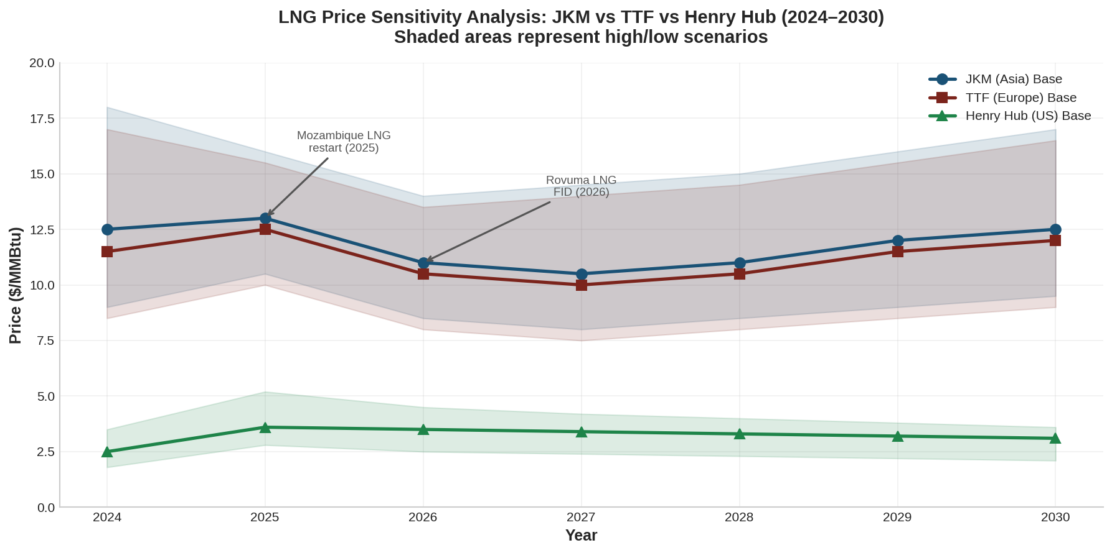
The chart illustrates JKM, TTF, and Henry Hub trajectories through 2030. Mozambique LNG project economics remain robust across all but the lowest price scenarios, given the basin's low production costs ($3.50–4.50/MMBtu FOB breakeven). The critical risk is not absolute price level but price volatility and the convergence of global benchmarks with US variable export costs as 110 Mtpa of American capacity ramps up through 2030

2. Existing LNG Commercial Structures and Export Commitments
Mozambique LNG (Area 1) operates under an EPCC (Exploration and Production Concession Contract) framework with the following commercial architecture:
- Capacity: 13.12 MTPA initial (two trains), expansion potential to 43 MTPA
- FID: $19.6 billion (2019), restarted January 2026
- Offtake: Predominantly long-term contracts with Asian buyers (CNPC, Shell portfolio, KOGAS)
- Pricing: Oil-indexed (S-curve, 11–14.5% slope) with limited spot exposure
Rovuma LNG (Area 4) commercial structure:
- Capacity: 18 MTPA (two trains)
- FID: Anticipated 2026
- Reserves: 21.7 TCF developed from Mamba complex
- Offtake: ExxonMobil portfolio marketing, Indian and Asian utility buyers
Coral South FLNG (3.4 MTPA, operational) and Coral North FLNG (3.6 MTPA, under construction) provide near-term cash flow but limited domestic gas offtake due to floating facility constraints.
Fiscal Terms: Government revenue derives from:
- Royalty: ~2% on gas, ~3% on condensate (increasing 2 percentage points every ten years)
- Cost recovery ceiling: 65–75% of net revenues during payback
- Profit petroleum split: R-factor progressive sliding scale
- Corporate income tax: 32%

3. Domestic Market Obligation (DMO) Framework
Mozambique's DMO framework mandates that Area 1 and Area 4 concessionaires allocate a combined 900 MMscf/d for domestic use:
Phase | Area 1 (MMscf/d) | Area 4 (MMscf/d) | Total | Timing
Phase 1 | 100 | 150 | 250 | LNG start-up
Phase 2 | 300 | 350 | 650 | Post cost-recovery
Total | 400 | 500 | 900 | Full plateau

Critical constraint: DMO gas is virtually all contracted to LNG export projects. The 900 MMscf/d represents less than 5% of total Rovuma production but faces a fundamental absorption problem. Mozambique lacks credible offtake projects at scale. The 450 MW Temane gas plant and Nacala GTP (+650 MW) are insufficient to anchor Phase 2 volumes. Without industrial fertiliser, methanol, or steel projects reaching FID, DMO gas risks being re-exported as LNG or flared.

4. Domestic Industrial Gas Demand Outlook
Mozambique's domestic gas demand is currently dominated by:
- Power generation: ~38 PJ/year (Temane, Ressano Garcia, Nacala emergency plant)
- Industry: Cement, ceramics, metal processing (~15 PJ/year)
- Transport: Minimal CNG penetration

The SADC Regional Gas Master Plan identifies Nacala as a potential gas hub for fertiliser, steel, and petrochemicals
. However, techno-economic analysis indicates that at delivered gas prices above $6/MMBtu, many downstream projects fail to achieve hurdle rates. The government's challenge is to balance:
- Low DMO prices ($3–5/MMBtu) to incentivize industrialization
- Opportunity cost of foregone LNG exports at $10–18/MMBtu
- Fiscal sustainability of subsidy regimes

5. Gas Demand from Mozambique's Power Sector
Electricidade de Moçambique (EDM) dominates the power sector, with gas-fired generation representing ~18% of installed capacity (454 MW gas vs 2,193 MW hydro). The Energy Transition Strategy (2023) targets 1,004 MW gas capacity by 2032 and universal electrification by 2030.
Key power projects requiring gas:
- Temane CTT: 450 MW (operational, expansion planned)
- Nacala GTP: +650 MW ($759m CAPEX, 2026 target)
- Maputo/Beluluane: 400 MW IPP ($2.3bn)
At full utilisation, Mozambique's power sector could absorb 100–150 PJ/year by 2035—still only ~15% of DMO Phase 2 volumes.

6. Regional Demand Across SADC
The SADC region presents a bifurcated gas demand landscape:
Coastal demand centres (pipeline-viable):
- South Africa: 489 MMscf/d current demand (~197 PJ/year industrial, declining Pande-Temane supply)
- Mozambique south: 94 MMscf/d (38 PJ/year) industrial demand
Inland/emerging markets (truck/CNG initially):
- Zimbabwe: Cabora Bassa Basin exploration (Invictus Energy, potential 4–7 TCF)
- Zambia/Malawi: 20–30 PJ aggregate latent demand for diesel/HFO replacement

Regional Gas Demand Forecast
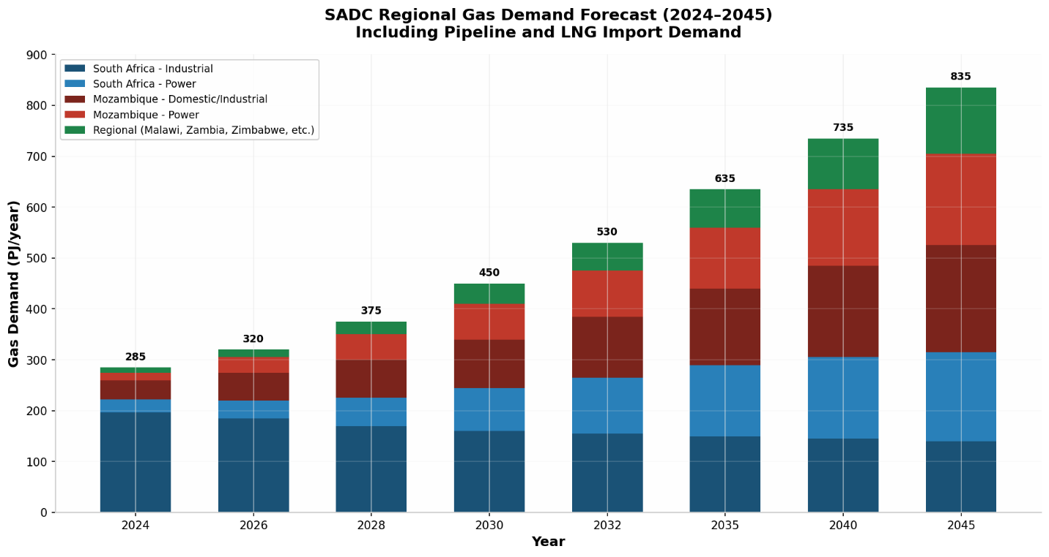
The forecast indicates total SADC gas demand rising from ~285 PJ/year (2024) to ~835 PJ/year by 2045, driven primarily by South African power sector demand and Mozambique domestic growth. However, infrastructure constraints limit pipeline-delivered volumes to ~500 PJ/year by 2040.

7. Pipeline Commercialisation Opportunities
The SADC Regional Gas Master Plan (2025) prioritises three corridors:
- Afungi-Nacala-Ndola Corridor: Large-scale GTP at Nacala ($759m) anchoring pipeline to Malawi/Zambia. CAPEX: $1.0bn (Afungi-Nacala) + $3.3bn (Nacala-Pande-Temane)
- East Coast to South Africa: Matola FSRU ($466m) + pipeline to ROMPCO ($60m), plus Richards Bay FSRU ($252m) and pipeline to Secunda ($1.68bn)
- Afungi-Dar es Salaam-Mombasa: Regional pipeline enabling Tanzania/Kenya integration
Pipeline economics challenge: At volumes below 200 PJ/year, unit transport costs exceed $2.50/MMBtu, rendering pipeline delivery uncompetitive against LNG trucking or CNG for inland markets
8. LNG versus Pipeline Economics
Metric | LNG Export | Domestic Pipeline | Regional Pipeline
Price realization | $10–18/MMBtu (JKM/TTF) | $3–6/MMBtu (regulated) | $6–9/MMBtu (blended)
Transport cost | $1.50–2.50/MMBtu | $0.50–1.50/MMBtu | $2.00–4.00/MMBtu
Capital intensity | High ($1,200–1,500/tpa) | Medium ($200–400/tpa) | Very high ($800–1,200/tpa)
Payback period | 8–10 years | 12–15 years | 15–20 years
Government takes | 45–55% (royalty + tax + profit oil) | 20–30% (lower revenue base) | 25–35%
FX earnings | 100% hard currency | 60% local / 40% FX | 70% hard currency

The economic hierarchy is clear: LNG exports maximize rent capture and foreign exchange. However, pipeline sales provide demand certainty (baseload power offtake) and geopolitical optionality (SADC energy security integration).

9. Revenue Optimization Under Different Gas Allocation Scenarios
Revenue Optimization Chart
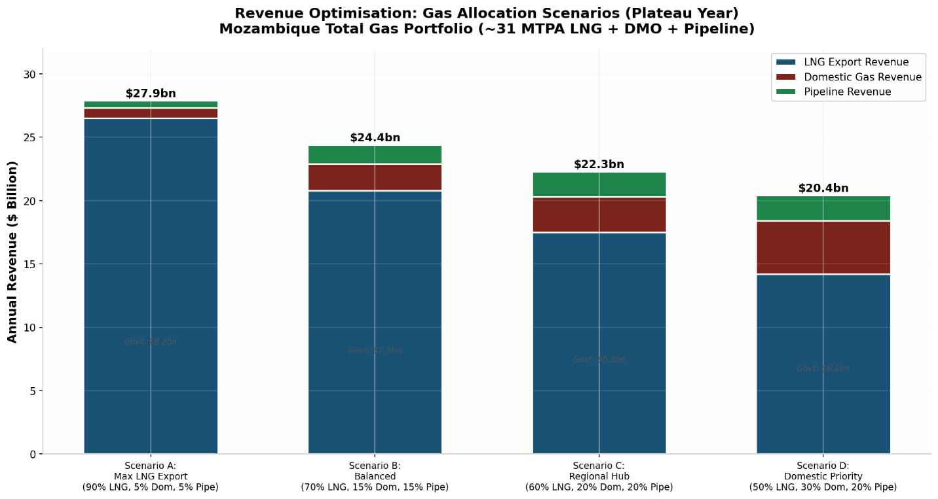
Four scenarios evaluated at plateau production (~31 MTPA LNG equivalent):
- Scenario A (Max LNG): $27.9bn total revenue, $8.2bn government take. Highest NPV but maximum-security risk concentration.
- Scenario B (Balanced): $24.4bn total revenue, $7.5bn government take. Optimal diversification.
- Scenario C (Regional Hub): $22.3bn total revenue, $6.8bn government take. Strong regional integration benefits.
- Scenario D (Domestic Priority): $20.4bn total revenue, $6.1bn government take. Highest employment multiplier but lowest fiscal yield.
Cash Flow Waterfall
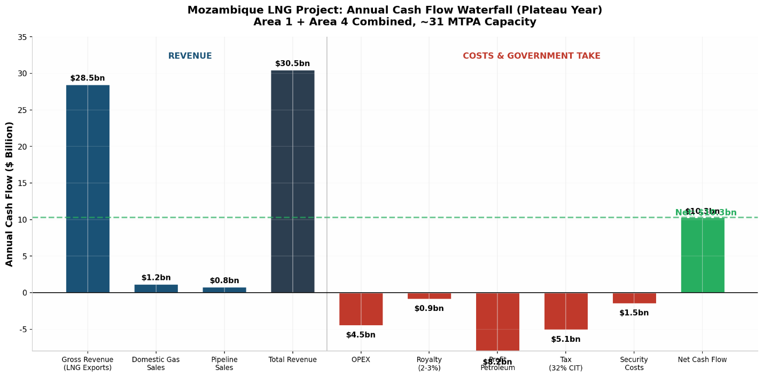
The waterfall illustrates the annual cash flow build-up for the Balanced Allocation scenario. Gross LNG revenues dominate ($28.5bn), but government take (royalty, profit petroleum, CIT) absorbs ~$14.2bn. Security costs represent a $1.5bn annual drag—an extraordinary 5% of gross revenue that few other LNG projects globally incur.

10. Contract Structures and Pricing Mechanisms
Mozambique's gas commercialization requires a hybrid contract architecture:
LNG Exports:
- Long-term SPAs (15–20 years) with oil-indexed pricing (JCC slope 11–14.5%)
- Increasing spot/short-term exposure (20–30% by 2035) to capture volatility
- DES and FOB structures depending on buyer preference
Domestic Market:
- Regulated DMO pricing: cost-plus or netback formula
- Industrial offtake: take-or-pay with floor/ceiling (Henry Hub + $1.50–3.00/MMBtu)
- Power sector: regulated tariff pass-through requiring subsidy mechanism
Regional Pipeline:
- ROMPCO-style long-term transmission agreements
- Ship-or-pay contracts with Sasol, Eskom, and IPPs
- Blended pricing: LNG netback minus regasification and transport

11. LNG Portfolio Marketing Strategies
Given the 2029–2030 start-up window, Mozambique LNG and Rovuma LNG will enter a market structurally different from the tight 2022–2025 period:
- Portfolio players (TotalEnergies, ExxonMobil, Shell) will optimise Atlantic vs Pacific arbitrage
- Asian buyers (China, India, Japan) are increasingly price-sensitive and may curtail demand above $12/MMBtu
- European demand stabilises post-2025 as renewables and nuclear expand, but Russian piped gas displacement sustains baseline LNG imports
Mozambique's strategic location allows dual-market optionality—unlike US Gulf Coast projects locked into Atlantic netbacks, Mozambique can swing cargoes to Asia (JKM) or Europe (TTF) depending on spread dynamics.

12. South African Gas Market Opportunities
South Africa represents Mozambique's most valuable regional market but also its most complex:
Demand drivers:
- Industrial: Sasol Secunda/Sasolburg (100–120 PJ/year Fischer-Tropsch feedstock)
- Power: IRP 2025 mandates 6,000 MW gas-to-power by 2030, 16,000 MW by 2039
- Gas cliff: Pande-Temane depletion by 2027 creates urgent import need
Supply options:
- Matola FSRU + ROMPCO pipeline extension
- Richards Bay FSRU + Lilly pipeline to Secunda
- Direct Rovuma pipeline (long-term, high CAPEX)
The South African market's scale (potentially 300+ PJ/year by 2040) justifies dedicated infrastructure, but procurement delays, Eskom financial distress, and IRP implementation risk temper near-term optimism.

13. Regional Energy Integration
The SADC Regional Gas Master Plan (2025) provides the institutional framework for integration, but implementation gaps remain severe:
- Regulatory harmonisation: No common gas transit code; bilateral negotiations dominate
- Infrastructure: $5.7bn required for priority projects through 2030
- Market design: No regional gas hub or trading platform; bilateral long-term contracts prevail
Mozambique's role as regional energy anchor depends on:
- Transparent DMO allocation mechanisms
- Third-party access to pipeline infrastructure
- Convertible gas pricing (LNG netback linkage)

14. Infrastructure Bottlenecks
Critical path items through 2030:
Project | CAPEX ($m) | Status | Risk
Mozambique LNG trains 1–2 | 19,600 | Construction restarted | Security
Rovuma LNG trains 1–2 | 25,000 | Pre-FID | Security, FID timing
Coral North FLNG | 5,000 | Under construction | Technical
Afungi-Nacala pipeline | 1,015 | Feasibility | Demand anchor
Matola FSRU | 466 | Pre-investment | Market
Richards Bay FSRU | 252 | Pre-investment | SA procurement
Nacala GTP | 759 | Development | Financing

LNG Shipping Routes: Mozambique's location enables two primary corridors:
- Eastern route: Mozambique Channel → Indian Ocean → Malacca Strait → Northeast Asia (14–16 days to Japan)
- Western route: Around Cape of Good Hope → Atlantic → Europe (18–22 days to NW Europe) or Americas
This routing flexibility commands a strategic premium in portfolio valuations.

15. Financing Requirements
Total infrastructure financing requirement: $80 billion through 2050 per Mozambique's Energy Transition Strategy
Funding sources:
- Project finance: Limited recourse debt for LNG trains (60–70% debt/30–40% equity)
- Development finance: AfDB, World Bank, DFIs for regional pipelines and power
- Sovereign wealth: Future sovereign fund (not yet operational)
- Private capital: ENH carried interest (15%), IOC equity
The financing challenge is sequential: LNG projects must reach production to generate cash flows that can cross-subsidise domestic and regional infrastructure. Without LNG export revenue, DMO and pipeline projects lack fiscal backing.

16. Regulatory and Fiscal Considerations
Mozambique's petroleum fiscal framework has evolved through successive concession agreements:
- Royalty: 2% gas, 3% condensate (escalating +2pp per decade)
- Cost recovery: 65–75% ceiling during payback
- Profit petroleum: R-factor sliding scale
- CIT: 32%
Key fiscal risks:
- Windfall taxation: Government may impose additional levies if JKM exceeds $15/MMBtu sustained
- Local content requirements: 25–30% local spend mandates increase project costs
- Transfer pricing: ENH lacks technical capacity to audit IOC cost recovery claims
- Stabilisation clauses: Existing EPCCs provide limited protection against unilateral tax changes

17. Security Risks
The Cabo Delgado insurgency remains the single greatest threat to Mozambique's gas commercialisation:
- Current posture: ~5,000 Rwandan troops securing Afungi enclave; SADC forces in central/northern districts
- Insurgent capability: IS-affiliated ASWJ retains operational capacity; attacks continue in Muidumbe and Mocímboa da Praia districts
- Enclave model: TotalEnergies' securitised concession limits local economic spillover, potentially fuelling grievances
- Maritime risk: Naval forces have fired on civilian vessels; LNG shipping lanes require naval escort through Mozambique Channel
Security cost impact: $1.5bn/year (5% of gross revenue), reducing government take by approximately $500m/year.

18. Climate Policy and Energy Transition Implications
Mozambique's Energy Transition Strategy (2023) positions natural gas as a "transitional fuel" while prioritising renewables. The updated NDC targets 40 MtCO₂eq reduction by 2025 (conditional on $7.6bn financing)
Transition risks to gas commercialisation:
- Carbon border adjustments: EU CBAM may penalise LNG imports from high-flaring projects
- Methane regulations: EU Methane Regulation (2024) requires supply-chain methane intensity disclosure
- Financing restrictions: OECD export credit agencies increasingly restrict upstream gas financing
- Stranded asset risk: Beyond 2040, global LNG demand may peak under aggressive net-zero scenarios
However, the IEA's low-transition scenario still projects 718 Mtpa global LNG demand by 2040, providing a 15–20 year commercial window for Mozambique's first-wave projects.

19. Comparative Commercial Returns
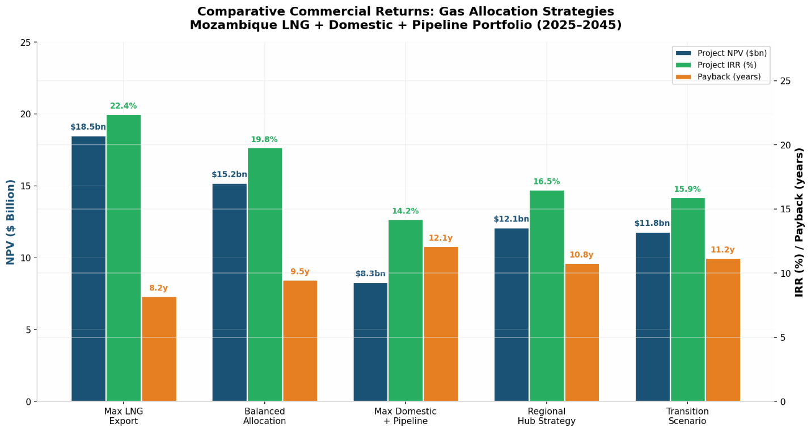
The comparative returns analysis demonstrates that while pure LNG maximization delivers the highest NPV ($18.5bn) and IRR (22.4%), the Balanced Allocation strategy provides superior risk-adjusted returns when accounting for:
- Security risk diversification
- Domestic political economy stability
- Regional market optionality
- Transition resilience
The Regional Hub strategy offers an attractive middle ground for investors with longer horizons and lower hurdle rates (infrastructure funds, DFIs).

20. Tornado Sensitivity Analysis
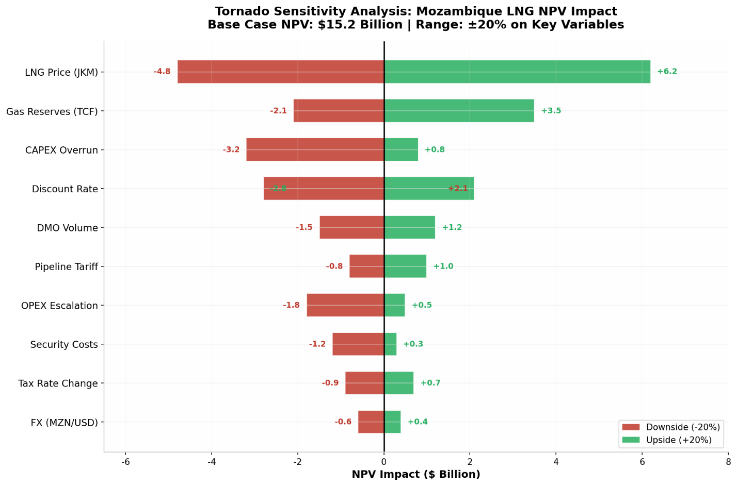
The tornado analysis confirms that LNG price (JKM) is the dominant value driver, with a ±20% price swing impacting NPV by $6.2bn (upside) to -$4.8bn (downside). CAPEX overrun represents the second-largest risk (-$3.2bn), reflecting construction cost inflation and security-related delays. Notably, DMO volume has a relatively modest NPV impact (-$1.5bn to +$1.2bn), suggesting that domestic obligation fulfilment is commercially manageable within a balanced portfolio.

21. Risk Matrix
Risk Category | Probability | Impact | Mitigation
Security (insurgency) | Medium | Critical | Rwandan/SADC deployment; enclave model; marine security
Market (LNG price collapse) | Low-Medium | High | Portfolio diversification; long-term contracts; hedging
Regulatory (windfall tax) | Medium | Medium | Stabilisation clauses; international arbitration
Operational (CAPEX overrun) | Medium | High | EPC wrap; contingency reserves; phased FID
Demand (domestic offtake failure) | High | Medium | Anchor power projects; fertiliser FID; CNG mandates
Geopolitical (SADC instability) | Low | Medium | Multi-lateral insurance; DFI involvement
Climate (stranded asset) | Medium | Medium | Accelerated depreciation; brown-to-green hydrogen pivot
FX (MZN devaluation) | High | Low | Dollar-indexed contracts; sovereign hedging

Strategic Intelligence Assessment
Mozambique's gas commercialisation strategy operates within a trilemma: maximising LNG export revenue, fulfilling domestic industrialisation mandates, and anchoring regional energy security. No single allocation satisfies all three objectives simultaneously.
Our assessment is that the Balanced Allocation scenario (70/15/15) represents the Pareto-optimal solution for the 2025–2045 horizon. It preserves Mozambique's emergence as a top-tier LNG exporter while building the domestic and regional demand infrastructure necessary to absorb DMO volumes and diversify geopolitical risk.
The security environment in Cabo Delgado remains the critical path constraint. The securitised enclave model enables construction to proceed but imposes a permanent $1.5bn annual cost premium and limits local content benefits. Sustainable stabilisation requires governance reform and economic inclusion beyond the LNG fence line.
Commercial Implications
- For IOCs (TotalEnergies, ExxonMobil, Eni): Prioritise LNG FID execution but negotiate DMO flexibility clauses. The domestic market lacks depth; rigid DMO commitments create stranded gas risk. Push for indexed DMO pricing linked to LNG netback minus transport.
- For LNG Buyers: Mozambique offers portfolio diversification away from Qatar/US concentration. Contract for 10–15 year SPAs with oil-indexed pricing, but negotiate destination flexibility to capture Atlantic/Pacific arbitrage.
- For Downstream Investors: Nacala fertiliser/methanol and Maputo GTP offer first-mover advantages but require gas price subsidies or government guarantees. Co-invest with DFIs to mitigate offtake risk.
- For Infrastructure Developers: ROMPCO expansion and Matola FSRU provide lower-risk, utility-style returns. The Richards Bay corridor depends on Eskom procurement certainty—delay commitment until IRP 2025 implementation is visible.

Investment Implications
- Upstream LNG: Overweight. Mozambique's reserve quality and location justify exposure despite security premiums. Target entry through ENH farm-in or midstream infrastructure rather than direct E&P in Area 1/4.
- Domestic Gas: Market weight. Selective opportunities in power (Temane expansion) and industry (cement, ceramics). Avoid greenfield fertiliser without sovereign offtake guarantees.
- Regional Pipelines: Underweight until FID. SADC regulatory fragmentation and demand uncertainty make pure pipeline plays speculative. Exception: ROMPCO expansion with Sasol anchor.
- LNG Shipping/FSRU: Overweight. Matola and Richards Bay FSRUs are critical infrastructure with scarcity value. Terminal operators (Vopak, Transnet JV) offer defensive exposure to SADC gas demand.

