SUSTAINING NIGERIA'S LNG DOMINANCE AMID RISING AFRICAN COMPETITION: STRATEGIC RISKS AND OPPORTUNITIES
Executive Summary
Nigeria remains Africa’s largest LNG exporter, shipping 14.78 Mt in 2025 versus Algeria’s 9.70 Mt and Africa-wide exports of 39.77 Mt. Its lead is still anchored in scale, legacy infrastructure and Atlantic Basin location, but not in operational resilience: NLNG’s utilization was only 66.6% in 2025, far below what Nigeria’s 22.2 mtpa installed capacity should permit. Nigeria’s strategic problem is therefore above-ground, not subsurface: feedgas reliability, pipeline security, expansion execution and carbon competitiveness now matter more than reserve size alone.
The competitive challenge is intensifying. Mozambique has only 3.4 mtpa operating today, but it holds ~100 Tcf of gas and an 18 mtpa Rovuma design plus the 12.88 mtpa Mozambique LNG project if security and financing risks ease. Mauritania/Senegal entered the market in 2025 with first GTA cargoes, while Tanzania is still trying to close a $42 billion LNG framework that could underpin a 15 mtpa export platform in the next decade. Algeria remains a formidable incumbent with 25.5 mtpa nameplate capacity, even if ageing assets and lower utilization are constraining exports.
Nigeria’s near-term opportunity is favorable: Europe still needs flexible LNG despite structural demand erosion, Iberia is already materially exposed to Nigerian supply, and Asian demand growth led by China and India keeps portfolio diversification valuable. But the next supply wave from the United States and Qatar is the dominant external threat. The IEA expects ~300 bcm/yr of new liquefaction capacity by 2030, with the United States and Qatar accounting for roughly 70% of the increase; price competition will intensify and buyers will become more selective on emissions, reliability and contract flexibility.
Key risks | Major opportunities | Intelligence assessment
Feedgas shortfalls; vandalism/sabotage; Train 7 slippage; global oversupply; carbon and methane constraints. | Train 7 + upstream tie-ins; flare gas monetization; Iberian/European demand; Asia diversification; lower-emissions LNG. | Base case: Nigeria likely retains African LNG leadership through the early 2030s, but its lead narrows materially if Mozambique restarts Area 1/Rovuma and Nigeria under-executes.

1. Africa’s LNG Landscape
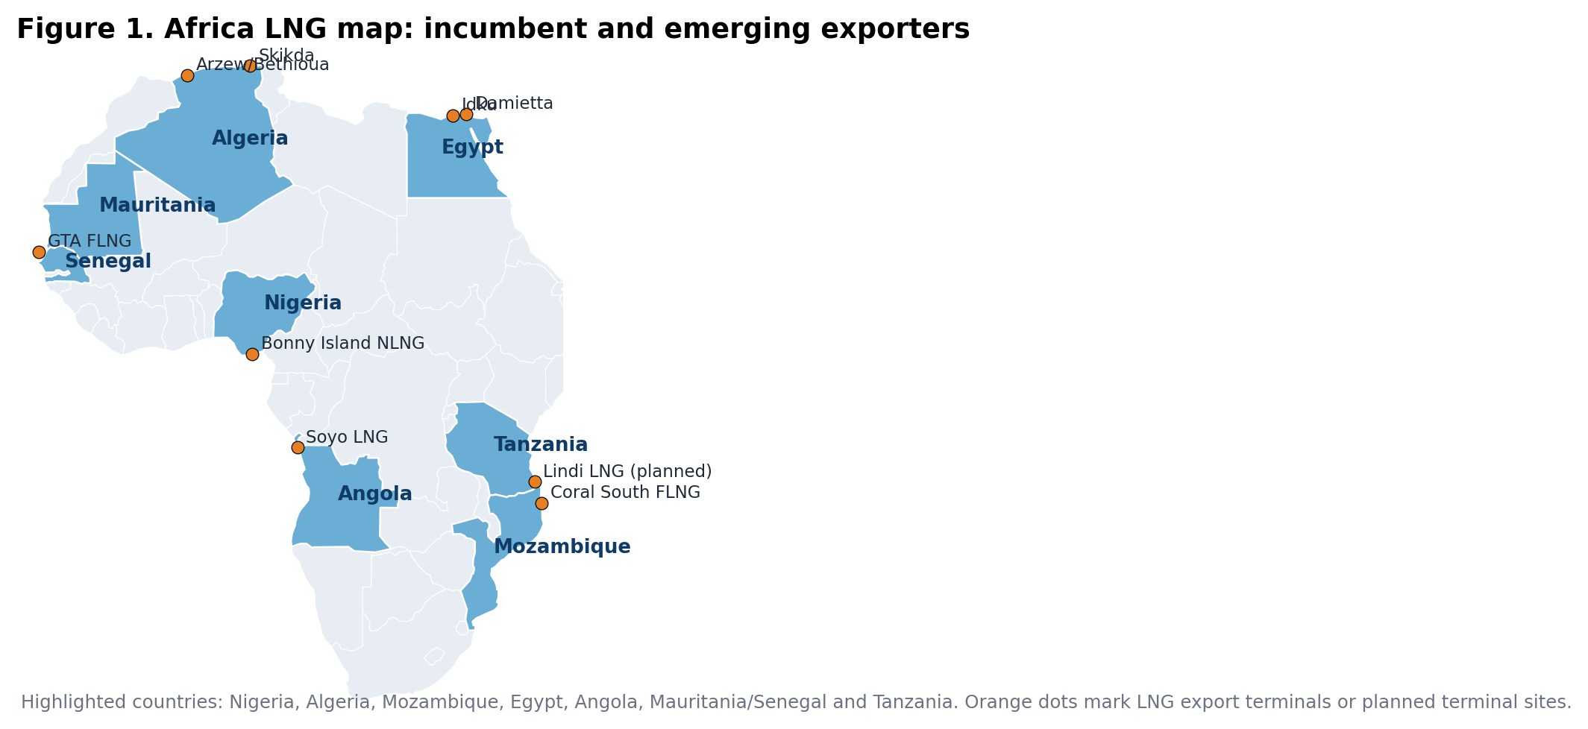
Africa holds about 17,221 bcm of proven gas reserves (~8% of the world total), led by Nigeria, Algeria and Mozambique. In 2024 the continent exported 37.98 Mt of LNG about 9.2% of global LNG trade rising to 39.77 Mt in 2025 after Mauritania/Senegal entered the market.
Africa’s LNG geography is splitting into three groups. First are incumbent exporters with operating infrastructure Nigeria, Algeria, Angola, Egypt, Equatorial Guinea, Cameroon, Mozambique and Congo. Second are new entrants, notably Mauritania/Senegal through GTA. Third are high-potential but delayed projects such as Tanzania and Mozambique’s larger onshore trains. Europe’s gas market is changing structurally, not disappearing: the IEA sees OECD Europe gas demand down about 10% by 2030 in the base case, yet Shell still expects Europe to require LNG into the 2030s because renewable buildout is not fully eliminating the need for flexible molecules. Asia remains the core growth engine, with China driving about a quarter of global gas demand growth to 2030 and India’s gas consumption expected to rise ~40% from 2024 to 2030.
Africa’s competitive field is broadening, but only Mozambique has the reserve depth and project pipeline to challenge Nigeria at scale by the 2030s; Mauritania/Senegal and Tanzania matter more as margin competitors than immediate leaders.
2. Nigeria’s LNG Position
Nigeria’s comparative advantage remains formidable on paper: 211.1 Tcf of proved gas reserves, six operating trains at Bonny Island, and Train 7 under construction to lift capacity from 22.2 mtpa to 30 mtpa. NLNG has contributed over $44 billion in dividends since inception, with roughly 49% accruing to the federal government through NNPC, and paid around $1.2 billion in corporate and tertiary education taxes in 2023. NLNG also estimates it contributes around 1% of rebased GDP and supplies about 40% of domestic LPG demand. In market terms, Nigeria enjoys rare two-basin flexibility: NNPC argues the country is roughly 10 sailing days from Europe while remaining commercially relevant to Asia, a structural logistics advantage over more distant Atlantic suppliers.
But the underperformance is plain. EIA estimates Nigeria exported about 650 Bcf of natural gas in 2024, down from its 2014-2023 average, while the World Bank reports a 12% rise in flaring in 2024 evidence that gas capture and monetization infrastructure is still inadequate. In response, NLNG signed 20-year gas supply agreements in 2025 for 1.29 bscf/d to support existing trains and Train 7, explicitly to address persistent supply disruptions and source diversification after IOC onshore divestments.
Nigeria’s leadership is real, but fragile. Without converting reserves into secure, low-loss feedgas, Nigeria’s LNG sector risks acting like a partially stranded giant large in capacity, inconsistent in execution and vulnerable to more nimble competitors.
3. Competitive Intelligence Assessment
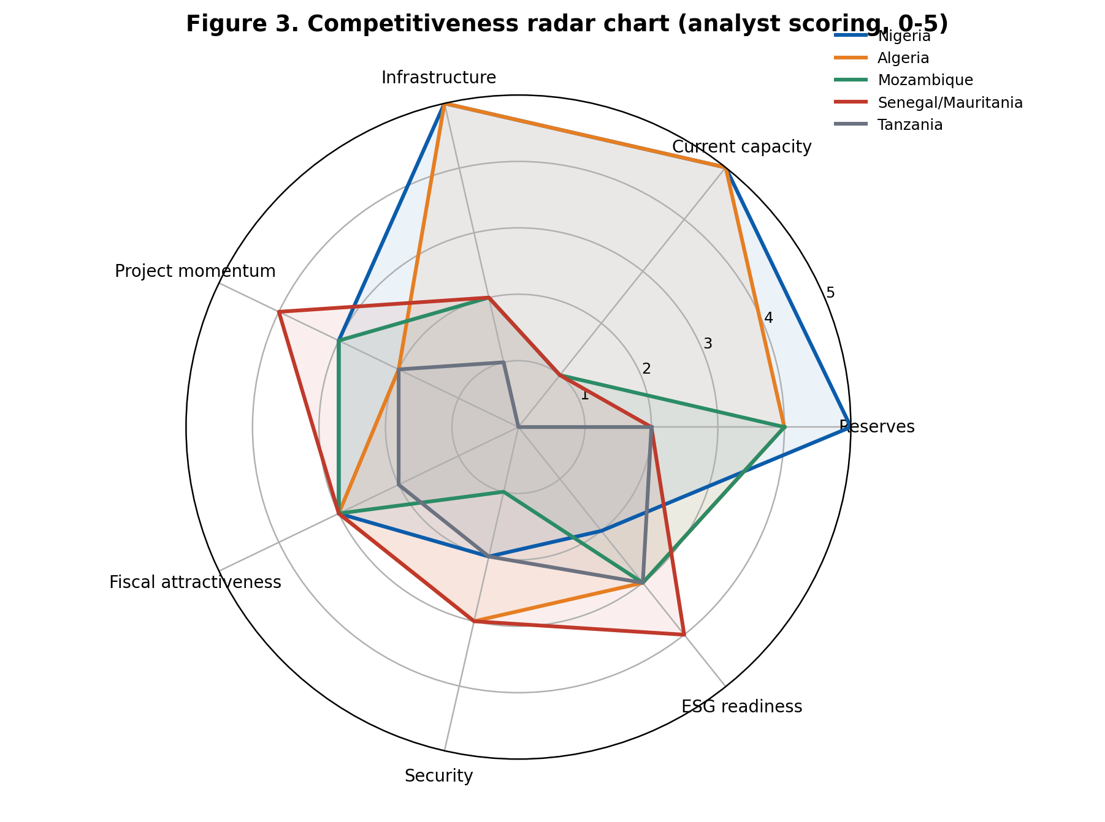
Nigeria scores highest on reserves, operating capacity and installed infrastructure. The weakest relative dimensions are security and ESG. Mozambique’s strategic threat is long-cycle but real; Senegal/Mauritania score well on momentum from a smaller base.
Competitive Intelligence Matrix
Market | Reserves (Tcf) | 2025 cap./exports | 2030 pipeline | Main constraint | Strategic read-through
Nigeria | 211.1 | 22.2 / 14.8 | 8.0 | Feedgas/security | Leader if execution improves
Algeria | 159.0 | 25.5 / 9.7 | — | Aging utilisation | Durable but mature incumbent
Mozambique | 100.3 | 3.4 / 3.7 | 30.9 | Security/financing | Main long-cycle challenger
Senegal/Mauritania | 15.0 | 2.5 / 1.2 | 2.5 | Scale | Meaningful niche competitor
Tanzania | 47.1 | 0.0 / 0.0 | 15.0 | Legal/fiscal closure | Option value, not yet a threat

Nigeria’s biggest challenger is not Algeria, which is an established but maturing exporter, nor Senegal/Mauritania, which remains small even after first cargoes. The credible strategic challenger is Mozambique: if security improves and both Area 1 and Rovuma move, Mozambique’s sanctioned/potential export system could exceed Nigeria’s current operating scale in the next decade. Tanzania is strategically important because its long delay does not remove its option value; if it closes its legal and fiscal framework, it could emerge as a large new East African supplier in the early 2030s.
Nigeria still has the strongest all-around position in Africa, but Mozambique has the strongest medium-term upside and therefore represents the principal threat to Nigeria’s 2030s leadership, especially if Nigeria fails to lift utilization before Train 7 comes online.
4. Strategic Risks
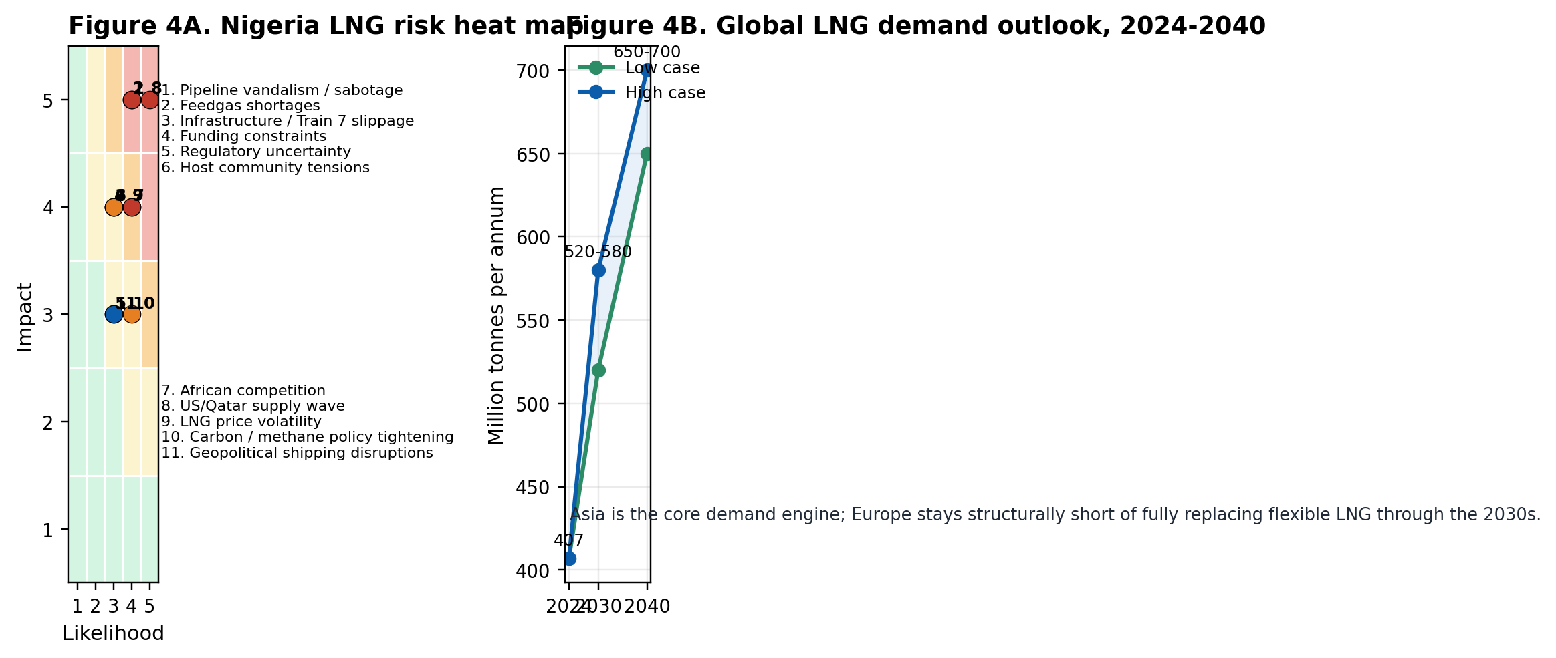
The highest-consequence risks are not purely international. Nigeria’s most severe vulnerabilities are still domestic pipeline sabotage, feedgas shortages and expansion slippage because they directly reduce utilization and weaken commercial credibility. The global supply wave from the U.S. and Qatar then amplifies every domestic weakness through lower prices and tougher buyer discipline.
Domestic risks remain structurally dominant. NLNG itself linked gas supply problems to pipeline disruptions, vandalism and sabotage in 2025, even as NNPC reported improved security and near-full pipeline receipts later that year. The World Bank’s flare tracker reinforces the diagnosis: rising flaring and high flare intensity indicate that monetization pathways remain too weak, especially for smaller producers without reliable access to Bonny Island. Externally, the IEA expects around 300 bcm/yr of new LNG capacity by 2030, with the U.S. and Qatar accounting for roughly 70% of additions, which will pressure Nigeria on price, reliability and emissions performance simultaneously.
Nigeria’s LNG risk profile is highly leverage-sensitive: modest improvements in domestic security and gas gathering can meaningfully lift exports, while modest deterioration can erase much of its scale advantage because global alternatives are multiplying.
5. Global LNG Market Outlook
The demand story remains supportive but less forgiving. Shell’s 2025 LNG Outlook places global LNG demand at roughly 520-580 mtpa by 2030 and 650-700 mtpa by 2040, up from 407 Mt traded in 2024, while Reuters reported Shell’s broader market estimate at 630-718 Mt by 2040. The IEA’s medium-term view is more cautionary on balance: gas demand still grows through 2030, but Europe declines structurally and the main growth engines are China, India and parts of emerging Asia. This implies Nigeria should not assume Europe alone can absorb expanding Nigerian supply at attractive margins; portfolio balance matters more than ever.
Low-carbon LNG is becoming a contract and financing differentiator. The IEA notes that CCUS and methane reduction are increasingly relevant to market access and long-term contracting, while Nigeria’s rising flare intensity weakens its starting position. Europe’s need for LNG into the 2030s is still real, but carbon scrutiny will sharpen. In Asia, China and India are still expanding import infrastructure, yet buyers there are price sensitive and will benefit from the coming supply wave.
Nigeria’s optimal market strategy is not a simple East-versus-West choice. It is to preserve Europe-facing flexibility while deepening Asia optionality and reducing emissions intensity fast enough to remain a preferred supplier.
6. Strategic Recommendations and Intelligence Outlook
Nigeria’s strengths are geology, infrastructure and location; its weaknesses are execution, security and emissions. The strategic implication is straightforward: leadership can be defended, but not passively.
Actor | Priority action (2026-2035)
Federal Government of Nigeria | Treat LNG feedgas security as national critical infrastructure; fast-track right-of-way, repair mandates and host-community compacting around gas lines.
NNPC Ltd. | Translate recent security gains into verifiable uptime metrics and underpin Train 7 with diversified upstream supply, not only traditional JV sources.
NLNG | Shift from a throughput mindset to a resilience mindset: multi-source feedgas, predictive maintenance, portfolio marketing and lower-emissions certification.
NUPRC / NMDPRA | Tighten methane, flaring and third-party access implementation so stranded and flare gas can reach export or domestic markets faster.
Investors | Prioritise brownfield debottlenecking, gas gathering and security-linked midstream over pure nameplate expansion; returns hinge on reliability.
DFIs / export credit agencies | Tie financing to measurable flare reduction, methane abatement and local gas utilisation co-benefits to improve project bankability.

Nigeria is still the most likely country to remain Africa’s LNG leader through 2035, but the probability is conditional rather than assured. My base case is roughly 60%: Nigeria retains leadership if Train 7 enters service by 2027-28, the 1.29 bscf/d supply agreements materially improve feedgas availability, and security gains hold. A downside case emerges if Train 7 slips, sabotage returns or carbon competitiveness worsens. In that scenario, Mozambique becomes the only realistic African challenger with enough reserve depth and project scale to overtake Nigeria in the 2030s.
Early warning indicators to monitor
- Train 7 completion slippage beyond 2027, or weaker-than-expected ramp-up after commissioning.
- Execution quality of the new 1.29 bscf/d supply agreements, especially pipeline uptime and supplier diversification.
- Any formal lifting of force majeure / financing closure for Mozambique LNG Area 1 and FID progress at Rovuma LNG.
- Tanzania’s final legal framework signature and financing mobilisation for its proposed 15 mtpa project.
- EU methane and carbon-intensity rules that differentiate contract access for higher-emissions LNG.
- Nigeria’s flaring and flare-intensity trend: persistent deterioration would signal lost monetisation and ESG competitiveness.
Nigeria can sustain LNG dominance, but only by turning reserve scale into reliable, lower-emissions deliverability. In the next decade, execution quality—not geology—will determine whether Nigeria stays first or becomes merely one large supplier among several credible African rivals.

References
OPEC Annual Statistical Bulletin 2025. https://www.opec.org/assets/assetdb/asb-2025.pdf
IGU World LNG Report 2025. https://www.datocms-assets.com/146580/1751026179-igu-world-lng-report-2025-hr_dp_c.pdf
IGU World LNG Report 2026. https://www.datocms-assets.com/146580/1783403747-igu-world-lng-report-2026.pdf
NLNG Facts and Figures 2024. https://www.nlng.com/documents/2024_NLNG_FACTS_FIGURESB_compressed.pdf
U.S. EIA Country Analysis Brief: Nigeria (2025). https://www.eia.gov/international/content/analysis/countries_long/Nigeria/Nigeria-2025.pdf
IEA Gas 2025. https://iea.blob.core.windows.net/assets/db3d568d-b985-4cc2-bb1a-119517f118ac/Gas2025.pdf
Shell LNG Outlook 2025. https://www.shell.com/what-we-do/oil-and-natural-gas/liquefied-natural-gas-lng/lng-outlook
Reuters: Nigeria sees more interest from LNG buyers (2026-03-25). https://www.reuters.com/business/energy/ceraweek-nigeria-has-seen-spike-interest-buyers-its-lng-cargoes-nnpc-says-2026-03-25/
Reuters: Nigeria licenses first floating LNG plant (2024-09-06). https://www.reuters.com/business/energy/nigeria-licenses-first-floating-lng-plant-export-domestic-use-2024-09-06/
Reuters: ExxonMobil pushing forward with Mozambique LNG (2024-05-02). https://www.reuters.com/business/energy/exxon-mobil-pushing-forward-with-mozambique-lng-project-official-says-2024-05-02/
Reuters: Tanzania expects to sign LNG project deal (2026-01-26). https://www.reuters.com/business/energy/tanzania-expects-sign-42-billion-mega-lng-project-before-june-minister-says-2026-01-26/
Reuters: BP/Mauritania-Senegal GTA project update (2025-03-05). https://www.reuters.com/business/energy/bp-says-gas-bubbles-discovered-senegal-mauritania-gta-project-2025-03-05/
World Bank Global Gas Flaring Tracker Report 2025. https://thedocs.worldbank.org/en/doc/bd2432bbb0e514986f382f61b14b2608-0400072025/original/Global-Gas-Flaring-Tracker-Report-July-2025.pdf
Reuters: Portugal to import more U.S., Nigerian LNG (2025-01-21). https://www.reuters.com/business/energy/portugal-import-more-us-nigerian-lng-aims-end-russian-supply-2025-01-21/
Businessfront: NNPC CEO on Nigeria LNG destination mix (2025). https://businessfront.com/energy/insights/about-60-of-nigerias-lng-goes-to-portugal-and-spain-nnpc-boss-reveals/
Reuters: NLNG inks long-term contracts to secure gas supply (2025-08-23). https://www.reuters.com/business/energy/nigeria-lng-inks-long-term-contracts-secure-gas-supply-2025-08-23/
Reuters: NNPC says pipeline theft nearly eliminated (2025-08-25). https://www.reuters.com/business/energy/nigerias-nnpc-says-pipeline-theft-has-been-nearly-eliminated-2025-08-25/
Reuters: Nigeria LNG signs EPC contract for Train 7 (2020-05-13). https://www.reuters.com/article/business/finance/nigeria-lng-signs-epc-contract-for-train-7-oil-minister-idUSKBN22P2P8/

