MONETIZING NIGERIA'S VAST NATURAL GAS RESERVES: ASSESSING THE GAP BETWEEN RESOURCE POTENTIAL AND EXPORT PERFORMANCE
Executive Summary
Nigeria holds 210.54 trillion cubic feet (Tcf) of proven natural gas reserves the largest in Africa and among the top ten globally yet converts only a fraction of this endowment into economic value. Current national gas production stands at approximately 7.59 billion standard cubic feet per day (Bscf/d), with 3 Bscf/d exported as LNG and merely 1.5 Bscf/d utilized domestically (Policy Center for the New South, 2024; NUPRC, 2025). The monetization gap is stark: with a production-to-reserves ratio of approximately 1%, Nigeria ranks 17th in global gas production despite being a top-10 reserve holder (PwC, 2024).
Key Constraints: Infrastructure deficits, persistent pipeline vandalism and crude theft, gas flaring (7.16% of production as of July 2025, down from historical peaks), regulatory fragmentation, pricing distortions, financing gaps estimated at $60 billion through 2030, and security challenges in the Niger Delta continue to suppress output and investment (World Bank, 2025; NNPC Ltd., 2025).
Emerging Opportunities: The Petroleum Industry Act (PIA) 2021 has improved governance architecture and fiscal terms for gas. The Decade of Gas Initiative (2021–2030) is driving policy focus. NLNG Train 7 (92% complete as of May 2026) will expand LNG capacity from 22 to 30 million tonnes per annum (MTPA). The Ajaokuta–Kaduna–Kano (AKK) and OB3 pipelines are nearing completion, promising to unlock northern and western gas markets. In 2024, Nigeria's gas sector attracted over $5 billion in new investments, with the country accounting for three of four Final Investment Decisions by global majors in Africa, totaling $13.5 billion (Forbes Africa, 2025).
Intelligence Assessment: Nigeria is at an inflection point. The policy framework has improved materially, but execution risks remain elevated. Without accelerated infrastructure deployment, security stabilization, and pricing reform, Nigeria risks ceding market share to Qatar, the United States, and Mozambique in the global LNG surge of 2026–2028.
Strategic Outlook (2026–2035): Under an optimistic scenario, Nigeria could double gas production to 12 Bscf/d, expand LNG exports to 35+ MTPA, and anchor West African regional gas trade. Under a pessimistic scenario, persistent bottlenecks could relegate Nigeria to marginal supplier status as global LNG markets tip into oversupply.

1. NIGERIA'S NATURAL GAS RESOURCE BASE
Nigeria's proven natural gas reserves reached 210.54 Tcf as of January 2025, representing 33% of Africa's total gas reserves and positioning the country as the continent's undisputed gas giant (NUPRC, 2025; Afripoli, 2026). Estimated unproven reserves exceed 600 Tcf, suggesting substantial upside from exploration.
Reserve Characteristics:
- Associated vs. Non-Associated: A significant portion of Nigeria's gas is associated with oil production, making output vulnerable to oil investment cycles and OPEC quotas. The shift toward non-associated gas development is critical for sustainable production growth.
- Geographic Distribution: Reserves are concentrated in the Niger Delta basin (onshore and offshore), with emerging deepwater prospects in the Bonga, Egina, and Zabazaba fields.
- Global Ranking: Nigeria holds the 9th largest proven reserves globally, behind Russia, Iran, Qatar, Turkmenistan, the United States, China, Saudi Arabia, and the UAE (EIA, 2025).
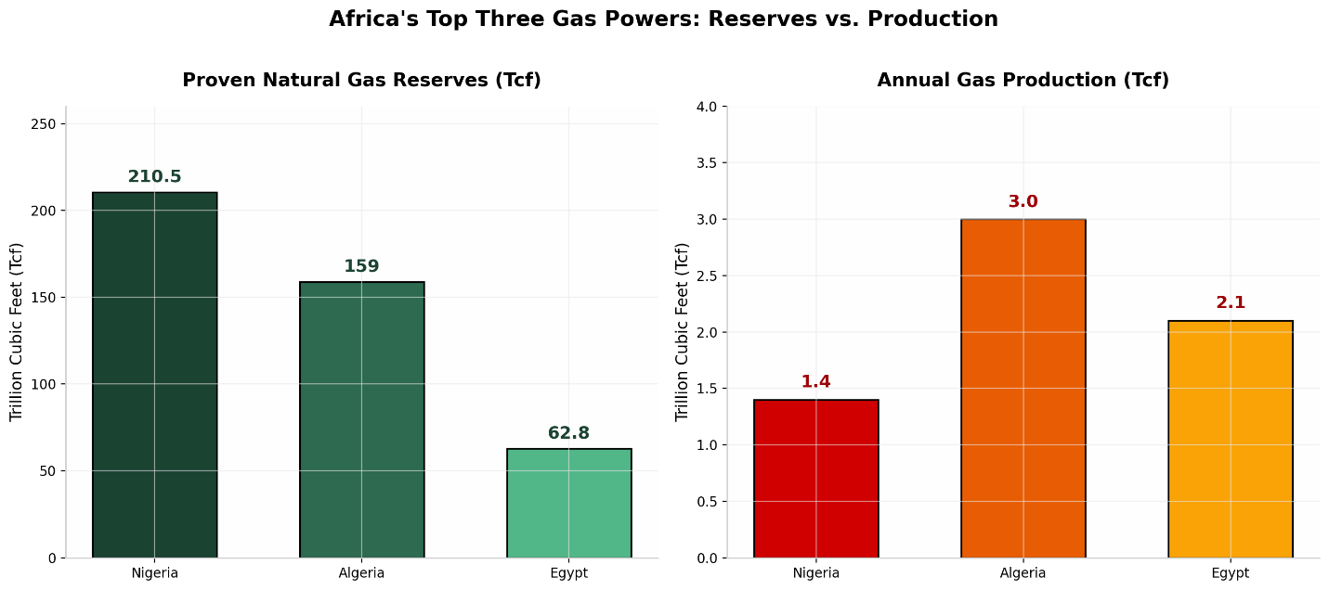
Nigeria's 210.5 Tcf of proven reserves significantly outpace Algeria (159 Tcf) and Egypt (62.8 Tcf), giving it a commanding lead in Africa. However, this reserve advantage has not translated into proportional production or export dominance. Algeria, with smaller reserves, has historically exported more gas to Europe via pipeline, while Nigeria's export model remains heavily LNG-dependent and constrained by single-terminal capacity.
Nigeria's reserve base is more than adequate to support a 50-year production horizon at significantly expanded rates. The constraint is not geology but above-ground factors—infrastructure, policy, and investment.

2. PRODUCTION VERSUS MONETIZATION PERFORMANCE
Nigeria produces approximately 1.5 Tcf of dry natural gas annually (averaging 7.59 Bscf/d in 2025), of which:
- 35.88% is exported as LNG (≈2.72 Bscf/d equivalent)
- 27.82% supplies the domestic market (≈2.11 Bscf/d)
- 29.13% is used for field and plant operations (reinjection, fuel, gas lifting)
- 7.16% is flared (down from over 20% in the early 2000s but still above global averages)
(NUPRC, 2025; World Bank Global Gas Flaring Tracker, 2025)
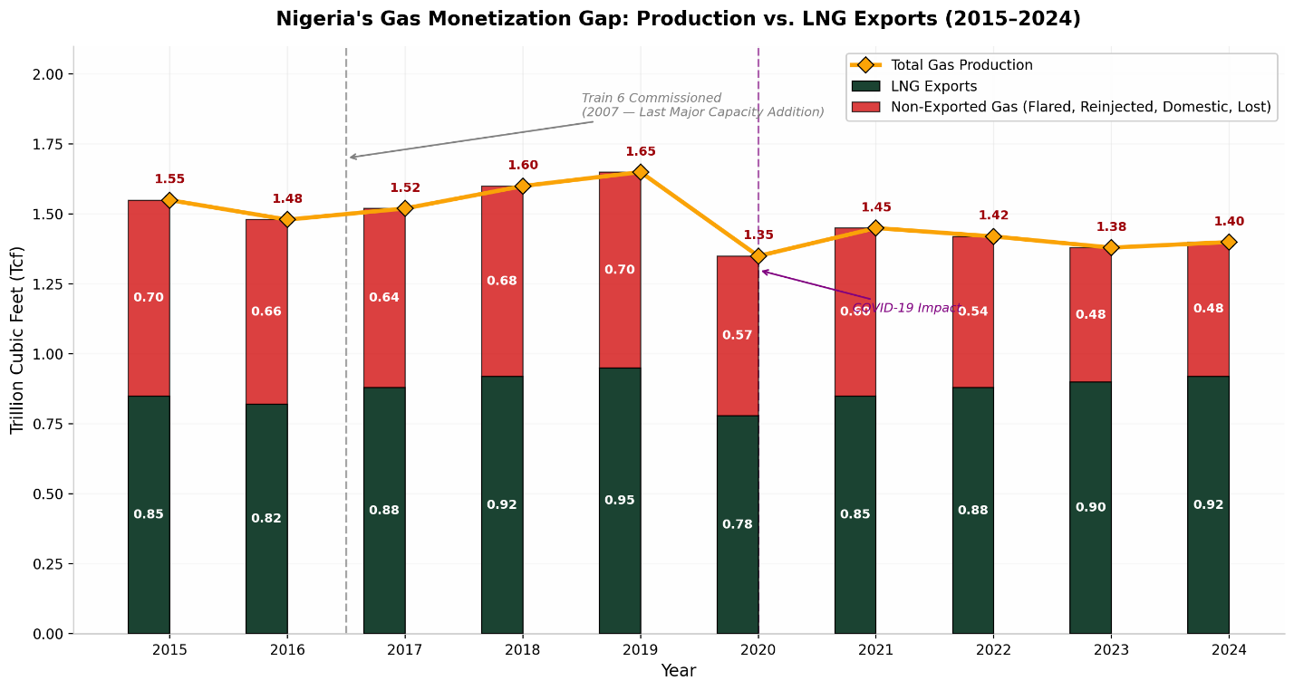
The divergence between total production and LNG exports reveals the scale of Nigeria's monetization gap. While production has recovered from COVID-19 lows, LNG exports have grown only modestly, constrained by feedgas availability, pipeline disruptions, and the lack of new liquefaction capacity since Train 6 (2007). The gap between production and exports represents gas that is either flared, reinjected, or underutilized domestically each representing foregone revenue.

/mnt/agents/output/chart3_gas_allocation.png
The stacked allocation chart reveals a structural imbalance. Nearly 30% of produced gas is consumed in field operations, and flaring though declining still wastes valuable resources. The domestic market absorbs only 28% of output, insufficient to drive industrialization in a country of 220+ million people. LNG exports at 36% represent the primary revenue stream but are capped by infrastructure limits.
Nigeria's gas utilization efficiency remains poor by global standards. The country flares gas equivalent to the annual consumption of several West African nations combined, while its power sector suffers chronic fuel shortages.

3. NIGERIA LNG (NLNG) AND EMERGING LNG PROJECTS
NLNG Trains 1–6: The Bonny Island facility, operational since 1999, currently comprises six trains with a combined capacity of 22.2 MTPA. Utilization averaged only 65% in 2024, among the lowest of major LNG exporters, due to feedgas supply disruptions, pipeline sabotage, and force majeure declarations (IGU World LNG Report, 2025).
NLNG Train 7: The $5–6.5 billion expansion projects reached 92% completion as of May 2026 and is transitioning into pre-commissioning. Train 7 will add 4.2 MTPA of capacity (via a complete train and common liquefaction unit), raising total capacity to 30 MTPA a 36% increase. Start-up is anticipated in 2026–2027 (NLNG, 2026; IGU, 2025).
Other Proposed Projects:
- Brass LNG: Shelved since 2014; requires significant investment and security guarantees to revive.
- Olokola LNG: Also stalled; strategic location on the western coast could serve Atlantic markets.
- Floating LNG (FLNG): Several FLNG concepts have been discussed for stranded gas fields, but none have reached FID.
LNG Export Destinations (2024): Nigeria exported approximately 650 Bcf of natural gas, mostly as LNG. Top destinations included France (34 Bcf), Spain (77 Bcf), China (67 Bcf), and India (69 Bcf) (EIA, 2025; Energy Institute, 2025). Nigeria ranked as the 6th largest global LNG exporter in 2024.

4. DOMESTIC GAS UTILISATION
Nigeria's domestic gas consumption remains underdeveloped relative to its industrial potential:
- Power Generation: Absorbs ~55% of domestic gas supply, yet the country generates only ~4,250–5,370 MW on average against an installed capacity of ~12,500 MW. Gas-to-power deliveries averaged 862.86 million scf/d in July 2025—the highest in three months but still inadequate (NERC, 2025; NUPRC, 2025).
- Gas-Based Industries: Fertilizer (Indorama, Dangote), petrochemicals, and methanol plants represent ~18% of domestic use.
- Manufacturing & Cement: ~12%—constrained by pipeline access and pricing.
- CNG for Transport: Emerging sector; government is promoting CNG conversion to reduce petrol import dependency.
- LPG: ~4%—growing household demand for cooking gas.
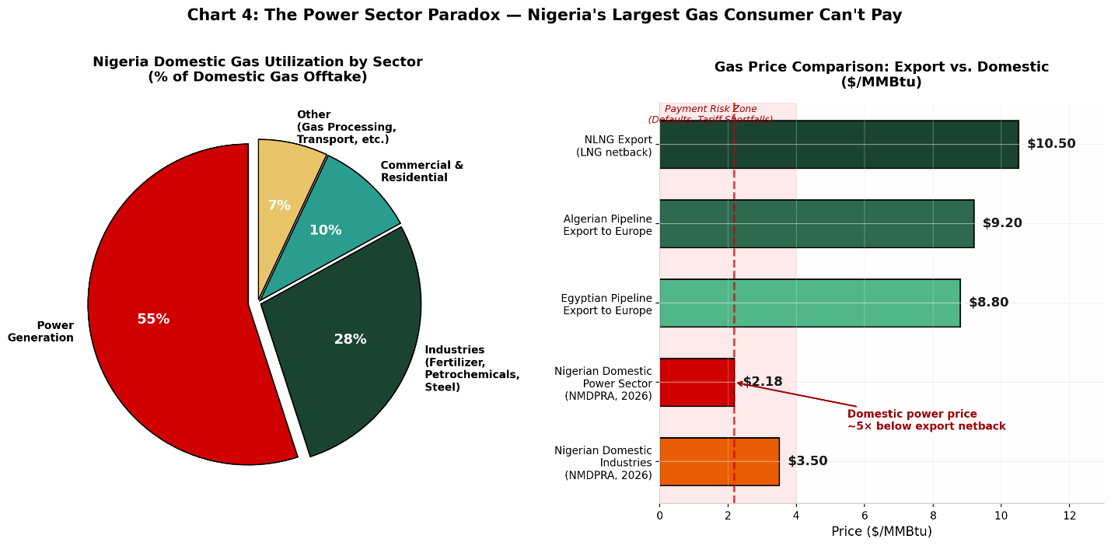
The dominance of power generation in domestic gas use (55%) highlights both the opportunity and the risk. The power sector is the largest off-taker but is plagued by payment defaults, grid instability, and tariff shortfalls. Gas suppliers frequently prioritize export markets where prices exceed $8–12/MMBtu over domestic power plants paying $2.18/MMBtu (NMDPRA, 2026). Until power sector liquidity improves, domestic gas demand will remain constrained. Domestic gas demand is artificially suppressed by structural issues in the power sector, not by lack of industrial appetite. Resolving the power sector's liquidity crisis is prerequisite to unlocking domestic gas monetization.

5. INFRASTRUCTURE ASSESSMENT
Nigeria's gas infrastructure is insufficient for its reserve base:
Major Pipeline Projects:
- Ajaokuta–Kaduna–Kano (AKK) Pipeline: $3 billion, 614 km. River Niger crossing completed June 2025. Will deliver gas to northern Nigeria for power and industry. Commissioning expected 2025–2026.
- OB3 (Obiafu-Obrikom-Oben) Pipeline: 130 km, designed for 2 Bscf/d. River Niger crossing completed April 2026. Links eastern gas fields to western networks.
- Escravos–Lagos Pipeline System (ELPS): Supplies western Nigeria; expansion planned to support Lekki industrial zone and Dangote Refinery.
- West African Gas Pipeline (WAGP): Currently supplies Ghana, Togo, Benin. Proposed extension to Morocco ($25 billion, 7,000 km) remains in feasibility stage.
Processing & Storage: Nigeria has limited gas processing capacity relative to production. Most associated gas requires treatment before commercial use, and processing plant deficits force operators to flare.
Investment Gap: NNPC Ltd. estimates $60 billion is required by 2030 to achieve production targets of 20 Bscf/d and add 500,000 b/d refining capacity (NNPC Ltd., 2025; BusinessDay, 2025). Current annual investment (~$5–7 billion) falls well short of this trajectory.
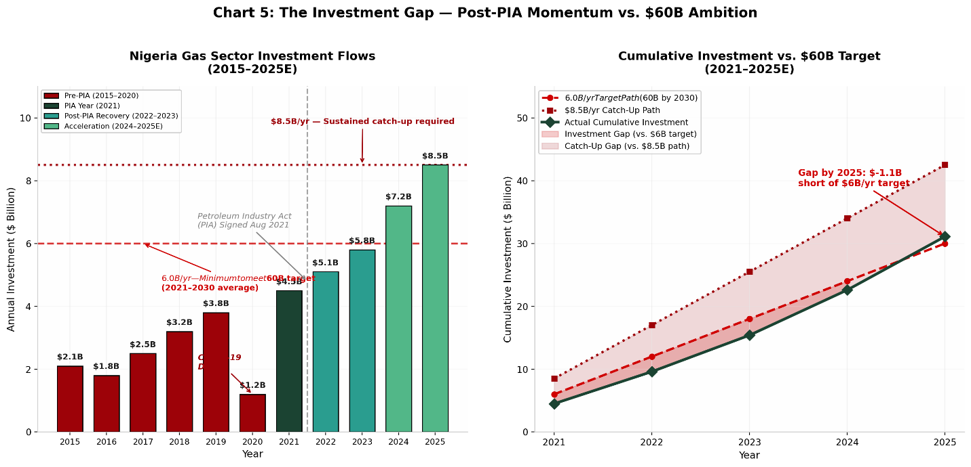
Investment surged post-PIA (2021) and accelerated in 2024–2025, but the $60 billion target requires sustained annual flows of $8–10 billion. The 2020 COVID-19 dip illustrates vulnerability to external shocks. Without diversified financing mechanisms (DFIs, green bonds, resource-backed loans), the investment gap will persist. Infrastructure is the binding constraint. The AKK and OB3 pipelines are game-changers for domestic market development, but transmission and distribution networks remain inadequate. Nigeria needs a national gas grid, not just corridor pipelines.

6. POLICY AND REGULATORY ASSESSMENT
Petroleum Industry Act (PIA) 2021: The PIA represents Nigeria's most significant energy reform in two decades:
- Governance: Split NNPC into NNPC Ltd. (commercial entity) and created NUPRC (upstream regulator) and NMDPRA (midstream/downstream regulator).
- Fiscal Terms: Improved gas economics through lower royalties and production-based taxes. The 2025 TotalEnergies PSC is cited as a new template aligned with PIA gas incentives (African Energy Research, 2026).
- Domestic Gas Delivery Obligation (DGDO): Mandates upstream producers to allocate gas to strategic sectors (power, commercial, gas-based industries). DGDO compliance reached 72.5% in July 2025 (NUPRC, 2025).
- Host Community Trusts: 103 trusts incorporated by February 2024; fund reached ₦373 billion by October 2025 (African Energy Research, 2026).
Gas Pricing Framework: The NMDPRA sets annual Domestic Base Prices:
- Power Sector: $2.18/MMBtu (effective April 2026)
- Commercial Sector: $2.68/MMBtu
- Gas-Based Industries: Floor $0.90/MMBtu, ceiling $2.42/MMBtu (NMDPRA, 2026)
Challenges: Pricing remains contentious. Power sector tariffs are not cost-reflective, creating a subsidy burden. Gas suppliers argue domestic prices are too low to justify investment in production and infrastructure. The Minister of Power has acknowledged that gas companies prioritize exports at 2× domestic prices (NMDPRA, 2026).
Decade of Gas Initiative: Launched 2021, focusing on supply, infrastructure, pricing, and utilization. 70 priority gas projects identified, targeting $20 billion in investments (Decade of Gas, 2024).
Key Intelligence Insight: The PIA improved the rulebook, but implementation gaps persist. Regulatory overlap, administrative friction, and pricing distortions continue to deter capital. The DGDO is a useful tool but requires enforcement credibility.

7. FINANCING AND INVESTMENT LANDSCAPE
- Foreign Direct Investment (FDI): $5 billion+ in gas sector in 2024; $17 billion across the energy value chain (NNPC, 2025).
- Development Finance: AfDB, IFC, and AFC have supported pipeline and power projects, but volumes remain modest relative to needs.
- Private Equity & Infrastructure Funds: Increasing interest in midstream gas processing and distribution.
- Green Finance: Potential for methane reduction and flare gas commercialization projects to attract climate finance.
- Challenges: Foreign exchange volatility, repatriation risks, security premiums, and bureaucratic delays elevate Nigeria's cost of capital above peer markets.
Key Intelligence Insight: Nigeria's gas sector is investable but requires risk mitigation instruments—political risk insurance, FX hedging facilities, and blended finance structures—to attract the $60 billion needed.

8. BENCHMARKING NIGERIA AGAINST PEER COUNTRIES
Indicator | Nigeria | Algeria | Qatar | Australia | Mozambique | Egypt
Proven Reserves (Tcf) | 210.5 | 159.0 | ~900 | ~140 | 100 | 62.8
LNG Capacity (MTPA) | 22.2 (30 post-T7) | 25.5 | 77.1 | 87.6 | 3.4 | 12.2 (offline)
2024 LNG Exports (MT) | 13.8 | 11.6 | 77.2 | 81.0 | 3.1 | 0.8
Utilization Rate | 65% | 25% | 102% | ~90% | ~90% | 0%
Domestic Gas Use | Low | Very High | Moderate | High | Negligible | Very High
(Sources: IGU World LNG Report, 2025; Rystad Energy, 2025; EIA, 2025)
Nigeria scores highly on reserve size but poorly on infrastructure, investment attractiveness, and domestic market development. Qatar and Australia demonstrate what consistent policy execution and infrastructure investment can achieve. Algeria's low LNG utilization (25% in Q3 2025) reflects domestic demand absorption and facility aging an instructive warning for Nigeria. Mozambique, with smaller reserves, is attracting major LNG investment due to fiscal stability and security partnerships.

9. KEY CONSTRAINTS TO GAS MONETIZATION
Infrastructure deficit and pipeline vandalism sit in the critical risk quadrant (high likelihood, high impact). These are existential threats to monetization. Financing gaps and security challenges follow closely. Pricing distortions and regulatory delays are medium-high risks that compound investment uncertainty. Technology limitations and low domestic demand are comparatively lower priorities but still constrain growth.
Detailed Constraints:
- Infrastructure Deficit: Inadequate gathering, processing, transmission, and distribution networks.
- Pipeline Vandalism & Theft: Crude oil theft and pipeline sabotage in the Niger Delta disrupt gas supply to NLNG and domestic users.
- Gas Flaring: 7.16% of production flared in 2025; smaller indigenous operators lack capital for gas capture.
- Financing Gaps: $60 billion needed; current flows insufficient.
- Security: Militancy, kidnapping, and community conflicts elevate operational risk.
- Regulatory Delays: Licensing, approvals, and permitting remain slow despite PIA reforms.
- Pricing Issues: Domestic gas prices below export parity discourage supply to strategic sectors.
- Contract Enforcement: Weak judicial frameworks and payment defaults undermine investor confidence.
- Low Domestic Demand: Power sector dysfunction suppresses the largest potential market.
- Political Risks: Policy reversals, election cycles, and fiscal instability.

10. STRATEGIC OPPORTUNITIES
European gas demand diversification and Asian LNG growth (China, India) sit in the strategic priority quadrant—high impact and feasible. Gas-to-power expansion and petrochemicals also offer high impact but face implementation hurdles (power sector reform, industrial policy). Blue hydrogen and carbon capture are longer-term opportunities with current low feasibility. CNG for transport and digital technologies represent quick wins with moderate impact.
Opportunity Assessment:
- European Demand: Post-Russia diversification creates a premium market for Nigerian LNG, but competition from U.S. and Qatar is intensifying.
- Asian Growth: China's LNG demand is recovering; India is adding 5 MTPA of import capacity. Nigeria is well-positioned but needs shipping and marketing partnerships.
- Regional Trade: AfCFTA and WAGP expansion could create a West African gas market of 400+ million people.
- Gas-Based Industrialization: Fertilizer, methanol, and petrochemical clusters near gas sources (e.g., Dangote Refinery, Indorama) can absorb domestic supply and create jobs.
- CNG Transport: Government push to convert vehicle fleets; potential to reduce petrol imports and emissions.
- Digital Technologies: IoT, AI, and satellite monitoring can reduce flaring, optimize pipeline operations, and improve security.

11. SWOT ANALYSIS
STRENGTHS | WEAKNESSES
• Largest proven gas reserves in Africa (210.5 Tcf) | • Production-to-reserves ratio of only ~1%
• Established LNG export infrastructure (NLNG) | • Chronic infrastructure deficits
• Favorable geographic position (Atlantic access to Europe/Americas) | • Pipeline vandalism and crude theft
• Large domestic market (220+ million people) | • Power sector dysfunction suppressing demand
• PIA (2021) provides improved governance framework | • Pricing distortions and subsidy burdens
• Growing indigenous operator capacity | • Regulatory implementation gaps
• Decade of Gas policy momentum | • Foreign exchange volatility

OPPORTUNITIES | THREATS
• European gas demand diversification | • Global LNG oversupply (2026–2028) pressuring prices
• Asian LNG demand growth (China, India) | • Competition from Qatar, U.S., Mozambique
• AfCFTA regional market expansion | • Energy transition accelerating beyond gas
• Gas-to-power and industrialization | • Climate finance shifting away from fossil fuels
• CNG transport market | • Security deterioration in Niger Delta
• Blue hydrogen and CCS potential | • Political instability and policy reversal
• Digitalization and flare gas commercialization | • Stranded asset risk for new LNG projects

12. SCENARIO ANALYSIS
Scenario | Accelerated Monetization | Business as Usual | Missed Opportunity
Probability | 25% | 50% | 25%
Production (2030) | 12 Bscf/d | 9 Bscf/d | 6 Bscf/d
LNG Exports | 35+ MTPA | 30 MTPA (Train 7 only) | 22 MTPA (stagnant)
Domestic Utilization | 4 Bscf/d | 2.5 Bscf/d | 1.5 Bscf/d
Revenue ($bn/yr) | $25–30 | $15–18 | $8–10
Industrial Growth | Rapid (fertilizer, petrochemicals) | Moderate | Stagnant
Employment | 2+ million new jobs | 500,000–800,000 | Minimal
FDI | $60+ billion by 2030 | $30–40 billion | <$20 billion

Accelerated Monetization: Requires successful Train 7 commissioning, AKK/OB3 pipeline completion, Brass/Olokola FIDs, security stabilization, and power sector reform. Nigeria becomes Africa's gas hub.
Business as Usual: Train 7 comes online, AKK/OB3 partially operational, but new projects delayed. Nigeria maintains 6th place in global LNG but loses ground to competitors.
Missed Opportunity: Persistent insecurity, financing shortfalls, and regulatory stagnation stall growth. Global LNG oversupply makes new projects uneconomic. Nigeria's gas remains stranded.

13. STRATEGIC RECOMMENDATIONS
For the Federal Government:
- Expedite Pipeline Infrastructure: Prioritize AKK, OB3, and ELPS expansion with sovereign guarantees and blended finance.
- Reform Power Sector: Address liquidity crisis through tariff adjustment, subsidy rationalization, and payment discipline to make gas-to-power bankable.
- Security Stabilization: Deploy technology (drones, IoT sensors) and community-based protection models in the Niger Delta.
- Fiscal Incentives: Extend PIA gas tax incentives to non-associated gas and marginal field operators.
For NNPC Ltd.:
- Accelerate Train 7 Commissioning: Ensure Q3/Q4 2026 start-up; plan Train 8–10 feasibility.
- Advance Brass & Olokola LNG: Secure equity partners and offtake agreements before the LNG supply wave peaks.
- Expand Domestic Gas Supply: Meet and exceed DGDO targets; invest in gas processing plants.
For NUPRC & NMDPRA:
- Enforce DGDO Compliance: Penalize non-compliance credibly; publish quarterly performance dashboards.
- Pricing Reform: Transition domestic gas prices toward export parity over 5 years with power sector cost-reflective tariffs.
- Regulatory Certainty: Streamline licensing; reduce approval timelines to <90 days.
For Investors:
- Midstream Opportunities: Gas processing, pipeline infrastructure, and storage offer attractive risk-adjusted returns.
- Gas-Based Industries: Fertilizer, methanol, and petrochemical plants near gas sources.
- CNG & LPG Distribution: Retail gas infrastructure is underdeveloped.
- Flare Gas Commercialization: NGFCP sites offer stranded gas at low acquisition cost.
For Development Finance Institutions:
- De-Risk Infrastructure: Provide political risk insurance, FX hedging, and concessional debt for pipeline projects.
- Support Industrial Clusters: Anchor gas-based special economic zones with blended finance.
- Methane Reduction Finance: Fund flare capture and CCS projects under climate finance frameworks.
For International Partners:
- Technology Transfer: Partner on digital oilfield, pipeline monitoring, and LNG optimization.
- Market Access: Secure long-term offtake agreements for Train 7+ volumes.
- Regional Integration: Support WAGP expansion and West African gas market development.

REFERENCES
African Energy Research. (2026, April 29). The Petroleum Industry Act (PIA) in Practice: Progress, Gaps, and Policy Priorities. https://africanenergyresearch.org
Afripoli. (2026, March 17). Nigeria's Natural Gas and Africa's Sustainable Industrialization. https://afripoli.org
APA News. (2026, May 31). Nigeria: $5bn NLNG Train 7 Nears Completion. https://apanews.net
BusinessDay Nigeria. (2025, August 28). NNPC Targets $60bn Investment to Boost Gas, Refining Capacity by 2030. https://businessday.ng
Channels TV. (2026, January 21). Nigeria to Benefit as Global LNG Supply Set to Jump in 2026. https://channelstv.com
Decade of Gas Initiative. (2024). Nigeria Eyes $20bn in Investments from 70 Priority Gas Projects. https://decadeofgas.com.ng
Energy Institute. (2025, June). Statistical Review of World Energy (74th ed.). https://energyinst.org
Forbes Africa. (2025, May 28). Nigeria Energy 2025. https://cms.forbesafrica.com
Gas for Africa. (2025, June 14). Nigeria Gas Profile. https://gasforafrica.org
Global Energy Monitor. (2026, July 8). Nigeria LNG Terminal. https://gem.wiki
International Gas Union (IGU). (2025). World LNG Report 2025. https://igu.org
Nigerian Midstream and Downstream Petroleum Regulatory Authority (NMDPRA). (2026, April 2). New Gas Price to Take Effect in Nigeria. https://doowe.ng
Nigerian Upstream Petroleum Regulatory Commission (NUPRC). (2025, August 31). Nigeria's Gas Production Rises to 7.59 Billion SCFD as Flaring Drops. https://premiumtimesng.com
Nigerian Upstream Petroleum Regulatory Commission (NUPRC). (2025). Gas Production Status Reports (2021–2025). Abuja: NUPRC.
NNPC Ltd. (2025, July 1). Nigeria Committed to Pursuing Gas as "Low-Carbon Transition Fuel". https://gasoutlook.com
NNPC Ltd. (2025, August). Group CEO Statement on Investment Targets. Abuja: NNPC Ltd.
Policy Center for the New South. (2024, December 27). Nigeria: Africa's Gas Powerhouse in the Making. https://policycenter.ma
Premium Times Nigeria. (2025, August 31). Nigeria's Gas Production Rises to 7.59 Billion SCFD as Flaring Drops. https://premiumtimesng.com
PwC Nigeria. (2024). Evaluating Nigeria's Gas Value Chain. https://pwc.com/ng
Saipem. (2025). Bonny NLNG Train 7 Project Overview. https://saipem.com
Springer. (2025, October 11). Environmental Economic Impacts and Policy Pathways of Gas Flaring in Nigeria from 2002 to 2024. https://link.springer.com
Templars Law. (2024, July 31). An Overview of Nigeria's Domestic Gas Pricing Framework. https://templars-law.com
U.S. Energy Information Administration (EIA). (2025). Country Analysis Brief: Nigeria. https://eia.gov
World Bank. (2025, July). Global Gas Flaring Tracker Report. https://thedocs.worldbank.org

