Mozambique's LNG Investment Landscape in 2026
Executive Summary
Mozambique is entering the most significant phase of LNG development since the discovery of the Rovuma Basin. Following the January 2026 full restart of TotalEnergies' 13.1 mtpa Mozambique LNG (Area 1) project, the October 2025 final investment decision (FID) on Eni's $7.2bn Coral Norte FLNG, and ExxonMobil's move toward a targeted FID on the 18 mtpa Rovuma LNG project by the second half of 2026, the Rovuma Basin is transitioning from a stalled resource commercialisation story to an active, multi-train construction pipeline. Combined, these projects underpin resource access to approximately 150 tcf of discovered gas offshore Cabo Delgado, among the largest undeveloped gas endowments outside the Middle East.
Upstream investment momentum has been driven by a materially improved, though not fully resolved, security environment in Cabo Delgado, where a multinational stabilisation effort involving Rwandan and SADC forces has allowed operators to re-enter Afungi and resume onshore works after the 2021 force-majeure shock. Eni's Coral South FLNG continues to demonstrate strong operating performance, validating the floating-LNG model that Coral Norte will replicate from 2028, while TotalEnergies now targets first LNG from Area 1 in 2029 at a revised capital envelope above $20bn.
The country's LNG strategy is characterised by a diversified development model that combines floating liquefaction technology with large-scale onshore export facilities. This phased approach reduces project execution risk while enabling operators to monetise offshore gas resources more efficiently. Coral South FLNG has demonstrated the commercial viability of floating LNG production in the Rovuma Basin, providing valuable operational experience that is expected to support the development of Coral Norte and future offshore projects. At the same time, the planned Mozambique LNG and Rovuma LNG projects are designed to establish Mozambique as a globally competitive supplier of long-term LNG volumes through large-capacity onshore liquefaction facilities.

Investment Highlights
- Mozambique LNG (Area 1) — TotalEnergies
TotalEnergies and Mozambican President jointly announced the restart of onshore and offshore activity at Afungi on 29 January 2026, following the 7 November 2025 decision to lift the force majeure declared after the March 2021 Palma attack. More than 4,000 workers have been remobilised and offshore installation work in Area 1 has resumed alongside onshore EPC activity. First LNG is now targeted for 2029, a multi-year slip from the pre-suspension schedule, with capex guidance raised to above $20bn (incremental costs of approximately $4.5bn) and a request for a ten-year concession extension. Construction is estimated at roughly 40% complete and remains in a security-conscious 'containment mode' pending further stabilisation.

Investment Implications
- Expected to attract billions of dollars in renewed engineering, procurement, and construction (EPC) contracts.
- Significant opportunities for offshore services, logistics, marine support, fabrication, and local supply chains.
- Strong potential to catalyse additional exploration and infrastructure investment across the Rovuma Basin.
- Coral South FLNG — Eni (operating)
Coral South FLNG, Africa's first deepwater floating LNG facility, has been producing since 2022 at a nameplate 3.4 mtpa from the Coral gas field in Area 4, and continues to be cited by operators and government as commercial validation for Mozambique's floating-LNG monetisation route, insulated from onshore security risk.

Investment Implications
- Demonstrates stable production performance.
- Provides operational experience for future FLNG developments.
- Generates early export revenues for both investors and the Mozambican government.
- Reinforces confidence in floating LNG technology as a complementary monetisation strategy.
- Coral Norte FLNG — Eni
Eni and partners CNPC, Kogas, ENH and ADNOC's XRG sanctioned the $7.2bn Coral Norte FLNG project on 2 October 2025, targeting 3.6 mtpa of additional capacity from the northern Coral reservoir. Construction of the FLNG hull was launched at the Geoje shipyard (South Korea) in January 2026, and Technip Energies has since expanded its EPC role; first LNG is expected by 2028. Eni estimates the project will generate roughly $23bn in lifetime fiscal revenue for Mozambique and $3bn in local contracting opportunities.
Investment Implications
- Expands Area 4 production capacity.
- Supports incremental LNG export growth.
- Diversifies Mozambique's LNG infrastructure portfolio.
- Creates additional offshore contracting opportunities.
- Rovuma LNG — ExxonMobil / Eni / CNPC / XRG / Kogas / ENH
ExxonMobil lifted force majeure on the 18 mtpa Rovuma LNG project in Area 4 on 20 November 2025. Mozambican officials now expect a final investment decision around September 2026 on the roughly $20-30bn onshore development, with first LNG targeted for 2030. Government-established multisectoral teams have been created to fast-track technical and operational approvals for both the TotalEnergies and ExxonMobil megaprojects, and Rovuma LNG is expected to share Afungi-area infrastructure with Mozambique LNG.
Investment Implications
- Represents one of Africa's largest future upstream investments.
- Expected to generate substantial EPC, drilling, and infrastructure contracts.
- Will diversify Mozambique's LNG export portfolio beyond Area 1 developments.

Project | Operator | Status | Estimated Investment | Capacity
Coral South FLNG | Eni | Operating (since 2022) | ~$8bn (sanctioned 2017) | 3.4 mtpa
Coral Norte FLNG | Eni | FID Oct 2025; under construction | $7.2bn | 3.6 mtpa
Mozambique LNG (Area 1) | TotalEnergies | Restarted January 2026 | >$20bn (+$4.5bn cost impact) | 13.1 mtpa
Rovuma LNG (Area 4) | ExxonMobile | Force majeure lifted, FID targeted H2 2026 | ~$20-30bn | 18 mtpa

Mozambique's Natural Gas Resource Base
Mozambique holds Sub-Saharan Africa's second-largest remaining discovered resource base, with natural gas accounting for the vast majority of total hydrocarbon resources. Independent estimates place discovered gas resources in the offshore Rovuma Basin at approximately 125 tcf, split roughly between TotalEnergies' Area 1 licence (approximately 65 tcf) and the ExxonMobil/Eni-operated Area 4 licence (approximately 85 tcf). By comparison, Qatar's North Field holds roughly 900 tcf, underscoring that while Rovuma is not of that scale, it remains exceptional relative to most global peers.
The Rovuma Basin
The Rovuma Basin, located along Mozambique's northern coastline bordering Tanzania, represents one of the most significant offshore gas provinces discovered globally during the past two decades. Extensive exploration campaigns conducted since the early 2010s have identified numerous giant gas fields containing exceptionally large recoverable resources.
The basin extends across deepwater and ultra-deepwater environments and contains multiple stacked sandstone reservoirs with favourable geological characteristics. Exploration success rates have remained high, reflecting the basin's considerable hydrocarbon prospectivity. From an investment perspective, the Rovuma Basin offers several strategic advantages:
- Concentration of multiple world-class gas discoveries within a relatively confined geographical area.
- Potential for shared infrastructure, reducing development costs.
- Opportunities for phased project expansion through tie-back developments.
- Significant exploration upside in underexplored offshore blocks.
- Capacity to support both floating and onshore LNG developments.

Offshore Area 1
Offshore Area 1 is operated by TotalEnergies on behalf of an international consortium and contains several major gas discoveries, including:
- Prosperidade
- Golfinho
- Atum
- Orca
- Tubarão
Collectively, these fields contain approximately 65 Tcf of recoverable natural gas resources, making Area 1 one of the world's largest undeveloped offshore gas provinces. From an upstream investment perspective, Area 1 offers:
- Long reserve life.
- Expansion opportunities through future LNG trains.
- High production scalability.
- Attractive project economics.
- Significant opportunities for additional exploration.

Offshore Area 4
Offshore Area 4, operated jointly by Eni and ExxonMobil, represents Mozambique's second major gas development area. The block contains several giant gas discoveries, including:
- Coral
- Mamba Complex
- Agulha
- Tubarão (Area 4 structures)
Estimated recoverable resources exceed 85 Tcf, making Area 4 one of the largest offshore gas developments globally. Unlike Area 1, Area 4 is pursuing a dual monetisation strategy: floating LNG through Coral South and Coral Norte, and large-scale onshore LNG through the Rovuma LNG project.
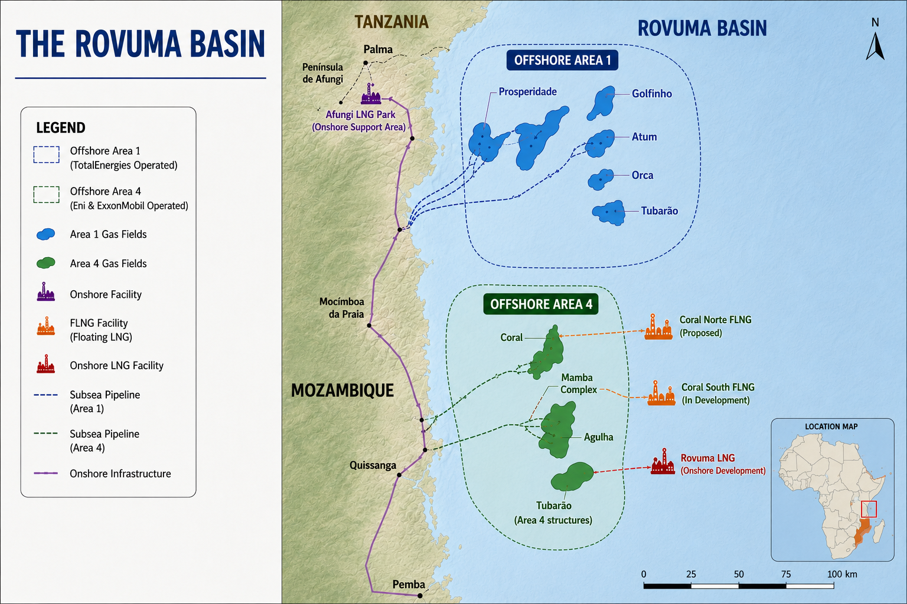

Major Upstream Operators
Mozambique's transformation into an emerging global LNG exporter has been driven by a consortium of leading international energy companies, national oil companies (NOCs), and strategic financial partners. Unlike many hydrocarbon-producing countries where upstream development is dominated by a single operator, Mozambique's offshore gas sector is characterised by collaborative joint ventures that combine technical expertise, financial strength, and access to global LNG markets.
The country's two flagship concession areas Offshore Area 1 and Offshore Area 4 are operated by international consortia with diverse shareholder structures. These partnerships have enabled the mobilisation of tens of billions of dollars in capital while distributing technical, commercial, and political risks among experienced industry participants.

Operators | Assets | Roles | Current Activity
TotalEnergies | Area 1 / Mozambique LNG | Operator (26.5%) | Full restart of onshore/offshore construction (Jan 2026); targeting first LNG 2029
ExxonMobil | Area 4 / Rovuma LNG | Onshore LNG operator | Force majeure lifted Nov 2025; FID targeted H2 2026
Eni | Area 4 / Coral South & Coral Norte | FLNG operator (50% Coral Norte JV) | Coral South operating; Coral Norte under construction, FLNG hull launched Jan 2026
CNPC | Area 4 | Equity partner (20% Coral Norte; Rovuma LNG partner) | Continued equity participation across Area 4 projects
ENH | Area 1 &4 | State-owned equity partner (10%) | Statutory participation; local content oversight
Kogas | Area 4 | Equity partner (10%) | LNG offtake and equity interest
ADNOC / XRG | Area 4 | Equity partner (10%) | Entered via 2025 acquisition of Galp's stake
Mitsui & other consortium partners | Area 1 | Equity partners (incl. Bharat Petroleum, ONGC Videsh, Oil India, PTTEP) | Remobilised alongside TotalEnergies restart

Infrastructure Development
The Afungi LNG Park in Palma district, Cabo Delgado, remains the anchor site for onshore developments (as shown in figure 2), hosting Mozambique LNG's liquefaction trains and designated to host Rovuma LNG's shared facilities. Offshore, subsea production systems tie back Area 1 and Area 4 gas fields to onshore and floating processing units, while the Coral South and Coral Norte FLNG vessels function as self-contained offshore production, liquefaction and storage platforms.
- LNG terminals: Afungi onshore trains (Mozambique LNG, Rovuma LNG) plus two Coral-area FLNG vessels.
- Offshore production systems: subsea manifolds and risers tying Golfinho/Atum (Area 1) and Mamba/Coral (Area 4) fields to processing facilities.
- Marine logistics and port infrastructure: expanded capacity at the Port of Pemba supporting construction logistics, plus dedicated marine offloading facilities at Afungi.
- Workforce and security infrastructure: an expanded multinational security footprint (Mozambican, Rwandan and SADC forces) protecting the Afungi peninsula and associated logistics corridors.
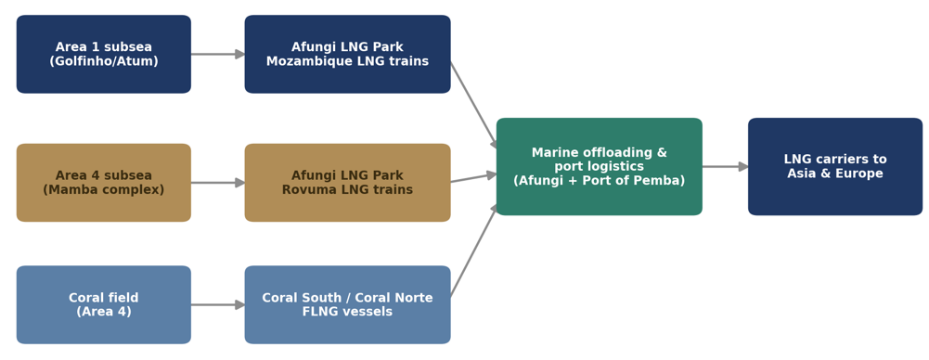
Figure 2 Mozambique LNG infrastructure network

Foreign Investment Landscape
Capital commitment spans European, US, Asian and Gulf investors, reflecting Mozambique's positioning as a diversified-buyer LNG source rather than a single-market play. TotalEnergies (France) and ExxonMobil (US) lead onshore development; Eni (Italy) leads floating LNG; CNPC (China) and Kogas (South Korea) hold significant equity and offtake-linked interests in Area 4; ADNOC's XRG (UAE) is a newer entrant following its 2025 acquisition of Galp's stake; and Indian entities (ONGC Videsh, Bharat Petroleum, Oil India) alongside Mitsui (Japan) and PTTEP (Thailand) hold equity in Area 1.
Project financing has historically drawn on export credit agencies and international development finance institutions. Although security-related disruptions delayed investment decisions following the force majeure declaration on the Mozambique LNG project in 2021, investor confidence has improved significantly with enhanced security measures, continued government support, and sustained long-term demand projections for LNG.

Investment Risks
- Security deterioration in Cabo Delgado
- Cost inflation / further capex escalation
- Regulatory / concession uncertainty
- Energy transition / long-term demand risk
- LNG price volatility

Investment Outlook
Mozambique's competitive position among LNG exporters has improved materially over the past twelve months. Relative to other frontier and emerging LNG suppliers, Mozambique combines resource scale (c.125 tcf discovered), a proven floating-LNG delivery model (Coral South), a diversified and creditworthy sponsor group, and renewed government commitment to fast-track approvals, a combination few other emerging gas provinces can currently match.
For upstream investors, the near-term opportunity set centres on: (i) equity and supply-chain participation in Coral Norte's ongoing construction phase through 2028, (ii) positioning ahead of Rovuma LNG's anticipated FID in the second half of 2026, which would be one of the largest project financings in African oil and gas history, and (iii) monitoring Mozambique LNG's execution through 2029 as a bellwether for onshore project delivery in a still-recovering security environment.

Conclusion
Mozambique has emerged as one of the most strategically significant frontier gas markets globally, with the potential to reshape Africa's position in international LNG trade over the coming decades. The country's vast offshore gas resources in the Rovuma Basin, combined with a diversified LNG development strategy encompassing both floating and onshore liquefaction, provide the foundation for sustained upstream investment and long-term export growth.
The successful operation of Coral South FLNG has demonstrated the commercial viability of Mozambique's offshore gas resources, while the anticipated progression of Mozambique LNG, Coral Norte FLNG, and Rovuma LNG is expected to unlock substantial additional production capacity through 2035. Supported by world-class operators, strong international partnerships, and continued demand for natural gas as a transition fuel, Mozambique is well positioned to become one of Africa's leading LNG exporters.

