Angola's LNG Export Resurgence and the Future of Gas Monetisation
Executive Summary
Angola is entering the most consequential phase of its gas-export history, positioning itself as one of Sub-Saharan Africa's most important LNG exporters since Angola LNG's difficult 2013 start-up. The commissioning of the Soyo non-associated gas plant in November 2025, sustained associated-gas debottlenecking on Block 0, following Angola's withdrawal from OPEC in late 2023, the government has greater flexibility in managing upstream production and associated gas development.
Complementing this progress is the development of dedicated non-associated gas resources, particularly through the New Gas Consortium (NGC) and the Quiluma and Maboqueiro (Q&M) project. These developments represent Angola's first major investment focused exclusively on supplying gas for LNG production rather than relying primarily on associated gas from oil fields. The Sanha Lean Gas Connection project further strengthens this strategy by expanding processing and transportation infrastructure needed to deliver stable feedgas to the LNG plant.

Angola's Natural Gas Resource Base
Angola holds proven natural gas reserves estimated at approximately 11 trillion cubic feet (Tcf) according to industry-association and government-linked estimates, although the U.S. Energy Information Administration's more conservative 2023 assessment placed proved reserves closer to 4.6 Tcf, and independent analyst ranges published in 2025 span roughly 10–13 Tcf. The spread reflects differing reserve-booking methodologies and the historically limited exploration focus on gas relative to oil. The great majority of produced gas to date has been associated gas, a byproduct of offshore crude production, with non-associated (standalone) gas only beginning commercial development in 2025–2026.
Angola's hydrocarbon endowment sits across four principal offshore basins as shown in figure 1: the Congo Basin (the historical core of oil and associated-gas production, including Block 0 and the Block 15 cluster), the Kwanza Basin (an emerging pre-salt play), the Benguela Basin, and the frontier Namibe Basin in the south, where ExxonMobil and Chevron have both recently taken exploration or licence positions. A material share of associated gas has historically been flared or re-injected rather than monetised: Angola ranked as the world's 15th-largest gas-flaring nation in 2023, flaring approximately 65 Bcf, underscoring both a legacy inefficiency and a forward monetisation opportunity as gas-gathering infrastructure expands.

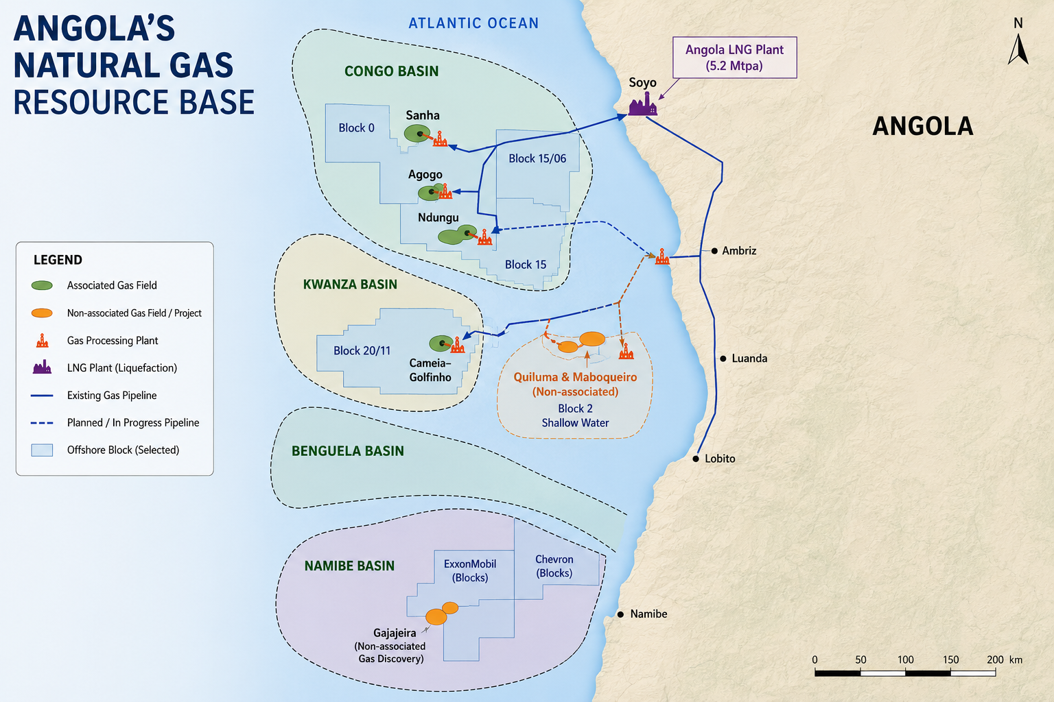
Figure 1 Angola Natural Gas Resource Base

Angola Gas Reserve Snapshot
Metrics | Estimate
Proven natural gas reserves | ≈11 Tcf
Proven natural gas reserves (conservative) | 4.6 Tcf
Analyst reserve range | ≈10–13 Tcf
Proven crude oil reserves | ≈7–9 billion barrels
2023 gas flaring volume | ≈65 Bcf/yr
Global flaring rank | 15th largest
Government gas-in-energy-matrix target | 25%

Major Gas Fields
Field/Project | Location | Gas Type | Status
Sanha (Block 0) | Offshore, Congo Basin | Associated | Producing; feeding Sanha Lean Gas Connection
Quiluma & Maboqueiro | Offshore Block 2 (shallow water) | Non-associated | Producing since early 2026, ramping to plateau
Agogo (Block 15/06) | Offshore, Congo Basin | Associated | Onstream via Agogo Integrated West Hub (Jul 2025)
Ndungu (Block 15/06) | Offshore, Congo Basin | Associated | Start-up announced Feb 2026
Cameia–Golfinho (Blocks 20/11) | Offshore, Kwanza Basin | Associated | TotalEnergies-operated; first gas targeted 2026
Gajajeira | Offshore | Non-associated (discovery) | first commercially significant non-associated gas discovery, 2025

Key Gas Operators and Roles
Operator | Primary Role
Angola LNG Limited | Owns and operates the Soyo LNG liquefaction and export terminal.
Azule Energy (bp–Eni 50:50 JV) | Operator of the New Gas Consortium (NGC); Angola's largest independent E&P operator.
Chevron / Cabinda Gulf Oil Company | Operator of Block 0 gas infrastructure including Sanha Lean Gas Connection.
Sonangol E&P | National oil company partner across NGC and Angola LNG; steward of the National Gas Master Plan.
TotalEnergies | NGC partner; operator of Cameia–Golfinho gas/oil development.
ExxonMobil | Operator and partner in several offshore developments including Block 15 and frontier Namibe exploration.

Angola LNG
The Angola LNG project represents the cornerstone of Angola's gas monetisation strategy and one of the largest energy infrastructure investments in Sub-Saharan Africa. Located in Soyo, Zaire Province, the facility was conceived to commercialise associated gas that had historically been flared or reinjected during offshore oil production. Beyond generating export revenues, the project supports Angola's environmental objectives by reducing routine gas flaring while creating value from resources previously regarded as by-products of oil extraction.
With a nameplate capacity of 5.2 million tonnes per annum (Mtpa), Angola LNG is currently the country's only LNG export terminal and serves as the primary gateway for Angolan natural gas to international markets. Its strategic location on the Atlantic coast provides efficient shipping access to Europe, the Americas, and, through global LNG trade routes, Asia.
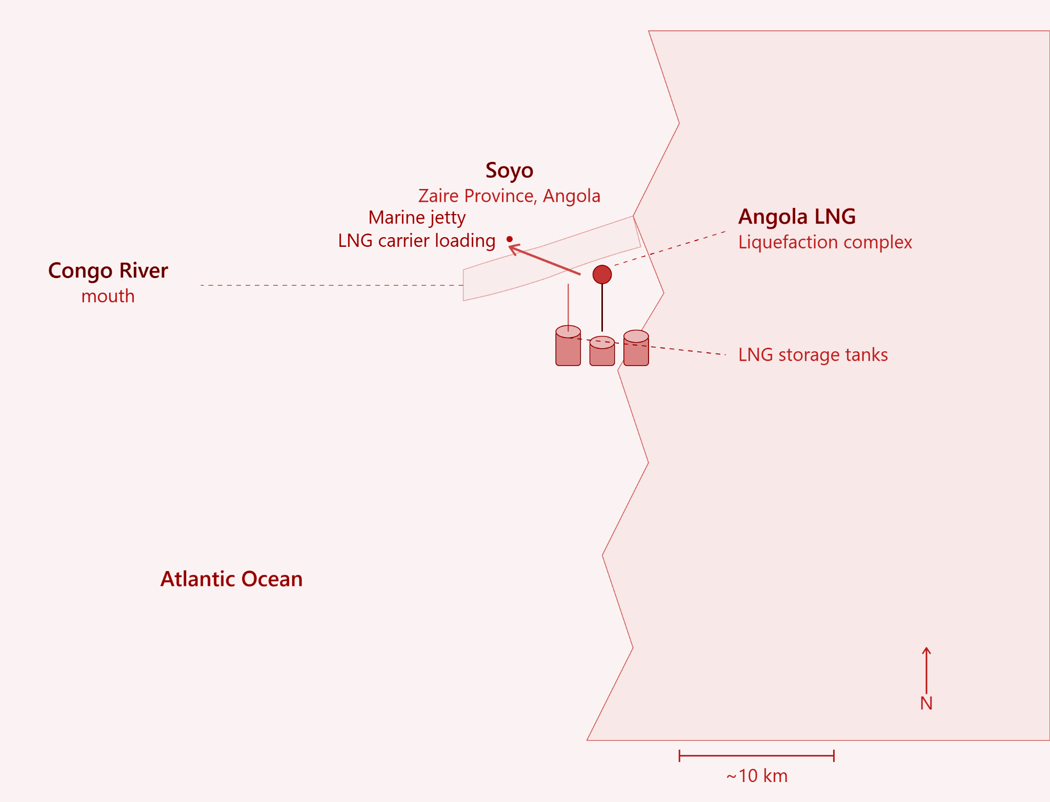
Figure 2 Angola LNG Liquefaction Complex
LNG Export Destinations
- Europe
- France
- United Kingdom
- Asia-pacific
- india

Associated Gas Commercialization
The majority of Angola's offshore oil fields produce associated gas alongside crude oil. Historically, limited domestic demand and the absence of large-scale processing infrastructure meant that much of this gas could not be commercially utilised.
Recognising the economic value of natural gas, the Angolan government has introduced policies aimed at maximizing gas utilisation while reducing routine flaring. These reforms seek to position gas as a central pillar of the country's long-term energy strategy. Key policy objectives include:
- Reducing routine gas flaring and associated emissions.
- Increasing the volume of gas available for LNG exports.
- Encouraging dedicated gas exploration and production.
- Expanding domestic gas utilisation in power generation and industry.
- Attracting international investment into gas infrastructure.
The Sanha Lean Gas Connection is the clearest recent example: an offshore subsea gas-gathering system in roughly 230 feet of water that ties Chevron's Sanha field and the existing Sanha condensate complex into the Congo River Crossing Pipeline, ultimately delivering lean gas to Angola LNG and to Soyo-area power generation. Its phased design, 80 mmscf/d in the first stage, rising by a further 220 mmscf/d once booster compression is commissioned, is representative of the brownfield, tie-back-led approach Angola is using to unlock associated gas without the capital intensity of new standalone platforms.
Investment Opportunities
For international capital, Angola's gas sector currently presents three distinct entry points.
- Non-associated gas development
Following the New Gas Consortium template, offers exposure to Angola's still-underexplored standalone gas resource, particularly in frontier basins such as Namibe, where ExxonMobil and Chevron have both recently taken exploration positions.
- Downstream and midstream capacity
potential Angola LNG expansion (additional train or mini-train), petrochemical off-take (ammonia/urea), and domestic power generation, offers exposure to gas demand growth independent of the export cycle.
- Brownfield tie-back and debottlenecking
Investment around existing associated-gas infrastructure (in the form of the Sanha Lean Gas Connection) offers relatively short-cycle, lower-capital-intensity exposure to rising feedgas volumes.

Risks
- Declining offshore oil production reducing associated gas
- Execution risk
- Financing
- LNG price volatility
- Competition from Qatar, US and Mozambique

Conclusion
Angola's gas sector is undergoing a structural transformation that extends well beyond the revitalisation of the Angola LNG facility. Through the commercialisation of associated gas, development of dedicated non-associated gas resources, and expansion of critical infrastructure, the country is laying the foundation for a more diversified and resilient hydrocarbon economy.
For investors, Angola offers a compelling combination of established export infrastructure, experienced international operators, supportive policy reforms, and growing opportunities across upstream, midstream, downstream, and low-carbon technologies. While risks associated with project execution, global market volatility, and the energy transition remain, the country's strategic commitment to gas monetisation provides a strong basis for long-term investment.

