Geopolitical and Commercial Mechanics of Morocco's Gas Commercialization Strategy
Executive Summary
Morocco holds almost no proven natural gas reserves of its own, yet gas has become the fulcrum of its energy diplomacy. Since Algeria severed the 25-year transit contract underpinning the Maghreb-Europe Gas Pipeline (GME) on 31st October 2021, Rabat has rebuilt its gas posture around three parallel tracks:
- A costly but functioning reverse-flow arrangement that imports regasified LNG from Spain through the same pipeline that once carried free Algerian transit gas
- An emerging domestic upstream sector, led by the Tendrara and Anchois fields, intended to reduce that import dependency
- The Nigeria–Morocco Gas Pipeline, a 5,600 to 6,000 km , roughly US$26 billion megaproject that would position Morocco as the southern gateway for West African gas into Europe.
However, the January 2026 suspension of the Nador FSRU tender signals a strategic recalibration. Global LNG price volatility, rising financing costs, and demand uncertainty have pushed Morocco toward modular, phased infrastructure models rather than capital-intensive megaprojects.

GEOPOLITICAL LANDSCAPE
- The Maghreb–Europe Pipeline (GME) Reversal
The foundational shock to Morocco's gas strategy occurred in November 2021, when Algeria unilaterally halted gas flows through the GME, the 1,400 km pipeline that had supplied Morocco (and onward to Spain) from Hassi R'Mel since 1996. This rupture forced Morocco into an improvised but effective workaround: reverse-flow imports via Spain.
Since 2022, Morocco has purchased LNG on global spot markets, had it regasified at Spanish terminals (notably Huelva, Barcelona, and Bilbao), and piped it south through the GME. In 2025, these flows reached 10,375 GWh, a 7% year-on-year increase and the highest level since the reversal, representing 26% of Spain's total gas re-exports and cementing Morocco as Spain's second-largest gas destination behind France.

- The Nigeria–Morocco Pipeline
The centerpiece of Morocco's longer-term ambition is the Nigeria–Morocco Gas Pipeline, also called the African Atlantic Gas Pipeline. First proposed in 2016, the pipeline would run roughly 5,660 km along the West African coast from Nigeria through 13 countries to Morocco, connecting there with the existing GME network for onward access to Spain and the European market. The table below summarizes the AAGP project.

The project has advanced through incremental but tangible steps:
- Four memoranda of understanding signed in 2023
- Topographic surveys beginning in Morocco, Mauritania and Senegal
- Seabed inspections by the Dutch firm N-Sea
- An intergovernmental agreement signed by ECOWAS heads of state in Freetown that formalizes transit-country participation and establishes ECOWAS as political co-sponsor.

Project attributes | Specifications
Total Length | Approximately 5,600 km
Estimated Cost | $25 billion
Capacity | 30 bcm/year
Timeline | 25-year construction; completion by 2046
Owners | NNPC (Nigeria) + ONHYM (Morocco)
Financing | OPEC Fund ($14.3M FEED Phase II), Islamic Development Bank, EIB, UAE investors
Status | FEED Phase II ongoing; pre-construction

COMMERCIAL MECHANICS
The commercial architecture behind Morocco's gas strategy involves a small number of repeat institutional actors, summarized below.

Entity | Role
ONHYM | State hydrocarbons agency; co-developer of the Atlantic Pipeline; holds a non-diluted 25% interest in Tendrara; transitioning toward a more commercial mandate
ONEE | State power/water utility; principal offtaker of reverse-flow gas for power generation (e.g., Tahaddart, Aïn Beni Mathar)
Metragaz | GME pipeline operator on Moroccan territory (JV of Spanish, Portuguese and Moroccan interests)
Managem | Mining group; majority owner of Tendrara following 2026 acquisition from Sound Energy
Chariot Energy | Operator of the Anchois offshore field near Larache; preliminary gas sale terms agreed with ONHYM
NNPC Ltd | Nigerian state oil company; co-developer of the Atlantic Pipeline with ONHYM; leads upstream gas monetization on the Nigerian side
Shell | 2023 LNG supply agreement for ~500 mmcm/yr delivered via Spanish regasification

Demand Trajectory
Morocco's current gas consumption of approximately 1 bcm/year is projected to reach 8 bcm by 2027 and up to approximately 12 bcm by 2030, a twelvefold increase in under a decade. Key drivers of this increase in demand include:
- Coal-to-gas switching
Morocco aims to reduce coal dependence while scaling renewables to 52% of installed capacity by 2030. Gas provides the dispatchable baseload that intermittent solar and wind cannot.
- Industrial demand
Chemicals, fertilizers, and steel sectors are transitioning from fuel oil to natural gas ahead of the EU Carbon Border Adjustment Mechanism (CBAM).
- Power generation
ONEE plans significant gas-fired capacity expansion, including a 1,200 MW IPP plant at Nador.

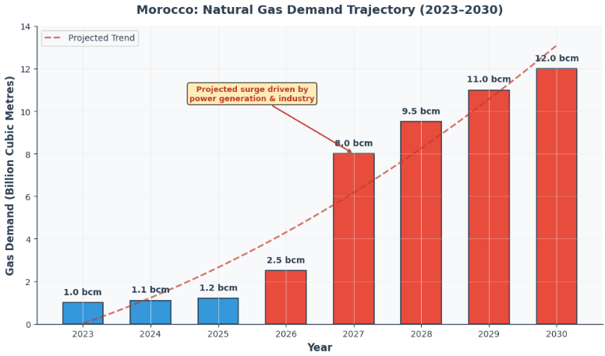
Figure 1 Morocco Natural Gas Demand Trajectory

Risk Assessment
- Financing risk
The Atlantic Pipeline's greatest vulnerability is capital. At an estimated US$26 billion with no financial institution yet committed, the project depends on a multilateral and export-credit package (World Bank, US Exim Bank) coming together on a timeline consistent with a 2031 first-gas target. Cost estimates have already risen once, from US$25 billion to roughly US$26 billion, a pattern common to megaprojects of this scale and duration.
- Execution and coordination risk
A 13-country, 6,900 km corridor multiplies permitting, right-of-way, security, and coordination risk relative to a bilateral pipeline. Political commitments (the ECOWAS intergovernmental agreement, MoUs) are necessary but not sufficient; commercial supply and offtake agreements, environmental approvals, and construction contracts must all still be finalized.
- Competitive risk from the Trans-Saharan Pipeline
Because both the Atlantic Pipeline and the TSGP compete for the same underlying Nigerian gas supply and, to some extent, the same European buyers, only one or neither at full design capacity may prove commercially viable. Algeria's construction head start on its own territory is a meaningful signal, though it does not resolve the harder cross-border sections in Niger and along the West African coast.
- Domestic demand-sizing risk
The Nador West Med suspension illustrates a broader risk. Morocco's infrastructure ambitions have periodically outpaced realistic near-term demand (a proposed 5 bcm/year terminal against approximately 1 bcm/year of consumption). Future large commitments, LNG terminals, pipeline connections will need to be sized more conservatively or explicitly justified by export/re-export ambitions rather than domestic use alone.
- Geopolitical dependency risk
Morocco's interim gas supply is now hostage to the durability of its partnership with Spain and to global LNG spot prices, both of which are exposed to swings in political relations or international energy markets outside Rabat's control. The Western Sahara dispute remains the single most consequential variable capable of disrupting relationships with Algeria, Spain, the EU, and West African transit states simultaneously.

Conclusion
Morocco’s gas market presents a significant investment opportunity between 2026 and 2028, particularly as the Nador project is re-tendered and the AAGP agreement progresses. The strongest opportunities are likely to be in midstream infrastructure such as pipelines, storage and regasification, while future hydrogen integration could extend the value of these assets beyond 2040. For policymakers, the priority should be rapid project delivery, greater competition through unbundling the Nador terminal, and securing long-term European transit agreements to support project financing. Overall, Morocco is evolving into an increasingly important Atlantic and Mediterranean gas hub, with the potential by 2035 to influence regional gas flows, pricing and West African gas market economics.

