Morocco’s Gas Transition: Infrastructure Shifts, Corporate Restructuring, and Micro-LNG

EXECUTIVE SUMMARY
Morocco's natural gas strategy is undergoing its most consequential transformation in two decades. Following Algeria's 2021 suspension of direct gas flows through the Maghreb-Europe Gas (MEG) Pipeline, the country has pivoted from a single-source import model to a multi-pronged architecture combining domestic micro-LNG production, large-scale import terminals, and continental pipeline integration. Three structural forces are reshaping the landscape simultaneously:
- A recalibration of infrastructure priorities, including the January 2026 suspension of the Nador West Med LNG terminal tender
- The June 2026 corporate restructuring of ONHYM from a public establishment to a joint-stock company, unlocking new capital-raising capabilities
- The imminent commissioning of the Tendrara micro-LNG plant.
Underpinning all three is a common thread: Morocco is moving away from capital-intensive, single-point infrastructure bets and toward a modular, phased, and increasingly commercially-driven model. The clearest expression of this is the emergence of micro-LNG as a bridging technology, small-scale liquefaction and containerized distribution that lets domestic gas (and imported US LNG under a newly approved Free Trade Agreement channel) reach industrial consumers years ahead of any pipeline or terminal completion.
For investors and counterparties, the practical implication is a broader but shallower opportunity set. The value chain now spans storage, small-scale regasification, ISO-tank logistics, upstream consolidation, and a re-capitalized national oil and gas agency preparing to co-invest in continental pipeline infrastructure.

Demand Overview
Morocco imports roughly 90% of its energy needs and has run persistent power-sector strain since Algeria halted gas transit through the Maghreb-Europe pipeline (GME) in 2021. Since 2022, Morocco has kept two gas-fired plants alive via reverse-flow imports of Spanish-sourced LNG through the GME. Ministry projections have long pointed to gas demand rising sharply this decade, but the scale of that rise, and its timing, remain the central point of contention.
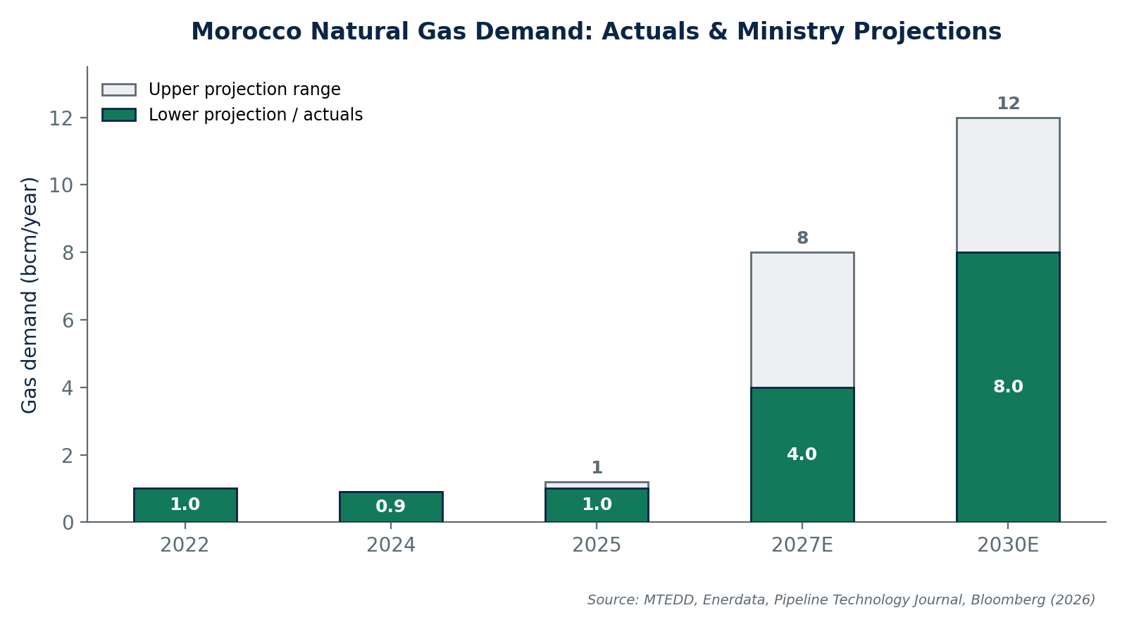
Figure 1 Morocco Gas Demand
The Nador West Med terminal was designed for roughly five times current national demand, intended to anchor a pipeline network linking Nador to the industrial corridors of Kenitra and Mohammedia. Ministry officials, including ONHYM chief executive Amina Benkhadra, have characterized the January 2026 tender suspension as a strategic reset from a single capital-intensive anchor project toward smaller, phased, and commercially calibrated infrastructure that can scale with actual demand growth and complement an electricity system targeting 52% renewables by 2030.
That reset is also a response to global market conditions. Large LNG capacity additions from the United States, Qatar's North Field expansion, and Mozambique's Coral FLNG and related onshore projects have pushed global LNG markets toward oversupply, improving spot pricing for importers but weakening the long-term investment case for fixed, large-scale receiving infrastructure, particularly for a market the size of Morocco's.

Domestic Infrastructure
The Nador West Med Reset
Morocco launched tenders for the Nador West Med floating storage and regasification unit (FSRU) in December 2025, only to suspend the process in January 2026, one of the fastest tender reversals in the country's recent energy-infrastructure history. The Ministry of Energy Transition and Sustainable Development cited 'new parameters and assumptions' underpinning what it still calls a 'highly strategic' venture, leaving the door open to relaunch in due course, but with a different structure and likely smaller initial scale.
The port itself remains on track: Nador West Med is scheduled to become operational in the second half of 2026, offering 800 hectares of industrial development space in its initial phase, expandable toward 5,000 hectares over time. LNG terminal infrastructure if and when relaunched, would piggyback on this broader port buildout rather than lead it.

The Three-Phase Gas Roadmap
Morocco's Natural Gas Roadmap (2021–2050), updated in May 2024, structures infrastructure deployment across three phases:

Phase | Period | Key infrastructure | Objective
Phase 1 | 2025-2027 | 2027 Nador West Med LNG terminal; MEG pipeline tie-ins to Tendrara; CCGT power plant; pipeline connections to Kenitra & Mohammedia | Establish import capacity and domestic production anchor
Phase 2 | 2028-2032 | Atlantic Coast LNG terminal; Dakhla Atlantic LNG terminal; expanded national gas network | Diversify supply sources and geographic coverage
Phase 3 | 2033-2050 | Africa-Atlantic Gas Pipeline (Nigeria–Morocco); connections to Mauritania & Senegal; green hydrogen synergies | Regional integration and energy hub positioning

Corporate Developments
Beyond Tendrara, the broader signal is consolidation of strategic gas assets under Moroccan corporate control. Managem the country's dominant diversified mining group, now controls the operating and majority equity position in Tendrara, while ONHYM's stake and its new joint-stock structure position the state to co-invest in both domestic assets and the continental pipeline project without the legal constraints of its former public-establishment status.

Date | Party | Development
June 2024 | Sound Energy → Mana Energy | Farm-out of 55% operating interest in Tendrara
May 2026 | Sound Energy → Managem | Sale of remaining 20% (via SEML) for $57m; exit from Anoual/Grand Tendrara permits
May 2026 | Sound Energy | Shares fall ~33%; company to retire €28.8m senior secured notes
May 2026 | Sound Energy | Noteholder consent solicitation; meeting scheduled 18 Jun 2026
May 2026 | US DOE → Navergy Infrastructure Partners | FTA approval for up to 51.75 bcf/year LNG exports incl. to Morocco
June 2027 | ONHYM | Formal conversion to ONHYM-SA (Law 56.24, royal decree)

The Micro-LNG Transition
Micro-LNG is the operational core of Morocco's near-term gas strategy, and Tendrara Phase 1 is its proof of concept. Rather than waiting for pipeline connectivity to the national grid, the project liquefies gas produced from wells TE-6 and TE-7 on-site and distributes it to industrial customers via road transport, bypassing the need for immediate large-scale midstream infrastructure.
The commercial anchor is a 10-year gas supply agreement with Afriquia Gaz, one of Morocco's major energy distributors, providing revenue predictability for a project with roughly 100 million cubic metres/year of Phase 1 capacity. First gas entered the gathering system in December 2025, with liquefaction and storage infrastructure in advanced commissioning through mid-2026 and first commercial sales targeted for the third quarter of 2026.
A parallel channel is emerging on the import side: in May 2026, the US Department of Energy authorized Navergy Infrastructure Partners to export LNG to FTA partners including Morocco, using a logistics model built on containerized LNG moved from existing US liquefaction and storage sites by road or barge to port, then shipped via container vessel. Combined with the Middle East Institute's case for ISO-tank LNG distributed through existing Moroccan port and logistics infrastructure, this reinforces micro-scale and containerized LNG — not a single FSRU — as the dominant near-term supply architecture.

Key Risks

Risk Category | Specific Risk
Financing | Global LNG price volatility and high interest rates may delay Nador terminal FID
Execution | Tendrara Phase 2 FID contingent on FEED update and EPC contractor selection
Geopolitical | Algeria-Spain-Morocco tensions could disrupt MEG reverse flows
Exploration | 2025 slowdown in licensing and drilling activity
Corporate | Sound Energy's tight balance sheet (£2.1m cash as of Aug 2025)
Regional | AAGP financing ($25B) and 13-country coordination complexity

Outlook and Strategic Implications
- The Nador West Med reset broadens the investable opportunity set, expect future tenders (if relaunched) to be smaller, phased, and more commercially structured, alongside parallel openings in storage, small-scale regasification, and downstream industrial gas supply.
- Managem's consolidation of Tendrara signals that Morocco's most bankable onshore gas asset is now controlled by a well-capitalized domestic group with mining-sector balance-sheet strength, a materially different counterparty profile than a junior AIM-listed operator.
- ONHYM-SA's new financing powers, and the broader 50-entity conversion program, point toward a multi-year pipeline of Moroccan state-enterprise capital-markets activity worth tracking beyond the energy sector alone.

