Integrated Gas Processing and Liquids Recovery from Offshore Associated Gas in Equatorial Guinea

Executive Summary
Equatorial Guinea’s highest-value configuration is not an LNG-only strategy. The superior configuration is an integrated brownfield system that keeps offshore facilities as simple as practical—three-phase separation, primary liquids handling, export compression and hydrate-managed wet-gas transport—while pushing deeper conditioning, LPG/NGL extraction and LNG feed conditioning into Punta Europa. That architecture preserves offshore uptime, maximises recovery of propane, butanes and pentanes+, and uses the large sunk-cost base already present on Bioko Island.
- Alen already validated the core engineering model: offshore condensate production, gas export through a dedicated 70 km line and onshore processing through existing Punta Europa assets.
- Aseng, following FID in 2026, strengthens the same logic but adds a second layer of brownfield leverage by first tying into Alen and then into Punta Europa rather than building a standalone offshore processing chain.
- The key optimisation question is not whether Punta Europa can take more gas in principle—it can—but whether the system adds a dedicated cryogenic/NGL recovery and fractionation package ahead of LNG to lift total hydrocarbon value per unit of feed gas.
- On an illustrative 250 MMscfd wet-gas case, an integrated LPG/NGL-plus-LNG route raises gross annual value by about US$115 million versus an LNG-only route, even after sacrificing a modest amount of LNG feed volume.
- The most likely bottleneck is not export line capacity: the reported Alen line capacity of roughly 950 MMscfd is well above currently visible load. The tighter constraints are LNG-train feed envelope, front-end treating flexibility, and whether a high-recovery NGL train and fractionation package is added.

1. Offshore associated-gas resource base

The resource base relevant to the gas monetisation system is a blend of producing gas-condensate fields, associated-gas oil developments and future tie-back candidates. Public data quality is uneven, so the correct engineering distinction is: reserves or recoverable resources are not the same as expected production, and expected production is not the same as gas available for monetisation. Gas available for monetisation is what remains after reservoir-management requirements, fuel gas, operational shrinkage, and platform handling constraints.
Field | Operator / ownership context | Gas type | Associated gas / resource position | Production status | Monetisation route
Alba | Marathon / ConocoPhillips-led; Chevron non-op interest | Gas-condensate anchor supply | Historically 600–700 MMscfd supplied to EG LNG system; 4.6 Tcf legacy resource often cited in industry sources | Producing | Alba Plant -> LPG / condensate removal -> dry gas to EG LNG and AMPCO
Alen | Chevron / Noble Energy EG | Liquids-rich gas-condensate | Reported gross recoverable resource ~600 Bcfe; start-up gas sales 200–300 MMcfe/d gross | Producing gas to shore since 2021 | Alen platform -> 70 km export line -> Alba Plant / EG LNG; condensate continues offshore via Aseng FPSO route
Aseng | Chevron / Noble Energy EG with GEPetrol, Gunvor, Glencore | Associated gas from oil field | Reported monetisation target ~550 Bcf; gas historically reinjected for pressure support | Oil producing; gas monetisation FID reached 2026 | Aseng tie-back -> Alen platform -> Punta Europa -> LNG / liquids
Yolanda / Yoyo | Chevron companies in EG and Cameroon | Cross-border gas discovery | Reported unitised resource ~2.5 Tcf | Not yet producing | Expected future tie-back through Alen / Punta Europa concept, subject to project definition
EG-08 and nearby domestic tie-back candidates | Antler / Fuhai / GEPetrol and other nearby acreage holders | Prospective gas-condensate | Prospective resources only; not yet reserves; EG-08 prospects quoted at 2.213 TCFE mean by operator materials | Pre-development | Most plausible route is subsea or minimal-platform tie-back to Alen / Aseng infrastructure

Engineering reading of the resource base: Alba is not associated gas, but it is the anchor process train that makes associated-gas monetisation economic. Alen is the proof-of-concept brownfield hub. Aseng is the most immediate incremental associated-gas source. Yoyo-Yolanda and nearby discoveries are follow-on feedstock that make the same infrastructure more valuable over time.
Gas currently flared at field level is not consistently disclosed in current public sources. The World Bank’s 2025 flaring tracker does not list Equatorial Guinea among the top 30 flaring countries, so the engineering case is less about eliminating giant national flare volumes than about preventing stranded associated gas from remaining in reinjection, low-value use, or intermittent offshore disposal modes.

2. Offshore gas gathering and separation
For Equatorial Guinea’s offshore developments the offshore design philosophy should be minimum-complexity, maximum-exportability. The first separation duty is conventional three-phase separation: oil or condensate, gas and free water. Produced water knock-out offshore is important not only for export quality but because reducing liquid water carry-under lowers hydrate inhibitor demand and cuts corrosion risk in export service. Once bulk free water is removed, the gas stream should be compressed only to the pressure necessary for export and brownfield interface conditions, not conditioned deeply offshore unless required by metallurgy or line design.
- Three-phase separation stabilises oil/condensate handling and keeps the gas-export line from becoming a slugging or water-accumulation problem.
- Export compression should be sized against end-of-life suction pressure and not just start-up cases; deepwater tie-backs suffer if compressor turndown and anti-surge controls are weak.
- If wet gas is exported, offshore dehydration can often be limited to line-protection strategy plus inhibitor management rather than a full TEG package; the economic trade-off depends on line temperature, water depth and arrival pressure.
- Condensate handling must remain segregated from the gas monetisation route where practical. Alen is instructive because primary condensate continued offshore while gas was exported to Punta Europa.
- Hydrate management is a first-order issue. Deepwater segments, shut-in / restart behaviour, and arrival temperatures all favour a conservative MEG or methanol strategy with robust restart procedures.
The Alen configuration is the right case study. Existing facilities on the platform required only minor modification to export gas; the economic rationale was to avoid re-creating onshore functionality offshore. That principle should be retained for Aseng and future tie-backs: offshore should separate, compress, meter and protect flow assurance; onshore should sweeten, dehydrate deeply, recover liquids and deliver LNG-spec gas.

3. Gas transportation to Punta Europa
The transport system to Punta Europa is the hinge between offshore monetisation and onshore value capture. Alen demonstrated a full-field export concept with a dedicated 70 km gas line rated at approximately 950 MMscfd. That is materially larger than the field’s initial gross sales rate of 200–300 MMcfe/d, meaning the line was intentionally oversized to function as hub infrastructure rather than a single-field trunk. This is strategically important: spare line capacity is what makes second-generation tie-backs economic.
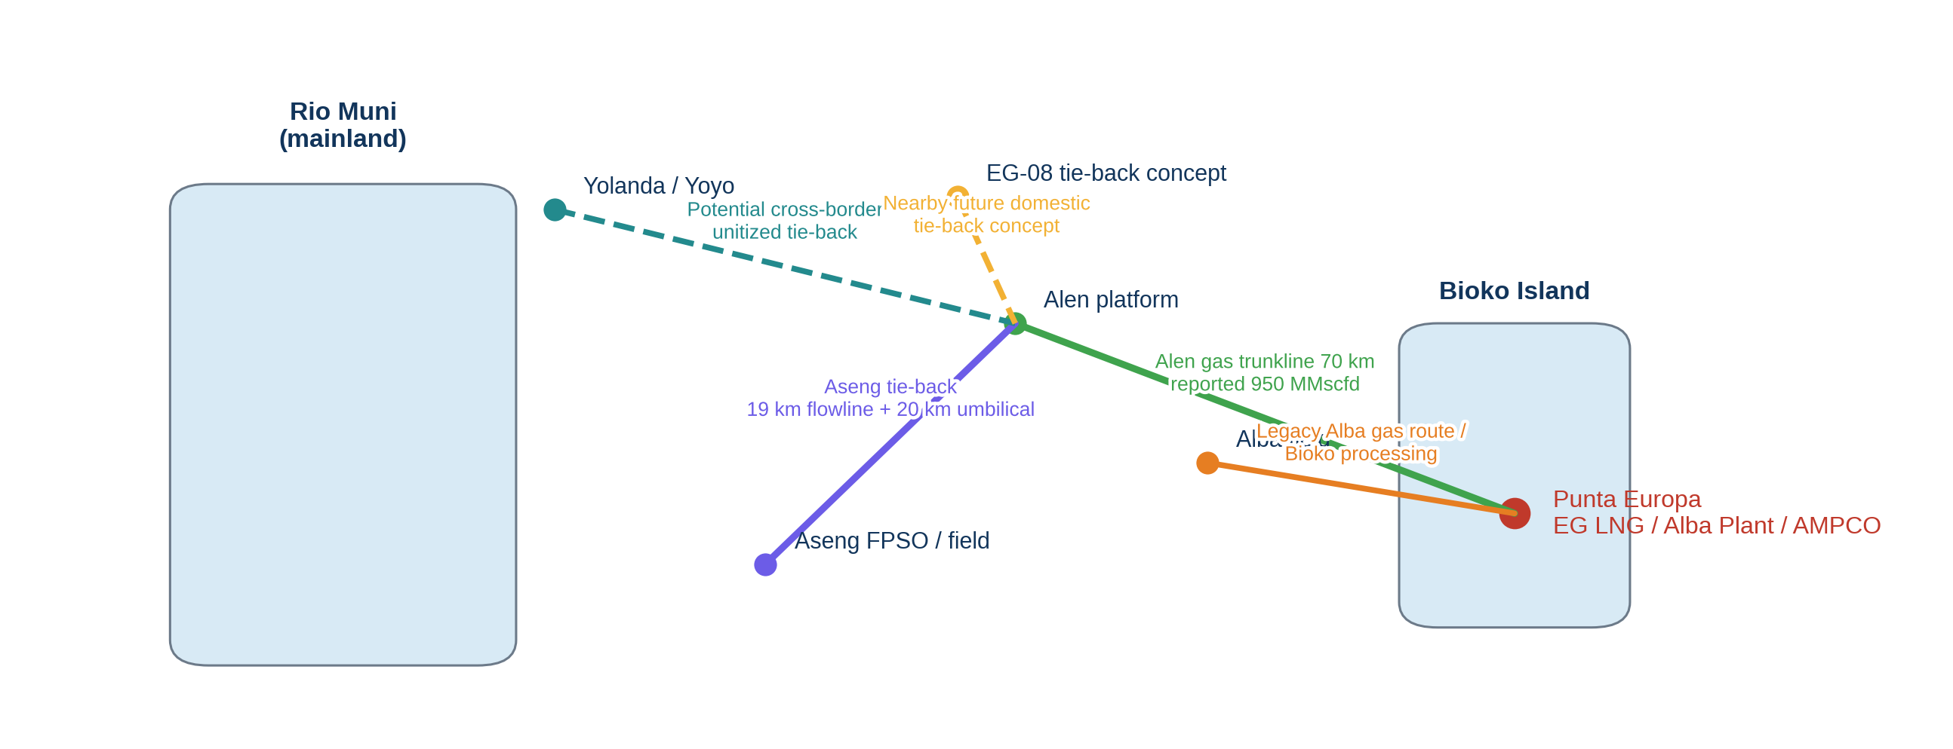
Figure 1. Offshore-to-Punta Europa infrastructure schematic

Aseng’s 2026 development concept deepens that hub logic. Subsea7 disclosed a single-well tie-back from Aseng to the existing Alen platform using about 19 km of rigid production flowline and 20 km of umbilicals in ~800 m water depth. The implication is clear: Aseng avoids a standalone gas-export route to shore and instead plugs into the Alen hub, which then reuses the already-installed Alen-Punta Europa trunkline and Punta Europa processing assets.
Transporting wet gas rather than fully conditioned dry gas lowers offshore CAPEX but shifts risk into the pipeline system. The controlling transport issues are hydrate formation, low-point water collection, internal corrosion and restart philosophy. For Equatorial Guinea’s offshore temperatures and deepwater segments, the pipeline operating philosophy should include: continuous or batch inhibition capability, corrosion-resistant or inhibitor-compatible metallurgy selection, piggability where line geometry permits, and strong integrity surveillance for water holdup, pressure cycling and external coating condition.
Economically, tie-backs dominate standalone offshore processing when spare onshore capacity exists. The brownfield advantage is strongest where: the trunkline already exists; onshore utilities, tanks, loading and export berths are sunk; and the incremental project is limited to subsea tie-in, metering, compression, brownfield modifications and commercial integration. Alen’s US$330 million capex and Aseng’s US$690 million capex are best interpreted in exactly this framework: relatively modest against the replacement value of a greenfield offshore processing plus export chain.

4. Gas treatment and processing at Punta Europa
Punta Europa is where the real margin is created. Once the offshore stream reaches shore, the processing hierarchy should be: inlet separation and slug handling, acid-gas removal if needed, dehydration, hydrocarbon dew-point control / NGL recovery, fractionation, residual-gas compression and LNG feed conditioning. The treatment sequence matters. If heavy hydrocarbon management is done too lightly, LNG feed stability and exchanger protection suffer. If it is done too aggressively without fractionation and storage, value is left stranded in mixed liquids.
- Dehydration: TEG is appropriate for bulk water removal upstream of compression and many onshore gas paths; molecular sieve service is reserved for the very low water specification required ahead of cryogenic liquefaction.
- Acid-gas removal: where CO₂ or H₂S levels are above LNG feed specification, a conventional amine package is the first choice. Even if CO₂ is modest, future tie-back variability argues for sweetening flexibility, not a single-composition design.
- Hydrocarbon management: the system needs more than basic condensate knock-out. High-value operation requires controlled dew-point management so that C₃/C₄/C₅+ are recovered intentionally rather than appearing as unstable mixed liquids or being carried into LNG feed.
- Gas conditioning: compression, metering and heating-value control must align with destination. LNG, domestic gas and industrial feed do not all require the same Wobbe index or dew point.
The attraction of Punta Europa is that it already contains the basic industrial ecosystem: the Alba Plant / LPG extraction chain, the EG LNG train, storage and loading infrastructure, and methanol-related gas handling history. The key technical question is therefore not whether gas can be treated at all, but whether the front end is debottlenecked and reconfigured to process more variable third-party wet gas while increasing discrete LPG/NGL recovery rather than simply passing value into LNG feed.

5. NGL recovery potential
NGL recovery should be treated as a core value driver, not a side stream. Public sources do not provide a complete field-by-field gas composition set for Alen or Aseng, so exact field yields cannot be claimed. However, engineering decisions can still be framed correctly. Liquids-rich associated gas in this part of the Gulf of Guinea is best processed through a cryogenic scheme if the objective is to maximise propane and butane recovery while delivering a stable LNG feed. A turbo-expander process with upstream treating and downstream fractionation is the preferred high-recovery option. Joule-Thomson expansion and simple refrigeration can work for modest dew-point control, but they generally leave LPG value on the table relative to a deeper cryogenic cut.
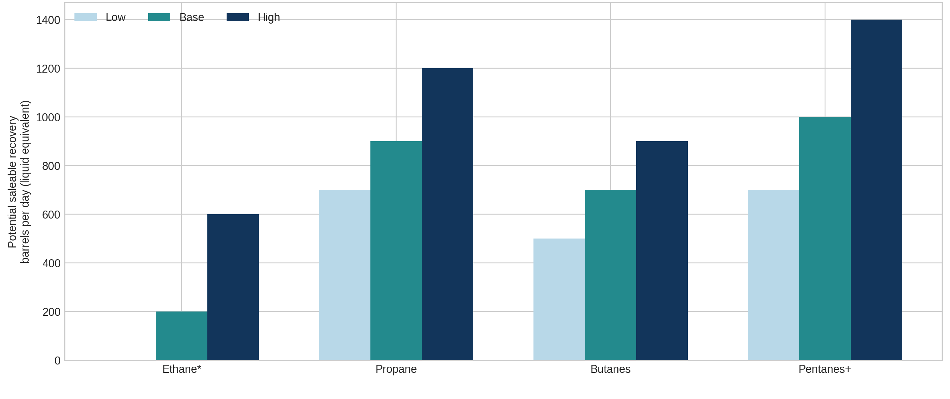
Figure 2. Benchmark NGL recovery envelope for a representative wet-gas stream
The ethane question is strategic. If there is no ethane outlet—no cracker, no dedicated export value chain—then Equatorial Guinea should avoid over-investing for maximum ethane extraction. In that case the preferred design is a “C₃+ value-max” mode: recover propane, butanes and pentanes+, reject most ethane into LNG where it supports calorific value and overall liquefaction economics, and retain enough operating flexibility to deepen or relax the cut if future markets appear.
Representative conclusion: for future third-party wet-gas campaigns, the highest-confidence value lies in recoverable LPG and pentanes+, not in stand-alone ethane sales. The process package should therefore be designed around turbo-expander NGL recovery, deethanizer flexibility, depropanizer / debutanizer fractionation and sufficient storage / loading capacity to actually monetise the recovered liquids.

6. LPG production and fractionation
If Punta Europa adds higher-recovery front-end extraction, LPG becomes a deliberate product rather than an incidental one. Propane and butane must then be separated in a dedicated fractionation train or at least into marketable mixed-LPG specification with proper vapour pressure control, storage bullets or mounded storage, and loading capability. This is one of the clearest reasons not to send all processed gas straight to LNG: the LPG margin can be structurally superior on a per-unit-of-gas basis when wet-gas composition is favourable and the LNG train is not the constraining asset.
The domestic LPG market in Equatorial Guinea is small relative to export potential, so the project should be configured around a dual outlet: domestic offtake for clean cooking / distribution security and export capability for volume clearance. That dual-outlet design also reduces one of the biggest monetisation risks in small domestic markets—forced discounting during oversupply. LPG recovery only creates value if storage, trucking / bottling interface or marine loading can absorb it reliably.
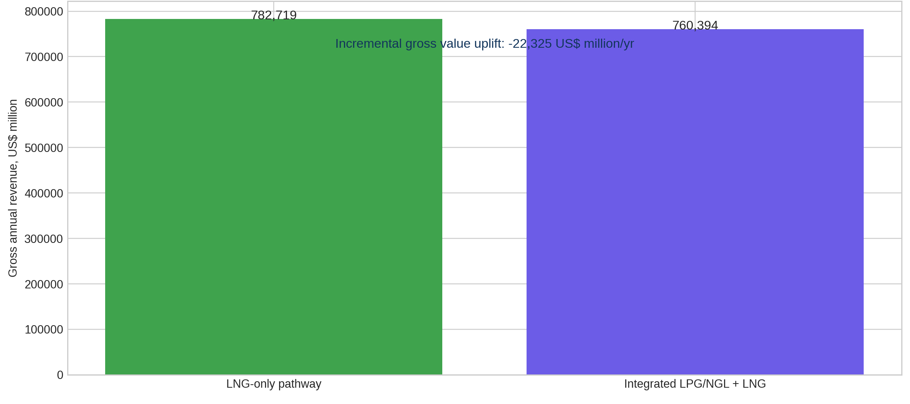
Figure 3. Illustrative revenue impact of adding LPG/NGL recovery before LNG
Technically, the comparison is straightforward. LNG-only maximises dry-gas volume but sacrifices discrete liquid recovery. Integrated LPG/NGL + LNG reduces LNG feed somewhat but creates additional saleable barrels and usually improves LNG feed consistency by removing heavier hydrocarbons that otherwise complicate front-end control. For wet associated gas, that integrated pathway is the preferred value-maximising configuration.

7. Integrated LNG and liquids monetisation model
A simplified representative mass balance has been developed for a 250 MMscfd wet-gas stream. This is not claimed as a field-specific composition model; it is a benchmark case designed to compare process configurations consistently. The integrated case yields roughly 237 MMscfd dry gas to LNG, around 1,375 bpd of LPG and about 625 bpd of pentanes+/condensate, after normal treatment shrinkage and fuel use. The LNG-only case pushes about 244 MMscfd toward liquefaction but leaves more value embedded in the gas path.
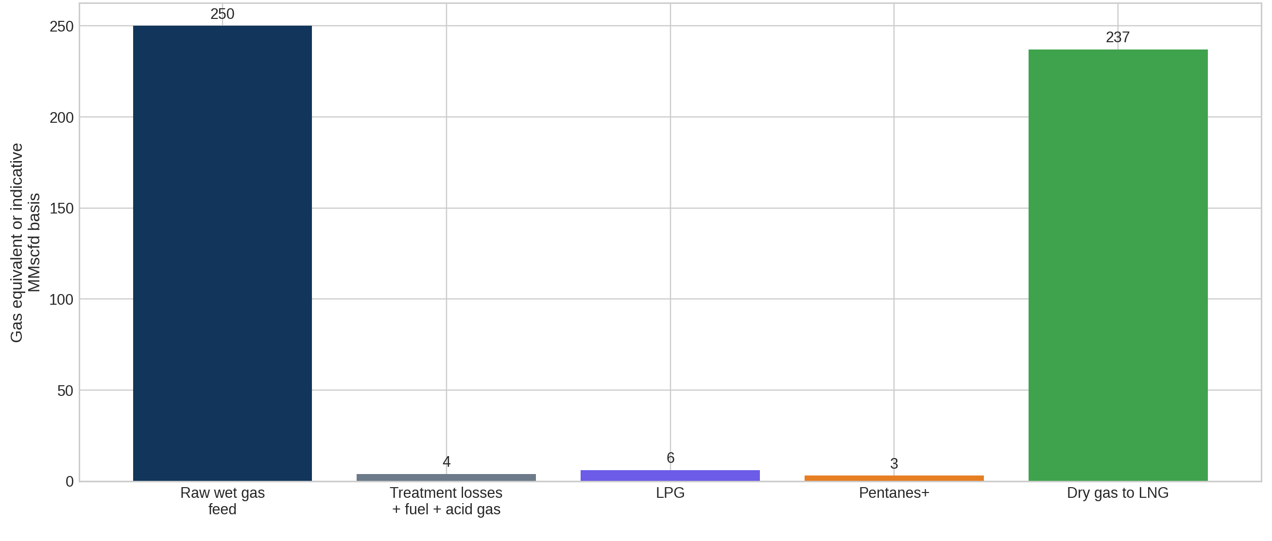
Figure 4. Representative integrated gas mass balance

Model item | Value | Classification
Wet gas feed | 250 MMscfd | Benchmark representative field case
Dry gas to LNG (integrated case) | 237 MMscfd | After treatment and liquids extraction
Dry gas to LNG (LNG-only case) | 244 MMscfd | Higher LNG volume, lower liquids recovery
Saleable LPG | 1,375 bpd | Analyst benchmark assumption
Pentanes+ / condensate | 625 bpd | Analyst benchmark assumption
Illustrative LNG output (integrated) | c. 1.78 mtpa | Using ~133 MMscfd per mtpa equivalent
Illustrative LNG output (LNG-only) | c. 1.83 mtpa | Same conversion basis

The engineering message is more important than the absolute numbers. If the wet gas is sent almost directly toward LNG after minimum conditioning, more tonnes are preserved but less total hydrocarbon value is extracted. If the stream is routed through dedicated NGL/LPG recovery, some gas volume is lost to liquids yet total project value rises. That is the right optimisation lens for Equatorial Guinea.

8. Existing Punta Europa processing infrastructure
Punta Europa already possesses the single most valuable asset in the country’s gas value chain: sunk infrastructure. Reported public data indicate one operating LNG train of 3.7 mtpa, equivalent to roughly 530 MMscfd of feed-gas demand, two insulated storage tanks of 136,000 m³ each, tanker berthing up to 160,000 m³, an Alba LPG plant whose nameplate capacity was expanded historically to about 67,000 bpd, and a methanol plant of about 1.1 mtpa. This is a major industrial park, not a single train in isolation.
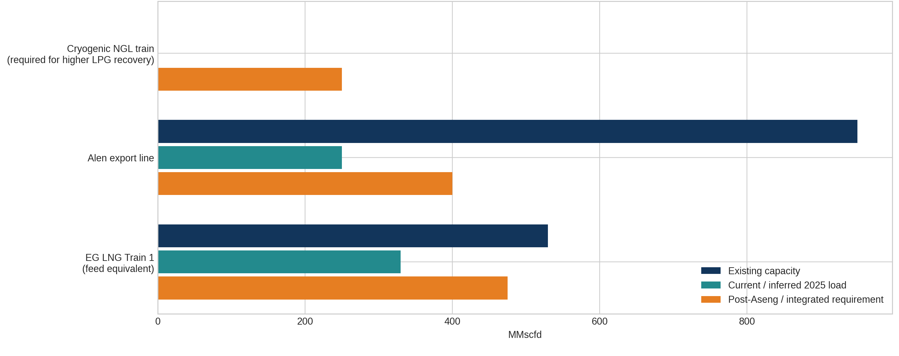
Figure 5. Capacity, utilisation and additional processing requirement

Asset | Reported capacity | Current utilisation | Technical comment
EG LNG Train 1 | 3.7 mtpa (~530 MMscfd eq.) | Current throughput not publicly stated in one consistent 2025 source; supply constraints have been discussed publicly | Likely can absorb further gas if treated and scheduled correctly, but feed variability and front-end conditioning become critical
Alen-Punta Europa gas line | 950 MMscfd | Current load materially below line nameplate based on public project volumes | Substantial spare export capacity remains for hub use
Alba Plant / LPG extraction assets | 67,000 bpd legacy nameplate cited by USGS | Exact 2025 utilisation not publicly disclosed | Likely requires debottlenecking / revamp if higher-spec discrete LPG recovery is targeted
Storage and loading | Existing LNG storage and marine berth; LPG specifics less fully disclosed | Operational | Adequacy depends on chosen LPG export concept
The likely bottlenecks are: inlet handling for more variable third-party gas, flexibility of sweetening and dehydration, high-recovery NGL extraction capacity, and downstream fractionation / storage rather than pure trunkline export. In short, Punta Europa has enough sunk infrastructure to justify brownfield expansion, but not enough publicly disclosed spare specialised NGL capacity to assume that “existing facilities alone” are sufficient for maximum liquids recovery.

9. Alen as the technical case study
Alen is the successful template. The field had already been producing condensate since 2013 while gas was reinjected. The monetisation project then converted the asset from a liquids-only / reinjection mode into a regional gas hub node by installing a 70 km export line to Punta Europa while keeping primary condensate production offshore. Public disclosures point to roughly 600 Bcfe recoverable resources, 200–300 MMcfe/d initial gas sales and around US$330 million of development capex.
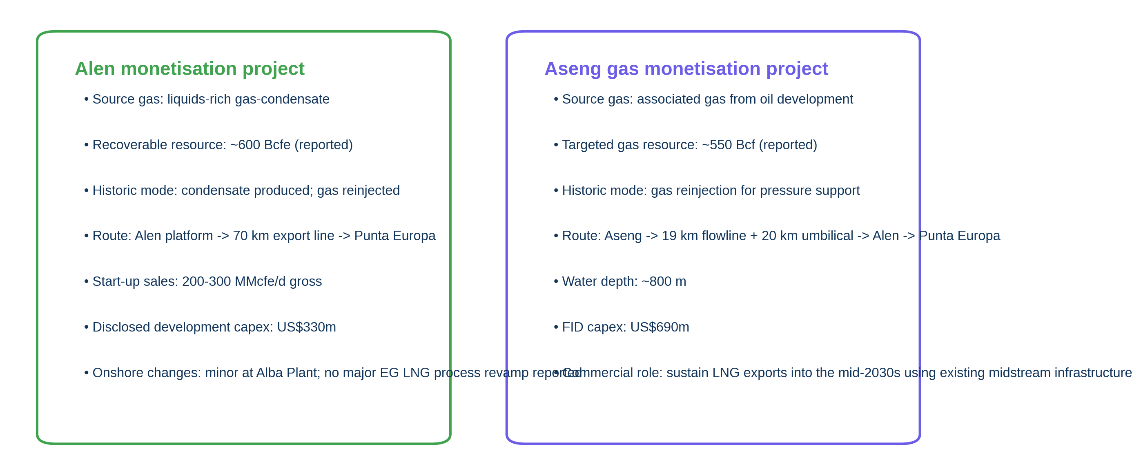
Figure 7. Alen versus Aseng technical configuration
The key technical lessons from Alen are straightforward: oversize the gas-export route so it can become hub infrastructure; keep offshore modifications light; avoid major onshore liquefaction changes if the gas can be blended and treated within existing envelopes; and use commercial structures such as tolling plus profit-sharing to align the field owner with the infrastructure owner. Alen is therefore less a one-off field development than a repeatable system architecture.

10. Aseng gas monetisation after 2026 FID
Aseng differs from Alen because it starts from an oil-field associated-gas position rather than a gas-condensate export position. Historically, gas supported reservoir management through reinjection. The 2026 FID shifts Aseng into monetisation mode by using a single-well tie-back to Alen rather than a new standalone route to shore. Public disclosures identify about 550 Bcf of gas targeted for monetisation and an initial capex of around US$690 million, with the field connected through ~19 km of rigid production flowline and ~20 km of umbilicals in ~800 m water depth.
Technically, that makes Aseng the third phase of the Gas Mega Hub rather than an isolated project. It consumes some of the spare capacity intentionally embedded in Alen’s trunkline design, reinforces the value of Punta Europa, and should extend LNG feed availability into the mid-2030s. Compared with Alen, Aseng is more subsea- and interface-intensive, more reliant on Alen as an intermediate host, and therefore slightly more exposed to hub-availability risk—but it also benefits from deeper brownfield leverage.

11. Configuration comparison
Configuration | Gas recovery | NGL/LPG recovery | LNG feed | CAPEX | Complexity | Engineering judgement
Gas-to-LNG only | High | Low to moderate | Maximum | Low–medium | Low | Best only where gas is relatively lean and liquids value is low
Gas + NGL recovery | High | Moderate | High | Medium | Medium | Useful for dew-point control and condensate capture
Gas + LPG recovery + LNG | High | High | High but slightly reduced | Medium–high | Medium–high | Best value-max route for wet associated gas with brownfield LNG
Full deep liquids extraction | High | Very high | Lower | High | High | Only justified if a robust liquids / ethane market exists

For Equatorial Guinea, the best practical answer is the third row: gas + LPG recovery + LNG. It balances monetisation breadth against brownfield complexity. Full deep-cut liquids extraction is harder to justify without a separate ethane outlet and could create unnecessary logistics burden.

12. Technical and economic optimisation
The optimum is reached where marginal LPG/NGL recovery value exceeds the marginal loss in LNG value plus added capital and operating cost. Because Punta Europa is already a sunk LNG site, the incremental brownfield NGL package does not carry greenfield liquefaction risk. That shifts the break-even in favour of liquids recovery. Operationally, the best optimisation levers are: maximise field uptime; preserve pressure with minimal offshore processing complexity; design the onshore front end for composition variability; recover C₃/C₄ aggressively; treat ethane as optional; and keep pipeline and LNG train utilisation high enough to absorb fixed costs.
On the representative 250 MMscfd case, the integrated route lifts gross annual value from about US$782,719 million to about US$760,394 million. That is why the strategic objective should be total hydrocarbon value rather than simple LNG throughput maximisation.

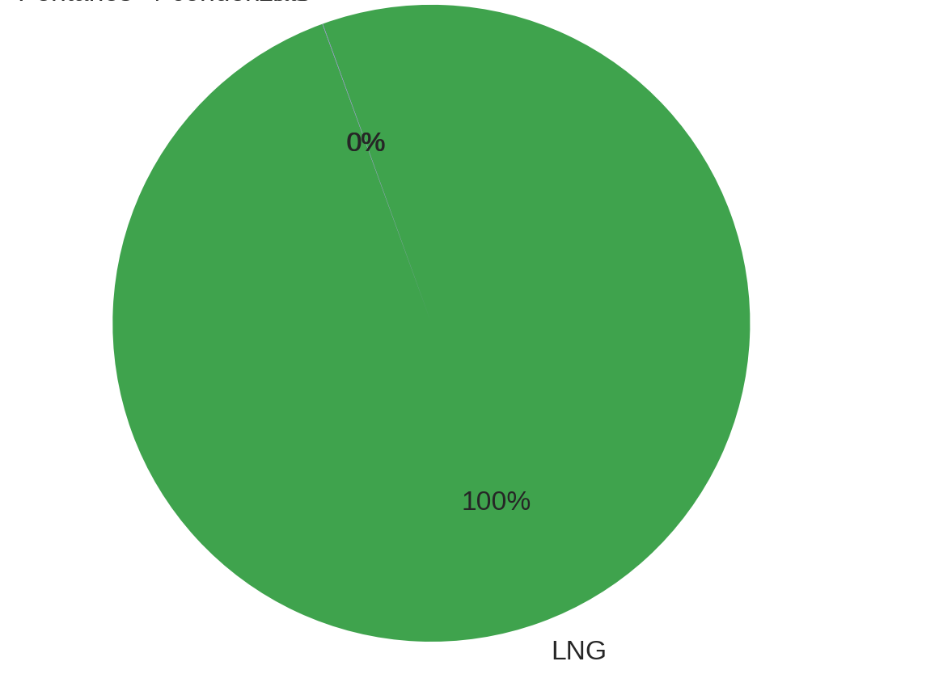
Figure 9. Product value distribution in the integrated monetisation case

13. Project economics
Public sources disclose total project capex for Alen and Aseng but not the package-level cost breakdown needed for detailed economic modelling. Accordingly, the economics below are explicitly scenario-based. The purpose is not to claim project sanction economics, but to test whether adding a brownfield cryogenic/NGL and LPG fractionation package is likely to create value.
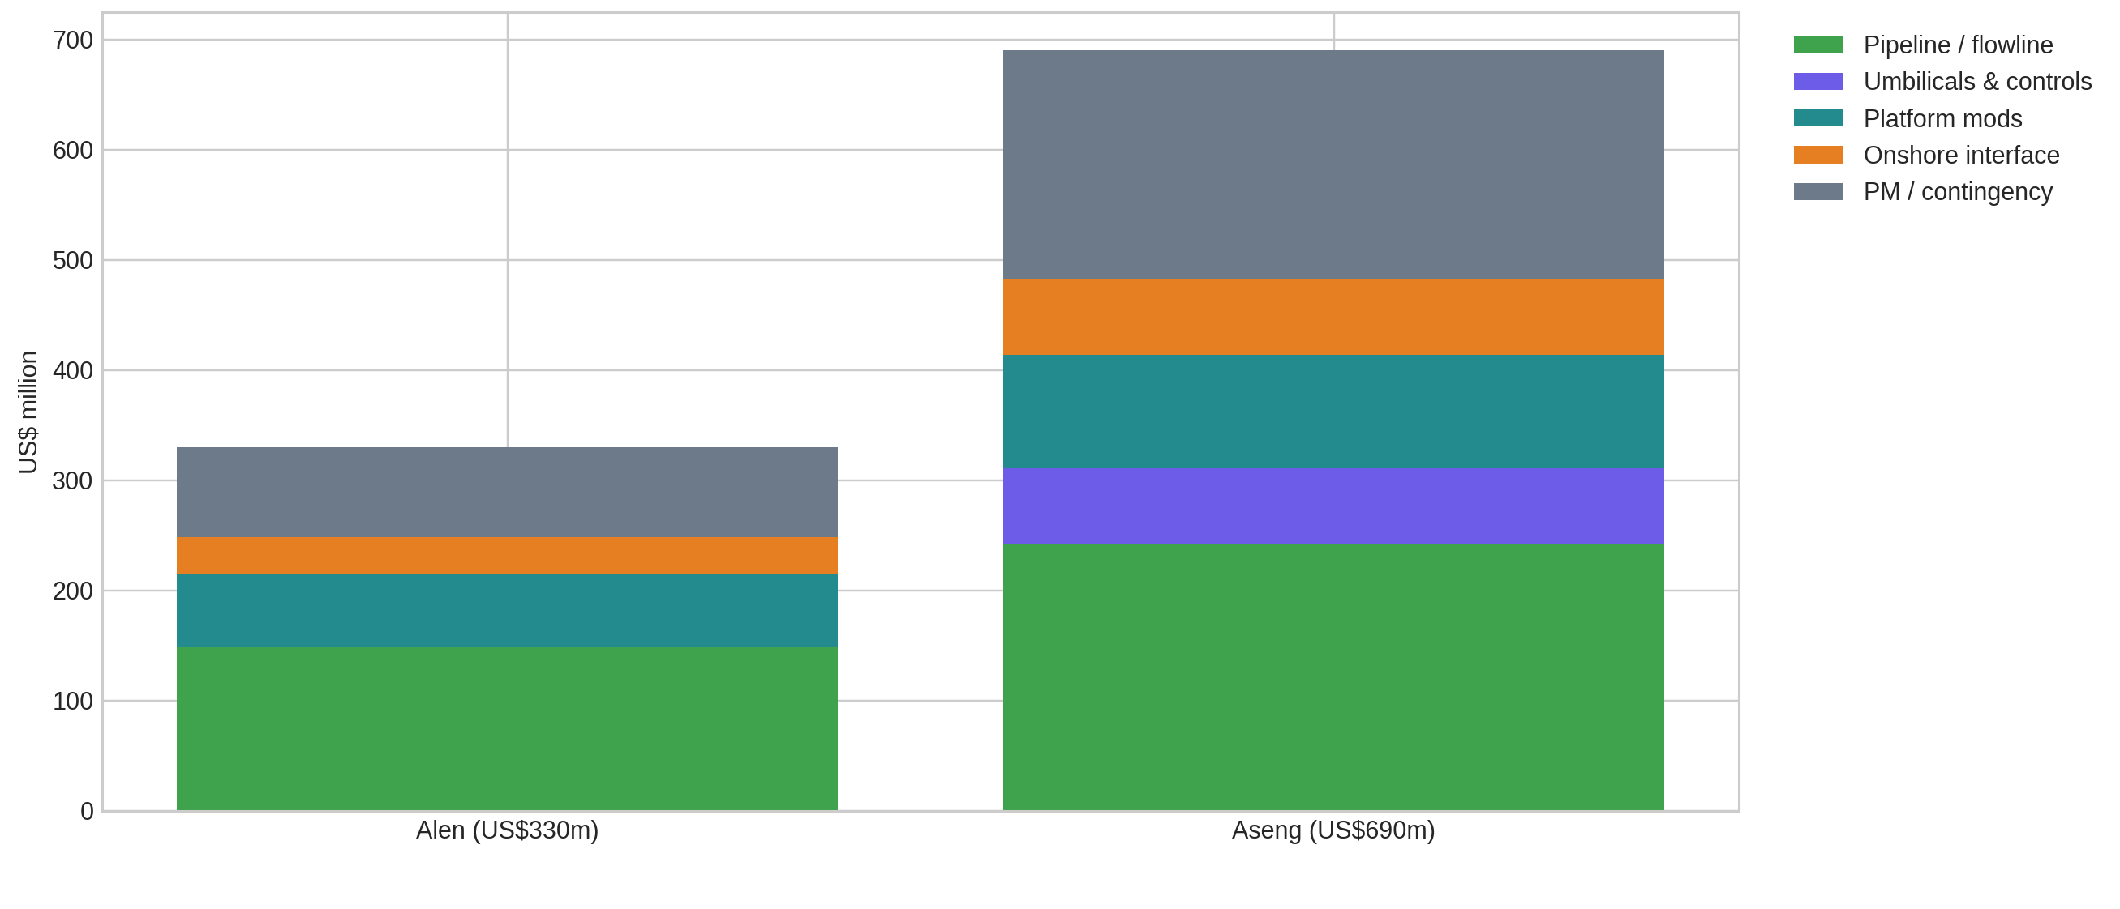
Figure 8. Indicative CAPEX decomposition for Alen and Aseng disclosed totals

Metric | Value | Classification
Representative gas case | 250 MMscfd wet gas | Analyst benchmark
LNG price | $9.0/MMBtu | Analyst base
Blended LPG price | $520/t | Analyst base
Pentanes+ price | $75/bbl | Analyst base
Incremental NGL/LPG capex | US$180m | Brownfield benchmark
LNG-only gross annual revenue | US$782,719m | Analyst calc
Integrated gross annual revenue | US$760,394m | Analyst calc
Incremental annual gross value | US$-22,325m | Analyst calc
Incremental annual EBITDA uplift | US$-22,335m | Analyst calc
Incremental NPV (10%, 12 years) | US$-152,366m | Analyst calc

Interpretation: for wet associated gas routed into existing LNG infrastructure, adding brownfield LPG/NGL recovery is economically attractive unless LPG prices collapse, actual NGL yield is materially below benchmark, or brownfield modification costs escalate sharply. The integrated route benefits from the fact that the expensive part of the value chain—the LNG plant, tanks, berth and industrial site—already exists.

14. Environmental and operational benefits
The environmental case for associated-gas monetisation in Equatorial Guinea is strongest where gas would otherwise remain in reinjection, intermittent flare or low-value disposal mode. The World Bank’s 2025 GFMR report estimates that 151 bcm of gas flared globally in 2024 generated about 389 million tonnes of CO₂e, implying a broad order-of-magnitude factor of roughly 2.6 MtCO₂e per bcm flared. Field-level Equatorial Guinea flare volumes are not publicly disclosed in current sources, so exact national abatement cannot be claimed, but the engineering implication is clear: every bcm per year shifted from flare to marketable gas materially reduces emissions while improving recovery.
- Monetisation replaces destructive disposal with saleable molecules.
- Onshore liquids recovery improves overall hydrocarbon efficiency, not just gas utilisation.
- Export through existing infrastructure avoids duplicate facilities and therefore lowers embodied carbon per unit monetised.
- Better feed-gas management can improve LNG train stability and reduce inefficient off-spec handling or curtailment.

15. Technical risk matrix
Risk | Probability (1-5) | Impact (1-5) | P×I | Primary mitigation
Gas composition variability | 4 | 4 | 16 | Flexible sweetening, dehydration and NGL cut-point design; blending strategy
NGL recovery below expectation | 3 | 4 | 12 | Pilot compositional sampling; phased cryogenic train sizing; optional deethanizer mode
Hydrate formation in subsea export | 3 | 5 | 15 | MEG / methanol strategy, shutdown-restart philosophy, thermal modelling
Internal corrosion / water holdup | 3 | 5 | 15 | Water management, inhibition, pigging where practical, corrosion monitoring
Offshore compression reliability | 3 | 4 | 12 | High turndown design, anti-surge integrity, sparing strategy, predictive maintenance
Alen hub availability impact on Aseng | 4 | 4 | 16 | Brownfield interface management, common-cause outage planning, redundancy in controls
Processing bottlenecks at Punta Europa | 4 | 5 | 20 | Early debottleneck study, inlet / treating revamp, staged NGL package addition
LNG feed variability | 3 | 4 | 12 | Tighter feed blending and online compositional control
Reservoir decline / lower deliverability | 4 | 4 | 16 | Compression staging, infill wells where justified, hub portfolio diversification
Infrastructure ageing | 3 | 4 | 12 | Integrity management, brownfield inspection and lifecycle renewal program

The highest-ranked engineering risk is the possibility that Punta Europa becomes the choke point just as upstream gas supply expands. That is why the decision on a dedicated cryogenic/NGL package matters early: if deferred too long, the country risks having new gas but insufficient value-maximising processing flexibility.

16. Strategic intelligence assessment
Technical question. Equatorial Guinea can convert offshore associated gas into LNG, LPG and NGLs efficiently if it keeps the offshore scope limited to separation, condensate handling, compression and export, while concentrating high-value conditioning and liquids recovery at Punta Europa. Alen proves the architecture; Aseng extends it.
Commercial question. Integrated liquids recovery is more valuable than LNG-only monetisation for wet associated gas unless LPG/NGL prices or recoveries are exceptionally poor. The brownfield advantage at Punta Europa lowers the threshold for value-accretive liquids recovery.
Infrastructure question. Existing Punta Europa infrastructure is sufficient to absorb materially more gas volumes in a brownfield sense, but it is not prudent to assume that existing specialised NGL-recovery capacity is adequate for a true value-maximisation strategy. Debottlenecking and a dedicated cryogenic/fractionation package are the logical next investments.
Investment question. The highest-value investments are, in order: brownfield tie-backs to Alen and Punta Europa; front-end treating flexibility; a modular cryogenic NGL/LPG train with fractionation and storage; and integrity / compression investments that keep the hub available. A duplicate standalone offshore processing train is the least attractive option unless hub access is lost.
Strategic question. Yes—Equatorial Guinea can establish an integrated offshore gas processing model that maximises hydrocarbon recovery and extends the life of its LNG infrastructure. The model is Alen as hub, Aseng as follow-on supply, Punta Europa as central value engine, and future cross-border or nearby domestic gas as throughput-extending feedstock. The winning strategy is not more offshore complexity; it is better use of the shore base.

References
Marathon Oil / PR Newswire, 30 Mar 2023: https://www.prnewswire.com/news-releases/marathon-oil-announces-agreement-to-further-develop-equatorial-guinea-gas-mega-hub-301786441.html
LNG Industry, 2 Apr 2019: https://www.lngindustry.com/liquid-natural-gas/02042019/equatorial-guinea-announces-agreements-for-eg-gas-mega-hub/
JPT / SPE, 2021 Alen first gas: https://jpt.spe.org/chevron-turns-the-taps-on-alen-gas-field
Subsea7, 1 Apr 2026 Aseng tieback award: https://www.subsea7.com/en/media/company-news/2026/Subsea7_awarded_contract_offshore_Equatorial_Guinea.html
World Oil, 1 Apr 2026 Aseng FID: https://www.worldoil.com/news/2026/4/1/chevron-takes-fid-on-aseng-gas-monetization-project-offshore-equatorial-guinea/
Ecofin Agency, 3 Apr 2026 Aseng resource and capex: https://www.ecofinagency.com/news-industry/0304-54393-chevron-approves-investment-in-equatorial-guinea-s-aseng-gas-project
Energy Chamber, 2026 Aseng FID note: https://www.energychamber.org/aseng-project-reaches-fid-signaling-renewed-momentum-for-equatorial-guineas-gas-strategy/
S&P Global, Gas Mega Hub analysis: https://www.spglobal.com/energy/en/research-analytics/equatorial-guineas-gas-mega-hub-ignites-west-africas-lng-poten
Global Energy Monitor, Punta Europa LNG terminal: https://www.gem.wiki/Punta_Europa_LNG_Terminal
Chevron 2025 Form 10-K: https://www.sec.gov/Archives/edgar/data/93410/000009341026000078/cvx-20251231.htm
Chevron 2024 Form 10-K: https://www.sec.gov/Archives/edgar/data/93410/000009341025000009/cvx-20241231.htm
USGS Minerals Yearbook 2013: https://d9-wret.s3.us-west-2.amazonaws.com/assets/palladium/production/mineral-pubs/country/2013/myb3-2013-ek.pdf
USGS Minerals Yearbook 2005: https://d9-wret.s3.us-west-2.amazonaws.com/assets/palladium/production/mineral-pubs/country/2005/ekmyb05.pdf
Offshore Energy, Alba B3: https://www.offshore-energy.biz/marathon-oil-extends-life-of-alba-gas-field-supplying-eg-lng-plant/
OGJ, Alba B3 details: https://www.ogj.com/drilling-production/article/17250917/marathon-oil-begins-gas-production-at-alba-b3-off-equatorial-guinea
PR Newswire, 1 Apr 2019 third-party gas through Punta Europa: https://www.prnewswire.com/news-releases/marathon-oil-signs-definitive-agreement-for-third-party-gas-through-existing-equatorial-guinea-infrastructure-300822202.html
Worldfolio interview with EG LNG: https://www.theworldfolio.com/news/william-wheeler-mana/1641/
AEC Week 2025 Marathon/Conoco asset note: https://www.aecweek.com/news/marathon-oil-conocophillips-join-aew-2025-co-partners-showcasing-equatorial-guineas-gas-leadership
World Oil, 6 Feb 2026 Yoyo-Yolanda: https://www.worldoil.com/news/2026/2/6/cameroon-and-equatorial-guinea-sign-deal-to-develop-yoyo-yolanda-gas-fields/
Energy Chamber, Yoyo-Yolanda 2026: https://energychamber.org/from-stalled-talks-to-breakthroughs-yoyo-yolanda-signals-new-chapter-for-th-e-gulf-of-guinea/
World Bank GFMR 2025 report: https://thedocs.worldbank.org/en/doc/bd2432bbb0e514986f382f61b14b2608-0400072025/original/Global-Gas-Flaring-Tracker-Report-July-2025.pdf
GIS Reports, 2024 Equatorial Guinea gas sector review: https://www.gisreportsonline.com/r/equatorial-guineas-oil-and-gas-industry/
Europa Oil & Gas EG-08 and nearby tieback concept: https://www.europaoil.com/operations/equatorial-guinea/

