CAPITAL ALLOCATION, PROJECT ECONOMICS AND INVESTMENT FLOWS IN LIBYA'S NATURAL GAS MONETIZATION
Executive Summary

Libya holds the fifth-largest proven natural gas reserves in Africa (approximately 26 Tcf) and has re-entered a period of visible capital commitment: Eni's $8 billion Structures A&E offshore development, the $20 billion TotalEnergies/ConocoPhillips 25-year Waha agreement, and a $1.9 billion direct budget allocation to NOC within Libya's first unified national budget in 13 years (April 2026) together represent the largest wave of hydrocarbon-sector capital commitment Libya has seen since the early 2000s. Yet this headline capital wave sits alongside a starkly underwhelming result from Libya's first competitive licensing round in 17 years: only 5 of 22 offered blocks were awarded in February 2026, with dozens of pre-qualified companies declining to submit final bids. The two data points together define the core finding of this note: capital is flowing to Libya, but selectively, concentrated among incumbent operators (principally Eni) extending existing positions, rather than broadly across new entrants and new project types.
Of the five monetization pathways assessed gas-to-power, LPG/NGL recovery, LNG, pipeline exports, and gas-based industrialization this note finds pipeline export recovery to be the most capital-efficient near-term opportunity by a wide margin. The Green Stream pipeline to Italy has a design capacity of 775 MMscfd (8–11 billion cubic metres/year) but carried only around 1 billion cubic metres in 2025 (roughly 95 MMscfd equivalent), down from 1.4 bcm in 2024. This is a largely sunk capital asset running at a fraction of capacity; the binding constraint is upstream gas availability and domestic consumption growth, not pipeline infrastructure. Every incremental MMscfd of gas made available for export through upstream development or power-sector efficiency gains can reach the Italian market at near-zero incremental pipeline CAPEX.
Gas-to-power efficiency (addressed in depth in the companion CCGT intelligence note) ranks second: it requires only moderate capital relative to upstream and LNG development, does not depend on new export infrastructure or long-term offtake contracts, and its value is anchored to the opportunity cost of gas rather than to volatile international LNG/LPG pricing making it comparatively insulated from the market-price risk that dominates the sensitivity analysis in Section 5. LPG/NGL recovery ranks third: it requires moderate, modular capital investment, can be phased incrementally as gas processing capacity allows, and captures higher per-Mcf value than power generation, though it remains exposed to global product-price cycles.
LNG development and gas-based industrialization (fertilizer, methanol, petrochemicals) both carry materially higher capital intensity, longer development timelines, and greater dependence on a stable, internationally bankable contracting and security environment that Libya has not yet consistently demonstrated the muted licensing-round outcome is a direct market signal on this point. These pathways should be sequenced for the medium-to-long term, after upstream supply, gas-to-power efficiency and pipeline-export recovery have re-established Libya's marketed-gas base and demonstrated contract and payment reliability to prospective financiers.
The financing structure observed to date is heavily weighted toward NOC/state capital and IOC equity investment in joint ventures (Mellitah Oil & Gas, Waha Oil Company); commercial bank, DFI and export-credit participation remains comparatively limited, reflecting persistent political, security and institutional risk premiums. The African Development Bank's newly approved 2025–2028 Libya country strategy and the World Bank's Global Flaring and Methane Reduction Partnership (which Libya joined in April 2026) represent the clearest near-term multilateral financing entry points, particularly for flare-gas recovery, which the World Bank estimates could save Libya on the order of $650 million per year once fully implemented.

1. Libya's Natural Gas Investment Landscape

1.1 Reserves, production and the monetization gap
Libya holds approximately 26 Tcf of proven natural gas reserves (OPEC, 2025 data) the fifth-largest in Africa alongside EIA-estimated technically recoverable shale gas resources of roughly 122 Tcf, comparable in scale to the Eastern Mediterranean's Levant Basin. Gross gas production reached a record of approximately 3,400 MMscfd in 2019, but structural losses mean only about 45% of gross output reaches the market: substantial volumes are reinjected for enhanced oil recovery, flared, or consumed in field operations. Domestic consumption driven overwhelmingly by an inefficient, ~70%-gas-dependent power sector has risen from roughly 788 MMscfd in 2015 to over 1,150 MMscfd in 2025, steadily eroding the marketed-gas surplus available for export.
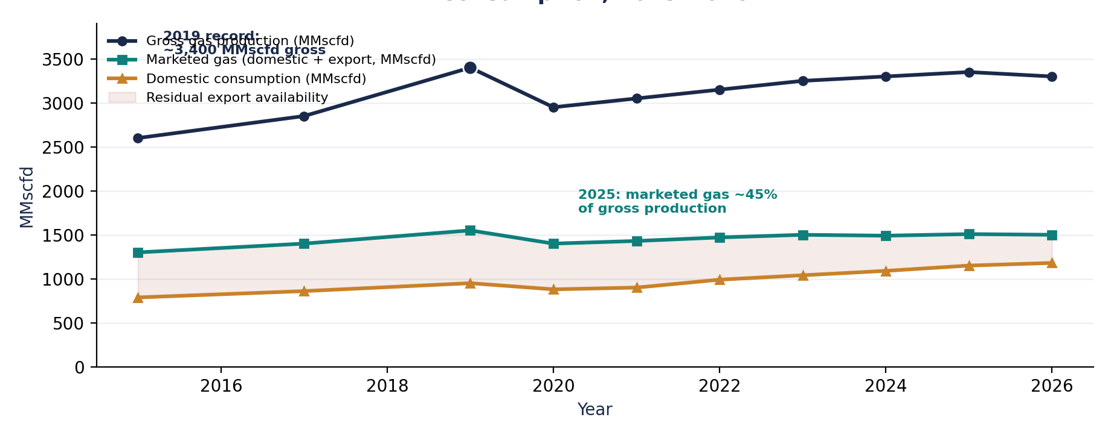
Figure 1. Libya gas production, marketed gas and domestic consumption, 2015–2026.

1.2 Existing infrastructure and its constraint on monetization
Libya's gas infrastructure center’s on the Mellitah Complex in the west, which processes gas from the Wafa and Bahr Essalam fields and feeds the Green Stream pipeline to Sicily. This infrastructure is decades old in parts, built around the original Western Libya Gas Project, and represents substantial sunk capital that current monetization strategy can leverage rather than replace. The critical constraint is not pipeline or processing capacity in aggregate Green Stream alone carries a design capacity of 775 MMscfd (8–11 bcm/year) against 2025 export flows of roughly 1 bcm (approximately 95 MMscfd equivalent) but upstream production and treatment capacity feeding that infrastructure, and the domestic consumption growth that competes with it for scarce marketed gas.

1.3 Investment levels, projects under development, and IOC participation
Eni is Libya's dominant international operator, present since 1959, with equity production of approximately 162,000 boe/d in 2025 and three development projects currently in execution totaling roughly $10 billion in investment. The centre piece is the $8 billion Structures A&E offshore development (Mellitah Oil & Gas, a 50-50 Eni/NOC joint venture in Block D), targeting first gas in 2027 and a combined plateau of 750 MMscfd, alongside a Carbon Capture and Storage facility at Mellitah. Nearer-term, Eni's Bahr Essalam gas compression project is scheduled to add approximately 100 MMscfd from early 2026, with a second gas utilization project targeting a further 100–120 MMscfd from Q3 2026; the Sabratha Compression Project also began production in June 2026 as part of this same effort to sustain and increase output from maturing fields. Eni has also announced multiple 2026 discoveries in Block D (BESS 2 and BESS 3, estimated at over 1 Tcf combined) that could extend the investment pipeline beyond Structures A&E.
A second, largely oil-weighted but sector-relevant capital wave arrived in January 2026: a 25-year development agreement between Waha Oil Company (an NOC subsidiary) and TotalEnergies/ConocoPhillips, involving more than $20 billion in foreign-financed investment, targeting an increase in Waha production capacity from roughly 340,000–400,000 bpd to 850,000 bpd, including development of the North Gialo field (expected to add 100,000 boe/d, with associated gas volumes relevant to the domestic gas balance). Libyan officials project the agreement could generate over $376 billion in net revenue over its lifetime, though this figure has not been independently verified and revenue-sharing terms were not disclosed.
Chevron re-entered Libya's upstream sector in January 2026 via a memorandum of understanding with NOC and, in February 2026, was awarded onshore Contract Area 106 (Block S4, Sirte Basin) in the licensing round described below its first Libyan acreage since exiting after the 2011 conflict. NOC has also signed a memorandum of understanding with Chevron covering exploration in the Sirte, Murzuq and Ghadames basins, and, separately, with Algeria's Sonatrach, which yielded a new gas/condensate discovery at the A1-69/02 well in April 2026.

1.4 The February 2026 licensing round: a market signal on investor appetite
Libya's first competitive oil and gas licensing round in 17–19 years, launched by NOC in March 2025 under updated EPSA V fiscal terms, offered 22 onshore and offshore blocks across the Sirte, Murzuq and Ghadames basins. Initial interest appeared strong 44 companies and one consortium applied, with 37 pre-qualified by July 2025, including majors such as Shell, ExxonMobil, Eni, TotalEnergies and Chevron. The result, announced 11 February 2026, was materially weaker than the pipeline of interest suggested: only 5 of the 22 blocks (two offshore, three onshore) were awarded, to Chevron, an Eni-QatarEnergy consortium, Repsol-TPOC, a Repsol-TPOC-MOL consortium, and Nigeria's Aiteo. The most competitive award, onshore Block S4 in the Sirte Basin, saw Chevron outbid a TotalEnergies-ConocoPhillips consortium.
This outcome is a directly relevant investment-risk data point: dozens of qualified, well-capitalised companies evaluated Libya's updated, investor-friendly fiscal terms and chose not to submit binding bids. Independent risk analysts have attributed this to lingering uncertainty over Libya's political dysfunction and security conditions around the blocks on offer, rather than to the fiscal terms themselves, which are regarded as among the most competitive in the region. The practical implication for capital allocation strategy is that near-term investment is more likely to come from expansion of existing, trusted positions (Eni, Waha's incumbent partners) than from new-entrant greenfield exploration, at least until the political and security environment demonstrates further durable improvement.

2. Capital Requirements Across the Gas Value Chain

2.1 Mapping CAPEX by value-chain stage
Capital requirements differ by an order of magnitude or more across stages of the gas value chain, and by CAPEX category (greenfield exploration and field development; brownfield expansion of producing assets; infrastructure rehabilitation of aging facilities; routine maintenance CAPEX; and expansion CAPEX for processing or export capacity). Libya's own recent transactions provide the clearest available anchor points: the $8 billion Structures A&E project is a combined upstream-plus-midstream greenfield development (two offshore platforms tied into existing Mellitah treatment facilities) targeting 750 MMscfd plateau production, implying a blended capital intensity on the order of $10.7 million per MMscfd of plateau capacity for this specific integrated project — a Libya-specific data point, not a generic industry benchmark, and one that includes CCS infrastructure not required by all projects.
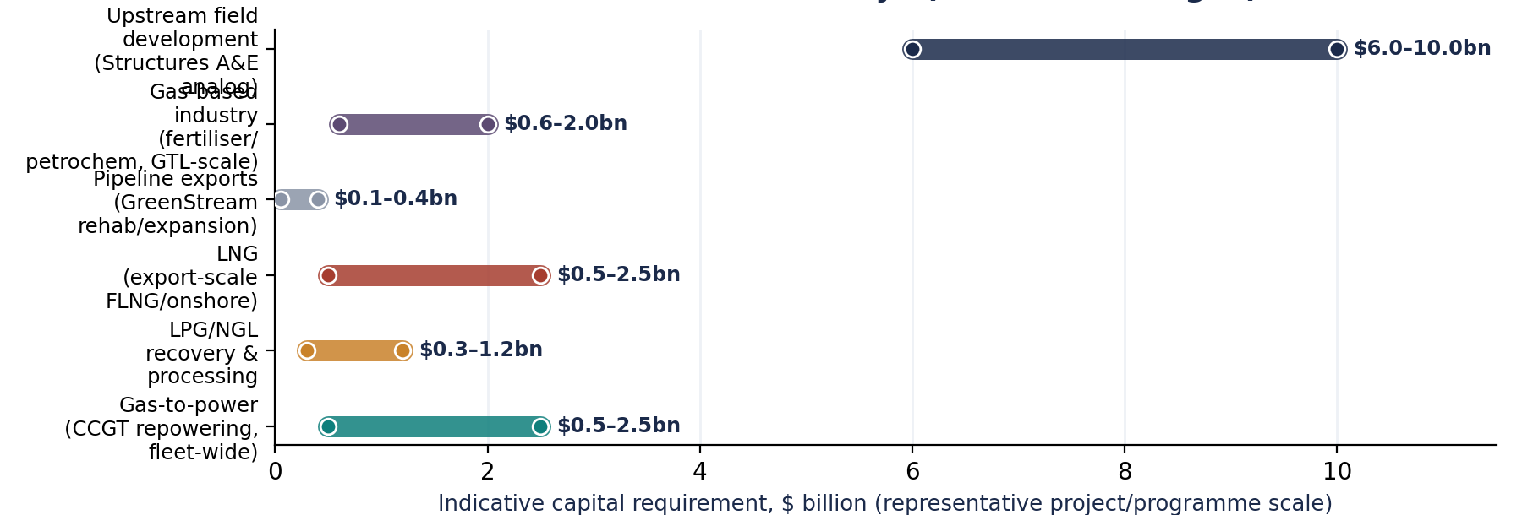
Figure 2. Estimated capital requirements across major gas monetization pathways (indicative ranges, representative project scale).

2.2 Pathway-specific benchmarks

Gas-to-power
Combined-cycle gas turbine CAPEX benchmarks (U.S. EIA, NREL Annual Technology Baseline) range from roughly $900/kW at the lower end of historical reference costs to $2,000+/kW amid the current tight global gas-turbine and HRSG supply environment. Applied to an illustrative 500–1,250 MW CCGT repowering programme (comparable in scale to Libya's committed South Tripoli and Zliten projects), this implies a programme-level capital requirement in the range of roughly $0.5–2.5 billion far below upstream field development or LNG on a per-project basis, and deployable incrementally, plant by plant.

LPG/NGL recovery
No Libya-specific NGL/LPG plant CAPEX data is publicly available. Directionally relevant international benchmarks include gathering-and-processing fees of $0.65–$1.30 per Mcf of feed gas and fractionation fees of $2–$4 per barrel of NGL recovered (U.S. EIA upstream cost data), alongside modular cryogenic gas processing trains (e.g., Honeywell UOP Russell) available in standard sizes from 40 to over 300 MMscfd, indicating that meaningful LPG/NGL recovery capacity can be added in modular increments rather than requiring a single large capital commitment a materially different risk profile from LNG or greenfield upstream development.

LNG
Modern floating LNG (FLNG) liquefaction CAPEX has fallen substantially from early-generation outliers (Shell's Prelude reached $2,114/tonne) toward $500–$1,134 per tonne of annual capacity for recent projects (Rystad Energy, 2026), with conversion-based FLNG facilities (repurposed carriers) achieving the lowest costs (e.g., $500–$640/tonne) and newbuild Gulf Coast-style developments averaging around $1,054/tonne. Applied to an illustrative 1–2.2 Mtpa Libyan FLNG train a plausible scale given Libya's offshore gas discoveries and existing Mellitah tie-in infrastructure this implies a liquefaction-only capital requirement of roughly $0.5–2.5 billion, excluding feed-gas development, shipping and regasification infrastructure at the receiving end.

Pipeline exports
This is the pathway with the lowest incremental capital requirement by a wide margin: Green Stream's 775 MMscfd design capacity is a largely sunk asset. Incremental capital need is limited to compression, treatment capacity and field-side tie-ins required to fill existing pipeline headroom exactly the kind of investment represented by Eni's $100–120 MMscfd Bahr Essalam compression and gas-utilization projects, which are far smaller in absolute dollar terms than Structures A&E despite adding materially to marketed gas.

Gas-based industrialization
No Libya-specific fertilizer, methanol or petrochemical project CAPEX data is available. As a general order-of-magnitude industrial gas-monetization benchmark, U.S. DOE/NETL analysis of Fischer-Tropsch gas-to-liquids (GTL) plants indicates capital costs of roughly $80,000–$86,000 per barrel/day of capacity implying that even a modest 10,000 bpd facility would require on the order of $0.8–$0.9 billion, before accounting for Libya-specific infrastructure, logistics and political-risk premiums. Fertilizer and methanol plants typically carry lower per-unit capital intensity than GTL but still represent large, lumpy, multi-year capital commitments relative to gas-to-power or LPG/NGL.

2.3 CAPEX intensity comparison
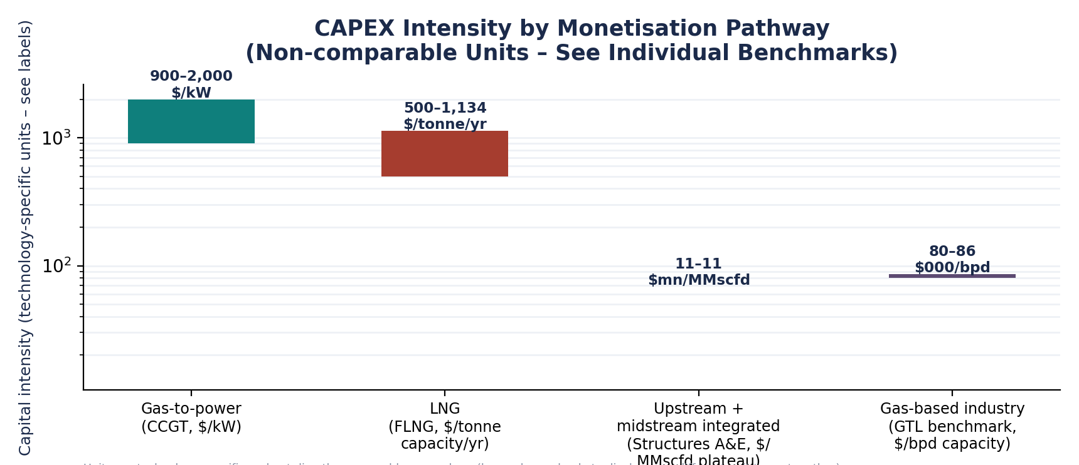

2.4 Greenfield vs. brownfield vs. rehabilitation CAPEX
Libya's near-term capital efficiency case rests heavily on brownfield and rehabilitation spending rather than greenfield development. Structures A&E, while described as greenfield offshore field development, ties into existing Mellitah treatment infrastructure rather than building a new processing complex from scratch — reducing its effective capital intensity relative to a fully standalone greenfield project. Bahr Essalam compression and the Sabratha Compression Project are textbook brownfield expansion CAPEX: adding compression and utilisation capacity to already-producing, already-connected fields. On the power side (see companion CCGT note), OCGT-to-CCGT conversion at Tripoli West and Misrata is similarly brownfield in character — adding HRSG and steam-turbine capacity to existing gas-turbine islands rather than building new sites. This brownfield-first pattern is consistent with a capital-constrained environment in which extending and better-utilising existing sunk infrastructure offers a faster, lower-risk return on capital than greenfield alternatives.

3. Project Economics and Monetisation Pathways

3.1 Gas-to-power
Gas-to-power economics in Libya are dominated by a single structural fact established in the companion CCGT intelligence note: GECOL recovers only a small fraction of its operating costs from heavily subsidised domestic tariffs. This means gas-to-power cannot be evaluated on conventional LCOE/tariff-revenue economics; its economic value lies in the opportunity cost of gas saved through efficiency (CCGT vs. legacy OCGT, a benchmarked 30–38% reduction in gas burned per MWh) and in the avoided cost of blackouts, emergency oil-burn, and Egyptian power imports (currently only 100 MW, covering under a tenth of the reported shortfall). CAPEX benchmarks of $900–$2,000/kW (Section 2.2) combined with near-zero fuel-price exposure (gas is allocated internally, not purchased at market price) make this the most execution-risk-insulated pathway of the five assessed, even though it generates the lowest direct hard-currency revenue.

3.2 LPG and NGL recovery
LPG/NGL recovery monetises the heavier hydrocarbon fractions in Libya's associated and non-associated gas streams at a materially higher value per Mcf than power generation, while requiring only moderate, modular capital (Section 2.2). Feed-gas requirements scale with recovery train size (modular units from 40–300+ MMscfd are commercially available); recovery rates and yields depend on the specific gas composition of Libyan fields, on which comprehensive public data is limited. Both domestic LPG demand (for cooking and heating) and export potential exist, though Libya's domestic LPG market data was not identified in available sources for this note. Project margins depend on the spread between feed-gas opportunity cost (effectively the same opportunity-cost logic as Section 3.1) and international LPG/NGL product prices, which are more directly exposed to global petrochemical and heating-fuel demand cycles than gas-to-power.

3.3 LNG
LNG is the most capital-intensive and technically complex of the five pathways, and the one most exposed to global LNG price cycles and to Libya's ability to secure bankable long-term offtake contracts with European or other buyers — exactly the kind of long-duration counterparty commitment that the muted February 2026 licensing-round outcome suggests remains difficult to secure at scale. FLNG CAPEX benchmarks of $500–$1,134/tonne (Section 2.2) are meaningfully lower than a decade ago, and Libya's existing Mellitah tie-in infrastructure could plausibly host a moderate-scale FLNG or onshore liquefaction addition once Structures A&E gas reaches the complex from 2027. Break-even LNG pricing depends on feed-gas cost assumption (again tied to the opportunity-cost framework), liquefaction CAPEX recovery, and shipping costs to target markets; no Libya-specific break-even estimate is available, and this note does not fabricate one. Terminal utilisation risk is a further consideration: Libya's own GreenStream pipeline currently operates at roughly 10–13% of design capacity, illustrating how underlying production shortfalls can leave even completed export infrastructure under-utilised for years.

3.4 Pipeline gas exports
Pipeline exports via GreenStream represent the most immediately monetisable pathway in capital-efficiency terms, precisely because the pipeline itself requires minimal incremental investment (Section 2.2). The binding constraints are upstream production, domestic consumption growth (which competes directly with export volumes for the same marketed-gas pool, Section 1), and geopolitical/contractual factors: Italy remains the primary buyer, gas exports to Italy fell from 1.4 bcm in 2024 to roughly 1 bcm in 2025 due to domestic constraints and political instability, and Italian and Libyan leaders (Prime Ministers Meloni and Dbeibeh) reaffirmed the strategic importance of the relationship in May 2026 — a positive signal for continued market access, though not a guarantee of expanded contracted volumes. Transit risk is comparatively low given the pipeline's multi-decade operating history, though it remains exposed to the same security disruptions documented for domestic gas supply (Section 6 of the companion CCGT note).

3.5 Gas-based industrialization
Fertilizer, methanol, petrochemical and hydrogen opportunities represent the longest-dated, highest-complexity pathway. These projects typically require the largest, most reliable feed-gas commitments (often 20+ year supply guarantees to underpin project financing), the most sophisticated offtake and marketing arrangements, and the deepest technical and operational capability — none of which Libya has yet demonstrated at scale in the gas sector specifically. GTL capital-intensity benchmarks ($80,000–$86,000/bpd, Section 2.2) illustrate the scale of commitment required even for modest facilities. These opportunities should be viewed as a long-term diversification objective contingent on Libya first re-establishing a reliable, well-monetised marketed-gas base through the other four pathways.

3.6 Ranking by economic value creation, capital intensity and risk
Pathway | Capital intensity | Technical complexity | Investment risk | Near-term value-creation potential
Pipeline exports (GreenStream recovery) | Very low (sunk asset) | Low | Moderate (security, upstream supply) | High — fastest path to incremental hard-currency revenue
Gas-to-power (CCGT) | Low–moderate | Moderate | Low–moderate (domestic, insulated from export contracting risk) | High — opportunity-cost value, reliability benefit
LPG/NGL recovery | Moderate, modular | Moderate | Moderate (product-price exposure) | Moderate–high — phased, scalable
LNG (FLNG/onshore) | High | High | High (offtake contracting, price cycles) | Moderate — medium-term, contingent on upstream volume
Gas-based industry | Very high | Very high | Very high (long-tenor feed-gas and offtake risk) | Low near-term — long-term diversification play

4. Investment Flows and Financing Structures

4.1 Capital flow architecture
Libya's gas-sector capital flow runs predominantly through the National Oil Corporation, which allocates state and retained cash-flow capital across upstream, midstream and power-sector gas supply, and structures international participation through joint ventures principally Mellitah Oil & Gas (50-50 NOC/Eni) and Waha Oil Company (NOC subsidiary, with TotalEnergies and ConocoPhillips as the current 25-year development partners). This structure concentrates deal-making and risk allocation at the NOC/JV level rather than through a broader syndicate of independent operators, banks and financiers a pattern visible in the figure below.
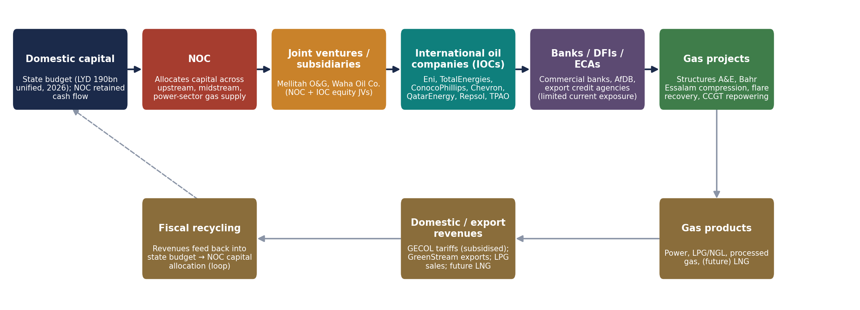
Figure 4. Libya gas-sector capital flow, from domestic and international sources to projects, products and revenue.

4.2 NOC capital expenditure and the 2026 budget breakthrough
Libya's rival legislative bodies approved a unified state budget of 190 billion Libyan dinars ($29.95 billion) in April 2026 the first unified national spending framework in over 13 years. This allocated 12 billion dinars ($1.9 billion) directly to NOC, alongside a broader 40-billion-dinar allocation for strategic development infrastructure. This fiscal unification is arguably as significant to the investment outlook as any single project announcement: it removes a major source of institutional and payment-certainty risk that international financiers had cited as a barrier to deeper engagement, and provided the financial foundation that allowed Structures A&E to proceed to full-scale execution.

4.3 International oil company investment
Eni's roughly $10 billion in current Libyan project execution (across three projects) and TotalEnergies/ConocoPhillips's $20 billion Waha commitment represent the two largest active capital deployments. Chevron's re-entry (MoU plus a Block S4 licence award) and QatarEnergy's participation (as Eni's 40% partner in Offshore Area 01) signal broadening, though still concentrated, IOC interest. Other pre-qualified companies from the 2025–2026 licensing round including Shell, ExxonMobil, and Lukoil did not convert interest into binding bids, illustrating that broad IOC awareness of Libya's resource potential has not yet translated into broad-based capital commitment.

4.4 Development finance, multilateral and commercial bank engagement
Multilateral engagement is emerging but remains modest relative to IOC capital flows. The African Development Bank approved a new 2025–2028 Libya country strategy in December 2025, targeting public financial management, private-investment climate, and non-oil value-chain development, including renewable energy a framework that could extend to gas-sector-adjacent infrastructure but is not gas-investment-specific. More directly relevant, Libya formally joined the World Bank's Global Flaring and Methane Reduction Partnership's Zero Routine Flaring by 2030 initiative on 30 April 2026, joining 36 governments and 60 oil companies representing over 60% of global routine flaring; the Libyan Ministry of Oil and Gas has stated this could save the country on the order of $650 million per year once achieved. This is the clearest identified multilateral financing and technical-assistance entry point currently available for Libya's gas sector specifically. No Libya-specific commercial bank project-finance transactions or export-credit-agency-backed gas deals were identified in available sources for this note, consistent with the broader finding that non-IOC capital participation remains limited.

4.5 How the political and institutional environment affects cost of capital
Three data points from Sections 1 and 4 together indicate an elevated but improving risk premium environment:
- The February 2026 licensing round drew binding bids on only 5 of 22 blocks despite competitive fiscal terms, suggesting investors continue to price in political and security risk beyond what contract terms alone can offset;
- The April 2026 budget unification directly addressed a major source of institutional/payment risk and appears to have been a precondition for Structures A&E's full-scale progression;
- Capital continues to flow overwhelmingly to incumbent, deeply experienced operators (principally Eni, present since 1959) rather than to new entrants, consistent with a market that still charges a significant risk premium for unfamiliarity with Libya's operating environment. Financiers and prospective investors should expect financing costs and contract structures (e.g., shorter initial commitment periods, phased capital release, heavier reliance on NOC/JV risk-sharing rather than standalone project finance) to reflect this premium until a longer track record of institutional and fiscal stability is established.

5. Investment Risk and Economic Sensitivity

5.1 Risk categories
Twelve risk categories are relevant to Libyan gas investment; the matrix below positions the most material seven on illustrative likelihood/impact axes, informed by the specific 2025–2026 developments documented in this note rather than generic country-risk scoring.
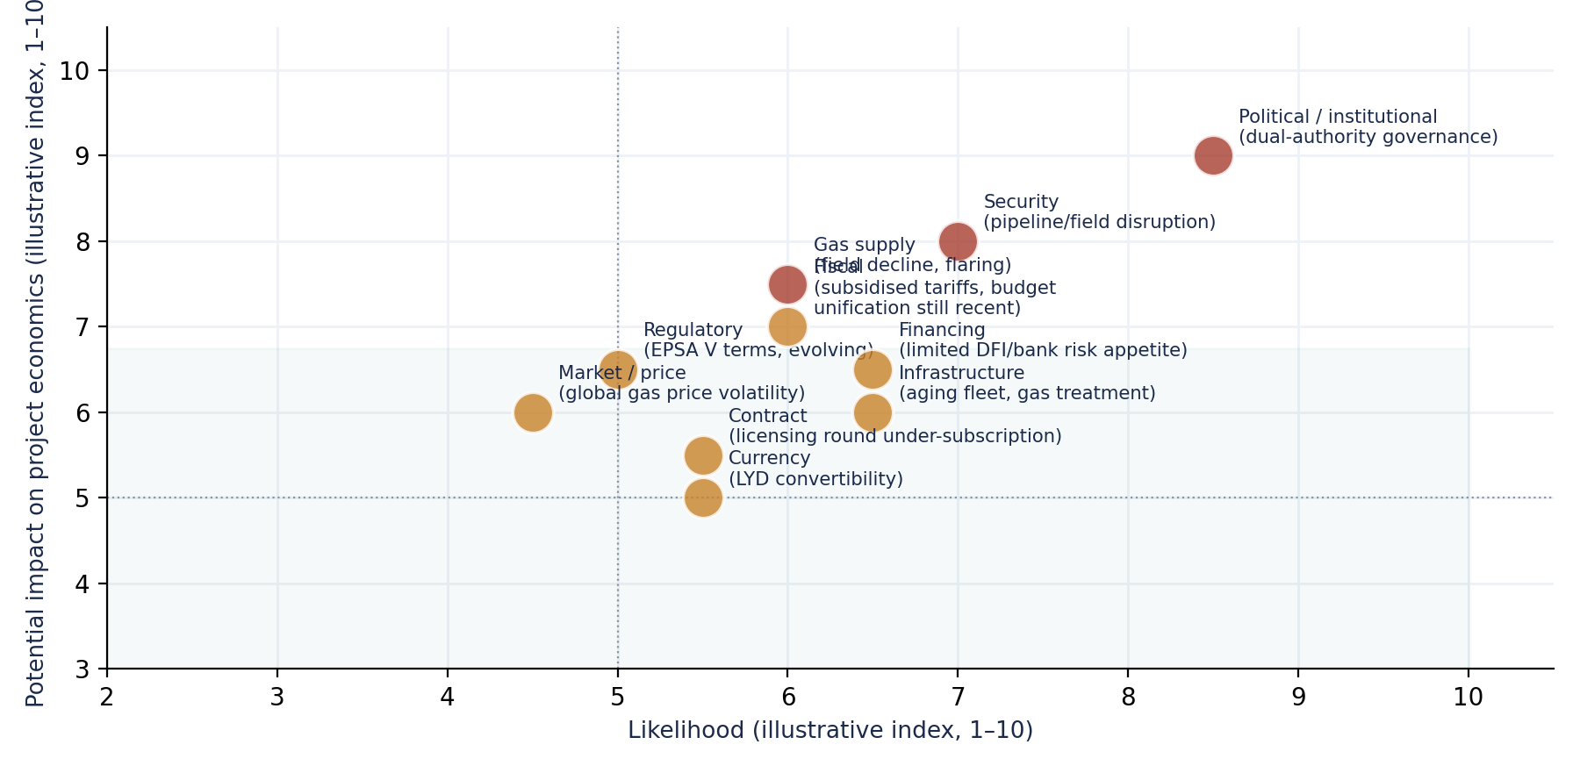
Figure 5. Libya gas-sector investment risk matrix (illustrative qualitative positioning).

- Political / institutional risk: Libya's dual-authority governance structure remains the dominant risk factor; the April 2026 budget unification is a significant positive development but is recent and unproven over a full fiscal cycle.
- Security risk: GECOL has reported gas pipeline closures by armed groups directly affecting power-plant fuel supply; comparable risk applies to upstream and midstream gas infrastructure more broadly.
- Regulatory risk: the updated EPSA V fiscal framework is regarded as investor-friendly, but its durability and consistency of application across a still-evolving institutional landscape remain to be demonstrated over multiple licensing cycles.
- Fiscal risk: GECOL's subsidised tariff structure (recovering only a fraction of costs) and Libya's broader subsidy regime create ongoing fiscal-sustainability questions that could affect future capital allocation priorities.
- Currency risk: Libyan dinar convertibility and the dollar-denominated nature of most gas-sector investment and revenue create a structural currency mismatch for domestically-denominated obligations, though export revenues are typically dollar-denominated, providing a natural partial hedge for export-oriented projects specifically.
- Infrastructure risk: aging gas treatment and transmission infrastructure at some sites increases operational and rehabilitation risk relative to greenfield international benchmarks.
- Gas supply risk: field decline (flagged by NOC for Bahr Essalam and Wafa from 2025) and persistently high flaring rates (Libya is among the world's top-nine flaring countries) both constrain the feed-gas base that downstream monetization investment depends on.
- Market/price risk: LNG, LPG and NGL pathways are directly exposed to global commodity price cycles; gas-to-power is comparatively insulated (Section 3.1).
- Contract risk: the muted licensing-round outcome (5 of 22 blocks awarded) is itself evidence of how counterparties price uncertainty over contract durability and enforcement.
- Financing risk: limited current DFI/commercial-bank participation means most projects to date rely on IOC balance-sheet or NOC/state financing rather than diversified project finance, concentrating financing risk.

5.2 Sensitivity analysis: NPV underprice scenarios
The chart below presents original illustrative scenario modelling constructed to show the structurally different price sensitivity of export-oriented pathways versus gas-to-power.
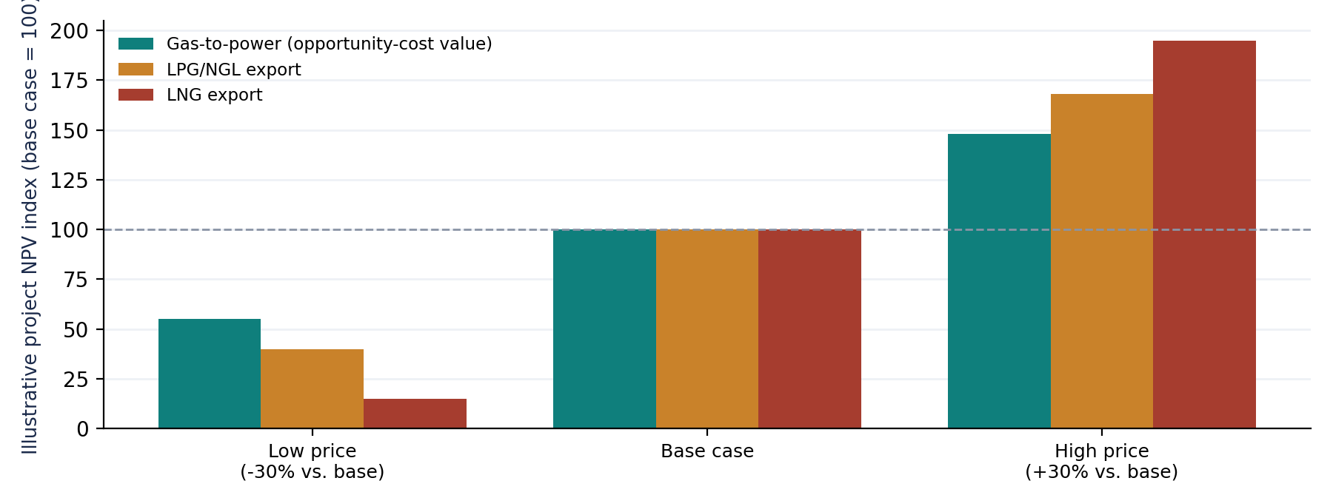
Figure 6. Illustrative NPV sensitivity to gas/product price scenarios across three representative pathways.

5.3 Tornado analysis: key NPV drivers
Across comparable emerging-market gas-export and monetization project literature, gas/product price and production volume/capacity utilization are consistently the two variables with the largest NPV impact, followed by CAPEX escalation, discount rate and OPEX, exchange rate and contract-duration effects.
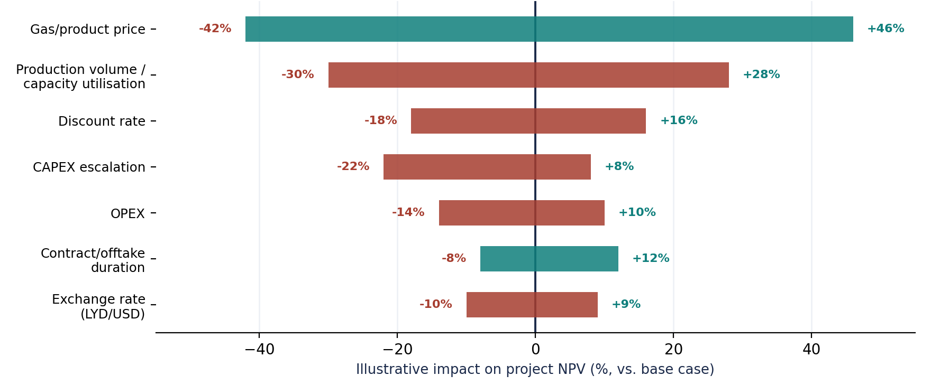
Figure 7. Illustrative tornado ranking of key variables affecting Libyan gas monetization project NPV.

5.4 Reading the sensitivity results
The combined message of Sections 5.2 and 5.3 is that Libya's investment risk is concentrated in variables largely outside any single investor's control (political stability, security, global commodity prices) rather than in variables a well-executed project can directly manage (OPEX efficiency, contract structuring). This argues for a capital-allocation strategy (Section 6) that favors pathways with the shortest payback and the least exposure to long-duration price and political risk in the near term, while reserving longer-dated, higher-risk pathways (LNG, gas-based industry) for a period when political and security conditions demonstrate sustained stability beyond a single budget cycle.

6. Capital Allocation and Monetization Strategy

6.1 Investment prioritization framework
Combining the capital-intensity findings of Section 2, the project economics of Section 3, and the risk assessment of Section 5 yields the following prioritizations framework across the five monetization pathways.
Pathway | CAPEX intensity | Technical complexity | Revenue potential | Domestic impact | Export potential | Investment risk
Gas-to-power | Low–moderate | Moderate | Moderate (opportunity-cost value, not direct FX) | Very high (reliability, blackout reduction) | None (domestic only) | Low–moderate
LPG/NGL | Moderate, modular | Moderate | Moderate–high | Moderate (domestic LPG supply) | Moderate–high | Moderate
LNG | High | High | High (long-run, contingent) | Low–moderate | High (new markets beyond Italy) | High
Pipeline exports | Very low | Low | High (fastest incremental FX) | Low (export-focused) | Very high (existing buyer, spare capacity) | Moderate
Gas-based industry | Very high | Very high | High (long-run, speculative) | Moderate (jobs, diversification) | Moderate–high | Very high
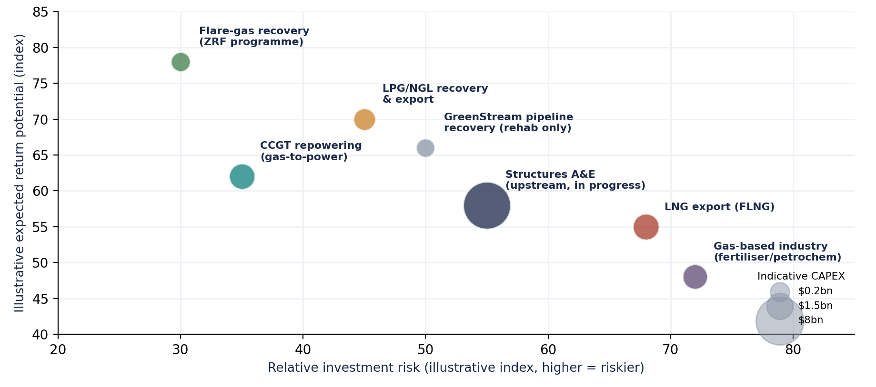
Figure 8. Gas monetization projects positioned by CAPEX (bubble size), illustrative expected return, and illustrative investment risk.

6.2 Short-, medium- and long-term prioritizations

Short-term priority (0–2 years): pipeline export recovery and gas-to-power efficiency
These two pathways combine the lowest incremental capital requirements with the fastest route to measurable value — additional export revenue in the case of Green Stream recovery, and reduced blackout frequency plus freed gas volumes in the case of CCGT repowering. Both can be pursued using largely existing infrastructure and do not require new long-duration offtake contracts or large-scale project financing, making them the most executable priorities in the current risk environment.

Medium-term priority (2–5 years): LPG/NGL recovery expansion and Structures A&E completion
Structures A&E is already committed and under execution (targeting 2027 first gas); completing it on schedule and beginning to plan modular LPG/NGL recovery capacity to capture value from the additional marketed gas it will bring online represents the natural next capital-allocation step, phased to match actual gas availability rather than committed in advance of it.

Long-term priority (5+ years): LNG development and gas-based industrialization
Both pathways should be sequenced after Libya has demonstrated several years of stable fiscal management (post-April 2026 budget unification), improved licensing-round conversion rates (a future round outperforming the 5-of-22 February 2026 result would be a strong positive signal), and a track record of reliable gas supply to existing offtakers. Premature large-scale commitment to LNG or petrochemical infrastructure ahead of these preconditions would concentrate capital in the highest-risk pathways before the risk environment has been de-risked by success in the nearer-term priorities.

7. Strategic Investment Outlook Through 2040

7.1 Expected capital requirements and scenario range
Original illustrative scenario modelling for this note (not an official government, NOC or IMF projection) suggests cumulative gas-sector investment requirements through 2040 could plausibly range from roughly $13 billion (a low scenario in which only already-committed projects proceed) to over $46 billion (a high scenario assuming sustained IOC re-entry at a pace comparable to 2025–2026 announcements), with a moderate scenario of approximately $28 billion. These figures build on, but extend well beyond, the two already-confirmed commitments described in Section 1 ($8bn Structures A&E, $20bn Waha) shown as the programme's starting point.
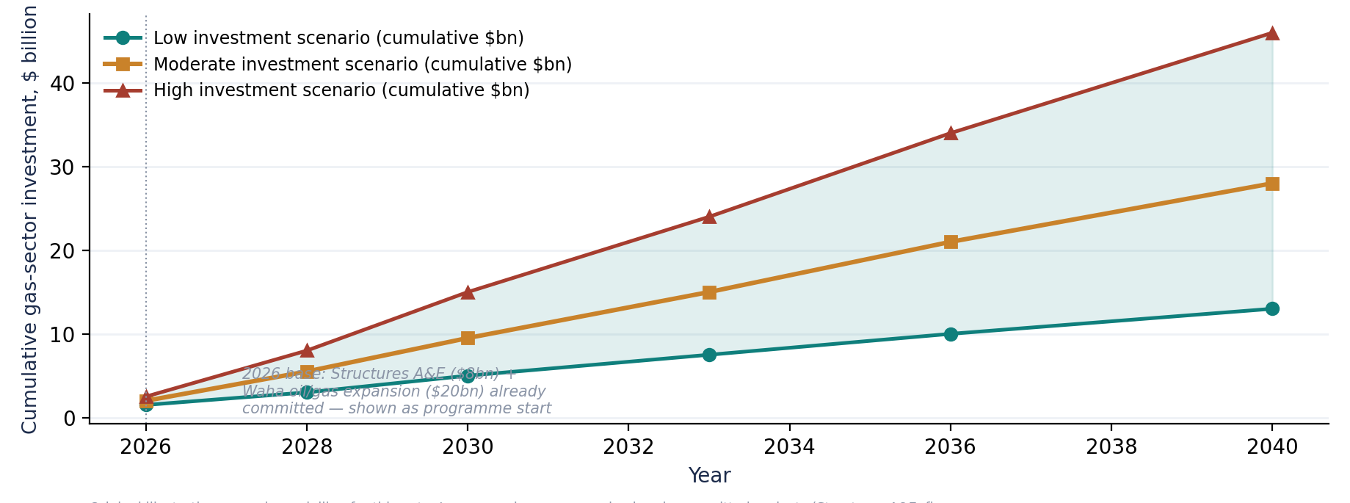
Figure 9. Illustrative cumulative gas-sector investment requirements through 2040 under three scenarios.

7.2 Value chain view and the conditions for unlocking further investment
The diagram below summarizes the full chain from reserves to revenue that this note's investment analysis addresses, underscoring that each stage constrains the next: only ~45% of gross gas production reaches the market, and (per the companion CCGT note) a further efficiency loss occurs wherever gas is converted to electricity through legacy simple-cycle plant rather than combined-cycle capacity.
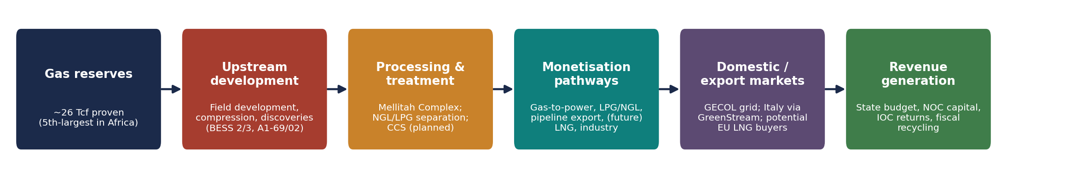
Figure 10. Libya gas value chain: reserves to revenue.

7. 3 European demand and competition for global gas capital
Italy remains structurally receptive to Libyan gas, reaffirmed at the political level in May 2026, and Libya's proximity (a short pipeline distance versus long-haul LNG shipping for competing suppliers) is a durable geographic advantage for the pipeline-export pathway specifically. However, Libya is competing for the same pool of global upstream and LNG capital as Algeria, Egypt, Mozambique, Qatar and a broadening set of FLNG-capable suppliers benefiting from the capital-cost declines; the muted February 2026 licensing round suggests Libya is not yet winning this competition for capital as decisively as its resource base alone would suggest it should.

7.4 Domestic demand growth as a competing claim on capital returns
GECOL's own forecasts (companion CCGT note) project peak electricity demand rising from roughly 14.8 GW (2025) to 21.7 GW (2030), which, absent efficiency gains, would directly compete with export volumes for Libya's limited marketed gas. This makes gas-to-power efficiency investment not merely a domestic-reliability project but a direct enabler of the export and monetisation pathways addressed elsewhere in this note every Mcf saved through CCGT conversion is a Mcf that does not have to be diverted from LNG, LPG or pipeline export volumes to meet growing domestic load.

7.5 Potential investor returns
No Libya-specific project-level IRR data is publicly available, and this note does not fabricate one. Directionally, the sensitivity analysis in Section 5 indicates that pipeline-export and gas-to-power investments carry the most favourable risk-adjusted return profile in the current environment (low capital intensity, limited exposure to long-duration offtake and price risk), while LNG and gas-based industrialisation likely require materially higher required returns to compensate for capital intensity, technical complexity and political/contract risk — consistent with why broader IOC interest has not yet converted into binding commitments for those pathway types specifically.

8. Conclusion

Answering the Final Intelligence Question
Where Libya should allocate scarce investment capital across its natural gas value chain to maximize economic value, attract foreign investment, strengthen domestic energy security, and develop commercially sustainable gas monetization opportunities?

8.1 The three most commercially attractive opportunities
- Pipeline export recovery via Green Stream: the lowest-CAPEX, fastest-payback opportunity identified in this note, constrained almost entirely by upstream gas availability rather than by infrastructure or market access; every incremental MMscfd of marketed gas can reach an already-receptive Italian market at near-zero additional pipeline investment.
- Gas-to-power efficiency (CCGT repowering): the pathway best insulated from global commodity price risk and long-duration contract risk, with value anchored to gas opportunity cost and domestic reliability rather than export markets; it also directly enables the other four pathways by reducing the domestic demand claim on Libya's limited marketed-gas pool (see the companion CCGT intelligence note for full technical detail).
- LPG/NGL recovery, phased and modular: the strongest medium-term complement to Structures A&E's incoming gas volumes, offering higher per-Mcf value capture than power generation with a capital profile that can scale incrementally with actual gas availability rather than requiring large upfront commitment.

8.2 Conditions required to unlock further investment
- Sustained fiscal and institutional stability beyond the April 2026 budget unification's first full cycle, to reduce the payment-certainty and institutional-risk premium that appears to have suppressed licensing-round participation despite competitive fiscal terms.
- Demonstrated security reliability for gas infrastructure specifically, given documented instances of armed-group interference with pipeline supply to power plants; this is a precondition for the kind of long-duration offtake contracts LNG and gas-based industrial projects require.
- A stronger conversion rate in future licensing rounds, translating pre-qualification interest into binding bids at a materially higher rate than the 5-of-22 outcome of February 2026, as the clearest available market signal of improving investor confidence.
- Deliberate sequencing of capital toward low-risk, high-velocity pathways (pipeline exports, gas-to-power) in the near term, using the value and reliability they generate to build the track record that can subsequently de-risk and finance LNG and gas-based industrialisation over the following decade.
- Broader development-finance and commercial-bank engagement beyond the current NOC/IOC-JV-dominated financing structure, building on entry points such as the World Bank's Global Flaring and Methane Reduction Partnership and the African Development Bank's 2025–2028 Libya country strategy.
Libya's gas endowment is not in question; its capacity to convert that endowment into reliably monetized, investment-grade projects is the binding constraint this note has sought to map. The evidence assembled here a genuine capital wave from incumbent operators alongside a genuinely underwhelming broad-based licensing outcome suggests Libya is at an inflection point rather than at either extreme of failure or full recovery, and that the sequencing of capital allocation across the five pathways assessed will materially shape which outcome the next decade delivers.
References and Data Sources
- Eni S.p.A., press releases: “Eni launches a major gas development project in Libya” (2023/2026 update); “Eni and NOC increase Libya's gas production with start-up of Sabratha Compression Project” (June 2026); “Our work in Libya” (eni.com).
- Reuters / CNBC / Bloomberg (via WorldOil), Enerdata, Africanews, Ecofin Agency, Voice of Africa – reporting on the TotalEnergies/ConocoPhillips $20bn Waha 25-year agreement, January 2026.
- Libya Tribune / Minbar Libya, “Libya's Natural Gas Sector: Between Vast Potential and Structural Constraints” (June 2026) and “Libya's Oil Licensing Round Fails to Deliver Promised Comeback” (February 2026).
- Libya Herald, “Seven companies successful as Libya announces results of first public bidding round… in 17 years” and “Libya joins World Bank's initiative to eliminate Routine Gas Flaring by 2030” (2026).
- OilPrice.com, Al Jazeera, Energy Capital & Power, Middle East Observer, MEES – coverage of the February 2026 Libya licensing round results and IOC participation.
- Al Majalla, “Is Libya entering a gas golden age?” (July 2026) – GreenStream export volumes and Eni discovery data.
- World Bank, 2026 Global Gas Flaring Tracker Report and Global Flaring and Methane Reduction Partnership (GFMR) programme pages.
- African Development Bank, “AfDB Approves 2025-2028 Strategy to Drive Libya's Reconstruction and Economic Diversification” (December 2025).
- U.S. Energy Information Administration (EIA), Country Analysis Brief – Libya; Capital Cost Estimates for Utility Scale Electricity Generating Plants; upstream cost and gathering/processing fee data.
- National Renewable Energy Laboratory (NREL), Annual Technology Baseline (ATB), gas turbine cost and performance assumptions.
- Rystad Energy, FLNG capital cost survey and “Global FLNG capacity to more than triple by 2030” (2026), via Energy Institute's New Energy World and company reporting.
- U.S. Department of Energy / National Energy Technology Laboratory (NETL), “Analysis of Natural Gas-to-Liquid Transportation Fuels via Fischer-Tropsch,” DOE/NETL-2013/1597 (GTL capital-cost benchmark).
- Honeywell UOP, “Modular NGL Recovery – Gas Processing” product documentation (cryogenic plant capacity ranges).
- OPEC Annual Statistical Bulletin (2025 reserves data, as cited in Libya Tribune analysis).

