HIGH-EFFICIENCY COMBINED-CYCLE GAS TURBINE INTEGRATION FOR NATURAL GAS CONSUMPTION OPTIMIZATION IN LIBYA
Executive Summary

Libya generates roughly 70% of its electricity from natural gas, with oil-fired generation accounting for almost all of the remainder. This makes the power grid highly exposed to the volatility of domestic gas supply, and 2026 has exposed that exposure starkly: chronic six-to-ten-hour daily blackouts have hit Tripoli, Zawiya, Misrata and other cities through the summer, driven in large part by gas production shortfalls and pipeline disruptions rather than by a simple shortage of generation hardware.
The central finding of this note is that Libya's gas-to-power inefficiency is a solvable, quantifiable problem distinct from its gas-supply problem. A large share of Libya's installed thermal fleet remains open-cycle (simple-cycle) gas turbine (OCGT) capacity including large E-class and F-class units at Tripoli West, Misrata and elsewhere operating at benchmark heat rates in the range of 9,300–10,500 Btu/kWh (HHV). Combined-cycle gas turbine (CCGT) technology, which recovers gas turbine exhaust heat through a heat recovery steam generator (HRSG) to drive a supplementary steam turbine, benchmarks at 6,300–6,600 Btu/kWh for the same duty a 30–38% reduction in fuel burned per MWh generated. Converting or repowering Libya's OCGT fleet to combined-cycle configuration, or prioritizing new-build capacity as CCGT rather than simple-cycle, would allow GECOL to generate materially more electricity from the same gas allocation, or the same electricity from substantially less gas.
Illustrative scenario modelling in this note (Section 3), built on these benchmark heat-rate differentials rather than on any official government projection, suggests that a progressive CCGT conversion pathway could reduce Libya's 2040 power-sector gas demand by roughly 30% relative to a business-as-usual trajectory with no efficiency improvement and by closer to 40% if paired with demand-side efficiency and renewable deployment. In absolute terms this could free several hundred MMscfd of gas by the mid-2030s for higher-value uses: LPG and NGL recovery, petrochemical and fertiliser feedstock, industrial gas supply, or a partial recovery of Green Stream pipeline exports to Italy, which have fallen from nearly 700 MMscfd in 2015 to under 100 MMscfd in 2025 against a 775 MMscfd pipeline capacity.
Critically, the economic case for CCGT in Libya cannot be built on cost-reflective electricity tariff revenue: GECOL recovers only a small fraction of its operating costs from heavily subsidised domestic tariffs. The stronger and more defensible economic case rests on the opportunity cost of gas, gas burned inefficiently in legacy OCGT plants is gas that cannot be monetised through LPG, petrochemicals or export, and every Mcf saved through efficiency has a market value largely independent of Libya's domestic tariff structure.
Libya's existing infrastructure is not a blank slate: the country already operates at least one combined-cycle facility (Al-Zawiya CCPP) and Siemens/ENKA-built E- and F-class gas turbine islands at Tripoli West and Misrata that were engineered with combined-cycle conversion in mind. Two large gas-fired projects South Tripoli (1,320 MW) and the Zliten Emergency Power Plant (1,044 MW) are in active commissioning as of mid-2026, and a 1.5 GW Benghazi CCGT is in GECOL's planning pipeline alongside roughly 6,075 MW of additional capacity through 2030. The immediate opportunity is to ensure these committed and pipeline projects are specified, financed and sequenced as combined-cycle rather than simple-cycle wherever grid location, gas pressure, cooling water availability and duty-cycle requirements allow, and to evaluate brownfield HRSG/steam-turbine addition at existing OCGT sites.

Key figures at a glance

- Gas-fired share of Libya's electricity generation: ~70% (2026)
- OCGT benchmark heat rate: 9,300–10,500 Btu/kWh (HHV) vs. CCGT benchmark: 6,300–6,600 Btu/kWh — a 30–38% efficiency gap
- Domestic gas consumption: 788 MMscfd (2015) → >1,150 MMscfd (2025); marketed gas is only ~45% of gross production
- Illustrative 2040 gas-savings potential from CCGT repowering: ~30% vs. business-as-usual (scenario estimate, Section 3)
- GECOL peak demand forecast: 14,834 MW (2025) → 21,669 MW (2030), against 2023 record operational capacity of 8.2 GW

1. Libya's Gas-to-Power Baseline

1.1 Generation mix and gas dependency
Libya's electricity system is built almost entirely on hydrocarbon combustion: natural gas supplies approximately 70% of generation, with oil-fired units (many of them dual-fuel gas turbines burning crude or heavy fuel oil when gas is curtailed) making up nearly all of the balance. Renewable generation remains marginal relative to the national plan targets set out in Libya's 2013–2025 renewable energy strategy, which envisaged 10% renewables penetration by 2025 (roughly 2,650 MW across wind, solar PV, concentrated solar power and solar water heating); actual deployed capacity has fallen far short of these targets, leaving the system almost fully exposed to gas-supply volatility.
This gas dependency is the direct transmission mechanism for Libya's 2026 electricity crisis. Gas accounts for roughly three-quarters of the country's electricity output, and years without a significant new upstream gas project mean that even fields already in production have been “shrinking in terms of output,” in the words of one Libya specialist, while demand continues to climb. The result has been daily blackouts of six to ten hours across Tripoli, Zawiya and Misrata through summer 2026, protests calling for the resignation of the Prime Minister, and emergency imports of only 100 MW from Egypt covering less than a tenth of the reported generation shortfall.

1.2 Installed capacity, operational capacity and demand
Libya's capacity figures must be read with three distinct concepts in mind, which are frequently conflated in public reporting: nameplate installed capacity (what is physically built), operational or dispatchable capacity (what can actually be brought online, net of outages, fuel shortages and deferred maintenance), and peak demand (what the grid is asked to serve). GECOL's own reporting put installed nameplate capacity at roughly 10.2 GW as early as 2017, rising to approximately 11.2–11.4 GW by 2023–2025 with new project completions. Operational capacity has followed a far more volatile path: from roughly 5.05 GW available in January 2017, down through a low point during the 2019–2020 Tripoli conflict, to 5.9 GW in 2022, and a widely publicized record of 8.2 GW in 2023 following an intensive overhaul and rehabilitation programme backed by USAID and foreign contractors.
A 2022 UN sector assessment captured the structural problem precisely: against roughly 10,236 MW of installed capacity, average output was only about 5,300 MW, falling to as low as 3,700 MW during summer heat stress, while peak demand reached over 7,600 MW a shortfall on the order of 40–50%. GECOL forecasts peak demand climbing much further, to 14,834 MW by 2025 and 21,669 MW by 2030, though these are planning targets rather than confirmed realized loads and should be read as an indication of expected system growth rather than a guaranteed trajectory.
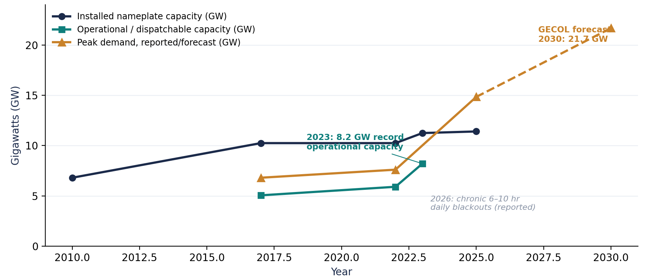
Figure 1. Libya electricity capacity vs. demand trend, 2010–2030.

1.3 Gas supply constraints behind the generation deficit
Libya's gross natural gas production reached a record high of roughly 3,400 MMscfd in 2019 but has fluctuated since with recurring upstream and security disruptions; associated gas (produced alongside crude oil) accounts for about 40% of total output, tying gas availability directly to oil-field operating status. Critically, less than half of gross gas output ever reaches the market: large volumes are reinjected into oil reservoirs for enhanced recovery, flared, or consumed in field operations and processing. Marketed gas available for domestic consumption and export represented only about 45% of gross production in 2025.
Domestic gas consumption overwhelmingly driven by the power sector has risen steadily from around 788 MMscfd in 2015 to more than 1,150 MMscfd in 2025, absorbing an ever-larger share of a marketed-gas pool that has been largely stagnant. This has directly squeezed export availability: Green Stream pipeline exports to Italy have fallen from nearly 700 MMscfd in 2015 to less than 100 MMscfd in 2025, against a nominal pipeline capacity of 775 MMscfd. Gas flaring remains a further source of inefficiency, averaging 614 MMscfd in 2024 before NOC's flare-gas-recovery programme cut it to approximately 514 MMscfd in 2025, with a further 120 MMscfd reduction targeted for 2026 and a 60% cut from current levels targeted by 2030.
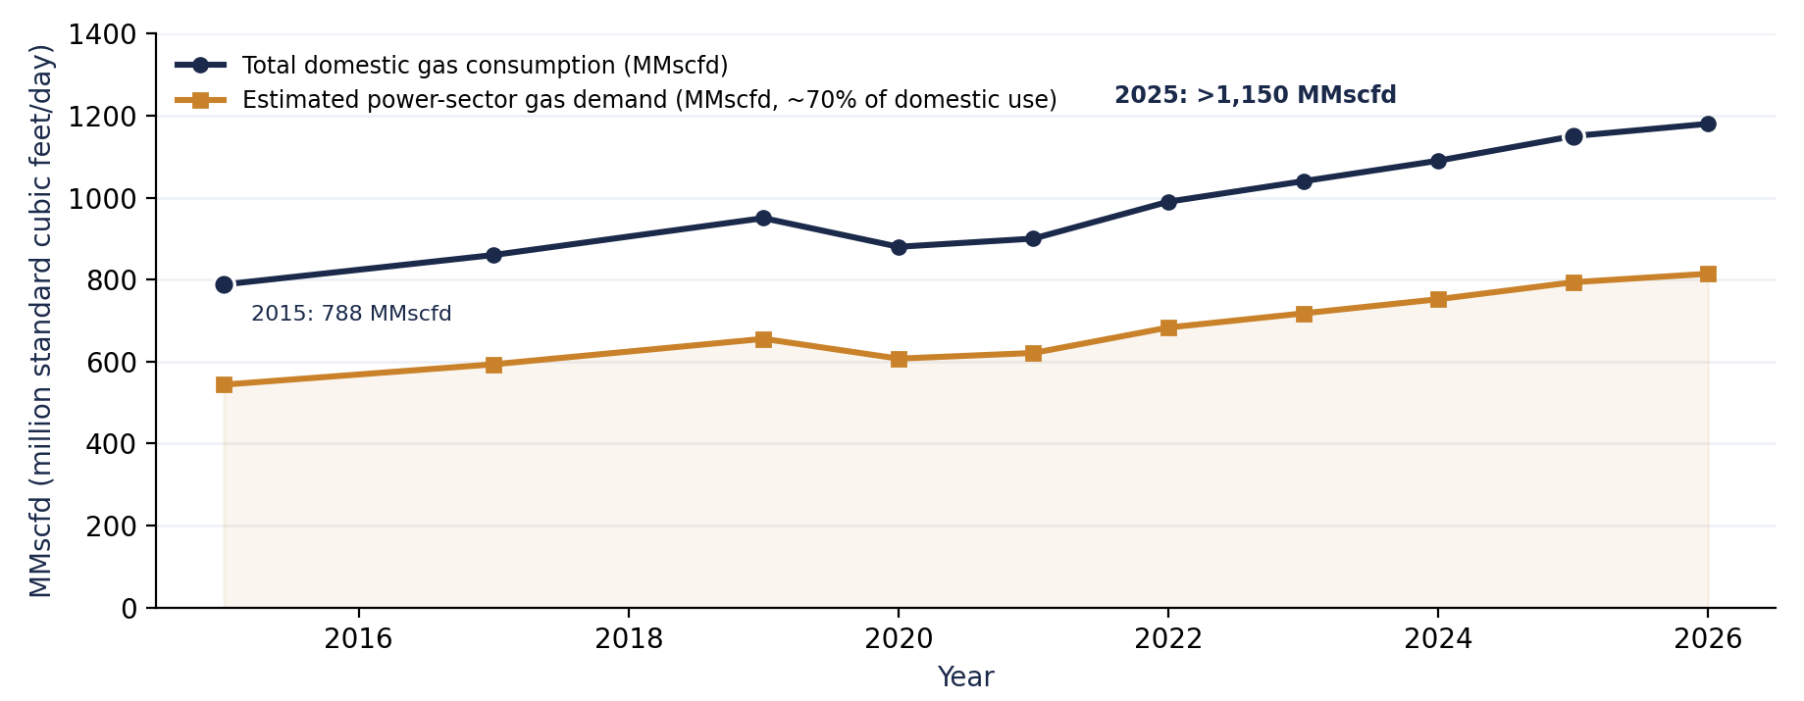
Figure 2. Libya domestic gas consumption and estimated power-sector gas demand, 2015–2026.

1.4 Major inefficiencies identified
- Fleet-level heat-rate gap: a substantial share of dispatched capacity remains simple-cycle OCGT (E-class and F-class gas turbines at Tripoli West, Misrata and other sites), burning 30–38% more gas per MWh than combined-cycle configurations of comparable turbine class.
- Reduced part-load and forced-outage performance: aging units and deferred maintenance (GECOL's own reporting cites units that should be retired on end-of-useful-life grounds) push effective heat rates above nameplate design values.
- Fuel-source mismatch: when gas supply is curtailed including through deliberate pipeline closures during localized security incidents units revert to oil firing, which is both less efficient in this application and diverts crude that could otherwise be exported or refined.
- Marketed-gas bottleneck upstream of the power sector: only ~45% of gross gas production reaches any end use, meaning power-sector efficiency gains compound with upstream monetization gains rather than substituting for them.
- Subsidized, non-cost-reflective tariffs: GECOL recovers only a small fraction of operating costs from consumer tariffs, removing normal price signals that would otherwise incentivize efficiency investment and demand-side management.
2. Technical Assessment of CCGT Integration

2.1 Thermodynamic basis: why combined cycle outperforms simple cycle
A simple-cycle (open-cycle) gas turbine (OCGT) operates on the Brayton cycle alone: air is compressed, mixed with fuel and combusted, and the resulting hot, high-pressure gas expands through the turbine to drive a generator. A large fraction of the fuel's energy typically 55–65% exits as hot exhaust gas and is discarded. A combined-cycle gas turbine (CCGT) captures that exhaust heat in a heat recovery steam generator (HRSG), raising steam that drives a second, Rankine-cycle steam turbine coupled to the same or a separate generator. Because the steam turbine produces additional electricity from heat that would otherwise be wasted, combined-cycle plants convert a substantially larger share of fuel energy into electricity without burning any additional gas.
International benchmarks illustrate the scale of the gap. Current F-class gas turbines run at 36–38.5% simple-cycle efficiency (LHV) but 56–58% in combined-cycle configuration. IPIECA's efficiency compendium places typical onshore CCGT overall efficiency at approximately 60%, against 33–43% for simple-cycle gas turbines at maximum load (with simple-cycle efficiency dropping further at part load). The most advanced H-class combined-cycle installations such as GE's 9HA.01 unit at EDF's Bouchain plant in France have demonstrated net electrical efficiencies above 62%, a Guinness World Record at the time of commissioning.

2.2 Heat rate and gas consumption benchmarks
Expressed as heat rate (fuel energy input per unit of electricity output), the efficiency gap translates directly into fuel savings. U.S. EIA capital-cost assumptions and NREL Annual Technology Baseline data used here as internationally comparable benchmarks in the absence of published Libya-specific plant heat rates place typical simple-cycle combustion turbines (CT) at roughly 9,300–10,500 Btu/kWh (HHV basis) and typical natural gas combined-cycle (NGCC) plants at 6,300–6,600 Btu/kWh. Converting these heat rates to gas volume using a representative pipeline-quality natural gas heating value of approximately 1,030 Btu/scf yields the gas-consumption-per-MWh comparison in Figure 4.
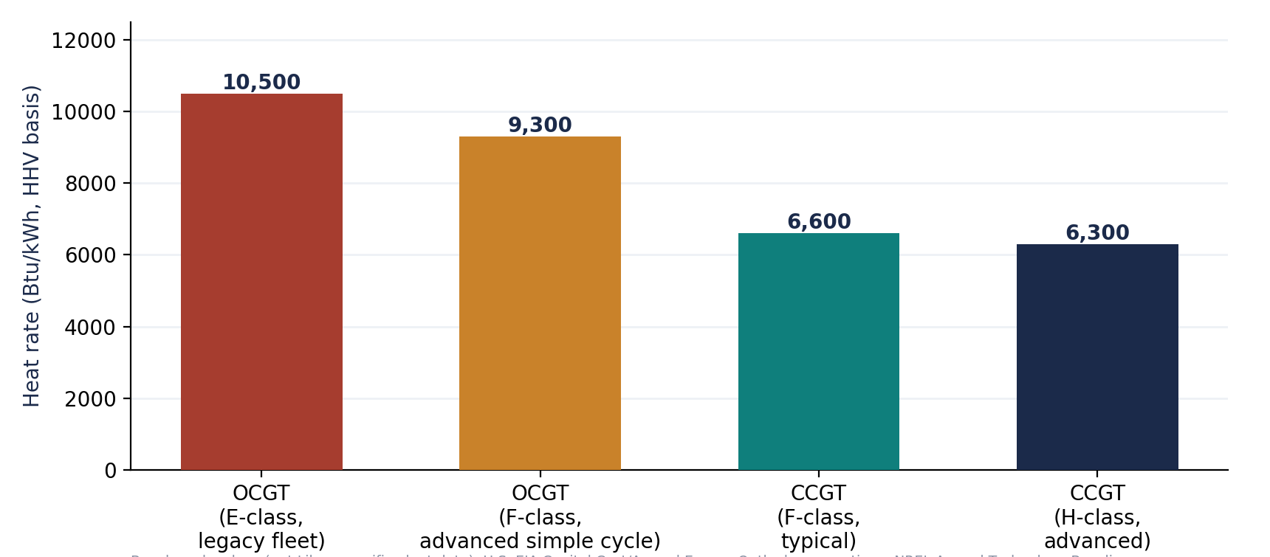
Figure 3. International benchmark heat rates, OCGT vs. CCGT (HHV basis).
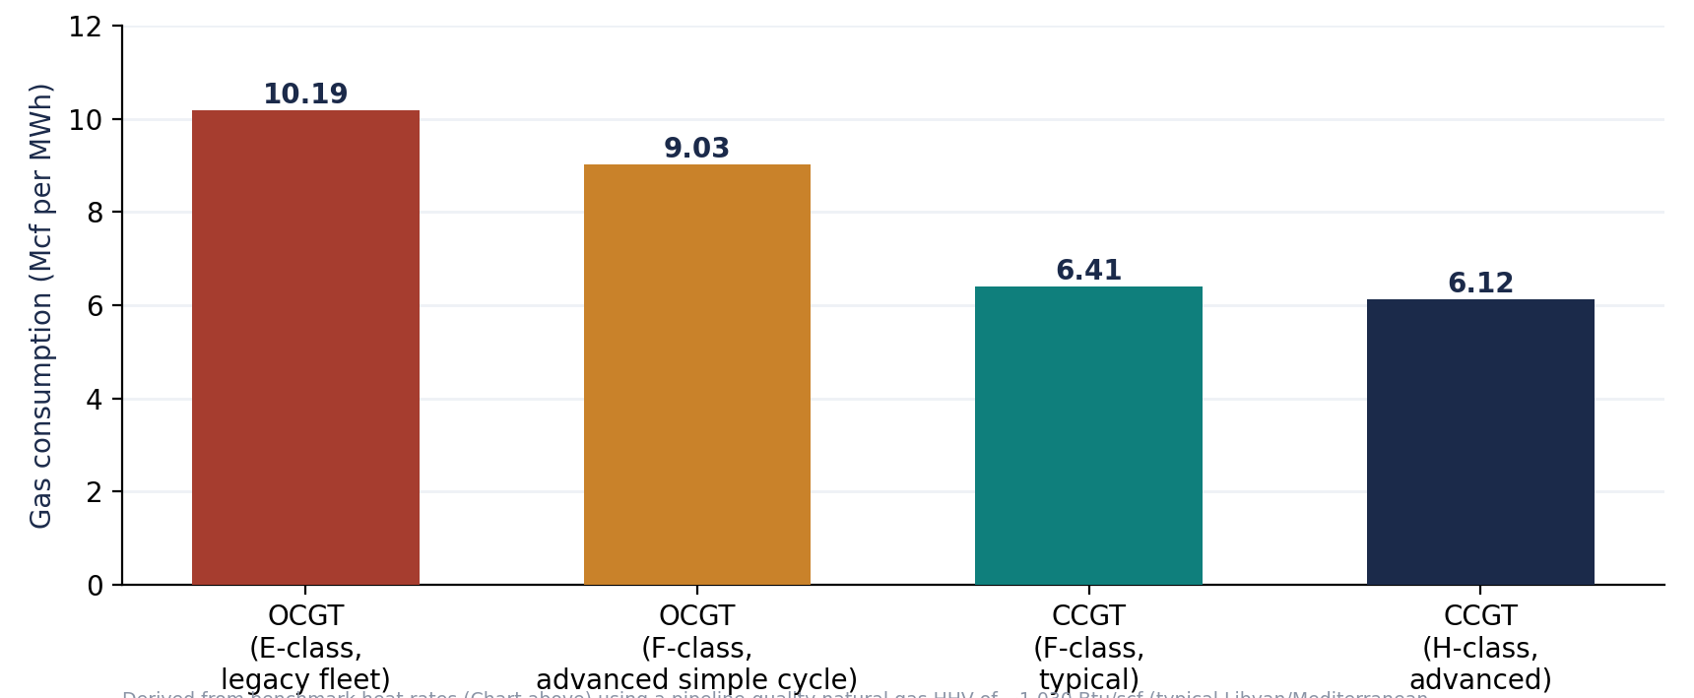
Figure 4. Derived natural gas consumption per MWh generated, OCGT vs. CCGT
The practical implication is stated most simply in output terms: for the same volume of gas consumed, a modern F-class CCGT can generate roughly 50–55% more electricity than a comparable-vintage OCGT, and an advanced H-class CCGT roughly 65–70% more (Figure 5). Equivalently, meeting a fixed generation target with CCGT rather than OCGT reduces the gas volume required by 30–38%.
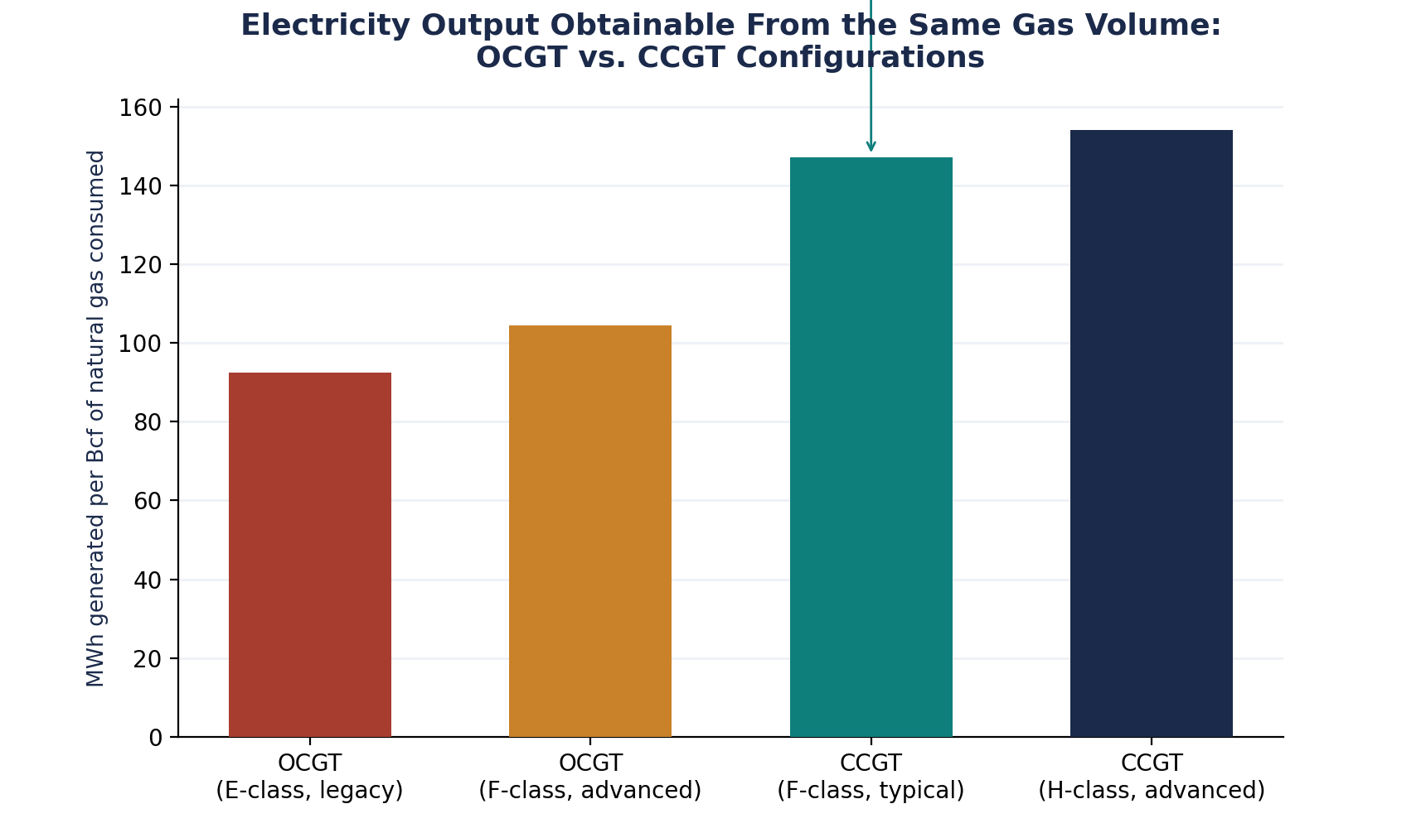
Figure 5. Electricity output obtainable from the same gas volume, OCGT vs. CCGT configurations

Across a broader range of internationally deployed CCGT technology classes, gas consumption intensity falls steadily and predictably as combined-cycle net efficiency rises — from around 7.1 Mcf/MWh for older E-class-based combined-cycle plants to roughly 5.7–5.9 Mcf/MWh for the most advanced H-class installations. No reliable plant-level efficiency data is publicly available for Libya's own combined-cycle asset (Al-Zawiya CCPP), which is precisely why an independent efficiency audit is recommended in Section 8.4.
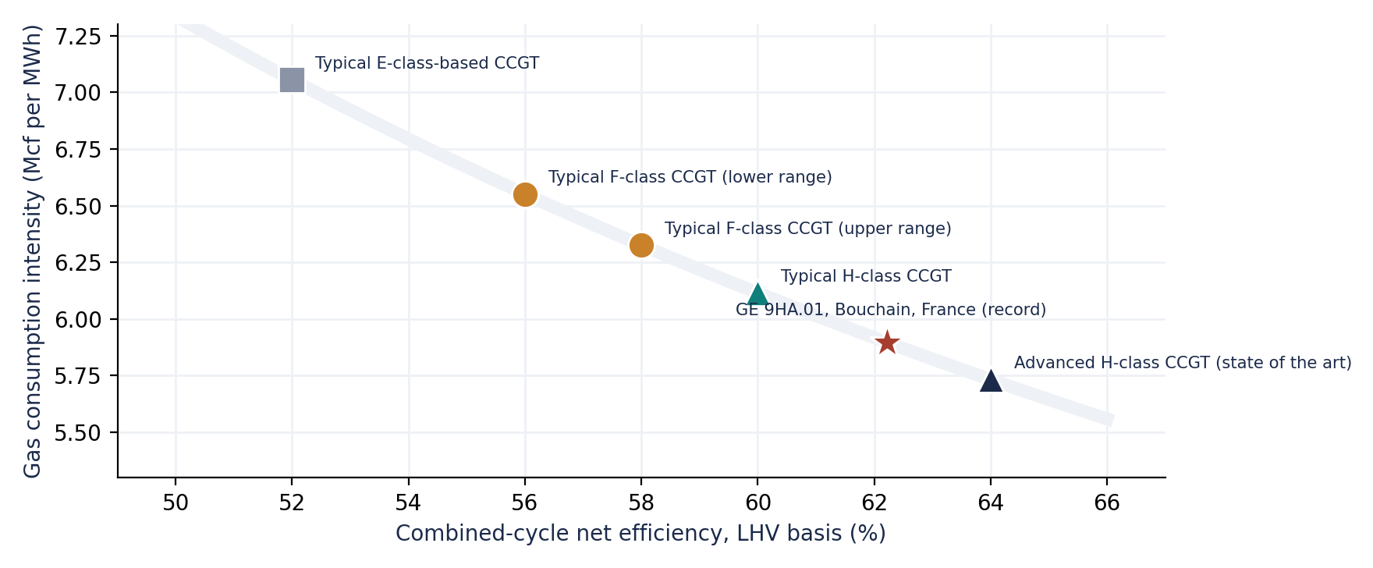
Figure 5b. CCGT efficiency vs. gas consumption intensity across representative international reference plants.

2.3 Configuration choices relevant to Libya

Single-shaft vs. multi-shaft
Single-shaft CCGT designs couple one gas turbine, one HRSG and one steam turbine on a common shaft with a single generator; they offer a smaller footprint, lower balance-of-plant cost and faster field erection, but less operational flexibility since the gas turbine cannot easily be dispatched independently of the steam cycle. Multi-shaft designs (typically 2:1 or 3:1 gas-turbine-to-steam-turbine configurations) allow the steam turbine and HRSGs to be added after gas turbines are already in simple-cycle operation directly relevant to Libya, where several OCGT islands (Tripoli West, Misrata) were already built with combined-cycle-ready siting and could in principle be converted to multi-shaft CCGT by adding HRSGs and a steam turbine without replacing the existing gas turbines.

Air-cooled vs. water-cooled condensing
The steam-cycle condenser in a CCGT requires a heat sink. Water-cooled (once-through or cooling-tower) systems achieve the highest steam-cycle efficiency but require reliable access to seawater or large freshwater volumes; air-cooled condensers avoid this dependency at the cost of several percentage points of cycle efficiency and higher capital cost, and are more sensitive to ambient temperature. Libya's coastal plant sites (Tripoli West, Misrata, Zawiya, South Tripoli, Zliten) are well positioned for seawater-cooled condensing, which should be the default configuration for coastal CCGT capacity; inland or southern sites (e.g., Sebha, Ubari) would likely require air-cooled or hybrid condensing given limited water availability.

Ambient temperature and turbine degradation
Gas turbine output and efficiency both decline as ambient (compressor inlet) air temperature rises, because hotter, less dense air reduces mass flow through the compressor. Libya's summer peak-demand season coincides precisely with its highest ambient temperatures 2026 saw temperatures reach 50°C meaning the gas turbine component of any CCGT will lose a meaningful fraction of rated output exactly when the grid needs it most. Inlet air cooling (evaporative or mechanical chilling) is a standard mitigation used in comparable hot-climate CCGT installations across North Africa and the Gulf and should be evaluated for new Libyan CCGT capacity. Coastal and desert dust loading also accelerates compressor fouling and hot-gas-path degradation, raising maintenance frequency and part-load derating relative to temperate-climate benchmarks; this should be reflected in O&M cost assumptions (Section 5) above generic international averages.

Start-up characteristics and minimum stable generation
CCGT plants require longer start-up sequences than OCGT the HRSG and steam turbine must be brought up in a controlled thermal ramp to avoid stress-related damage, typically 60–180 minutes for a warm start versus single-digit minutes for an OCGT peaker. This matters for Libya's dispatch planning: OCGT capacity retains clear value for fast-start, black-start and peaking duty (particularly given the frequency of unplanned outages and pipeline disruptions described in Section 1), while CCGT is better suited to baseload and mid-merit duty where it can run at high-capacity factor and capture its full fuel-efficiency advantage. A blended fleet strategy CCGT for base/mid-merit load, retained or rehabilitated OCGT for peaking and black-start is likely to outperform either technology deployed exclusively.

2.4 OCGT vs. CCGT technical comparison
Indicator | OCGT (simple cycle) | CCGT (combined cycle)
Thermal efficiency (LHV) | 33–43% at max load; drops sharply part-load | 50–64%; ~60% typical onshore, up to 62%+ for record H-class units
Heat rate (HHV benchmark) | 9,300–10,500 Btu/kWh | 6,300–6,600 Btu/kWh
Gas consumption per MWh (benchmark) | ~9.0–9.9 Mcf/MWh | ~6.1–6.4 Mcf/MWh
Relative capital cost | Lower ($/kW) | Higher ($/kW), but lower $/MWh at high-capacity factor
Start-up time | Minutes (fast-start capable) | 60–180 min (warm start); slower than OCGT
Part-load efficiency | Degrades quickly below ~50% load | Better retention, though still degrades below design load
CO2 emissions per MWh | Highest among gas-fired options | ~30–40% lower than comparable OCGT
Best grid application | Peaking, black-start, fast reserve | Baseload / mid-merit, high-capacity factor duty

3. Gas Consumption Optimisation Potential

3.1 Distinguishing total consumption from consumption intensity
A CCGT repowering programme does not, by itself, reduce Libya's total gas consumption if electricity demand keeps growing it reduces gas consumption intensity (gas burned per MWh generated). Whether total power-sector gas demand falls, flattens or simply grows more slowly than it otherwise would depends on the balance between efficiency gains and demand growth. This distinction matters for planning: CCGT deployment should be evaluated primarily as a tool for meeting more of Libya's growing electricity demand from a given (or slower-growing) gas allocation, freeing the difference for higher-value uses, rather than as a lever that mechanically shrinks the country's gas bill in absolute terms.

3.2 Illustrative scenario modelling, 2026–2040
The scenarios below are original illustrative modelling constructed for this note using the benchmark heat-rate differentials from Section 2, an estimated 2026 power-sector gas baseline of approximately 810 MMscfd (derived from the ~70% gas-generation share and domestic consumption trend in Section 1), and indicative assumptions about the pace of fleet conversion and demand growth. They are explicitly not official GECOL, NOC or government projections, and should be read as directional rather than predictive.
- Business-as-usual (BAU): no material shift toward combined-cycle capacity; power-sector gas demand grows roughly in line with assumed 5%/year generation growth, reaching an estimated ~1,600 MMscfd by 2040.
- CCGT repowering: the share of thermal generation served by combined-cycle capacity rises progressively roughly 30% by 2030, 60% by 2035, 85% by 2040 through a mix of new-build CCGT, brownfield HRSG/steam-turbine addition at existing OCGT sites, and prioritised commissioning of pipeline projects as combined-cycle. Estimated 2040 gas demand: ~1,120 MMscfd, roughly 30% below BAU.
- CCGT combined with renewable generation: adds indicative solar PV and demand-side efficiency measures that reduce thermal generation growth by a further ~20% on top of the repowering pathway, alongside a shift toward more advanced (H-class) CCGT technology. Estimated 2040 gas demand: ~950 MMscfd, roughly 41% below BAU.
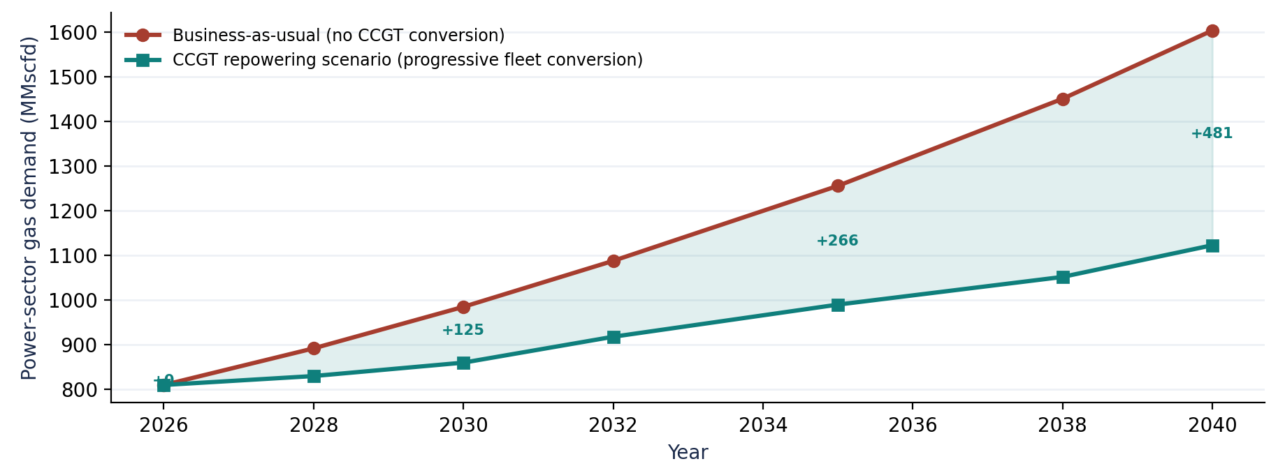
Figure 6. Illustrative power-sector gas demand and cumulative gas savings under CCGT repowering, 2026–2040.
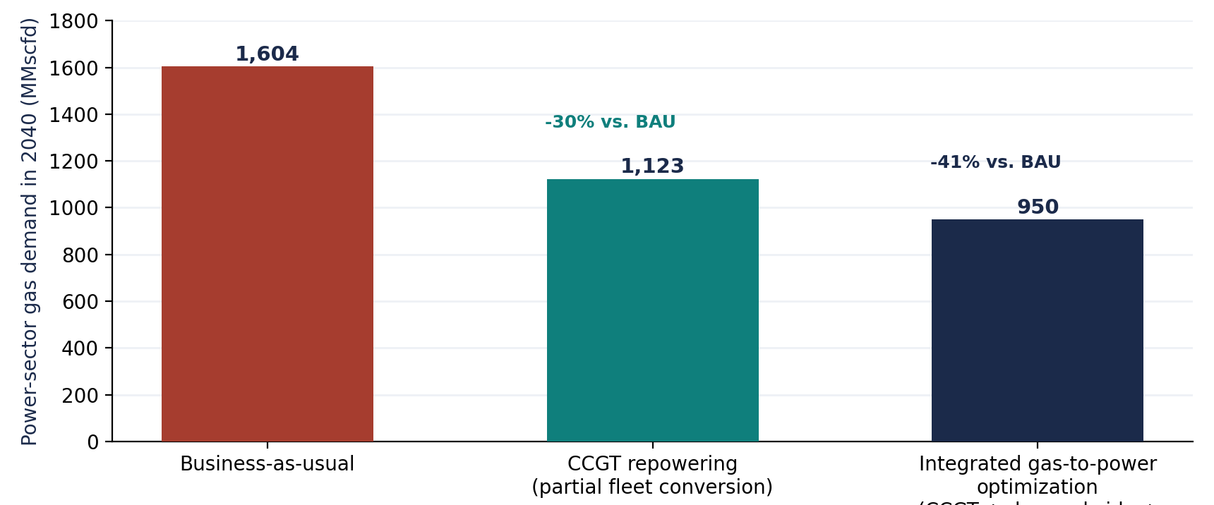
Figure 7. 2040 power-sector gas demand under three illustrative development pathways.

3.3 Reading the scenario range
Even under conservative assumptions, the gap between the business-as-usual and CCGT-repowering pathways widens from negligible in the near term to on the order of 300–480 MMscfd by the mid-to-late 2030s a volume comparable to the entire Green Stream pipeline's design export capacity of 775 MMscfd, or to several times the annual flare-gas-recovery targets NOC has set for 2026–2030. This underlines that power-sector efficiency and upstream supply-side measures (flare reduction, new field development) are complementary rather than competing levers on Libya's gas balance: efficiency buys time and headroom while upstream investment matures over its typical seven-to-eight-year development horizon.

4. Libya's Existing Power Infrastructure and CCGT Integration Potential

4.1 Existing and committed generation assets
Libya's generation fleet is more combined-cycle-ready than is often assumed. GECOL already operates at least one combined-cycle facility the Al-Zawiya Combined Cycle Power Plant (Al-Zawia CCPP) alongside the six-unit Western Mountain gas power plant, both of which have been the subject of published operational assessments covering the 2019–2020 period. Several of the country's largest simple-cycle assets were engineered by the same contractors (Siemens Energy, ENKA) that build combined-cycle plants elsewhere, using turbine frames (SGT5-PAC 2000E, F-class units) that are routinely deployed in combined-cycle service internationally.
Facility | Capacity | Configuration / status | Technology
Tripoli West | 671–748 MW | Simple-cycle, operational since 2023 | 4x Siemens SGT5-PAC 2000E (E-class), dual-fuel
Misrata | 650 MW | Simple-cycle (Siemens contract) | 2x F-class gas turbines
South Tripoli | 1,320 MW | Gas-fired; final commissioning stage, 2026 | 4 units, Siemens/Çalık EPC
Zliten Emergency Power Plant | 1,044 MW | Under construction from 2025; targeted 2026 operation | 6 units, Siemens turbines; UCC/Elsewedy EPC
Ubari | 640 MW | Revamped from crude oil to natural gas firing | 4 units (ENKA-built)
Al-Zawiya CCPP | n/a (existing) | Operating combined-cycle plant | Existing HRSG + steam turbine
Mellitah / Misrata (Daewoo contract) | n/a | Planned, $790m EPC contract | Gas-fired, contractor: Daewoo E&C
Benghazi CCGT | Up to 1,500 MW | Planned / early development | Combined-cycle (flagship project)

An additional ~6,075 MW of capacity is planned across Sebha, Derna, Tripoli, Khoms, Tobruk and Benghazi through 2030, alongside GECOL's 20-strategic-projects programme targeting grid bottlenecks in the Jabal Al-Akhdar and Al-Batnan regions of eastern Libya.

4.2 Suitability assessment for CCGT integration

Brownfield conversion candidates
Tripoli West and Misrata are the strongest near-term brownfield conversion candidates: both are coastal (supporting seawater-cooled condensing), both use turbine frames with well-established combined-cycle reference designs from their OEMs, and both sit close to the Mellitah gas processing and transmission corridor that supplies western Libya's grid. Multi-shaft HRSG and steam-turbine addition at these sites would not require replacing existing gas turbines, shortening the engineering and permitting timeline relative to a greenfield project.

New-build priority
Committed but not-yet-operational projects South Tripoli, Zliten, and the Daewoo-contracted Mellitah/Misrata units represent the highest-value near-term opportunity to lock in combined-cycle configuration before construction is finalized. Where these projects are already committed as simple-cycle, GECOL and its EPC partners should evaluate late-stage design amendment to combined-cycle-ready (space-reserved, multi-shaft) configuration, since retrofitting after commissioning is markedly more expensive than designing HRSG and steam-turbine provision in from the outset. The planned 1.5 GW Benghazi facility, explicitly conceived as a CCGT, should be treated as the reference design for subsequent eastern-Libya capacity.

Transmission, substation and gas-pipeline connectivity
Western Libya's grid is comparatively well served by the Mellitah gas processing complex and associated transmission infrastructure, but remains vulnerable to localized disruption: GECOL has reported units at the Zawiya plant forced offline after an armed group closed the feeding gas pipeline, illustrating that gas-supply security is as much a security and governance issue as an engineering one. Eastern and southern Libya faces a different constraint profile greater reliance on revamped crude-to-gas conversions (as at Ubari) and longer transmission distances from processing hubs meaning CCGT integration in these regions should be sequenced alongside, not ahead of, gas gathering and transmission investment (Section 6).

Rehabilitation requirements
GECOL's own assessments have identified units that are candidates for retirement on end-of-useful-life grounds; combined-cycle conversion is not a substitute for retiring genuinely obsolete units, and a fleet-wide condition assessment should precede any conversion investment decision to avoid retrofitting HRSGs onto gas turbines that are themselves near end of economic life.

5. CCGT Economics and Investment Requirements

5.1 Capital cost benchmarks
No published Libya-specific CAPEX data for CCGT or OCGT construction is available; the figures below are drawn from U.S. EIA capital-cost assumptions and NREL's Annual Technology Baseline, and should be treated as internationally comparable reference points rather than Libya-specific quotations. Global gas-turbine equipment costs have risen sharply since 2023 amid tight OEM order books, and the ranges below reflect that volatility.
Technology | Overnight capital cost (benchmark) | Heat rate (HHV benchmark) | Fixed O&M (benchmark)
Simple-cycle CT | $562–$1,427/kW (2023–2027 vintage, rising) | 9,300–10,500 Btu/kWh | ~$17.5/kW-yr (reference)
1x1 CCGT (F-class) | ~$824–$978/kW (EIA/S&L reference); market quotes now often $1,600–$2,000+/kW | 6,300–6,600 Btu/kWh | ~$10–$12/kW-yr (reference)

Two points bear emphasis for Libya specifically. First, CCGT's higher capital cost per kW is, in most gas-price and capacity-factor environments, more than offset by its lower fuel cost per MWh once the plant runs at moderate-to-high-capacity factor the crossover point depends on the implicit or opportunity-cost value assigned to the gas saved, discussed in Section 5.3. Second, current global gas-turbine and HRSG supply constraints mean lead times and pricing should be locked in early via long-term OEM framework agreements (as GECOL has already done with Siemens Energy and Daewoo) rather than assumed at historical benchmark pricing.

5.2 Rehabilitation, conversion and new-build comparison
Option | Relative CAPEX | Timeline | Gas-efficiency outcome | Key risk
OCGT rehabilitation (like-for-like) | Lowest | Shortest (12–24 months) | None — preserves existing heat rate | Locks in inefficiency for the rehabilitated unit's remaining life
OCGT-to-CCGT conversion (brownfield HRSG + steam turbine) | Moderate | 24–36 months | Large — captures most of the CCGT efficiency gain on existing GT fleet | Requires GT condition suitable for extended remaining life; site space for HRSG/steam island
New-build CCGT (greenfield or on committed project sites) | Highest upfront, lowest $/MWh at scale | 36–48 months | Largest — latest-generation turbine class achievable | Longest lead time; financing and EPC contracting risk
CCGT + renewable generation (hybrid) | Highest combined, but CCGT scaled to firm/mid-merit role | Phased | Largest system-wide — reduces thermal run-hours as well as heat rate | Grid flexibility and storage/curtailment management needed as renewables share rises

For Libya's immediate circumstances acute capacity shortfall, committed projects already in construction, and constrained fiscal capacity OCGT-to-CCGT conversion at Tripoli West and Misrata, combined with ensuring South Tripoli, Zliten and the Daewoo-contracted units are specified as combined-cycle where not already committed otherwise, represents the strongest near-term balance of cost, timeline and efficiency outcome. Greenfield new-build CCGT (Benghazi and subsequent eastern capacity) remains the right long-run technology choice once financing is secured.

5.3 The tariff-subsidy constraint and the opportunity-cost case
A conventional LCOE or payback-period analysis assumes that efficiency investment is repaid through electricity sales revenue. This framework does not hold cleanly in Libya: GECOL's tariffs are heavily subsidized, and the utility has been reported to recover only a small fraction on the order of one-tenth of its operating costs from consumer billing. Under these conditions, a CCGT investment's fuel savings do not show up as incremental utility revenue; they show up as reduced fiscal subsidy burden on the state (since GECOL's operating losses and gas allocation are ultimately state-funded or state-allocated) and as gas volumes that become available for direct monetization outside the power sector.
This reframes the appropriate economic test for CCGT investment in Libya: rather than asking whether electricity sales repay the incremental CAPEX, policymakers should ask whether the market or opportunity-cost value of the gas saved exceeds the incremental capital and O&M cost of combined-cycle over simple-cycle configuration. Given that Libya's marketed gas is scarce relative to demand and that even modest export recovery on Green Stream would represent meaningful revenue, this opportunity-cost case is very likely to be strongly positive, even before accounting for the reliability and blackout-reduction value of additional firm capacity.

6. Gas Infrastructure and Energy System Integration

6.1 Upstream and midstream context
Libya's gas balance is tightening structurally, not just cyclically. NOC expects production from the major Bahr Essalam and Wafa fields to decline from 2025, even as domestic demand keeps rising, and has set a target described in sector analysis as challenging of reaching 4 Bcf/d of production within three to five years, more than three times 2023 marketed output. The most concrete near-term supply addition is the $8 billion Structures A&E offshore development (Mellitah Oil & Gas, a 50-50 NOC/Eni joint venture in Block D), targeting first gas in 2027 and a combined plateau of approximately 750 MMscfd. This project only became fully financeable after Libya's rival legislative bodies approved a unified 190 billion Libyan dinar ($29.95 billion) state budget in April 2026 the first unified national spending framework in over 13 years which allocated 12 billion dinars ($1.9 billion) directly to NOC.
This upstream timeline matters directly for CCGT sequencing: Structures A&E gas will not reach the grid before 2027 at the earliest, meaning that near-term (2026–2027) improvements to Libya's electricity reliability must come predominantly from efficiency gains on existing gas allocations i.e., from CCGT conversion and rehabilitation rather than from new supply.

6.2 Coordination between gas and electricity dispatch
Libya's experience shows that gas-supply and electricity-supply risk are tightly coupled and, in the western region, exposed to localized security disruption: GECOL has reported units at the Zawiya plant forced offline after an armed group closed the gas pipeline feeding the facility. This is a distinct risk category from either a global heat-rate inefficiency or an upstream production decline, and argues for integrated gas-electricity operational planning shared visibility between NOC/gas transmission operators and GECOL's National Control Center over pipeline pressure, planned maintenance and security status, so that dispatch and fuel-switching decisions (including reversion to oil firing at dual-fuel units) can be made proactively rather than reactively.

6.3 Gas quality, pressure and treatment for CCGT service
CCGT gas turbines are generally more sensitive to fuel gas quality and inlet pressure consistency than simple-cycle units, particularly for advanced-class (F/H) turbines with tighter combustor tolerances. Libyan associated gas can carry higher levels of heavier hydrocarbons and impurities than lean pipeline-quality gas depending on field origin, which has implications for gas treatment and conditioning skids at CCGT sites; this should be assessed on a plant-by-plant basis as part of front-end engineering design, particularly for inland facilities drawing on less-processed field gas.

6.4 Seasonal demand and storage
Libya's peak electricity demand is strongly summer-weighted (linked to cooling load and, in 2026, an unusually severe heatwave reaching 50°C), while gas supply disruptions have historically clustered around security incidents and field-maintenance cycles that do not track the demand seasonality. Libya does not appear to operate significant dedicated gas storage for power-sector balancing; evaluating underground gas storage or LNG-based peak-shaving as increasingly used elsewhere in the Mediterranean basin would reduce the system's exposure to the coincidence of peak summer demand and unplanned supply interruption, complementing rather than substituting for the efficiency gains addressed in this note.

7. Strategic Gas Monetization Implications

7.1 The monetization paradox
Libya holds the fifth-largest proven natural gas reserves in Africa (approximately 26 Tcf per 2025 OPEC data) and EIA-estimated technically recoverable shale gas resources of roughly 122 Tcf comparable in scale to the Eastern Mediterranean's Levant Basin yet remains a relatively modest producer and an increasingly marginal exporter. In 2025, Libya's share of the European Union's gas import mix fell to just 0.3%. The core structural finding of Libyan gas-sector analysis is that this is a monetization problem, not a resource problem: rising domestic demand (driven overwhelmingly by an inefficient power sector), high flaring rates, and years of upstream underinvestment have steadily eroded export availability despite abundant underlying resources.

7.2 How power-sector efficiency changes the gas balance
Every Mcf of gas that CCGT deployment saves relative to continued OCGT operation is a Mcf that does not have to be extracted, processed and transmitted solely to be converted to electricity at a 33–43% simple-cycle efficiency and sold into a tariff structure that recovers only a fraction of cost. That same Mcf, redirected, could instead be:
- Processed into LPG or NGLs for domestic use or export typically capturing significantly higher value per Mcf than subsidized power generation;
- Used as feedstock for petrochemical or fertilizer production, supporting industrial diversification beyond crude oil and raw gas export;
- Supplied to industrial gas users directly, supporting non-power economic activity without competing with power-sector demand;
- Exported via the Green Stream pipeline to Italy, which is currently operating far below its 775 MMscfd design capacity and could accommodate meaningful additional volume without new pipeline capital investment;
- Retained as a buffer against the alternative scenario flagged by Libya specialists in which continued underinvestment in gas production capacity leaves Libya needing to import natural gas or LNG within a few years, reversing its historical position as a net exporter.

7.3 Opportunity cost of continued inefficient generation
The clearest way to frame the strategic stakes is in terms of foregone optionality. Gas burned in a legacy OCGT unit at a 9,300–10,500 Btu/kWh heat rate generates electricity sold into a tariff system that recovers only a fraction of GECOL's costs (Section 5.3); the same gas volume, saved through CCGT deployment and redirected to LPG/NGL processing or export, could generate revenue largely decoupled from Libya's domestic tariff economics and do so while a European market actively seeking to diversify away from Russian pipeline gas remains structurally receptive to additional nearby, low-transport-cost supply from Libya. NOC's own flare-gas-recovery programme (targeting a 60% flaring reduction by 2030) demonstrates institutional recognition of exactly this monetization logic applied further upstream; extending that logic through the power sector via CCGT deployment is the natural downstream complement.

7.4 Regional integration considerations
Beyond direct EU exports, Libya's extensive pipeline infrastructure and Mediterranean location position it as a potential alternative transit route for the proposed Nigeria-Niger-Libya pipeline concept, which has traditionally focused on Algeria and the Trans-Saharan Gas Pipeline as the export gateway. Any such role would depend on Libya first stabilizing its own domestic gas balance for which power-sector efficiency gains are a necessary, though not sufficient, condition before it could credibly offer meaningful transit or blending capacity to third-country gas.

8. System Integration Overview and Key Findings

8.1 System flow: from gas production to monetization
The diagram below summarizes the full value chain addressed in this note: gas moves from production through processing and transmission into generation, where the efficiency of that final conversion step determines how much gas is consumed per unit of electricity delivered and, by extension, how much gas remains available to redirect toward higher-value monetization pathways rather than being consumed by preventable thermal losses.
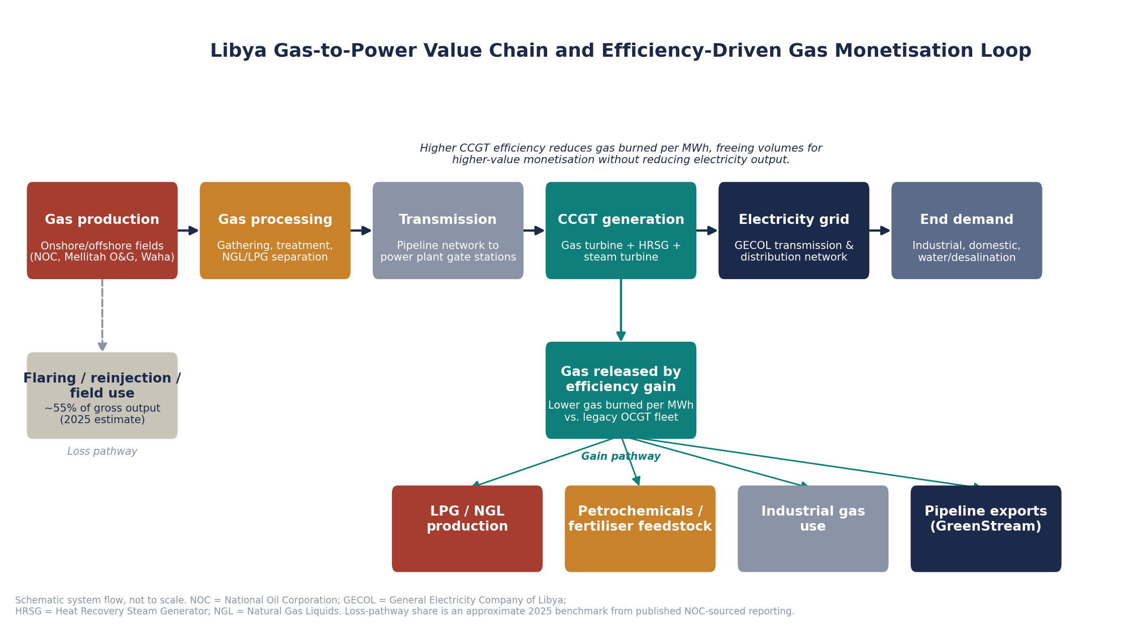
Figure 8. Libya gas-to-power value chain and efficiency-driven gas monetization.

8.2 Technology comparison summary
Attribute | OCGT | CCGT | Solar PV | Hybrid gas-renewable
Thermal/conversion efficiency | 33–43% | 50–64% | n/a (no fuel input) | Blended, improves with renewables share
Relative CAPEX ($/kW) | Lowest | Moderate–high | Low, falling | Higher (two asset classes)
Dispatchability | High — fast start | Moderate — slower start, best at high load factor | Low — weather-dependent, needs firming | High, with adequate firm/storage backup
Gas consumption impact | High per MWh | 30–38% lower per MWh than OCGT | Zero (displaces gas-fired MWh) | Reduces total gas burn beyond CCGT alone
Suited role in Libya's fleet | Peaking, black-start, remote/off-grid | Baseload / mid-merit, high-utilization duty | Daytime energy, fuel-saver alongside gas fleet | Long-run least-cost, least-gas-intensive pathway

8.3 Key findings
- Libya's electricity crisis in 2026 is fundamentally a gas-supply and gas-efficiency problem transmitted through a ~70%-gas-dependent generation mix, not simply an equipment-availability problem.
- A substantial share of Libya's dispatched thermal capacity remains simple-cycle, operating at an internationally benchmarked 30–38% higher gas consumption per MWh than combined-cycle configuration of comparable turbine class.
- Illustrative scenario modelling suggests a progressive CCGT conversion pathway could reduce 2040 power-sector gas demand by roughly 30% relative to business-as-usual, and by over 40% combined with demand-side efficiency and renewables directional estimates, not official projections.
- Libya already possesses combined-cycle-ready assets (Al-Zawiya CCPP, Tripoli West and Misrata turbine islands) and has committed but not-yet-configuration-locked projects (South Tripoli, Zliten, Daewoo-contracted units) where near-term CCGT specification decisions carry outsized long-run value.
- The domestic tariff structure cannot support a conventional revenue-based investment case for CCGT; the credible economic case rests on the opportunity cost of gas its value in LPG/NGL processing, petrochemical feedstock, industrial supply, and export rather than on electricity sales.
- Upstream supply additions (Structures A&E, flare-gas recovery) will not materially improve Libya's gas balance before 2027; CCGT conversion and rehabilitation of existing assets is the primary lever available to improve reliability and free gas value in the near term.
- Gas-electricity coordination shared operational visibility between NOC/gas transmission and GECOL dispatch is a distinct, non-technology risk factor given Libya's history of localized pipeline disruption affecting power plants directly.

8.4 Recommendations
- Commission a plant-by-plant engineering feasibility and condition assessment for HRSG/steam-turbine addition at Tripoli West and Misrata, the strongest brownfield CCGT conversion candidates.
- Review the design basis of not-yet-commissioned committed projects (South Tripoli, Zliten, Daewoo-contracted Mellitah/Misrata units) to confirm combined-cycle or combined-cycle-ready configuration before finalization, given the high cost of later retrofit.
- Treat the planned 1.5 GW Benghazi CCGT as the reference design and sequencing template for subsequent eastern and southern Libya capacity additions.
- Evaluate inlet air cooling and enhanced compressor filtration for all new and converted CCGT capacity, given Libya's high ambient temperatures and dust loading, which erode both output and efficiency relative to generic international benchmarks.
- Establish a shared operational data and coordination protocol between NOC/gas transmission operators and GECOL's National Control Center to manage gas-supply risk to power plants proactively.
- Reframe the CCGT investment case around the opportunity-cost value of gas saved (LPG/NGL, petrochemicals, export) rather than electricity tariff revenue, and route projected gas savings explicitly into NOC's downstream monetization and flare-recovery planning.
- Commission an independent Libya-specific plant-level heat-rate and efficiency audit; the international benchmarks used throughout this note should be replaced with measured Libyan data as soon as it becomes available, given the material differences hot, dusty coastal operating conditions can introduce relative to temperate-climate reference designs.
References and Data Sources
- U.S. Energy Information Administration (EIA), Country Analysis Brief: Libya (2024) and International Energy Data (eia.gov).
- U.S. Energy Information Administration, Capital Cost Estimates for Utility Scale Electricity Generating Plants; Annual Energy Outlook 2025 capital cost assumptions.
- National Renewable Energy Laboratory (NREL), Annual Technology Baseline (ATB), natural gas combined-cycle and combustion turbine cost and performance assumptions.
- General Electricity Company of Libya (GECOL), public statements via Libya Herald, Libya Observer and Libya Update (2022–2026).
- Libya Tribune / Minbar Libya, “Libya's Natural Gas Sector: Between Vast Potential and Structural Constraints,” June 2026.
- Middle East Eye, “‘We've run out of earthly solutions’: Inside Libya's electricity crisis,” August 2026.
- Libya Economic Review, “Libya's Electricity Crisis: Causes, Consequences, and the Path to Reform,” 2025.
- Oxford Institute for Energy Studies (OIES), “North Africa Gas,” Energy Comment, January 2025.
- Africa Energy Portal, Libya country profile (2023 installed capacity data).
- Siemens Energy, press releases and Combined Cycle Power Plants (CCPP) product documentation.
- ENKA İnşaat ve Sanayi A.Ş., Tripoli West Simple-Cycle Power Plant project documentation.
- IPIECA, “Combined-cycle gas turbines,” Energy Efficiency Compendium (2022).
- ScienceDirect / Elsevier, gas turbine combined-cycle engineering literature (efficiency and heat-rate benchmarks by turbine class).
- GridLab, “The New Reality of Power Generation: An Analysis of Increasing Gas Turbine Costs,” 2025.
- Global Energy Monitor, South Tripoli power station profile.
- IntechOpen, “Assessment of Power Plants in the Western Region of Libya during a Period of Insecurity,” covering Al-Zawiya CCPP and Western Mountain Power Plant.
- OPEC Annual Statistical Bulletin (2025 reserves data, as cited in Libya Tribune analysis).

