Balancing LNG Exports and Domestic Gas Development in Cameroon

Executive Summary
The commercial proposition for Cameroon’s natural gas is being reshaped as the country seeks to translate offshore resources into reliable domestic supply, industrial growth and new monetisation opportunities. The impending departure of the Hilli Episeyo FLNG vessel in July 2026 will eliminate the country's sole LNG export capability, triggering an estimated 16.1% contraction in oil and gas sector value in 2026 and a further 18.0% decline in 2027. However, three developments point to a broader, more diversified monetisation strategy taking shape:
- A February 2026 unitisation agreement with Equatorial Guinea unlocking the 2.5 Tcf cross-border Yoyo–Yolanda field under Chevron/Noble Energy operatorship
- A licensing round that has awarded five new upstream blocks to Murphy West Africa and Octavia Energy
- A pivot of upstream gas volumes from maritime LNG export toward the domestic market via the Bipaga Gas Processing Centre, expanding LPG supply and gas-to-industry sales.
The central strategic challenge for Cameroon is value creation optimisation: balancing the high-revenue, capital-intensive LNG export model against underexploited domestic monetisation pathways including gas-to-power, LPG, petrochemicals, and industrial feedstock. With proven gas reserves estimated at 160–200 billion cubic metres and significant undeveloped deepwater potential, Cameroon possesses the resource base to support a diversified gas economy but only if policy, financing, and technology transfer frameworks align.
LNG Exports and the Hilli Episeyo FLNG Project
The Hilli Episeyo FLNG (Floating Liquefied Natural Gas) facility, operated by Golar LNG under a tolling agreement with Société Nationale des Hydrocarbures (SNH) and Perenco Cameroon, has been the cornerstone of Cameroon's LNG export infrastructure since its commissioning in 2018. The vessel, converted from the LNG carrier Hilli, is moored offshore Kribi and processes gas from the Sanaga South and Ebome fields. The table below summarises the key technical and commercial parameters of the Hilli Episeyo project:
Parameters | Specification
Operator / owner | Golar LNG (Norway) — vessel, Perenco (France) — upstream operator, SNH — state partner
Feed gas source | Sanaga South and Ebomé fields, offshore Kribi
Start of operations | 2018 — first FLNG project in Central Africa
Nameplate capacity | 2.4 Mtpa LNG; actual run-rate 1.2–1.6 Mtpa
Offtake | 8-year agreement with Gazprom (sole offtaker)
Co-products | ~30,000–35,000 t/yr domestic LPG, ~5,000 bbl/d condensate
Charter status | Expired July 2026, vessel released for redeployment (reported: Argentina)

LNG export revenue peaked at roughly CFA622 billion in 2022 on high post-Ukraine-war TTF gas prices, before easing to about CFA350 billion in 2025 as prices normalised and the vessel neared contract expiry. Cameroon's National Economic and Financial Committee (CNEF) has flagged the vessel's July 2026 departure as a material drag on 2026–2027 GDP growth and export performance, projecting oil-and-gas sector output to contract sharply through 2027 before new supply comes on stream.
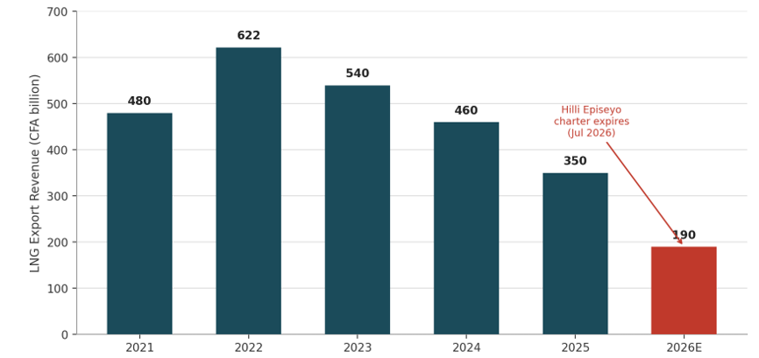
Figure 2. Cameroon LNG export revenue, (2021–2026)

Gas Monetisation Technologies and Future Pathways
With the FLNG export channel now closed, Cameroon's monetisation options fall into three groups: continue with the LNG/FLNG model once new gas is available (highest capital intensity and value-add, but a multi-year lead time); accelerate domestic conversion pathways (gas-to-power, LPG, CNG) that are faster to deploy and directly support industrialisation and import substitution; and pursue higher-value downstream integration (GTL, petrochemicals, fertiliser) that requires larger, more committed gas volumes and stronger institutional and financing capacity. Figure 3 shows Gas monetisation technologies plotted by relative capital intensity and downstream value-add

Liquefied Natural Gas (LNG) — Large-Scale & FLNG
Large-scale onshore LNG and FLNG represent the highest-capital, highest-reward monetisation pathways. The comparison between the two modalities is summarised below:
Attribute | Onshore LNG | FLNG (floating)
Capital Intensity | Very High ($10–15B for 2–3 MTPA) | High ($3–5B for 1–2 MTPA)
Resource Requirement | >5 Tcf proven reserves | 1–3 Tcf reserves
Development Timeline | 7–10 years | 4–6 years
Technology Transfer | Extensive (construction, operations, safety) | Moderate (marine + process integration)
Cameroon Suitability | Limited without major reserve additions | More suitable for stranded/deepwater fields

Gas-to-Liquids (GTL)
GTL converts natural gas into synthetic liquid fuels (diesel, naphtha, lubricants) via Fischer-Tropsch synthesis. While technologically proven (Shell Pearl, Qatar; Sasol, South Africa), GTL requires massive capital ($100,000+ per barrel per day of capacity), a large stable gas supply exceeding 1 Bcf/day, and a skilled workforce in chemical engineering and process control.

Compressed Natural Gas (CNG)
CNG offers a lower-capital alternative for gas transport, particularly for industrial offtake (cement, steel, mining operations), vehicle fuelling (bus and truck fleets), and virtual pipeline distribution to off-grid locations.

Liquefied Petroleum Gas (LPG)
LPG (propane/butane) is already Cameroon's most successful domestic gas monetisation pathway. The country has a rapidly growing LPG market driven by urbanisation and the government's "cooking gas" substitution policy (reducing firewood/charcoal use).

Gas-to-Power
Gas-to-power represents the highest domestic value creation potential for Cameroon. The country faces chronic electricity shortages (national access rate ~65%, rural access ~25%) and relies heavily on hydropower (Lagdo Dam, Song Loulou) which is vulnerable to climate variability.

Petrochemicals
Petrochemicals (methanol, ammonia, urea, polyethylene) represent the highest value-addition tier of gas monetisation but require significant capital and feedstock security.
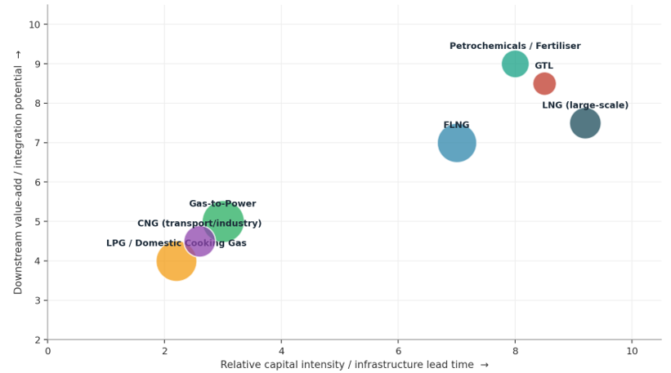
Figure 3. Gas Monetisation Technologies Plotted by Relative Capital Intensity and Downstream Value-add

Domestic Market Opportunities
With FLNG exports paused, Perenco and SNH are redirecting gas previously destined for Hilli Episeyo from Sanaga South and Ebomé to the Bipaga Gas Processing Centre onshore, prioritising LPG extraction for the state-subsidised domestic cooking-gas market and industrial gas supply, rather than shutting in the wells. This is a direct, near-term value-creation lever that substitutes imported LPG and diesel with domestic gas.

Gas-to-power
● Kribi Gas-Fired Power Plant: 216 MW (196 MW contractual capacity), operating since 2013, fed by Sanaga South gas; financed as a PPP involving AfDB, EIB, IFC, FMO, PROPARCO and BDEAC; supplies the Southern Interconnected Grid and is undergoing a Wärtsilä-led automation and reliability upgrade.
● Logbaba gas field (Douala): operated by SNH and Gaz du Cameroun, supplies industrial burners in the Bassa and Bonaberi districts, displacing higher-cost fuel oil and diesel for manufacturers.

Gas-to-industry
● Bipaga Gas Processing Centre: onshore facility supplying gas to the Keda Cameroon Ceramics plant under a 20-year, 3.5–6.5 MMscf/d supply agreement signed in 2022, one of the first anchor gas-to-industry contracts outside the power sector.
● Government's 2016 Industrialisation Master Plan positions gas-fed manufacturing (ceramics, cement, agro-processing) as a pillar of economic diversification and regional electricity supply.

LPG / clean cooking
● SNH's Bipaga depot is currently the sole source of domestically produced LPG, a 2016 LPG Masterplan envisages roughly €400 million in financing for an additional 7 million cylinders and expanded storage, transport and retail infrastructure.
● Government target: raise clean-cooking (LPG) penetration to 58% of households by 2035, reducing reliance on imported LPG and traditional biomass.
● Cylinder prices remain regulated via the Hydrocarbons Price Stabilisation Fund (CSPH), which currently fixes the 12.5 kg cylinder price at CFA6,500 to protect consumers from import-price volatility.

Future Outlook for Gas Monetisation
● 2026–2028: Transition gap: no active LNG export channel; revenue and growth headwinds as flagged by CNEF/IMF; gas redirected to Bipaga, Kribi power and Logbaba; focus on sustaining domestic value capture and advancing PSC negotiations on new blocks.
● 2027–2029: Pre-FID and early development: Yoyo–Yolanda technical and commercial studies, potential FID; new blocks move through exploration and appraisal; discussions continue on re-contracting a replacement FLNG vessel or onshore liquefaction option.
● 2030 and beyond: Second export wave (conditional): if Yoyo–Yolanda and/or new blocks reach FID and development on schedule, Cameroon could re-enter LNG export markets, potentially alongside expanded gas-to-power, LPG and early petrochemical/fertiliser investment, contingent on securing anchor financing and stronger local-content terms than in the first FLNG cycle.

Strategic Recommendations
- Prioritise Domestic Gas-to-Power: Fast-track 200–500 MW gas power at Kribi/Limbé with SNH-anchored gas supply agreements. This creates immediate value, jobs, and industrial demand.
- Secure FLNG Replacement: Engage Golar LNG or alternative FLNG providers for a second-generation FLNG unit by 2028–2029. Tie this to Yoyo-Yolanda gas supply.
- Expand LPG Domestic Production: Mandate LPG extraction from all new field developments, support mini-fractionation units to reduce import dependence.
- Develop Petrochemicals Anchor Project: Commission a feasibility study for a Kribi fertiliser plant (ammonia/urea). This addresses agricultural policy goals while creating stable gas demand.
- Strengthen Technology Transfer: Require IOC partners to establish local training centres and R&D partnerships with Cameroonian universities.
- Reform Gas Pricing Framework: Establish a domestic gas pricing mechanism that encourages upstream investment while ensuring power and industrial affordability.

