CONVERSION OF CAPTURED ASSOCIATED GAS INTO LIQUEFIED PETROLEUM GAS (LPG) AND NATURAL GAS LIQUIDS (NGLS) AT MARSA EL-BREGA
- Executive Summary
Libya's Sirte Basin currently flares over 3.8 BCM of rich Associated Petroleum Gas (APG) annually across major field clusters including Zelten (Nasser), Raguba, Hateiba, Lehib, and Waha. This practice not only generates severe carbon intensities (~7.4 Mt CO2e/year) but also represents a critical economic loss for a nation facing domestic LPG (cylinder) shortages and power grid load shedding.
The National Oil Corporation (NOC), in coordination with Sirte Oil Company (SOC), is advancing the modernization and brownfield expansion of the Marsa El-Brega Gas Processing Facility. By capturing and processing 150 to 250 MMSCFD of raw wet APG and 30,000 bpd of sour condensate, the upgraded complex will yield ~18,000 bpd of Liquefied Petroleum Gas (LPG: Propane/Butane), ~6,800 bpd of Natural Gas Liquids (NGLs/C5+ Condensate), and ~115 MMSCFD of dry treated sales gas.
Domestic Import Elimination & Carbon Offsetting
Upgrading Marsa El-Brega provides an immediate dual benefit: substituting $210M+ in annual imported bottled LPG with domestic supply managed by Brega Petroleum Marketing Company (BPMC), while directly serving NOC's Zero Routine Flaring (ZRF 2030) framework by abating over 5.2 Mt CO2e per year by 2028.

- Subsurface Feedstock & Plant Processing Architecture
2.1 Field Gathering & Gas Composition

The Marsa El-Brega gas processing complex acts as the centralized gathering terminal for Sirte Oil Company's main producing assets. Raw gas delivered via the 20-inch and 30-inch trunklines exhibits high liquid richness (GPM ~4.8 - 6.2 gal/MSCF) but contains significant sour contaminants (H2S up to 1,200 ppm and CO2 up to 4.5 mol%).

Table 1: Typical Feedstock Stream Composition - Brega Inlet Gas
Component Fraction | Mole % (Typical) | GPM (gal/MSCF) | Target Recovery Unit
Methane (C1) & Nitrogen (N2) | 72.5 % | N/A | Sales Gas Stream to Coastal Pipeline
Ethane (C2) | 11.2 % | 2.98 | Reboiler Fuel / Ethane Cracker Feed
Propane (C3) | 8.4 % | 2.31 | LPG Fractionation Column (De-propanizer)
Butanes (C4: i-C4 + n-C4) | 4.6 % | 1.45 | LPG Cylinder Blending (De-butanizer)
Pentanes+ (C5+ NGLs / Condensate) | 3.3 % | 1.26 | Stabilizer / Export Condensate Storage

2.2 Process Engineering Sequence
1. Gas Sweetening (MDEA): Raw APG passes through inlet receivers and a high-efficiency Methyl Diethanolamine (MDEA) amine unit to reduce H2S < 4 ppm and CO2 < 1.5 mol%.
2. Dehydration & Drying: Sweetened wet gas is routed through molecular sieve bed dehydrators to achieve a dew point below -100°C, preventing hydrate formation in downstream cryogenic stages.
3. Cryogenic NGL Extraction: Gas is chilled via mechanical propane refrigeration and high-differential turbo-expanders to extract >95% C3+ liquids from the methane stream.
4. Liquid Fractionation Train: Extracted liquid hydrocarbons flow through a sequential De-ethanizer, De-propanizer, and De-butanizer train to yield commercial grade Propane, Butane, and stabilized NGL (C5+).

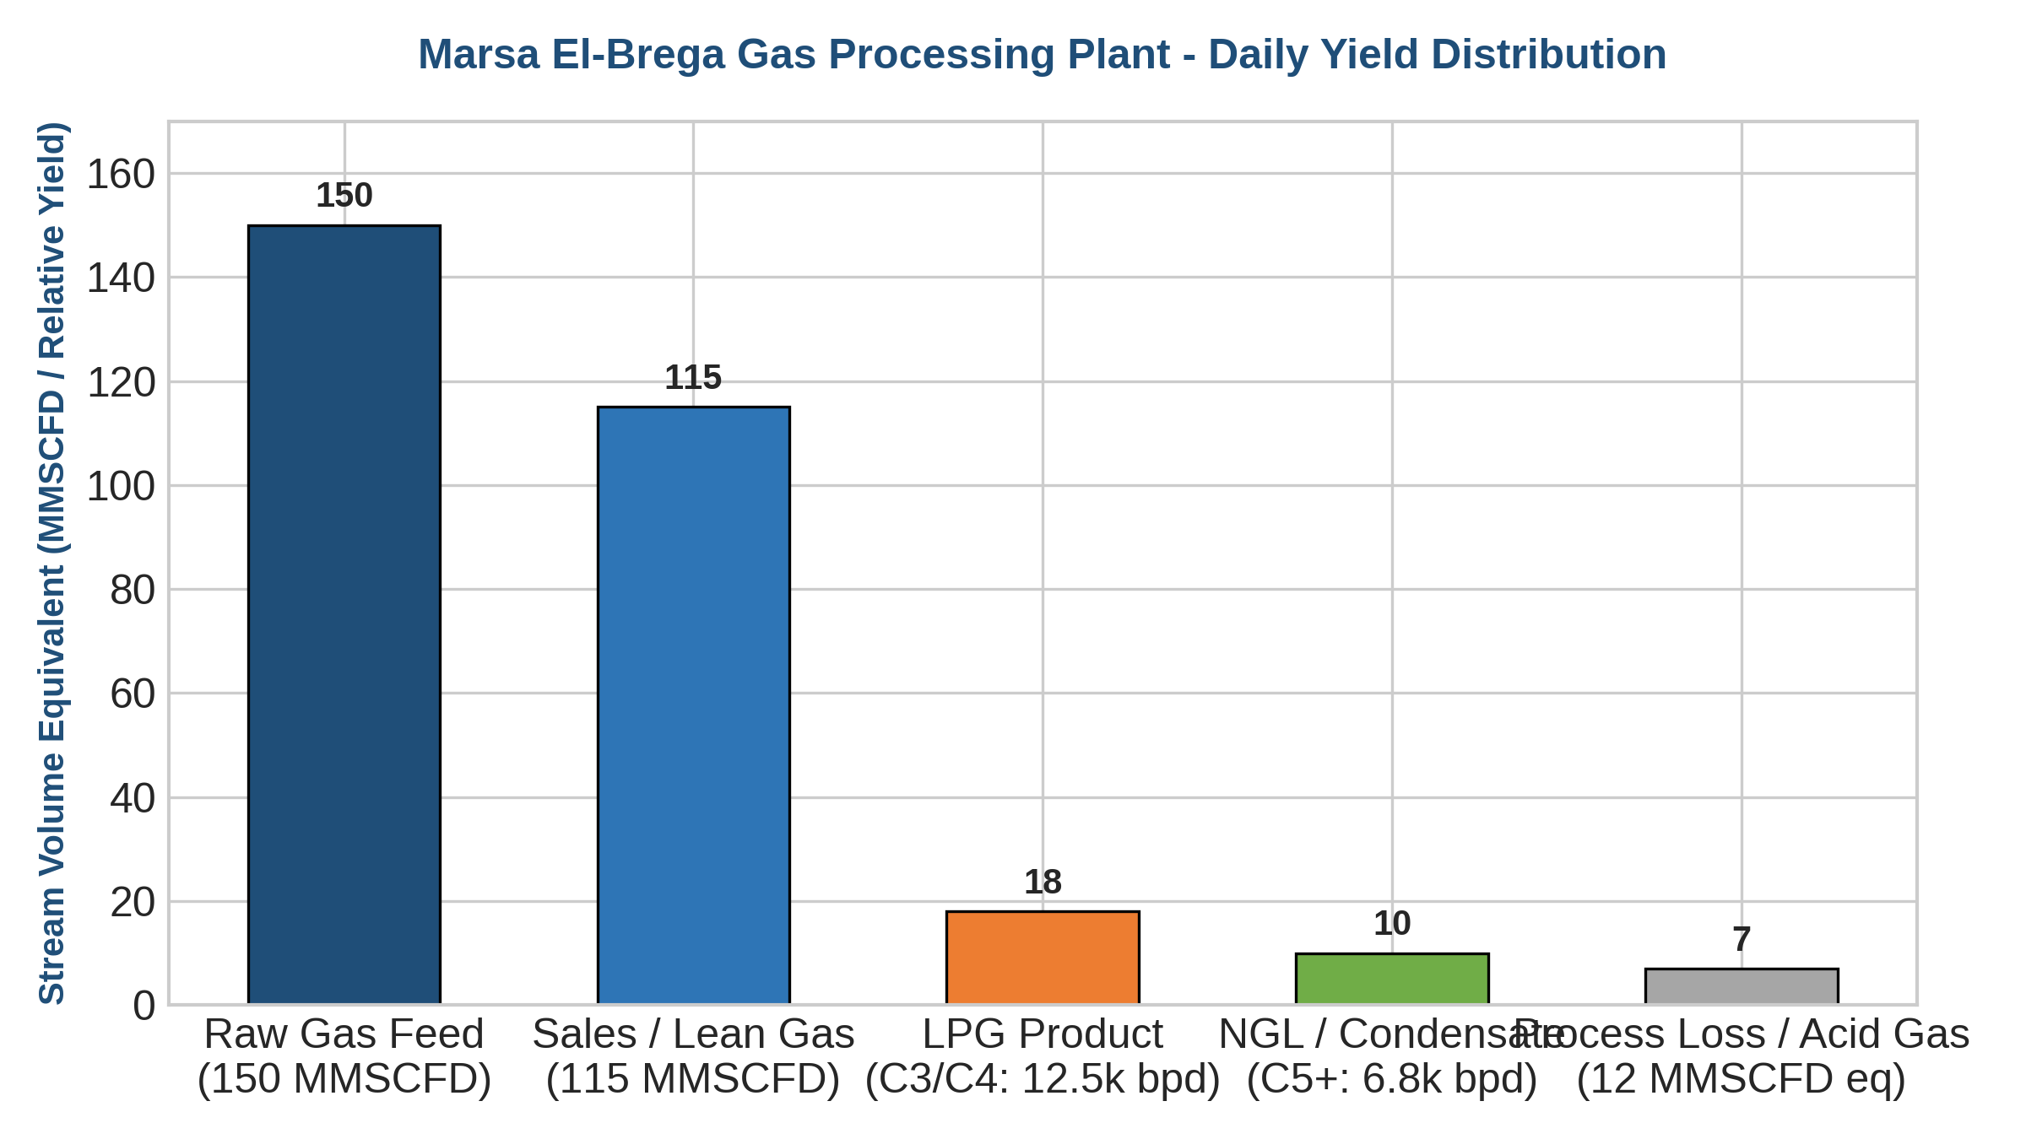
Figure 1: Marsa El-Brega Gas Plant Daily Mass Balance & Stream Distribution

- Economic Analysis & Domestic Import Substitution
Libya currently spends between $180M and $270M annually importing LPG cylinders from Mediterranean traders to meet domestic cooking and heating demand in Benghazi, Tobruk, and Western regions. Fully commissioning the Brega LPG extraction unit reverses this outflow.
- CAPEX & Capital Intensity: Project Capex: $420M - $480M for full brownfield EPC replacement and expansion.
- Operating Cost (OPEX): Estimated at $0.85 per MSCF of processed gas, benefiting from existing site logistics.
- Internal Rate of Return & NPV: Projected Net Present Value (NPV @ 10%) of $640M with an Internal Rate of Return (IRR) of 24.8%.
- Payback Period: Payback achieved in 3.6 years post-commissioning based on LPG import displacement at $680/tonne benchmark.
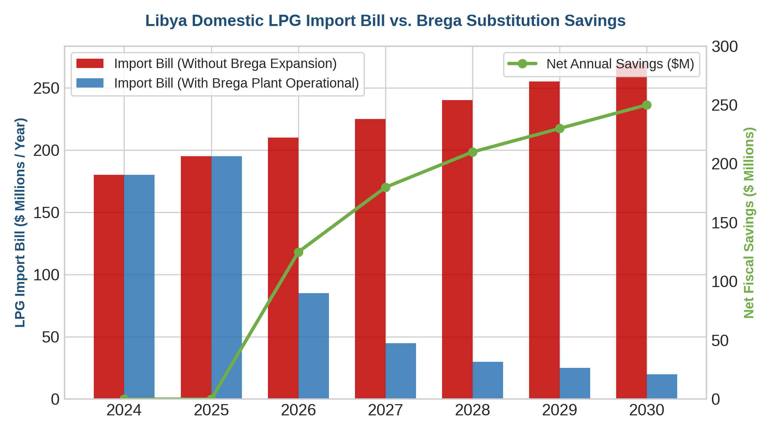
Figure 2: Financial Impact of Marsa El-Brega LPG Output on Libyan Domestic Fuel Import Expenditures

4. Policy, Regulatory & Decarbonization Framework
4.1 Zero Routine Flaring (ZRF) & Methane Intensity
The monetization of APG at Brega is the flagship project in NOC's strategic roadmap to fulfill Libya's commitment to the World Bank Zero Routine Flaring by 2030 initiative. Eliminating 3.8 BCM/yr of flared gas across Sirte Basin fields prevents massive atmospheric methane venting and VOC emissions.
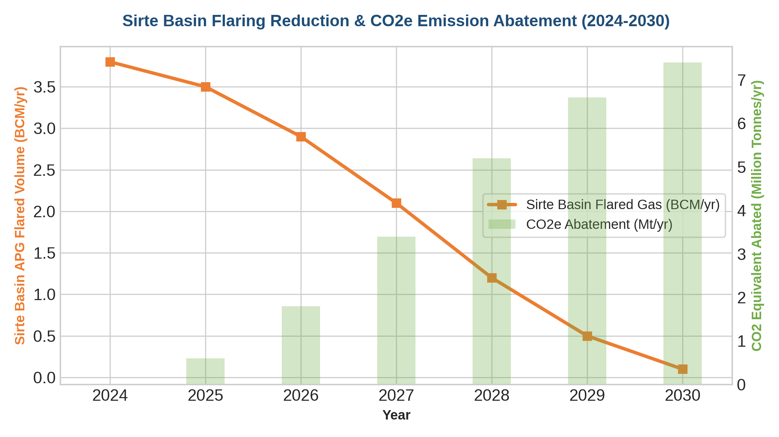
Figure 3: Projected Sirte Basin APG Flaring Reduction and Associated Methane Abatement (2024-2030)
4.2 Policy Enablers & EPSA Fiscal Reforms
- EPSA IV Gas Amendments: Allowing foreign operators (e.g., Eni, TotalEnergies, OMV) and local joint ventures to recover midstream investments through gas tariff indexing.
- Inter-Agency Commercial Off-Take: Creating formal off-take sales agreements between NOC, Brega Petroleum Marketing Company (BPMC), and GECOL power stations.
- Carbon Finance Integration: Filing Brega APG capture under Article 6 of the Paris Agreement to generate verified carbon units (VCUs) for international carbon trading.

- Strategic Risk Assessment & Actionable Policy Roadmap
Risk Domain | Specific Risk Factor | Impact / Severity | Mitigation Strategy
Upstream Supply | Pressure drops in aging Sirte fields (Zelten/Raguba) | High | Deploy field booster compressors and tie-in satellite fields (Hateiba/Attahady)
Security & Assets | Blockades or operational disruptions along pipeline corridors | High | Implement remote SCADA monitoring and enhanced perimeter security infrastructure
Commercial / Off-take | Subsidized domestic LPG pricing causing NOC cashflow gaps | Medium | Establish direct Treasury subsidy reconciliation or phased LPG domestic price reform
Technical Execution | Severe marine atmospheric corrosion at coastal site | Medium | Utilize duplex stainless steel, heavy anti-corrosive coatings, and modular skids

Actionable Policy Recommendations
1. Immediate Execution Mandate: Fast-track EPC contracting for Marsa El-Brega 150-250 MMSCFD gas plant under a priority national energy security mandate.
2. Off-Take Integration: Re-align BPMC domestic LPG logistics, upgrading bottling plants in Benghazi and Tripoli to receive direct pipeline/tanker shipments from Brega.
3. Regulatory Incentive Structure: Enact penal tariffs on uncaptured flaring while offering IOCs 100% cost recovery on gas gathering midstream pipelines.

