Building Domestic Gas Markets: Infrastructure as the Foundation of Cameroon's Gas Monetisation

Executive Summary
Cameroon's gas sector has, since 2013, developed almost entirely around export monetisation first through the Kribi gas-fired power plant's domestic offtake, and after 2018 through the Hilli Episeyo floating LNG (FLNG) facility, which absorbed the bulk of incremental offshore gas production. However, the departure of the Hilli Episeyo Floating LNG (FLNG) vessel in July 2026 after roughly eight years of operation, has exposed the fragility of Cameroon's gas infrastructure architecture.

The infrastructure gap is the binding constraint on further monetisation. Reserve and production data suggest that the deficit of gas supply capable of supporting materially higher domestic offtake lies in pipelines, processing capacity, and an electricity sector under acute financial strain following ENEO's November 2025 renationalisation and mounting arrears owed to Globeleq. For gas to underwrite Cameroon's energy security ambitions rather than remain a stranded export commodity after FLNG redeployment, midstream build-out planned pipeline links, Bipaga's expansion, and the LPG Masterplan will need to move from announcement to execution over 2026–2028.
Domestic Gas Demand
Domestic gas demand in Cameroon is concentrated in three segments: industrial thermal use, gas-fired power generation, and LPG for household cooking. Each is still small in absolute volume but growing from a low base as import-substitution economics improve.
- Industrial thermal demand (Douala)
an estimated 25+ industrial customers, cement, food processing, ceramics, glass, textiles and light manufacturing in the Bassa and Bonabéri districts have converted boilers and kilns from heavy fuel oil (HFO) to piped natural gas supplied by Gaz du Cameroun (GDC), citing lower equipment wear, no storage/heating overhead, and pricing generally below competing liquid fuels.
- Industrial demand (Kribi)
The Keda Ceramics tile factory alone is contracted to draw 3.5–6.5 million cubic feet of gas per day over a 20-year SNH/Perenco supply agreement a single project representing a meaningful step-change in non-power domestic offtake and a template for further gas-to-industry deals in the Kribi port-industrial zone.
- Gas-to-power demand
The Kribi plant is currently the sole large-scale consumer of gas for electricity generation,though this is set to expand materially if the Kribi II 125 MW extension and the new Kribi industrial-zone substation proceed on schedule.
- LPG / clean cooking demand
Government policy targets raising LPG's share of household cooking energy to 58% by 2035, up from a low base, via the 2016 LPG Masterplan (€400 million planned financing for ~7 million additional cylinders and expanded storage, transport and retail infrastructure).
Current Gas Supply
Cameroon's gas supply base rests on two producing basins: the onshore/near-shore Logbaba field outside Douala, and the offshore Sanaga Sud and Ebomé fields off Kribi, operated by the Perenco/SNH-led Sanaga South Association.
- Logbaba field (Douala)
Estimated reserves of ~6 bcm of gas and 2.8 million barrels of condensate; in production since 2010–2012 and the sole supply source for GDC's Douala industrial network.
- Sanaga Sud / Ebomé fields (offshore, Kribi)
Supply both the Kribi power plant and, historically, the Hilli Episeyo FLNG facility under a c. 500 bcf allocation; now the source of gas being redirected onshore to Bipaga as FLNG exports wind down.

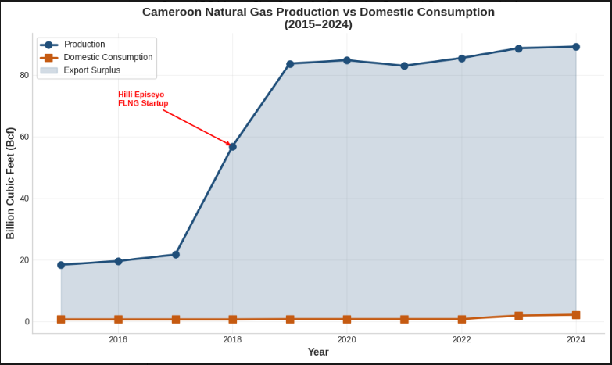
Figure 1 Cameroon Natural Gas Production Vs Domestic Consumption

Gas-to-Power Projects
Gas-fired generation plays an outsized strategic role in Cameroon's power system relative to its share of installed capacity. The Kribi Gas Power Plant, Cameroon's first natural gas-fired independent power plant, was commissioned in 2013 at a total project cost of $350 million. It utilizes 13 Wärtsilä 18V50DF reciprocating engines and sells electricity to ENEO, the national utility, through a 20-year power purchase agreement at a levelized tariff of $0.128/kWh, substantially below the average generation tariff of $0.180/kWh at the time of financing.

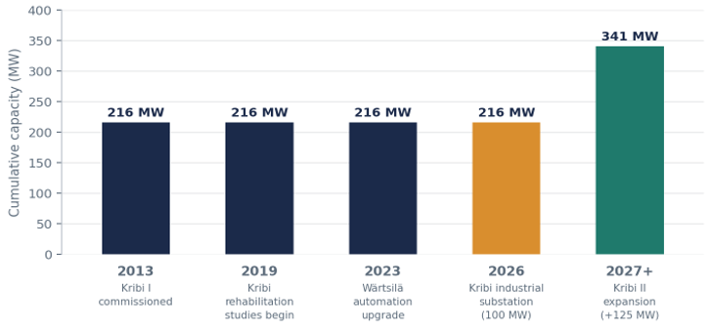
Figure 2 Kiribi Gas-Fired Power Plant: Capacity Build-Out Timeline

Projects | Capacity | Status | Notes
Kribi Gas-Fired Power Plant (Phase I) | 216 MW | Operational since 2013 | 13 Wärtsilä 50DF dual-fuel engines, fuelled by Sanaga Sud gas
Kribi automation/reliability upgrade | 216 MW (no capacity add) | Contracted 2022; multi-year execution | Wärtsilä electrical/automation upgrade plus 10-year service agreement
Kribi industrial-zone 225 kV substation & line | 100 MW initial / 330–400 MW planned | Construction launched Aug 2025; targeted end-2026 | Sonatrel-built dedicated line from Kribi plant to new port-zone substation for exclusive industrial supply
Kribi II expansion | +125 MW (to ~341 MW aggregate) | AfDB-appraised; development stage | Would draw on Sanaga gas field, displaces costlier/older thermal generation and diversifies fuel mix
Dibamba power plant (for reference non-gas) | 88 MW | Operational | Heavy fuel oil-fired, illustrates the cost gap thermal gas generation is meant to close (gas vs. HFO economics)

Industrial Gas Users
Industrial gas consumption in Cameroon is concentrated in the Littoral region (Douala) and the South region (Kribi).

Cluster | Anchor Supplier | Customer Base | Commercial use
Douala (Bassa / Bonabéri) | Gaz du Cameroun (Logbaba) | 25+ industrial customers: cement, food & beverage, glass, textiles, light manufacturing. | Boiler heating, process heat, power gensets
Kribi industrial-port zone | SNH / Perenco (Bipaga processing centre) | Keda Ceramics (anchor, largest ceramics plant in the region), further industrial prospects under Kribi's port master plan | 20-year gas supply agreement (Sept 2022), 3.5–6.5 MMcf/d, delivered via dedicated 6 km pipeline, ~20 million m² annual tile capacity once fully ramped

Pipeline Infrastructure
Cameroon's gas transmission infrastructure remains relatively compact but strategically important, supporting domestic electricity generation, industrial development, and urban gas distribution. While the country possesses significant offshore gas resources, its pipeline network is still concentrated around the coastal production and consumption centres of Kribi and Douala.
- Sanaga South–Kribi Pipeline (18 km)
The Sanaga South–Kribi Pipeline is an 18-kilometre offshore-to-onshore gas pipeline operated by the Société Nationale des Hydrocarbures (SNH). It transports natural gas from the Sanaga South offshore field to the Kribi gas-fired power plant, making it one of the country's most critical gas transportation assets.
- Bipaga–Keda Ceramics Pipeline (5.27 km)
The Bipaga–Keda Ceramics Pipeline, spanning 5.27 kilometres, is another strategic gas infrastructure asset managed by SNH. The pipeline links Bipaga to the Kribi Industrial Zone, supplying natural gas directly to the Keda Ceramics manufacturing facility. Although relatively short, this pipeline demonstrates Cameroon's broader gas monetisation strategy by directing natural gas toward industrial consumers rather than relying solely on electricity generation or exports.
- Douala Distribution Network (49 km)
The Douala Distribution Network is a 49-kilometre urban gas distribution system operated by Gaz du Cameroun (GDC). The network transports gas from the Logbaba gas field through Bonaberi and into Douala's major industrial districts. As Cameroon's largest urban gas distribution network, it supplies natural gas to manufacturing facilities, commercial users, and other industrial customers, replacing more expensive and carbon-intensive fuels.

Chad–Cameroon Oil Pipeline (1,070 km)
The Chad–Cameroon Pipeline is a 1,070-kilometre cross-border crude oil export pipeline operated by the Cameroon Oil Transportation Company (COTCO). The pipeline transports crude oil from Chad's Doba Basin to the offshore export terminal at Kribi on Cameroon's Atlantic coast. Although it is not part of Cameroon's natural gas infrastructure, the pipeline remains one of the country's most significant energy transportation assets. It generates transit revenues for Cameroon, supports regional energy cooperation, and has established Kribi as a major hydrocarbon export hub.

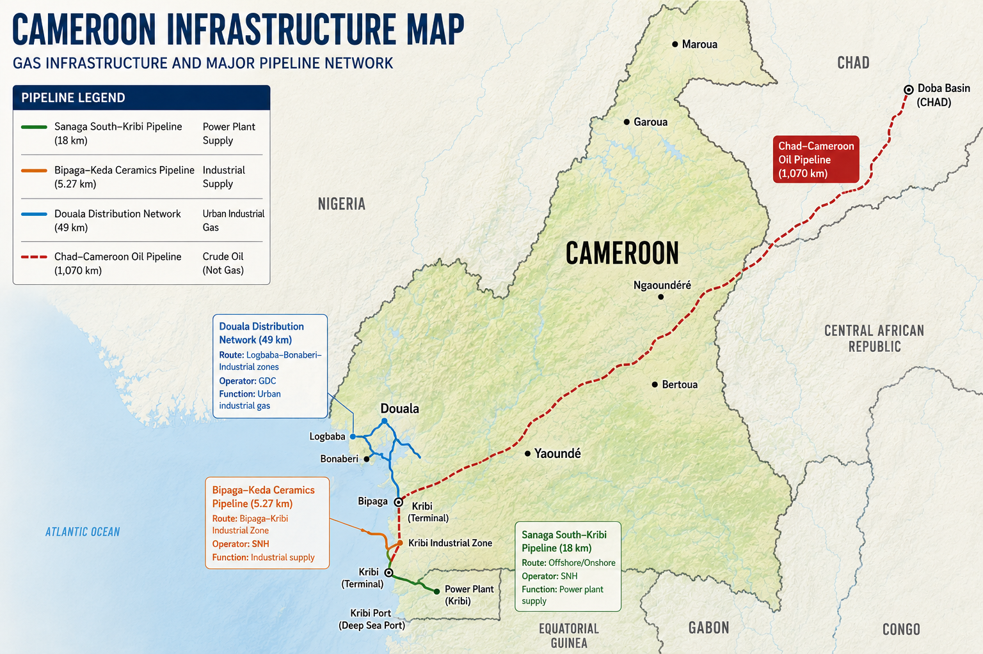
Figure 3 Cameroon Infrastructure Map

Processing Facilities
The Bipaga facility serves as the central processing hub for the Sanaga South association, receiving offshore gas and delivering processed products to domestic and export markets.

Facility | Operators | Function | Status /Capacity Note
Bipaga Gas Processing Centre (Kribi) | SNH / Perenco | Processes Sanaga Sud/Ebomé gas for LPG extraction and industrial gas supply | On-stream 2024, sole source of domestically-produced LPG, slated for capacity expansion as FLNG-linked volumes are redirected onshore from mid-2026
Logbaba Gas Processing Plant (Douala) | Gaz du Cameroun (Victoria Oil & Gas subsidiary) | Processes Logbaba field gas, separates condensate for onward sale to domestic refining | Acquired by GDC from Expro Worldwide, Douala distribution network
Hilli Episeyo FLNG (offshore Kribi) | Golar LNG / Perenco / SNH | Liquefies offshore gas for export, incidental domestic condensate/LPG output | 1.2–1.6 mtpa nameplate (target raised toward 5 mtpa by 2026 pre-redeployment),charter concludes July 2026, vessel contracted to Argentina a structural change for domestic supply
Kribi refinery (adjacent midstream link) | Cstar Petroleum / SNH / Tradex / Ariana Energy | Crude refining; not gas processing, but shares Kribi logistics corridor and receives associated condensate streams | US$622m project, partial start (10,000 bpd of planned 30,000 bpd) expected H2 2026, ~2 years ahead of original schedule

Infrastructure Gaps
Four structural gaps constrain further domestic gas monetisation:
- No national gas transmission backbone
Douala and Kribi/Bipaga remain unconnected gas islands, any future demand centre (Yaoundé, Edéa, Limbe) requires new dedicated infrastructure rather than tapping an existing grid.
- Split electricity grid
The Southern and Northern Interconnected Networks (SIN/NIN) are not connected, so Kribi's gas-fired output (and southern hydropower) cannot relieve the thermal-dependent, gas-poor north; a study-stage interconnection and a CFA 557.5 billion Chad interconnection are the only current mitigants.
- Power-sector financial distress
Globeleq (owner of both Kribi and Dibamba) is reportedly owed over CFA 137 billion by ENEO and the state, ENEO's November 2025 renationalisation addresses ownership but not the underlying tariff/collection shortfall, which discourages further IPP-financed gas infrastructure.
- Single-point processing and storage dependency
Bipaga is currently the sole domestic LPG source nationally, GDC's Logbaba plant is the sole processor for the entire Douala network. Neither has meaningful backup, creating concentration risk for the whole domestic gas system.

Planned Pipeline Expansion

The National Hydrocarbons Corporation (SNH) and the Ministry of Mines, Industry and Technological Development (MINMIDT) have outlined several expansion initiatives as shown in the table below.

Initiative | Scope | Timeline | Strategic Significance
Bipaga processing centre expansion | Increased LPG/butane extraction capacity to absorb redirected Sanaga Sud/Ebomé gas previously destined for FLNG export | From mid-2026 (post-Hilli Episeyo redeployment) | Single largest near-term addition to domestically available gas volumes, converts a stranded-export risk into a domestic-supply opportunity
Kribi industrial-zone 225 kV line & substation | Dedicated electricity (not gas) transmission from Kribi plant to new port substation; 100 MW immediate, 330–400 MW planned | Construction from Aug 2025; targeted end-2026 | Extends the reach of existing gas-fired generation to new energy-intensive industrial tenants without new gas pipeline capex
Douala network extension | Incremental extension of the existing 33 km GDC distribution grid to additional industrial customers | Ongoing | Lowest-capex route to near-term demand growth, constrained by Logbaba field reserve life and Douala's built-up geography
LPG Masterplan infrastructure | €400m planned financing for ~7 million additional cylinders plus expanded import, storage, transport and retail infrastructure nationally | Through 2035 (58% LPG cooking-share target) | Principal vehicle for extending gas benefits beyond industrial users to households, success depends on distribution logistics well beyond Douala/Kribi
Kribi II power plant extension | +125 MW gas-fired capacity, drawing on Sanaga field gas | AfDB-appraised; construction timeline pending final investment decision | Would materially raise gas-to-power offtake and further diversify away from hydro-dependence

Outlook (2026–2028)
- Bipaga ramp-up: monitor whether redirected Sanaga Sud/Ebomé volumes materially raise LPG output and new industrial gas contracts, or are partly reinjected/curtailed absent adequate processing capacity.
- Kribi II final investment decision: a positive FID would signal renewed confidence in gas-fired baseload despite ENEO's financial position; continued delay would suggest financing/counterparty risk is binding.
- Any announcement of a Douala–Kribi (or broader) trunkline would mark the clearest possible signal of a shift from project-by-project gas deals toward an integrated domestic gas market.
- Tracking actual cylinder distribution and retail-infrastructure spend against the €400m/58%-by-2035 targets will indicate whether household gas conversion is on pace or lagging plan.

