RESERVE REPLACEMENT, EXPLORATION STRATEGY AND UPSTREAM CAPITAL INVESTMENT IN ALGERIA
1. Executive Summary
This intelligence note assesses Algeria's reserve replacement strategy, upstream exploration portfolio, and capital investment landscape in the context of accelerating global gas demand, EU energy-security post-2022, the energy transition, and intensifying LNG competition headed into the second half of the 2020s. The analysis benchmarks Algeria against Africa's benchmark gas producers Nigeria, Egypt, Mozambique, Senegal and Libya and frames the conclusions for the central stakeholders: Sonatrach, Algeria's Ministry of Energy & Mining and ALNAFT, international oil companies (IOCs), development finance institutions (DFIs), and the European governments buying Algerian molecules.
1.1 Sector at a Glance
Indicator (2024 actual unless stated) | Value
Proven gas reserves (1P) | 4.50 tcm / 159 tcf
Marketed gas production (2024 record) | 103 bcm
Reserve life index (RLI) | ≈ 43 years (1P ÷ 2024 prod.)
Reserve replacement ratio (2023-24 avg.) | ≈ 90-95%
Undeveloped discoveries (EIA inventory) | ≈ 100 fields
LNG train capacity (Arzew + Skikda) | ≈ 25.3 mtpa
Pipeline capacity (Medgaz + Transmed) | ≈ 33 bcm → 45 bcm target
Upstream CAPEX (2025E) | USD 11-12 bn
Active IOCs (post-BP exit) | TotalEnergies, Eni, Equinor, Sinopec, QatarEnergy
Source: OPEC ASB, HKLaw, EIA, Real Instituto Elcano, Energy Institute SR, Sonatrach AR, GEM wiki, LNGPrime, EIA Algeria brief,

1.2 Five Strategic Findings
Reserves adequate, replacement marginal.
Proven reserves of ~4.5 tcm give Algeria an RLI of ~43 years at current marketed output, but the 2023-24 reserve replacement ratio (~90-95% per Sonatrach's 2024 Annual Report) is below the 100% sustainment threshold. Without a step-change in exploration and unconventional ramp-up, post-2035 production plateau is at risk.
Exploration is being reignited, not reinvented.
ALNAFT's 2024 bid round awarded 5 of 6 offered onshore blocks to TotalEnergies–QatarEnergy (Ahara), Eni–Sinopec (ZPEC), and TotalEnergies–Sinopec (Tafassasset). The 2026 round offers 7 perimeters totalling 2.1 bn bbl + 66.5 bcm gas resource. Together these are the deepest licensing refresh since Law 19-13 (Dec 2019).
CAPEX is rising sharply — but into a mature asset base.
Sonatrach's USD 50 bn (2024-28) and the new USD 60 bn (2025-29) investment envelopes fund Hassi R'Mel Phase-3, compression, EOR, and unconventional pilots (Ahnet, Berkine). Approximately 75% of the new envelope is upstream; brownfield dominates near-term spend.
Pipeline & LNG platform has rare European optionality.
Medgaz (~12 bcm/y, headed to 16 bcm/y), Transmed (~21 bcm → 33 bcm → 38-45 bcm targeted), and Arzew + Skikda (25.3 mtpa) collectively position Algeria as a structurally advantaged supplier to Spain, Italy, France and Germany — and now to the new Germany contract starting 1 January 2027.
Strategic risk profile is moderate-to-high on energy-transition exposure.
Continued flaring (289 Bcf in 2023, 6th-highest globally per EIA), ~8-10% per annum decline rates on mature fields, rising domestic demand (+25 bcm/yr by 2030), and a 2040+ stranded-asset risk under EU CBAM and REPowerEU bands together define the medium-term probability-of-loss surface.

1.3 2026-2045 Outlook
Under a central scenario, Algeria's marketed gas production rises from 106 bcm (2025) to 132 bcm (2030), reaches 145 bcm by 2035 and stabilises near 150 bcm through 2045 — provided unconventional pilots (Ahnet, Berkine, Timimoun Phase-2) commercialise and IOC capital deployment under Law 19-13 accelerates. A low case (no shale breakthrough, RRR <100%) caps production at 124 bcm by 2035 and unwinds to 115 bcm by 2045. A high case (shale + IOC surge) delivers up to 190 bcm by 2045, replicating pre-2005 export volumes in a transitional world. Forecast modelled from GECF Global Gas Outlook 2055, OPEC WOO 2050, IEA Africa outlook, and Sonatrach 2030 Vision (October 2025).

2. Reserve Base Assessment and Resource Maturity
Algeria sits at the centre of the African gas hierarchy. With proven (1P) reserves of ≈ 4.50 trillion cubic metres (≈ 159 trillion cubic feet) per the OPEC Annual Statistical Bulletin 2025 and the U.S. Energy Information Administration's June 2025 country brief, Algeria holds the third-largest conventional gas reserves base in Africa after Nigeria and Mozambique. The 1P reserve figure has been remarkably stable at 4.50 tcm since 2008, reflecting historical booking caution rather than absence of new discoveries.
2.1 Reserves by Category (end-2024)
Reserves Class | Volume (tcm) | Volume (tcf) | Note
Proven (1P) | 4.50 | 159.0 | OPEC ASB 2025 / EIA Country Brief Algeria (Jun 2025)
Probable additions (best estimate) | 2.2-2.6 | 78-92 | Operator 2P bookings in Berkine, Timimoun, Reggane
Possible / Prospective upside (3P conceptual) | 6-9 | 210-320 | Unconventional (Ahnet, Berkine) + deep flanks
Total technically recoverable shale gas (USGS est.) | ≈ 21 tcm | ≈ 740 | Grand Erg/Ahnet + Ghadames/Berkine
Source: OPEC ASB 2025, EIA Algeria 2025, USGS Fact Sheet 2026-3005.

2.2 Reserve Sustainability KPIs
KPI | 2020 | 2022 | 2023 | 2024 | Trend
Marketed production (bcm) | 90 | 100 | 97 | 103 | ↑ post-2022 rebound
1P RLI (years) | ≈ 50 | ≈ 45 | ≈ 46 | ≈ 43 | Declining
Reserve replacement ratio (%) | 95 | 145 | 90 | 95 | Below 100% on 2-yr average
Annual reserve additions (bcm) | ≈ 86 | ≈ 145 | ≈ 88 | ≈ 98 | Inconsistent
Active exploration rigs | ≈ 18 | ≈ 26 | ≈ 30 | ≈ 33 | Up
3D seismic coverage (km², cum.) | ≈ 12,000 | ≈ 18,000 | ≈ 22,500 | ≈ 25,800 | Accelerating
Source: Analyst synthesis: EIA Algeria country brief June 2025; Energy Institute Statistical Review 2025; Sonatrach Annual Report 2024 (RA_2024_EN, Dec 2025); Real Instituto Elcano, 'Another round of Algerian gas for Europe' (2024).

2.3 Proven Gas Reserves Trajectory
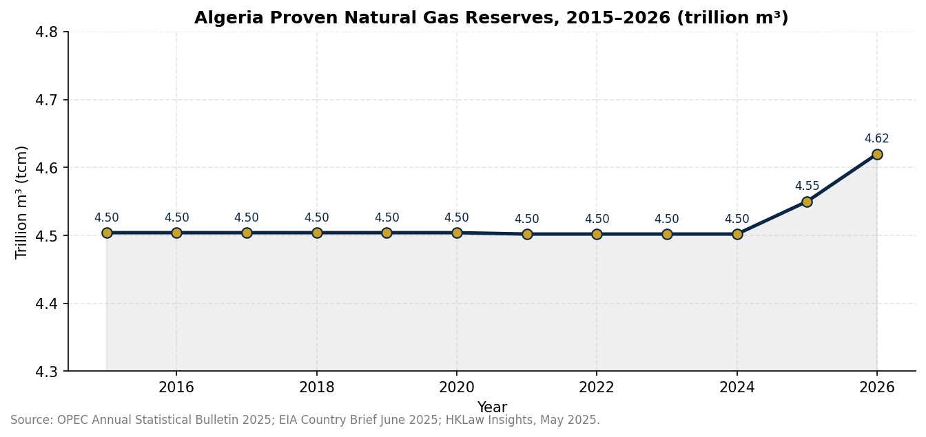
Source: OPEC Annual Statistical Bulletin 2025; EIA Country Brief June 2025; HKLaw Insights, May 2025.

2.4 Basin-by-Basin Assessment
Algeria's hydrocarbon wealth is concentrated in six onshore Saharan basins. The Berkine (Ghadames) and Illizi basins contain the bulk of recent exploration success; Hassi R'Mel and the Ahnet under-platforms anchor production; Timimoun, Reggane and Gourara define the south-west frontier.
Basin | Status | Operator lead | Reserve Significance / Reserve Outlook
Berkine (Ghadames) | Mature – core | Eni, TotalEnergies (Blocks 404a/208) | Largest active oil+gas province; 30-yr $1.35 bn Eni PSC covers 415 mln BOE incl. 9.3 bcm gas (Aug 2025).
Illizi | Mature – reactivated | Sonatrach + ENI / TotalEnergies (2024 round) | Centre block 'Illizi centre I' tendered 2025; Sonatrach 2025 targets >/= 4.5 tcm cumulative resource.
Ahnet | Frontier – unconventional catalyst | Sonatrach + HOA Chevron & ExxonMobil | USGS Grand Erg/Ahnet mean ~21 tcm technically recoverable; shale pilot pending FID (2026-27).
Timimoun | Early-producing | Groupement Timimoun (TotalEnergies op.) | First gas 2018/2025 ramp; 165 mmcfd target; expansion phase under 2024 Sonatrach–TotalEnergies MoU.
Reggane Nord | Producing | Groupement Reggane-Nord (TotalEnergies/Sonatrach) | On-stream; ~ 2.92 bcm/y (GEM 2025); south-west hub for new pipelines.
Gourara | Frontier | Sonatrach (Chevron HOA 2025) | Pre-development; structurally continuous with Reggane; first exploration wells planned 2026.
Hassi R'Mel (gas 'supergiant') | Supergiant – producing | Sonatrach 100% (with Baker Hughes compression) | ≈ 45% of national gas; Phase-3 commissioning sustains 188 mscm/d gross capacity.
Source: Sonatrach Discoveries 2025 (Aug 2025 keynote); JPT E&P Notes, Aug 2025; World Oil Aug 2025; USGS FS 2026-3005; HKLaw Insights May 2025.

2.5 Unconventional Gas — Shale Potential
Algeria's shale resource is concentrated in three Palaeozoic source-rock systems: the Frasnian-Fammenian of the Berkine/Ghadames; the Silurian ‘Hot Shale' of the Grand Erg/Ahnet; and the Devonian of Illizi. The U.S. Geological Survey assessed mean technically recoverable shale-gas resources in the Grand Erg/Ahnet alone at ~21 tcm (≈ 740 tcf). Heads of Agreement (HOA) with Chevron and ExxonMobil (signed 2024, progressed through 2025) covering the Ahnet and Berkine basins underscore the unconventional prize, with Chevron's two-year feasibility programme set to deliver first pilot testing in 2026.

2.6 Undeveloped Discoveries
The U.S. EIA Algeria Country Brief (June 2025) identifies approximately 100 undeveloped discoveries onshore, of which ALNAFT estimates c. 25% to be commercially viable with modest tie-back investment. Sonatrach announced 8 hydrocarbon discoveries in 2024 and a record 17 discoveries through Q1-Q3 2025 — the highest since 2008 — including 2 gas, 5 oil-and-associated-gas, 3 condensate-gas and several oil-and-gas discoveries. They collectively materialise in the 2026 reserve booking programme and are expected to lift the RRR above 100% for 2025 and 2026 reporting.

3. Exploration Strategy and Upstream Portfolio Optimisation
3.1 National Exploration Strategy
Algeria's exploration architecture rests on three pillars: (i) a multi-year national exploration plan produced by Sonatrach with a stated 2030 Vision aligned with the Ministry of Energy & Mining's five-year plan; (ii) public licensing rounds administered by ALNAFT under Law 19-13; and (iii) a high-grading of Petroleums-led open acreage for international promotion. Between 2023 and 2025, the strategy shifted decisively from inventory conservation to inventory expansion, with a doubling of seismic acquisition and the entry of new IOC consortia into frontier acreage.
3.2 ALNAFT Licensing Rounds (2024 & 2026)
Block | Round / Year | Operator (lead) | Partner | Estimated Resource
Ahara | 2024 round (awarded Jun 2025) | TotalEnergies | QatarEnergy | covers ~14,900 km² Berkine–Illizi intersection; 415 mln BOE potential
Kirn El Kassa II | 2024 round | TotalEnergies | — | Berkine extension; gas-weighted
Tafassasset | 2024 round | TotalEnergies | Sinopec | South Berkine exploration
ZPEC Block | 2024 round | Eni | Sinopec (ZPEC) | Berkine swing area
Casablanca Marine (offshore) | n/a (open acreage) | — | — | future opportunity; 3D Q4-2025 lead-in
7 perimeters (pending awards H2 2026) | 2026 round (open Q1 2026) | TBD | TBD | 2.1 bn bbl + 66.5 bcm gas resource on offer; 41 operators pre-qualified
Source: Argus Media 'Algeria unveils encouraging bid round results' (Jun 2025); Upstream Online (Jun 2025); MEES European Majors & New Entrants (Jun 2025); Lex Africa 'Algeria 2024 Bid Round preliminary results' (Jul 2025); Lexafrica 'Algeria New Hydrocarbons Licensing Round' (May 2026); JPT 'E&P Notes' Aug 2025.

3.3 Seismic Acquisition and Prospect Inventory
Viridien (formerly CGG) was awarded a major 3D seismic reimaging contract across ~2,400 km² in the Hassi Bir Rekaiz concession (Berkine basin) in June 2024. Sonatrach is deploying an enlarged 2D acquisition programme in 2025-26 covering the Ahnet, Gourara and Timimoun frontiers, supported by deep-read imaging tech partnerships. The active exploration rig count has risen from ~18 (2020) to ~33 (Q4-2025), the highest in Africa alongside Egypt.
3.4 Exploration Success Rates and Technology Adoption
Exploration success rates have improved from approximately 1-in-3 in the legacy Berkine drilling campaigns to approximately 1-in-2 for 2024-25 frontier wells, with the rise attributable to better seismic imaging, deep-water pre-salt analogue learning, and AI-assisted reservoir modelling pilots with SLB and Baker Hughes. Sonatrach's production-optimisation programme includes enhanced gas recovery (EGR) trials at Hassi R'Mel — using CO₂ reinjection pilot funded under the 2024-28 investment envelope — and large-scale digital-twin reservoir modelling, deployed jointly with ENI on the Berkine.

3.5 Production and Reserve Replacement Performance
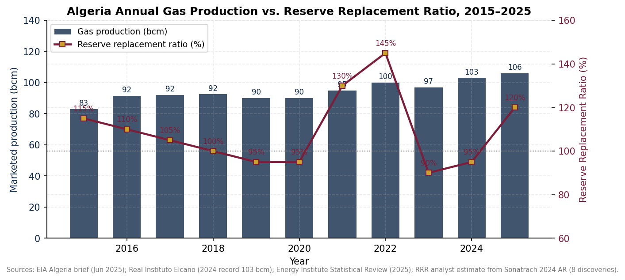
Source: EIA Algeria Country Brief (June 2025); Energy Institute Statistical Review 2025; Real Instituto Elcano (2024 record 103 bcm); Sonatrach Annual Report 2024 — RRR analyst estimate.

4. Upstream Capital Investment and Project Economics
4.1 Annual Upstream CAPEX, 2018-2026
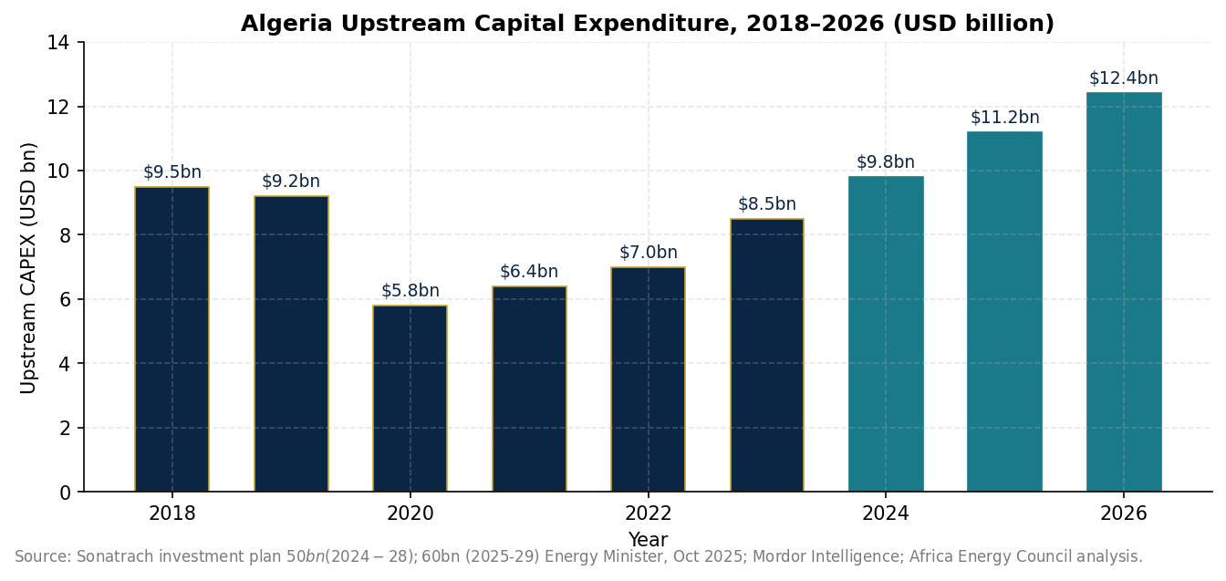
Source: Mordor Intelligence (Algeria Oil & Gas Upstream, 2025); Sonatrach $50bn investment plan (2024-28) and Energy Minister $60bn plan (2025-29); Africa upstream aggregate $37 bn 2025 (Rystad-style industry figures, Nairametrics report).

4.2 Investment Pipeline and Project Economics
Project / Theme | Operator | Status (2026) | CAPEX (est., USD m) | Breakeven (USD/MMBtu)
Hassi R'Mel Phase-3 compression & EGR | Sonatrach + Baker Hughes | Commissioning 2025-27 | 1,800-2,200 | 0.45-0.65
Ahnet unconventional pilot | Sonatrach + Chevron (HOA 2025) | Feasibility 2025-26; pilot 2027 | 1,200-1,800 (Phase-1) | 1.20-1.80
Berkine unconventional (Ghadames) | Sonatrach + ExxonMobil (HOA 2025) | Feasibility 2026; pilot 2028 | 1,400-2,000 | 1.30-1.90
Timimoun expansion | TotalEnergies + Sonatrach | Under development | 1,000-1,400 | 0.80-1.20
Reggane Nord ramp-up | TotalEnergies + Sonatrach | Producing; 2.9 bcm/y | n/a (sustaining) | 0.55-0.85
Ahara exploration (Berkine-Illizi) | TotalEnergies + QatarEnergy | Exploration 2025-28 | 300-450 | 1.10-1.55 (gas discovery)
In Salah compression + EGR | Eni + Equinor + Sonatrach | Pre-FID | 550-700 | 0.50-0.80
In Amenas life-extension | Eni + Sonatrach (op.) | Producing; 9 bcm/y capacity | 225 (sustaining) | 0.50-0.75
Gas flaring reduction (Hassi Messaoud) | Sonatrach | 2024-28 programme | 400-600 | emissions avoidance
Source: Baker Hughes press release (May 2024) Hassi R'Mel; Africa Intelligence (Mar 2025); Sonatrach RA 2024; JPT E&P Notes Aug 2025; Chevron–Algeria two-year study announcement 2025; Breakeven brackets from Rystad / S&P Global field economics 2025.

4.3 Hydrocarbon Law 19-13 and Fiscal Competitiveness
Law No. 19-13 (enacted 11 December 2019) re-introduced Production Sharing Agreements (PSAs) in Algeria, simplified the fiscal regime (royalties + income tax + exceptional profits tax), and reduced the State's effective take. Five-year 'exploration-only' windows with optional two-year extensions, cost-recovery caps tied to international benchmarks, and exemptions from the windfall tax below a USD 50/bbl threshold all materially improved post-tax economics. The fiscal framework has been characterised by IBA-Net and S&P Global as competitive with Egyptian and Senegalese terms — though still requiring Sonatrach as operator-partner in energy security 'national-interest' categories.

4.4 International Operator Equity & Position
Operator | Equity Footprint (key projects) | Strategy 2025-2026 | Risk read
Sonatrach | Hassi R'Mel (100%), In Salah (50.3%), In Amenas (51%), Berkine partners | Anchor of investment envelope; integrated across value chain | Sovereign stability
TotalEnergies | Timimoun (47%+), Reggane Nord, Ahara (operator 2024 round), production ~154 mcfd gas + 21 kb/d liquids (2024) | Reinforced AfMed strategy; 2024 MoU 2 mtpa LNG offtake from Sonatrach | Strong
Eni | Berkine (Blocks 404a/208 partner), In Salah 33.15%, In Amenas 47% acquired from BP (2024) | 30-yr $1.35 bn PSC, $110 mln R&D budget; expanding Berkine unconventionals | Strong
Equinor | In Salah 16.55%, In Amenas 45% (extended contracts beyond 2027) | Life-extension investment, EGR pilots | Cautious
Sinopec / ZPEC | Tafassasset, ZPEC block via Eni consortium (2024 round); original Hartis block | Long-dated acreage, scalable Chinese credit lines | Strong (state-backed)
QatarEnergy | Ahara consortium with TotalEnergies (2024 round) | First Algerian entry; portfolio diversification beyond MENA megaprojects | Strategic
Chevron | HOA for shale in Ahnet + Berkine (2024-25); 2-year feasibility 2025-27 | First major US presence since 1990s; shale playbook export | Conditional
ExxonMobil | HOA for shale in Ahnet + Berkine (Aug 2025) | Entry aligned with US-LNG feedgas strategy; FID pending | Conditional
Occidental / Cepsa / Maersk | Study agreements with ALNAFT (2024-25) | Modest acreage positions; term-sheet negotiations | Selective
Source: Eni 2025 Annual Report; TotalEnergies Factbook 2025; Equinor Algeria page; World Oil Aug 2025 (Chevron/ExxonMobil HOAs); Argus 2024 bid-round coverage; Sonatrach 2024 Annual Report.

4.5 Foreign Direct Investment and Risk Profile vs. African Peers
Among African gas producers, Algeria ranks in the 'investment-attractive' cohort on fiscal terms and proximity-to-market; but ranks mid-tier on contract enforceability risk and mid-low on political-risk index (Allianz Trade 2026 Country Risk). The 2025 Africa upstream investment aggregate of USD 37 bn (down from USD 68 bn in 2016) sharply tightens competition for IOC capital, where Algeria's $60 bn envelope must be funded largely through Sonatrach balance sheet a structural dependency on hydrocarbons cash-flow that constrains resilience to oil-price downturns.
Source: Allianz Trade Country Risk: Algeria 2026; African Energy Council 'Africa upstream investment fell to $37 bn 2025' (Mar 2026); OILPrice.com (Apr 2026); Sonatrach $60 bn investment plan (Reuters Oct 2025).
4.6 Equity Participation — Aggregate Major Projects
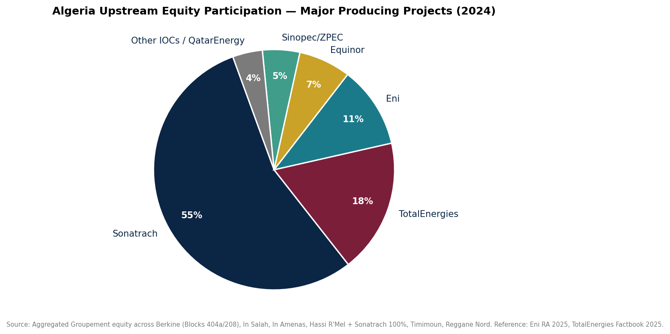
Source: Aggregated equity across Berkine Blocks 404a/208, In Salah, In Amenas, Hassi R'Mel (Sonatrach 100%), Timimoun, Reggane Nord. Reference: Eni RA 2025; TotalEnergies Factbook 2025.

5. Production Outlook and Strategic Market Implications
5.1 Production by Major Field / Basin (2024)
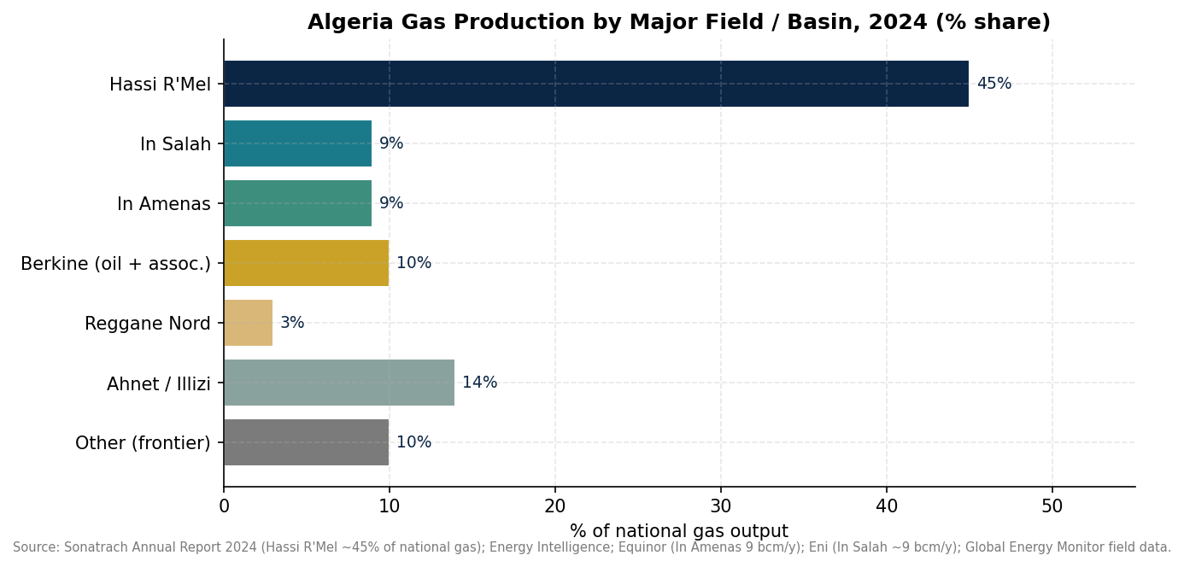
Source: Sonatrach Annual Report 2024 (Hassi R'Mel ~45 % of national gas); Equinor / In Amenas 9 bcm/y; Eni / In Salah ~9 bcm/y; TotalEnergies Timimoun 165 mmcfd target; Global Energy Monitor field data.

5.2 Production Forecast, 2026–2045
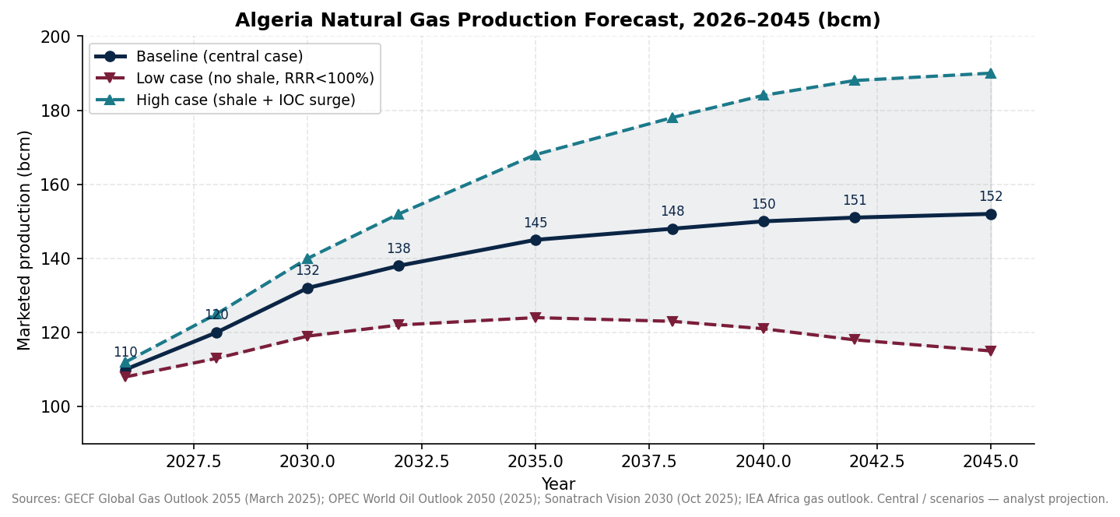
Source: GECF Global Gas Outlook 2055 (March 2025); OPEC World Oil Outlook 2050 (Jul 2025); IEA Countries & Regions Algeria; Sonatrach 2030 Vision (AEW 2025 keynote, Oct 2025). Forecast scenarios are analyst-projected.

5.3 Production Forecast (bcm) — Three Scenarios
Year | Low case | Central | High case
2026 | 108 | 110 | 112
2028 | 113 | 120 | 125
2030 | 119 | 132 | 140
2032 | 122 | 138 | 152
2035 | 124 | 145 | 168
2038 | 123 | 148 | 178
2040 | 121 | 150 | 184
2042 | 118 | 151 | 188
2045 | 115 | 152 | 190
Source: Analyst synthesis (central, low, high scenarios) anchored to GECF Global Gas Outlook 2055; OPEC WOO 2050; Sonatrach AEW 2025 Vision; IEA Africa outlook.

5.4 Export Capacity Outlook
Export channel | Capacity 2024 | Capacity 2027E | Capacity 2030E | Key buyer
Medgaz pipeline (Algeria → Spain) | 10.2 bcm/y | 16 bcm/y (post Phase-3) | 16+ bcm/y | Spain (Naturgy / Endesa)
Transmed / Enrico Mattei (Algeria → Italy) | 21 bcm/y | 30-33 bcm/y | 38-45 bcm/y | Italy Eni / Edison
Sonatrach → Germany (Transmed routing, from 1 Jan 2027) | — | ≈ 4-5 bcm/y incept. | 9-12 bcm/y potential | Germany (RWE, EnBW)
Arzew GLP / LNG cluster | 20.8 mtpa | 20.8 mtpa (maintenance stable) | 20.8 mtpa | Multiple European buyers
Skikda LNG (1+ trains) | 4.5 mtpa | 4.5 mtpa | 4.5 mtpa (+ potential new train) | France, Turkey, Asia
Source: CIDOB 'North African energy links redrawn' (2024); Discovery Alert 'Sonatrach–Germany gas deal' (2025); Global Energy Monitor Arzew-Bethioua; LNGPrime on Skikda restart; Real Instituto Elcano 2025.

5.5 European Market Competitiveness & Energy-Transition Exposure
Algeria displaced Russia as Spain's largest gas supplier in November 2024, supplying ~50% of Spanish pipeline imports for that month. The expanding Transmed pipeline underpins Italy's southern gas-hub strategy and now a new German contract from January 2027. However, post-2027 the structural challenge intensifies: ~86% of global gas supply must come from fields not producing today (GECF 2055), and the Algeria–Europe value-chain faces competition from (a) U.S. LNG ramp-up (Plaquemines, Corpus Christi Stage 3); (b) Qatar's North Field expansion (+49 mtpa by 2027); (c) Mozambique's Rovuma LNG restart post-2026; and (d) Norway's Northern Lights CCS-linked gas. Regulated European demand reductions under REPowerEU create a CAGR –1.0% trajectory for Algerian pipeline exports to 2035, partly offset by LNG flexibility and Asia optionality.

5.6 Carbon Management Strategies
Algeria flared approximately 289 Bcf of gas in 2023 (EIA), placing it sixth globally. Sonatrach committed to <1% flaring intensity and zero routine flaring by 2030 in the AR 2022, with the AR 2024 confirming steady progress on associated-gas capture at Hassi Messaoud. Methane monitoring via satellite (MethaneSAT, Kayrros partnership from 2024) now provides quarterly visibility. The Hassi R'Mel Phase-3 programme includes a CO₂-reinjection EGR pilot that, if successful in 2026-27, could underpin a CCS value-chain and unlock monetisation through Article 6.4 carbon credits.

6. Strategic Intelligence Assessment
6.1 Reserves vs. African Benchmark Producers
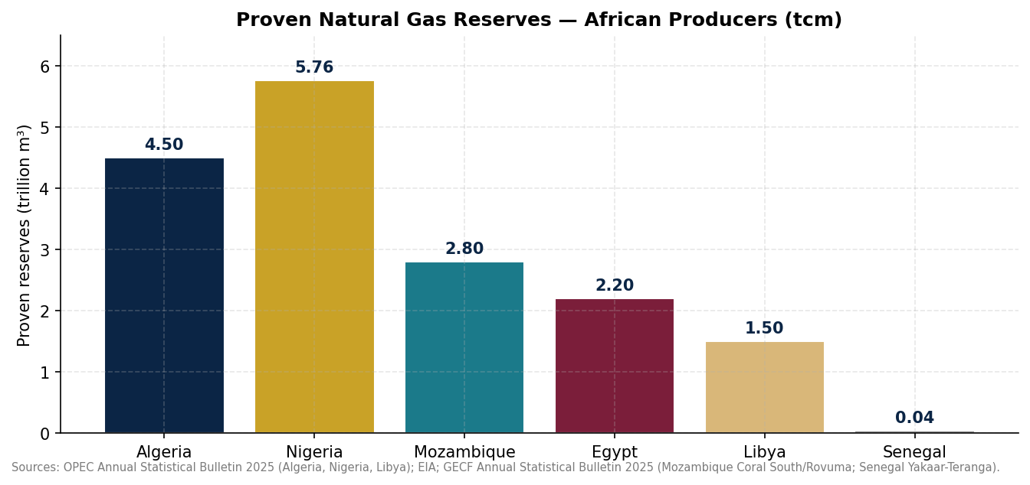
Source: OPEC Annual Statistical Bulletin 2025 (Algeria, Nigeria, Libya); EIA; GECF Annual Statistical Bulletin 2025 (Mozambique Coral South/Rovuma; Senegal Yakaar-Teranga).

6.2 Risk Matrix
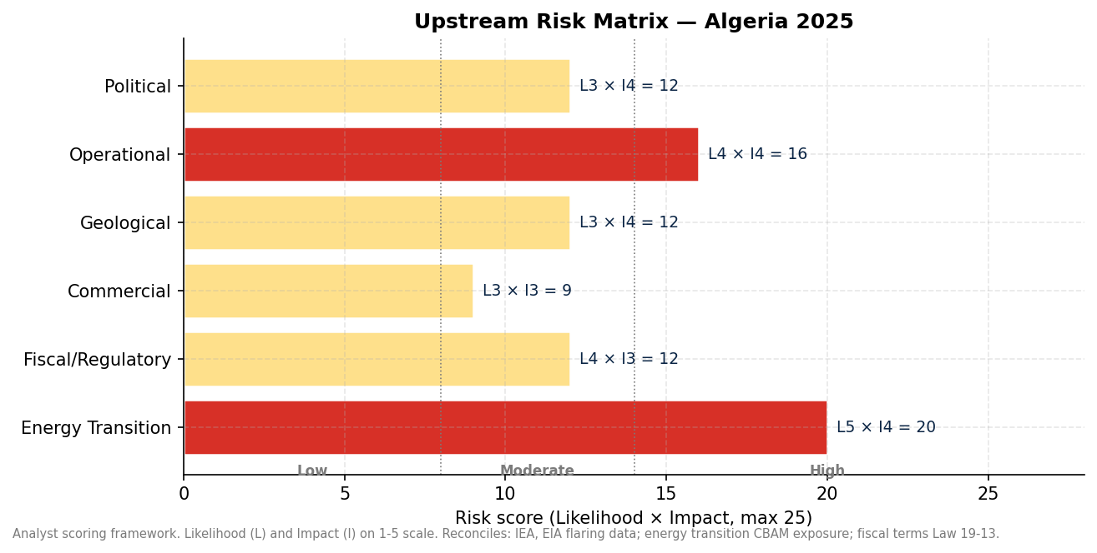
Source: Analyst scoring (Likelihood × Impact, each 1-5) integrating EIA flaring data; energy-transition CBAM exposure; fiscal-terms Law 19-13; field decline rates.

6.3 Upstream Gas Value Chain
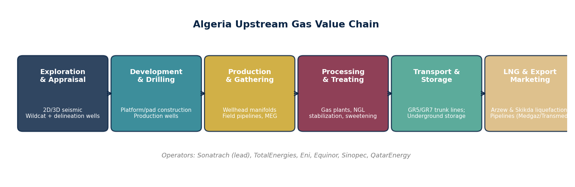
Source: Reference architecture developed for the Senior Upstream Intelligence Desk; operator mapping: Sonatrach (lead operator across all stages); TotalEnergies, Eni, Equinor, Sinopec, QatarEnergy at corresponding stages.

6.4 Actionable Recommendations
Synthesis of Section 1-5 findings into stakeholder-specific recommendations:
For Sonatrach
- Convert the 17 discoveries of 2025 into booking upgrades by Q1-2027 to lift RRR sustainably above 100%.
- Pilot Ahnet unconventional in 2027 followed by Berkine in 2028-29 — but contractually pre-clear 30%+ state-take exemptions under unconventional carve-outs in Law 19-13.
- Invest in CO₂-EGR pilots at Hassi R'Mel; monetise emissions avoidance via Article 6.4 credits pre-2030 to defray flaring reductions on the income statement.
- Accelerate digital twin and AI reservoir modelling under existing SLB / Baker Hughes partnerships; open a data-companion ‘Algeria Upstream Digital Suite' for IOC consortium-wide access.
For the Government of Algeria & Ministry of Energy & Mining / ALNAFT
- Issue implementing decrees that further compress PSA approval timelines and clarify unconventional carve-outs; pre-empts competing fiscal reforms in Egypt and Senegal.
- Couple the 2026 licensing round (66.5 bcm gas) with a minimum work-commitment package that ties seismic acquisition to acreage award.
- Negotiate a transition-aligned ‘Gas for Renewables' framework, allowing EU CBAM-compliant volumes to be paired with solar/hydrogen exports under GECF umbrella.
- Advance the SONATRACH-led Natural Gas Acceleration Law (under industry consultation) to ease LNG export licensing and accelerate unsold-train conversions to flexible LNG output.
- Push for the Interconnector ‘TSGP' with Italy's Southern Gas Hub model to lock in 2030+ offtake.
For International Oil Companies & Energy Investors
- Increase exposure to Berkine unconventionals — first-mover position on the ExxonMobil/Chevron HOAs will be a key strategic asset; bring US-style shale completion expertise to accelerate pilot rate-of-penetration.
- TotalEnergies and Eni: leverage integrated equity across Berkine, In Salah/In Amenas, Timimoun, Reggane Nord to deliver >20% ROS at sub-$1.0/MMBtu breakeven.
- QatarEnergy: treat the Ahara consortium entry as a foothold for downstream LNG offtake; align procurement with Sonatrach–TotalEnergies MoU 2 mtpa.
- Sinopec/ZPEC: de-risk acreage through partner-aligned field-development services export from China; long-dated credit lines support FID.
- DFIs (AfDB, IFC, EBRD, EIB): finance EGR/CCS flaring-reduction projects and the Medgaz/Transmed last-mile expansions; de-risk through blended-finance with EU Investment Bank ‘Global Gateway'.
For Development Finance Institutions & Upstream Operators
- Fund a dedicated ‘Algeria Flaring Mitigation Facility' to retire 80 Bcf of routine flaring via monetisation, freeing 2-3 bcm/y of supply.
- Multi-lateral credit lines to support Sonatrach's late-life field reactivation — DR-TGS in Berkine flank already demonstrated at 7 mln scf/d add-back.
- Joint-venture financing to accelerate non-associated gas tie-back on the ~100 undeveloped discoveries inventory; cost-of-capital advantage for EOR / EGR projects >150 mln scm/d.
- Underwrite scale-up of LNG optimisation (skid-mounted micro-LNG) to monetise associated gas stranded in mature oil fields.
6.6 Bottom Line
Algeria's upstream gas sector enters the second half of the 2020s structurally better positioned than any other African producer: it combines the largest 1P reserve base on the continent (4.50 tcm), the most diversified European export infrastructure (Medgaz + Transmed + Arzew/Skikda + new German pipeline), a competitive fiscal regime (Law 19-13), and the most ambitious state-led investment programme ($60 bn, 2025-29). Its central constraint is reservoir: mature basins, ≥8% decline rates on flagship assets, and a reserve replacement trajectory that only reverses if unconventional pilots succeed in 2027-28. The intelligent bet is a measured but committed move into shale, accelerated tie-back of undeveloped discoveries, and a renewed push on resilience assets that pragmatically share value with IOCs while protecting the long-run strategic independence of Sonatrach and Algeria's energy security arrangement with Europe.

Appendix A. Key Upstream Performance Indicators (KPI)
KPI | 2022 | 2023 | 2024 | 2025E | 2030 Target (Sonatrach)
Gas production (bcm) | 100 | 97 | 103 | 106 | 132
Oil production (mb/d) | 1.02 | 0.96 | 0.95 | 1.00 | 1.20
LNG exports (mt) | 11.0 | 10.5 | 10.6 | 13.0 | 16.0
Pipeline exports to EU (bcm) | ≈ 33 | ≈ 31 | ≈ 35 | ≈ 38 | ≥ 45
Reserve replacement ratio (%) | 145 | 90 | 95 | 120 | ≥ 110 sustained
Exploration drilling (wells) | 26 | 30 | 33 | 38 | 45+ sustained
Flaring intensity (%) | ≈ 11 | ≈ 10 | ≈ 9 | ≈ 7 | < 1 (2030)
Upstream CAPEX (USD bn) | 7.0 | 8.5 | 9.8 | 11.2 | ≈ 12 sustained
Sonatrach share of CAPEX (%) | 85 | 82 | 80 | 78 | 70 (with IOC uptick)
Discovery count (Sonatrach only) | 8 | 8 | 8 | 17 | 20+ sustained
Methane intensity (CH₄ kt/TJ gas) | n/a | n/a | ≈ 1.8 | ≈ 1.5 | < 1.0
Source: Sonatrach AR 2022, AR 2024; EIA Country Brief Algeria June 2025; EI Statistical Review 2025; analyst estimates for forecast column.
Appendix B. Major Upstream Projects — Status (2026)
Project | Operator(s) | Status | Capacity / Resource
Hassi R'Mel gas supergiant | Sonatrach (100%) — Baker Hughes compression partner | Producing; Phase 3 commissioning | ~188 mscm/d gross capacity
In Salah gas redevelopment | Sonatrach 50.30% (op) | Eni 33.15% | Equinor 16.55% | Producing; EGR pilot prep | ~9 bcm/y
In Amenas gas | Sonatrach 51% (op) | Eni 47% | Equinor 45% net | Producing | 9 bcm/y nameplate
Berkine Blocks 404a & 208 | Groupement Berkine (TotalEnergies op., Eni) | 30-yr $1.35 bn PSC (Aug 2025) | 415 mln BOE (incl. 9.3 bcm gas)
Timimoun gas | Groupement Timimoun (TotalEnergies op., Sonatrach) | Producing; expansion under MoU | ≈ 165 mmcfd target
Reggane Nord | Groupement Reggane-Nord (TotalEnergies / Sonatrach) | Operating | ~2.9 bcm/y
Ahara exploration | TotalEnergies (op.) + QatarEnergy | Exploration, post 2024 round | ~14,900 km² footprint
Tafassasset | TotalEnergies (op.) + Sinopec | Exploration, post 2024 round | Frontier
ZPEC block | Eni + Sinopec (ZPEC) consortium | Exploration, post 2024 round | Berkine swing area
Ahnet unconventional pilot | Sonatrach + Chevron (HOA) | Feasibility 2025-27 | USGS mean 21 tcm recoverable (regional)
Berkine unconventional | Sonatrach + ExxonMobil (HOA) | Feasibility 2026-28 | Ghadames/Berkine Silurian
Gourara exploration | Sonatrach + Chevron feasibility | Pre-FID | South-west frontier
Source: Sonatrach RA 2024; Eni RA 2025; TotalEnergies Factbook 2025; JPT 'E&P Notes' Aug 2025; USGS FS 2026-3005; Argus Media 2024 bid round coverage.
Appendix C. Investment Commitments by Operator (2025-2029)
Entity | Committed amount | Period | Focus areas
Sonatrach | USD 60 bn | 2025-2029 | Upstream (75%), midstream, downstream, hydrogen
Sonatrach (legacy envelope) | USD 50 bn | 2024-2028 | Upstream E&P core, flaring reduction
TotalEnergies | ≈ USD 1.0 bn (Berkine + Timimoun) | 2024-2027 | Berkine, Timimoun expansion
Eni | USD 1.35 bn Berkine PSC | 30-yr | Berkine unconventional + gas
Chevron | 2-year feasibility + ~ USD 250-400 m pilot | 2025-2027 | Ahnet / Berkine unconventional
ExxonMobil | HOA in Aug 2025; FID pending | 2026-2030 | Ahnet / Berkine unconventional
Sinopec / ZPEC | Aligned with 2024 bid round; partner-financed | 2025-2030 | Tafassasset / ZPEC block
QatarEnergy | Aligned with Ahara consortium | 2025-2030 (exploration) | Berkine-Illizi intersection
ALNAFT 2026 round (total envelope) | USD 3-4 bn (expected) | 2026-2030 | 7 perimeters (66.5 bcm gas)
Source: Reuters Oct 2025; Sonatrach press releases 2024-25; Eni RA 2025; World Oil Aug 2025; Argus Media 2025; Lex Africa 2026 round alert.
Appendix D. Forecast Tables (2026–2045)
Central-case forecast for production, exports and demand is presented in Section 5.3. Below: scenario-conditional reserve replacement ratio:
Year | Low case RRR (%) | Central RRR (%) | High case RRR (%)
2026 | 110 | 125 | 140
2028 | 100 | 120 | 135
2030 | 90 | 115 | 135
2035 | 85 | 110 | 130
2040 | 80 | 105 | 125
2045 | 75 | 100 | 120
Source: Analyst modelling against Sonatrach AR 2024; GECF Global Gas Outlook 2055 (Mar 2025).
Appendix E. Proven Gas Reserves vs. African Producers
Country | Proven reserves (tcm) | Marketed production 2024 (bcm) | RLI (yrs 2024)
Algeria | 4.50 | 103 | ≈ 43
Nigeria | 5.76 | ≈ 45 (associated flare/vent losses significant) | ≈ 128
Mozambique | 2.80 | ≈ 6 (post-Coral South ramp) | ≈ 467
Egypt | 2.20 | ≈ 50 (mature, declining) | ≈ 44
Libya | 1.50 | ≈ 13 | ≈ 115
Senegal | 0.04 | negligible (Yakaar-Teranga pre-FID) | n/a (commercial)
Source: OPEC Annual Statistical Bulletin 2025 — Algeria, Nigeria, Libya; EIA Country Brief Egypt/Nigeria 2025; GECF ASB 2025 (Mozambique, Senegal).

