FLOATING LNG (FLNG) AND FLOATING STORAGE REGASIFICATION UNITS (FSRUS) AS CATALYSTS FOR SOUTH AFRICA'S GAS MONETIZATION STRATEGY

Executive Summary

South Africa's gas economy stands at an inflection point. For more than two decades the country has relied on a single external umbilical the Republic of Mozambique Pipeline Investments Company (ROMPCO) line carrying gas from the Pande and Temane fields in southern Mozambique to Sasol's Secunda and Sasolburg complexes for the overwhelming majority of its natural gas. That supply is now in structural decline. Sasol has signaled that it will cease supplying third-party customers from mid-2026, and independent analysis commissioned by the Trade and Industry Policy Strategies (TIPS) institute in March 2026 places the point of sharp volumetric decline at 2028, after which the fields that have supplied roughly 90% of South Africa's gas for more than twenty years will fall away. Industry body IGUA-SA frames this in blunter terms in its 2025–2042 Gas Road map: without a committed alternative supply, the country faces a full "Gas Cliff" within twelve months of publication, threatening an estimated 70,000 jobs and the feedstock base of Sasol's Secunda synfuels operation, the Sasolburg chemicals complex, and dozens of downstream industrial users in steel, sugar, paper, pulp and fertiliser.
Floating LNG (FLNG) and Floating Storage Regasification Units (FSRUs) have moved from a peripheral technical curiosity to the central instrument of South Africa's gas-security response. Two decades of onshore terminal studies at Saldanha Bay, Coega/Ngqura and Mossel Bay failed to reach financial close, and the most recent attempt to import floating gas-to-power capacity, Karpowership's proposed FSRU deployments at Richards Bay, Coega and Saldanha Bay, collapsed in October 2024 after repeated environmental-authorisation setbacks. In their place, a state-private consortium Transnet National Ports Authority, Royal Vopak and, since June 2026, ExxonMobil as prospective gas supplier has advanced the Zululand Energy Terminal (ZET) at Richards Bay through a signed 25-year terminal operator agreement, a land concession, and a phased design combining an interim Floating Storage Unit (FSU, 135,000–174,000 m³) with onshore regasification (~400 mmscfd Phase 1), migrating later to onshore storage. This is the most advanced LNG import project South Africa has produced, though public reporting is inconsistent on the final investment decision (FID) date company guidance has referenced both 2026 and, more recently, 2028, which would push first gas into the early 2030s and narrow the margin against the 2028 supply cliff considerably.
On the supply side, South Africa's own offshore endowment principally the Brulpadda and Luiperd gas-condensate discoveries in Block 11B/12B, holding an estimated 3.4 trillion cubic feet of recoverable gas remains stranded. TotalEnergies and partners QatarEnergy and Canadian Natural Resources withdrew from the block in July 2024, citing an inability to agree an economic gas price with PetroSA and Eskom; operatorship passed to Canadian-listed Africa Energy Corp (via its Main Street 1549 subsidiary), which now targets first gas only by 2033. Regionally, Mozambique's Coral Sul FLNG (Eni-operated, 3.4 mtpa, operational since 2022) demonstrates that deepwater FLNG is technically and commercially provable in the Rovuma Basin, and the follow-on Coral Norte FLNG project (3.5 mtpa, FID expected 2026, start-up 2028) illustrates the replicability of the model but neither delivers gas into South Africa without new cross-border infrastructure.
This note assesses FLNG and FSRU technology as the accelerant for South Africa's transition from single-source pipeline dependency toward a diversified, import-optionality gas hub integrated with a nascent domestic offshore sector and the wider SADC gas market. It evaluates the technical architecture of both floating platforms, the infrastructure gap across Richards Bay, Durban, Coega, Saldanha Bay and Mossel Bay, indicative techno-economics benchmarked against global FLNG cost curves, and the regulatory backdrop including the Upstream Petroleum Resources Development Act (UPRDA, signed into law October 2024), its 2025/2026 draft regulations, and the new Gas Bill (B6-2026) intended to modernise the Gas Act of 2001. Three conclusions anchor the analysis:
- Commercial opportunity is real but time-constrained. A base-case scenario in which Richards Bay reaches FID by 2027 and first gas by the early 2030s narrows, but does not close, the gap left by Pande-Temane's decline; a bridging strategy potentially including a second import route via Mozambique's Matola or Inhassoro ports, as recommended in the July 2026 TIPS study is required to avoid a multi-year supply trough.
- Investment risk is concentrated in demand-side bankability, not technology. FLNG/FSRU hardware is mature (Rystad Energy estimates global FLNG capacity will more than triple from 14.1 Mtpa in 2024 to 42 Mtpa by 2030), and conversion-based designs have pushed indicative capex below US$650/tonne. The binding constraint in South Africa is securing creditworthy, long-tenor offtake from Eskom, Sasol, industrial IPPs and gas-to-power projects sufficient to underwrite terminal project finance.
- Strategic recommendation: pursue a dual-track, dual-terminal approach fast-track Richards Bay FSRU/FSU capacity for KwaZulu-Natal power and industrial demand, while pursuing a complementary Mozambique-side import and pipeline solution to protect Sasol's inland Secunda/Sasolburg feedstock — anchored by accelerated UPRDA regulatory finalisation, a published Gas Master Plan, and a credible offtake aggregation mechanism (e.g., a state-backed gas trading entity or IPP bundling structure) that reduces single-buyer counterparty risk for international suppliers and financiers.

- South Africa’s Emerging Gas Economy
  - Current Demand and the Structure of Consumption

South Africa's natural gas footprint is small relative to the size of its economy natural gas contributes roughly 2.5% of total primary energy supply against coal's dominant 70%+ share but it carries outsized strategic weight because it is concentrated in feedstock-critical industrial applications rather than diffuse residential heating or power. Total gas supply into the country has historically run at approximately 160–220 petajoules (PJ) per year, transported almost entirely via the ROMPCO pipeline from the Pande-Temane fields in Inhambane province, Mozambique, augmented by a small volume (roughly 20–25 PJ/yr) of methane-rich gas (MRG) that Sasol distributes via the Transnet-owned Lilly pipeline from Secunda to Durban and Richards Bay for industrial customers in Mpumalanga and KwaZulu-Natal.
Roughly 35–40% of Pande-Temane volumes feed Sasol's Secunda coal-and-gas-to-liquids and chemicals complex; a further 35–40% supplies the Sasolburg chemicals plant (wax, methanol, ammonia production); and the balance some 20–23 PJ/yr is sold to a diversified base of industrial and commercial customers, including steel, sugar, paper and pulp manufacturers and the motor industry. Globally, natural gas provides roughly 70% of ammonia production feedstock and 55–65% of methanol production, underscoring why the loss of reliable gas supply is a food-security and industrial-competitiveness issue for South Africa as much as an energy-security one.

1.2 The Mozambique Pipeline Cliff
The Pande and Temane fields, operated by Sasol in an unincorporated joint venture with the International Finance Corporation and the Mozambican state oil company Companhia Moçambicana de Hidrocarbonetos, began production in 2004 and 2009 respectively on an anticipated 25-year field life. Sasol confirmed in August 2023 that it would cease third-party gas sales by the end of June 2026, retaining remaining volumes for its own operations, and ROMPCO's own technical leadership has stated that supply is expected to decline structurally from 2026. A more recent, and less alarmist, framing published by TIPS in a March 2026 study and summarised in Wits University and Conversation Africa commentary in July 2026 places the point of sharp fall after 2028, giving the market a narrow but not immediate runway. Sasol's Bonito-1 discovery near the existing fields is described as a potential bridge, but is five to eight years from development and cannot plug the near-term gap; other Mozambican discoveries are either too far from the ROMPCO corridor or delayed by the security situation in Cabo Delgado province.

1.3 Domestic Offshore Discoveries: Brulpadda and Luiperd
Block 11B/12B in the Outeniqua Basin, roughly 175 km off South Africa's southern coast in water depths of 200–1,800 metres, hosts the Brulpadda (2019, an estimated 1.3 tcf gas/80 million barrels condensate) and Luiperd (2020, an estimated 2.1 tcf gas/112 million barrels condensate) discoveries — collectively South Africa's largest proven offshore gas resource at roughly 3.4 tcf recoverable and more than 600 million barrels of oil equivalent. TotalEnergies, which had operated the block since 2013 with a 45% interest alongside QatarEnergy (25%) and Canadian Natural Resources (20%), withdrew in July 2024 after failing to agree a commercially acceptable gas price with PetroSA and Eskom — a failure the Department of Mineral and Petroleum Resources (DMPR) confirmed to Parliament turned on price, not geology or technical feasibility. Africa Energy Corp's local subsidiary, Main Street 1549, assumed 75% operatorship in 2025 and targets first gas only by 2033, contingent on environmental authorisation (paused in late 2025 following an unrelated Western Cape High Court ruling against a neighbouring block's EIA) and a credible offtake structure, potentially anchored by a dedicated gas-to-power plant or a tie-in to PetroSA's existing FA-platform subsea infrastructure at Mossel Bay.

1.4 Demand Outlook and the Draft Gas Master Plan
The draft South Africa Gas Master Plan (GMP), developed by the Department of Mineral and Petroleum Resources with technical support from the South African Gas Development Company (iGas), sketches a long-run demand trajectory of approximately 400 PJ/year of inland gas demand by 2050, plus a further 350 PJ/year in coastal regions — a roughly threefold increase on current total consumption. The Integrated Resource Plan (IRP), most recently revised in its 2023/2024 draft and 2025 update, elevates gas from approximately 2.6% to a targeted 15.7% share of the national generation energy mix by 2030 under earlier IRP 2019 assumptions, with more recent reporting on the newly approved IRP describing a combined gas-and-nuclear target of 16% of generation capacity by 2042 (up from around 3% today) and a South Africa-wide ambition of roughly 6,000 MW of new gas-to-power capacity, much of it intended to convert or supplement existing diesel-fired Open Cycle Gas Turbine (OCGT) peaking plant. IGUA-SA's independently produced Gas Roadmap 2025–2042 models an even more ambitious endpoint of approximately 1,055 PJ/year by the planning horizon once LNG imports, domestic production and smaller regional sources are combined.

Table 1. South Africa Indicative Gas Supply-Demand Balance (illustrative, PJ/year)
Period | Domestic/Pipeline Supply | LNG Imports (indicative) | Total Supply | Demand (GMP-aligned) | Balance
2024 (actual/estimated) | ~185 | 0 | ~185 | ~190 | Marginal deficit
2028 (post-cliff onset) | ~40–70 | ~40–60 (if ZET online) | ~90–130 | ~230 | Material deficit
2035 (base case) | ~60 (11B/12B ramping) | ~180 | ~240 | ~430 | Deficit persists
2050 (GMP long-run target) | ~120 (domestic + regional) | ~300–400 | ~450–550 | ~750 (inland+coastal) | Deficit narrows, gap remains
Source: Author's synthesis of Gas Master Plan demand figures, TIPS (2026), IGUA-SA Gas Roadmap 2025–2042 and ROMPCO/Sasol supply disclosures.

2 Technical Architecture of Floating LNG (FLNG)
FLNG consolidates the upstream gathering, processing, liquefaction, storage and offloading functions of a conventional onshore LNG plant onto a single moored or dynamically positioned marine vessel, eliminating the need for subsea export pipelines, onshore land acquisition, and in many cases dredging. For a gas-monetisation strategy built around stranded or marginal offshore resources — precisely the profile of Block 11B/12B — FLNG's principal appeal is capital discipline and schedule compression relative to greenfield onshore trains.

2.1 Topside Process Architecture
A representative FLNG topside integrates eight functional blocks. Subsea production wells feed a gathering manifold that consolidates multi-well flow into a common riser system. Slug catching and primary separation remove free liquids and manage transient flow instabilities inherent to subsea production. Gas treatment trains then strip CO2, H2S and water to cryogenic-service specifications (typically below 50 ppmv CO2 and 4 ppmv H2S, and dew-pointed to prevent hydrate formation downstream) using amine contactors, molecular sieve dehydration, and mercury removal beds where reservoir gas contains trace mercury — a material risk-management item given aluminium heat-exchanger construction in the liquefaction train. Natural gas liquids (NGL) extraction recovers condensate and LPG-range hydrocarbons ahead of liquefaction, both for value uplift and to manage the heating value specification of the export LNG.
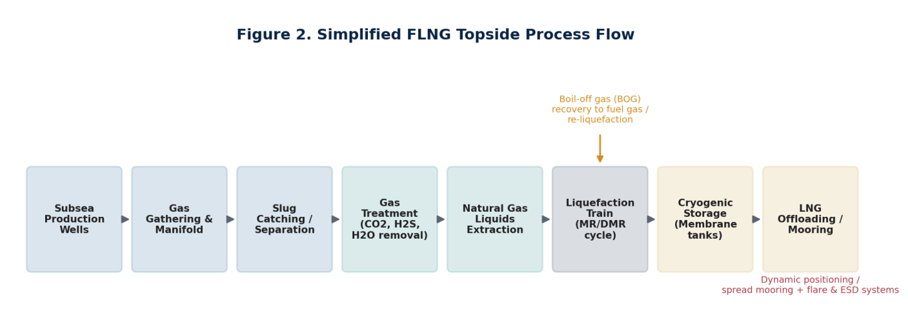
Figure 2. Simplified FLNG topside process flow, from subsea gathering through liquefaction, storage and offloading.

2.2 Liquefaction and Refrigeration Cycles
The liquefaction train is the technical and capital heart of the facility. Most modern FLNG designs use a Single Mixed Refrigerant (SMR) or Dual Mixed Refrigerant (DMR) cycle rather than the cascade or C3MR processes typical of large onshore trains, trading some thermodynamic efficiency for a smaller equipment footprint and weight envelope appropriate to a floating hull. Boil-off gas (BOG) generated by ambient heat ingress into cryogenic storage is recovered and either routed to the facility's own fuel-gas system (powering aeroderivative gas turbine generators) or re-liquefied, both to preserve product volume and to manage vapour pressure within storage tank design limits.

2.3 Storage, Offloading, and Station-Keeping
Cryogenic storage on FLNG vessels typically uses membrane-type containment systems (Gaztransport & Technigaz No. 96 or Mark III designs) integrated into the hull structure, or, in the case of converted LNG carriers such as the Golar Gimi-class vessels used for Tortue/Ahmeyim and other West African projects, the original Moss-type spherical tanks of the donor vessel. LNG offloading to conventional LNG carriers occurs either via side-by-side (STS) transfer with specialised cryogenic transfer arms and fendering, or tandem offloading in more exposed metocean environments. Station-keeping is achieved through spread mooring (multiple catenary or taut mooring lines to seabed anchors) for benign, sheltered locations, or dynamic positioning (DP2/DP3 thruster-based systems) where mooring is impractical or where rapid disconnect capability is required for cyclone avoidance a material design consideration for any prospective South African deployment given the cyclone-adjacent Mozambique Channel and the exposed Agulhas Current conditions along the Wild Coast and southern Cape shelf where Block 11B/12B sits.

2.4 Reliability, Safety, and Boil-Off Management
Shell's Prelude FLNG the largest floating structure ever built is frequently cited as a cautionary case: early operational years were marked by unplanned outages, electrical failures, and a 2021 fire that halted production for several months, illustrating that FLNG's compressed footprint concentrates process risk in ways that demand disciplined reliability engineering, redundancy in power generation, and rigorous permit-to-work and emergency shutdown (ESD) system design. Rystad Energy's 2025 assessment nonetheless finds the technology has matured substantially: FLNG terminals commissioned before 2024 achieved an average 86.5% utilisation rate in 2024, comparable to onshore facilities, and this figure held at approximately 76% through the first three quarters of 2025 evidence that early teething problems (also experienced, and since resolved, at Prelude itself) are not structural to the technology class.

3. Technical Architecture of FSRUs
Where FLNG monetizes stranded upstream gas by liquefying it for export, an FSRU performs the inverse function: receiving LNG cargoes from conventional carriers, storing them cryogenically, and regasifying the product for injection into an onshore pipeline grid. FSRUs are the technology of choice for South Africa's import-side strategy precisely because they compress the delivery timeline for new import capacity relative to a fully onshore terminal Höegh Evi, Excelerate Energy and Golar-class vessels have been deployed in Europe, Bangladesh, Brazil and elsewhere within 12–24 months of a chartering decision, versus 4–6 years for a greenfield onshore regasification plant.
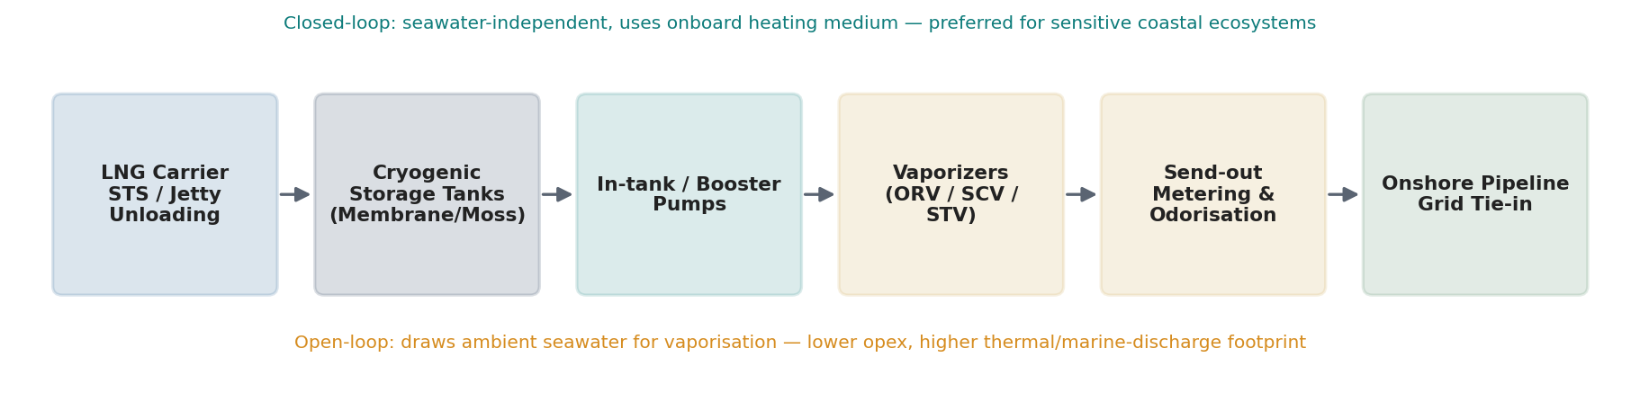
Figure 3. FSRU regasification system architecture, from ship-to-shore unloading through onshore grid tie-in.

3.1 Unloading, Storage and Send-Out
LNG carriers moor alongside the FSRU (or, in a hybrid jetty configuration such as that planned for Richards Bay, alongside a fixed jetty structure with the FSU providing storage) and transfer cargo via cryogenic loading arms into the vessel's membrane or Moss-type tanks. In-tank submerged pumps and topside booster pumps raise LNG to send-out pressure, after which vaporisers convert the cryogenic liquid back to pipeline-specification gas. Send-out metering, custody transfer measurement, and where required by downstream distribution codes odorisation with mercaptan complete the process before gas enters the onshore transmission network.

3.2 Regasification Technology: Open-Loop, Closed-Loop and Hybrid
Open-loop vaporisers (Open Rack Vaporizers, ORVs) draw ambient seawater as the heating medium, offering lower operating cost and energy consumption but discharging cooled, chlorinated seawater a design frequently contested on environmental grounds in South Africa's fisheries-sensitive coastal zones, and a material factor in the environmental objections that contributed to the collapse of the Karpowership FSRU proposals. Closed-loop systems (Shell & Tube Vaporizers, STVs, or Submerged Combustion Vaporizers, SCVs) use an intermediate heating fluid or onboard-generated heat, avoiding large-volume seawater intake and discharge at the cost of higher fuel consumption and, for SCVs, direct CO2 emissions from combustion. Hybrid configurations switch between modes seasonally or in response to regulatory or ambient-temperature constraints, offering operational flexibility at moderate additional capital cost. Given the sensitivity that has already sunk three prior South African FSRU proposals on environmental grounds, a closed-loop or hybrid configuration as appears to be favoured in the ZET Phase 1 design is the more bankable choice notwithstanding its opex premium.

3.3 Deployment Timelines, Flexibility and Availability
FSRUs offer two forms of flexibility unavailable to onshore terminals: locational (the vessel can, in principle, be redeployed to a different port if the original market thesis fails) and capacity-phasing (storage and send-out capacity can be scaled by chartering additional units without a full greenfield rebuild). This is reflected directly in the Zululand Energy Terminal's phased design: Phase 1 pairs an interim FSU (135,000–174,000 m³) with onshore regasification capable of approximately 400 mmscfd, connecting via a repurposed Lilly pipeline segment through Empangeni; Phase 2 introduces permanent onshore storage of up to approximately 220,000 m³, at which point the floating storage function is retired. Typical FSRU/FSU availability factors run 95%+ in mature deployments, materially higher than the 76–86% utilisation range reported for FLNG, reflecting the lower process complexity of regasification relative to liquefaction.

4. Commercialization Pathways
FLNG and FSRU infrastructure do not monetise gas in isolation; they are enabling infrastructure for a downstream demand portfolio that determines whether any terminal reaches financial close. South Africa's commercialisation pathways cluster into six categories, mapped against the value chain in Figure 1.
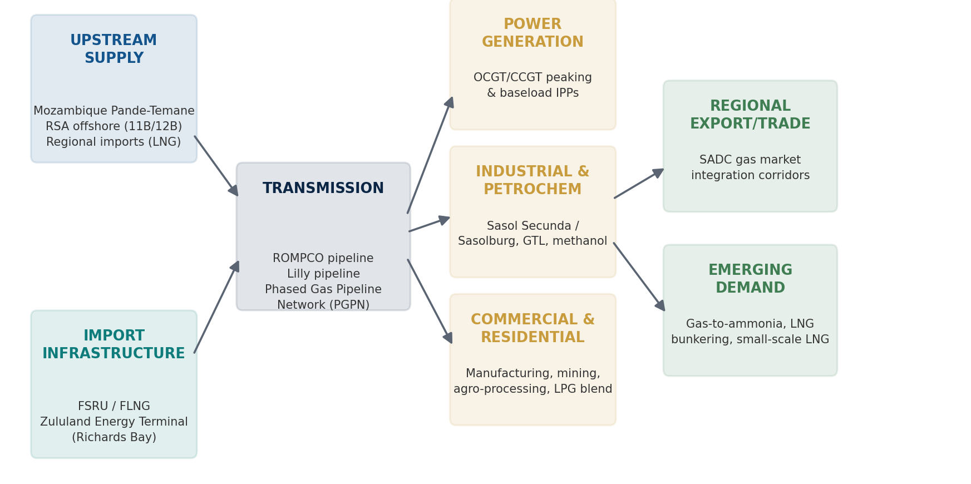
Figure 1. South Africa's emerging gas value chain, from upstream supply and import infrastructure through transmission to end-use demand.

4.1 Gas-to-Power
Power generation is the single largest identified demand pool, anchored by the IRP's target of approximately 6,000 MW of new gas capacity and the conversion of existing diesel-fired OCGT peaking plant (six units nationally) to natural gas a straightforward retrofit that could absorb meaningful early-stage LNG volumes without new plant construction. Independent Power Producer (IPP) gas-to-power procurement rounds (the DoE/DMRE's LNG-to-Power IPP programme, structured around Coega and Richards Bay RFQ/RFP tracks) provide the intended procurement vehicle, though prior rounds have been repeatedly delayed.

4.2 Petrochemicals, Fertiliser and Industrial Feedstock
Sasol's Secunda and Sasolburg complexes remain the largest single demand centres, consuming an estimated 185 PJ/year historically, split roughly 70–80% between synfuels/chemicals feedstock and the balance sold to third parties. Sustaining this feedstock base — critical to South Africa's ammonia, methanol and wax production and, by extension, to fertiliser security for the agricultural sector — is arguably the single most consequential commercial rationale for accelerating LNG imports, independent of new gas-to-power capacity.

4.3 Mining, Manufacturing and Transport Fuels
Beyond Sasol, direct industrial consumers span steel, sugar, paper and pulp manufacturing, and the automotive sector, distributed via a pipeline network covering more than 3,000 km across Mpumalanga, Free State, Gauteng, KwaZulu-Natal and North West. Mining sector applications include on-site power generation displacing diesel, and future potential in CNG/LNG-fuelled haul trucks. Small-scale LNG (SSLNG) truck-delivered LNG or CNG to gas-grid-disconnected industrial users offers a lower-capex bridging mechanism ahead of full pipeline build-out, and is explicitly identified in both the TIPS 2026 study and the IGUA-SA roadmap as a near-term demand-diversification and risk-mitigation tool.

Table 2. Gas Demand Segments and Indicative Monetisation Pathway
Demand Segment | Approx. Share (current) | Primary Monetisation Route | Key Enabling Infrastructure
Sasol Secunda (synfuels/chemicals) | ~35–40% | Direct pipeline supply / LNG blend | ROMPCO, Lilly pipeline, ZET
Sasol Sasolburg (chemicals) | ~35–40% | Direct pipeline supply | ROMPCO
Industrial/commercial (steel, sugar, paper) | ~10–15% | Pipeline distribution, SSLNG | Transnet gas network
Power generation (OCGT conversion, new CCGT) | Emerging, target ~6,000 MW | Gas-to-power IPP procurement | ZET, Coega/Richards Bay IPP programme
Mining and transport (CNG/LNG) | Nascent | SSLNG, truck/rail distribution | Regional LNG satellite terminals
Regional SADC export/trade | Nascent | Cross-border pipeline/LNG swap | SADC Regional Gas Master Plan corridors
Source: Author's synthesis of DMRE/DMPR Energy Sector Report 2025, Sasol disclosures, TIPS (2026) and IGUA-SA Gas Roadmap.
5. Infrastructure Gap Assessment

South Africa's 2,954 km coastline hosts eight commercial seaports, of which five have been formally studied or actively considered for LNG-related infrastructure. None currently hosts an operating LNG import terminal.

5.1 Richards Bay
Richards Bay is the clear first-mover and the only site with a signed terminal operator agreement, a 25-year land concession, and named commercial and financial partners (Transnet, Vopak, and, since June 2026, ExxonMobil as a Heads-of-Agreement gas supplier). Its advantages are deep-water access suitable for large LNG carrier classes (Q-Flex and, depending on final berth specification, potentially Q-Max), established heavy industry in the surrounding KwaZulu-Natal industrial development zone, and direct pipeline connectivity via the existing Lilly line back to Secunda through Empangeni. The principal open question is timeline: public statements have referenced FID dates as early as 2026 and as late as 2028, with the latter implying first gas only in the early 2030s — a schedule that would only partially offset the 2028 Mozambique supply decline.

5.2 Durban
Durban functions primarily as a secondary distribution node rather than an independent import site, benefiting from existing Transnet pipeline infrastructure and proximity to Richards Bay, but lacks a dedicated deep-water LNG berth proposal of its own in current public planning.

5.3 Coega (Ngqura)
Coega was one of two ports (with Richards Bay) prioritised in the original DoE/DMRE LNG-to-Power IPP programme, with up to 1,000 MW of gas-to-power generation earmarked for procurement, and was a target site for Karpowership's cancelled FSRU deployment. The Dedisa OCGT peaking plant provides an existing demand anchor, but the site has no active FSRU/FLNG proposal following the October 2024 Karpowership collapse.

5.4 Saldanha Bay
Saldanha Bay possesses the best natural deep-water characteristics of any candidate site (dredged depths to 23 m, an artificial breakwater, and favourable conditions for a jettyless mooring system) and was PetroSA's originally preferred location before studies shifted focus elsewhere. However, the 2016 DoE/Transnet 18-month feasibility study concluded it requires substantially more grid, pipeline-servitude and gas-plant infrastructure investment than Richards Bay or Coega, and it was consequently assigned to a later phase of the national LNG-to-Power programme. It remains the origin point for the proposed Phased Gas Pipeline Network's western leg toward Mossel Bay and Coega.

5.5 Mossel Bay
Mossel Bay hosts PetroSA's gas-to-liquids refinery (nameplate ~45,000 bpd), historically fed by declining offshore Block 9 gas reserves that sustained the plant for nearly 28 years. PetroSA's own 2014 attempt to site an FSRU at Mossel Bay was abandoned after metocean studies found the location technically unsuitable of thirteen operational FLNG/FSRU terminals reviewed globally at the time, all were located in sheltered ports, near-shore, or on calm rivers, conditions Mossel Bay's exposed coastline does not replicate. The port's more probable future role is as a landing point for Block 11B/12B gas via the existing FA-platform subsea tie-in, a possibility Africa Energy Corp has confirmed it is actively discussing with PetroSA, rather than as an LNG import site.
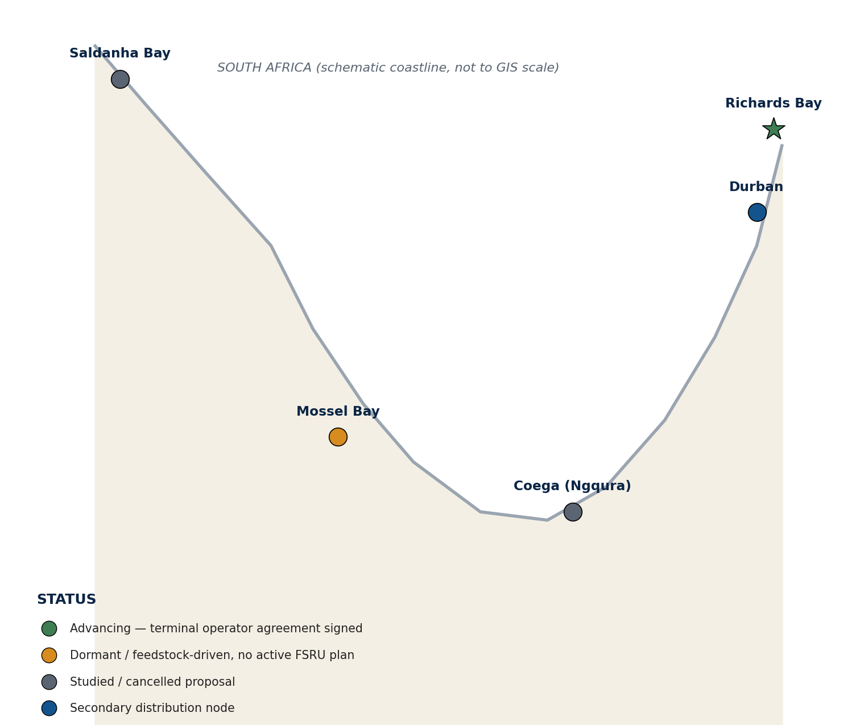
Figure 4. Existing versus proposed LNG import infrastructure across South Africa's principal coastal sites (illustrative schematic).

Table 3. Technical Infrastructure Gap Matrix
Site | Port Readiness | Pipeline Connectivity | Storage Capability | Regas Capability | Current Status
Richards Bay | High (deep-water, JV agreed) | Moderate (Lilly line, needs Empangeni tie-in) | Planned (FSU + future onshore) | Planned (~400 mmscfd Ph.1) | Advancing — FID pending
Durban | High (existing terminal ops) | High (Transnet hub) | None dedicated | None dedicated | Secondary node only
Coega (Ngqura) | Moderate–High | Low–Moderate | None (proposal cancelled) | None (proposal cancelled) | Dormant post-Karpowership
Saldanha Bay | High (natural deep-water) | Low (PGPN not built) | None | None | Studied; deprioritised
Mossel Bay | Low (unsuitable metocean) | Moderate (FA-platform tie-in potential) | None (2014 plan abandoned) | None | Feedstock-role only
Source: Author's assessment based on Transnet, DoE/DMRE 2016 port studies, GEM Global Gas Infrastructure Tracker, PetroSA and Africa Energy Corp disclosures.
6. Techno-Economic Analysis
Global FLNG cost curves have fallen sharply as the technology has matured and as vessel-conversion designs repurposing retiring Moss-type LNG carriers as liquefaction hulls have displaced newbuild construction as the default delivery model. Rystad Energy and Wood Mackenzie benchmarks place converted FLNG capex as low as US$500–650/tonne of annual capacity (e.g., Tortue/Ahmeyim, Cameroon FLNG, and Southern Energy's FLNG MkII), against US$800/tonne for newbuild FLNG hulls (Samsung Heavy Industries and Wison Offshore & Marine orders) and approximately US$950/tonne for greenfield onshore US Gulf Coast trains — meaning FLNG now undercuts onshore liquefaction capex by 30–45% at the unit level even before schedule and permitting advantages are counted.
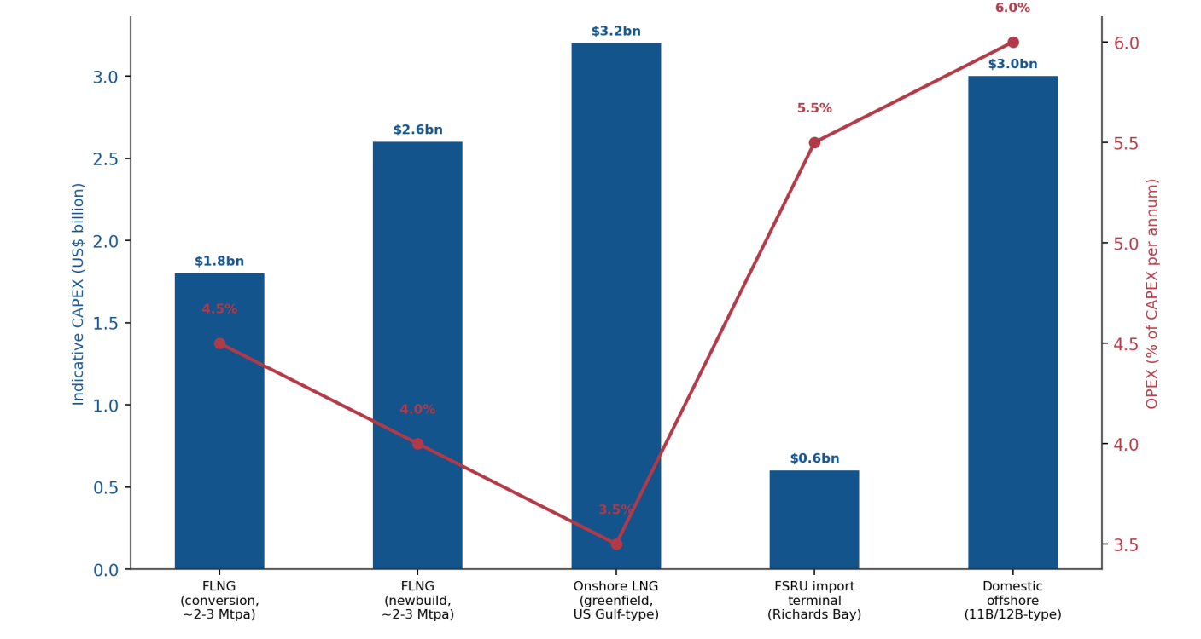
Figure 6. Indicative CAPEX and OPEX comparison across gas monetisation pathways relevant to South Africa (illustrative, scaled to representative project sizes).

6.1 Indicative Landed Cost of Gas
For an import-side facility such as Richards Bay, the relevant metric is not liquefaction capex but the fully landed cost of regasified gas delivered to the send-out flange, which stacks feedgas/LNG procurement cost, shipping, regasification tariff, pipeline transmission and trading margin. Using current JKM/TTF-referenced spot and term ranges alongside typical FSRU tolling fees, an illustrative build-up suggests a landed cost in the order of US$8–10/MMBtu at Richards Bay send-out — materially above Sasol's historical Mozambican pipeline gas cost, which is the central commercial tension underlying the 2024 TotalEnergies/PetroSA/Eskom price impasse on Block 11B/12B and a key reason South Africa's LNG strategy must pair import infrastructure with demand aggregation and, plausibly, some form of price-support or blended-tariff mechanism for the initial ramp-up period.
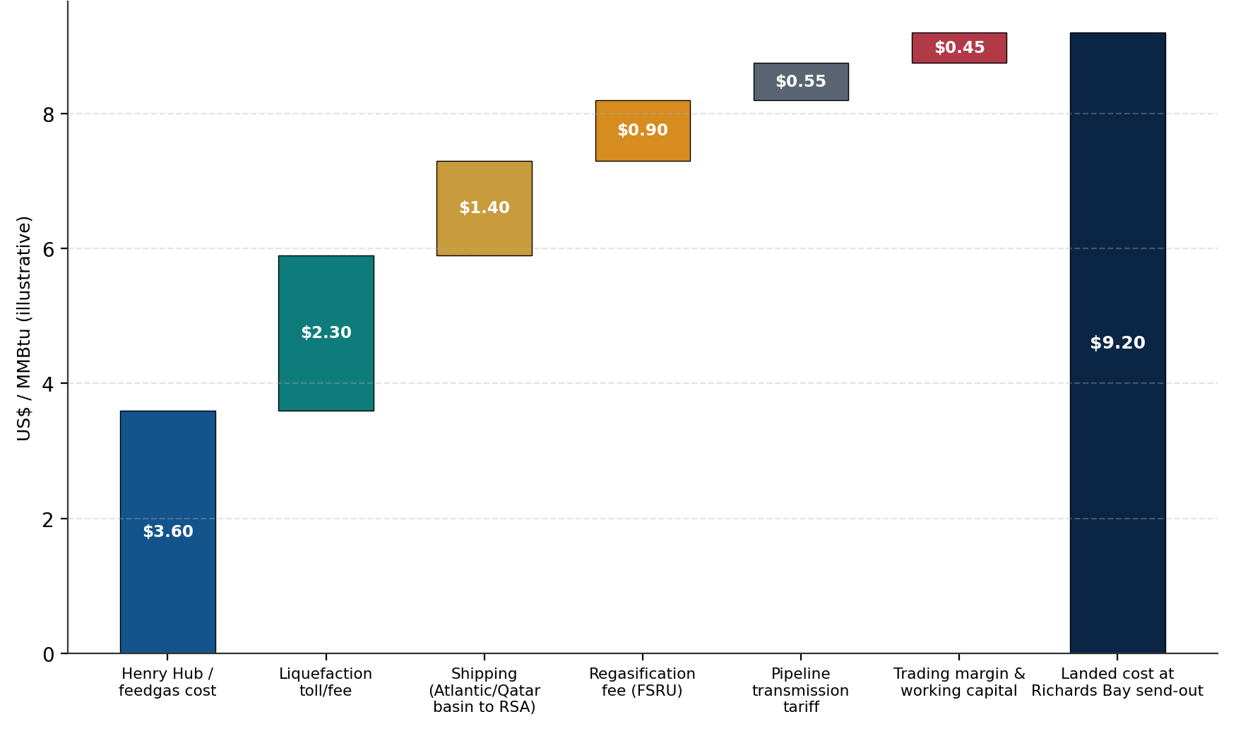
Figure 5. Illustrative LNG landed-cost waterfall to Richards Bay send-out (indicative build-up, not a market quote).

6.2 Levelized Cost of Gas, Break-Even Pricing and Returns
At an indicative capex of US$0.6 billion for FSU/FSRU-based Phase 1 infrastructure (excluding onshore storage and pipeline extensions) amortised over a 20-year concession at a South African-appropriate weighted average cost of capital of 11–13% (reflecting sovereign and currency risk premia over developed-market FSRU financings), the capital-recovery component of the regasification tariff alone is estimated at US$0.9–1.3/MMBtu, broadly consistent with global FSRU tolling benchmarks of US$0.50–1.50/MMBtu. Domestic offshore development of Block 11B/12B, by contrast, carries a materially higher upfront capital intensity (indicative capex of US$2.5–3.5 billion for subsea infrastructure, host facilities and pipeline tie-in) but a structurally lower marginal gas cost once developed, explaining Africa Energy's public confidence that 11B/12B gas would be "very competitive versus imported LNG" if a bankable offtake price can be agreed precisely the negotiation that collapsed under the previous operator.

6.3 Sensitivity Analysis
A tornado-style sensitivity of the landed cost of gas shows international LNG feedstock pricing (JKM/TTF exposure) as the dominant driver, followed by FSRU/FLNG capital cost, terminal utilisation rate, and ZAR/USD exchange-rate movement — the latter a structurally important risk given that South African gas buyers largely earn revenue in Rand while LNG cargoes are dollar-denominated. Regasification tariff structure, discount-rate assumptions, and pipeline transmission tariffs are second-order but non-trivial factors, particularly for financing parties assessing debt service coverage under conservative utilisation assumptions.
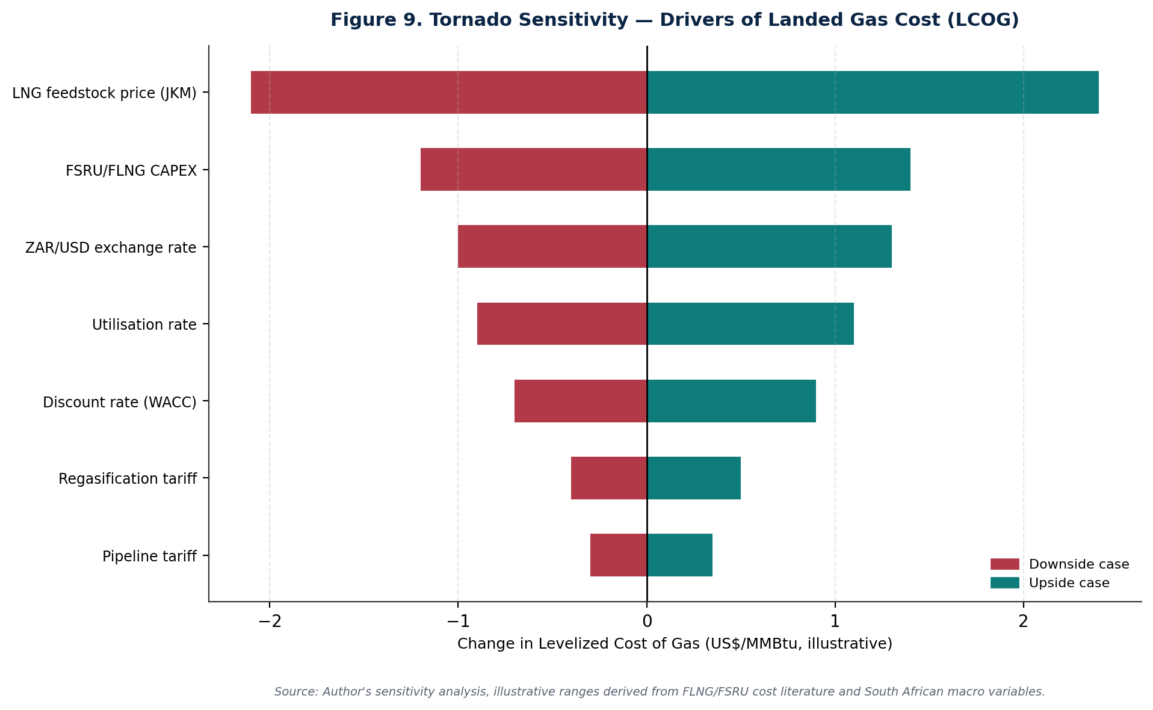
Figure 9. Tornado sensitivity of landed gas cost to key commercial and macroeconomic variables (illustrative ranges).

6.4 Comparative Pathway Economics
Table 4 summarises indicative comparative economics across the four principal pathways available to South Africa. FSRU-based import infrastructure offers materially lower upfront capital intensity and the fastest deployment timeline, at the cost of a higher long-run marginal gas price exposed to global LNG market volatility. Domestic offshore development offers the converse trade-off: higher capital intensity and longer lead time, but potentially lower and more stable long-run gas cost once sunk capital is recovered — assuming a bankable domestic offtake price can be negotiated, which is precisely where the previous 11B/12B development attempt failed.
Pathway | Indicative CAPEX | Deployment Timeline | Indicative Landed/Marginal Cost | Key Risk
FSRU import (Richards Bay Ph.1) | ~US$0.6bn | 3–5 years to first gas | ~US$8–10/MMBtu | Global LNG price volatility, offtake bankability
FLNG conversion (hypothetical SA offshore) | ~US$1.8bn (2–3 Mtpa) | 3–4 years | US$500–650/tonne liquefaction capex | Reservoir economics, environmental authorisation
Onshore LNG (greenfield, reference only) | ~US$3.2bn | 5–7 years | ~US$950/tonne liquefaction capex | Capital intensity, land/community consent
Domestic offshore (11B/12B via pipeline) | ~US$2.5–3.5bn | 7–9 years (to 2033) | Potentially below import parity once developed | Offtake price negotiation, financing, EIA delay
Source: Author's illustrative synthesis of Rystad Energy, Wood Mackenzie, Offshore Magazine FLNG cost benchmarks, and South African project disclosures.
7. Regional Supply Chain Integration
South Africa's gas strategy cannot be assessed in isolation from the wider Southern African Development Community (SADC) gas market, both because its principal historical supply (Mozambique) and its most promising near-term alternative import routes are regional, and because the SADC Regional Gas Master Plan explicitly identifies South Africa-relevant priority corridors.

7.1 Mozambique: From Sole Supplier to Regional LNG Hub
Mozambique's role is transitioning from South Africa's sole pipeline supplier to a much larger regional and global LNG exporter, a shift with direct implications for South African strategy. Eni's Coral Sul FLNG (3.4 mtpa capacity, operational since 2022, having shipped its 100th cargo by April 2025) demonstrated that deepwater FLNG is bankable in the Rovuma Basin; the follow-on Coral Norte FLNG project (approximately 3.5 mtpa, development plan approved by Mozambique's Council of Ministers, FID pushed from 2025 to 2026, start-up targeted 2028) will roughly double Area 4 output. Separately, the TIPS 2026 study's central recommendation is a dual-terminal strategy: one LNG import terminal in Mozambique (at Matola, near Maputo, or Inhassoro) to access the existing ROMPCO corridor and Mozambique's inland gas market, alongside the Richards Bay terminal serving KwaZulu-Natal directly both required to be operational by mid-2030 to manage the transition. Matola's LNG storage facility is already more advanced on permitting than a Richards Bay-only strategy would suggest, potentially offering South Africa a faster route to inland gas security than waiting for KwaZulu-Natal pipeline build-out alone.

7.2 Namibia: An Emerging Optionality
Namibia's offshore Orange Basin discoveries (led by TotalEnergies' Venus find, on trend with South Africa's own Block 3B/4B) have not yet produced a sanctioned gas monetisation project, but legal commentary published in mid-2026 notes that the SADC Regional Gas Master Plan's Walvis Bay-to-Cape Town corridor creates a plausible strategic interface between Namibian gas and Western Cape demand relevant to any future reconsideration of a Saldanha Bay import or regional distribution role. Realising this optionality would require Namibian gas commercialisation to reach a scale and bankability threshold it has not yet achieved, and contractual complexity (delivery point, currency, take-or-pay structure, political risk allocation) remains substantial.

7.3 Angola and Tanzania: Longer-Dated Optionality
Angola's existing Angola LNG facility and Tanzania's stalled onshore LNG project represent longer-dated, lower-probability supply diversification options for South Africa, more relevant to spot-cargo diversification than to firm long-term contracted supply given distance, existing offtake commitments, and, in Tanzania's case, project sanctioning delays.

7.4 SADC Gas Market Integration
The SADC Regional Gas Master Plan provides the overarching policy architecture for cross-border gas trade, identifying the East Coast-to-South Africa corridor (essentially formalising and potentially expanding ROMPCO-adjacent infrastructure) and the Walvis Bay-to-Cape Town corridor as priority projects. NERSA's own policy summaries flag the risk of an acute Sasol and inland-industrial gas shortage as a central planning concern shaping South Africa's engagement with these corridors. Effective regional integration would require harmonised technical standards, cross-border tariff and capacity-allocation mechanisms, and most challengingly coordinated investment timing between South African demand-side commitments and Mozambican, Namibian or other regional supply-side project sanctioning, none of which currently exist in binding form.

8. Risk Assessment
The risk landscape facing South Africa's FLNG/FSRU strategy is dominated less by engineering or marine risk which is well understood and manageable through established design codes and classification-society oversight than by commercial bankability, regulatory timing, and macroeconomic exposure. Figure 7 maps twelve principal risks by probability and impact.
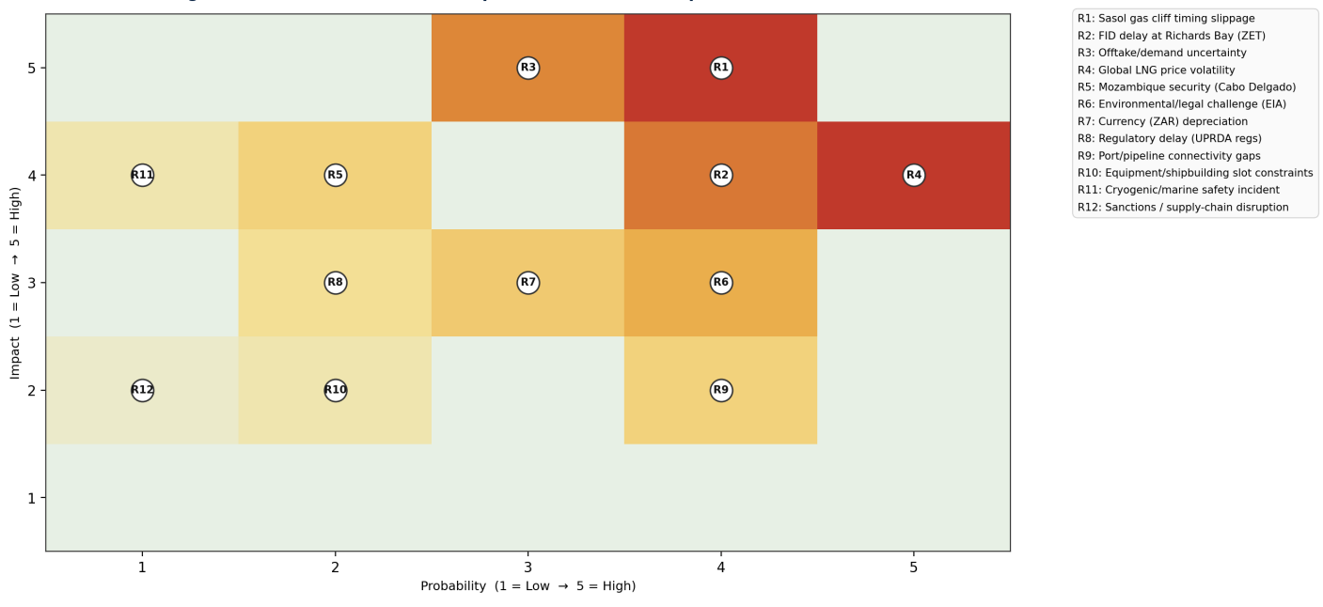
Figure 7. Investment risk heat map for FLNG/FSRU development in South Africa (qualitative probability-impact scoring).

8.1 Technical Risks
- Offshore weather and metocean exposure: the Agulhas Current and southern Cape shelf conditions that doomed PetroSA's Mossel Bay FSRU proposal remain relevant to any southern-coast floating infrastructure; Richards Bay's more sheltered east-coast setting substantially mitigates this for the lead project.
- Equipment failure and reliability: Shell's Prelude experience underscores that FLNG reliability engineering — redundant power generation, robust ESD architecture — is a first-order design requirement, not an afterthought.
- Cryogenic handling and marine safety: LNG transfer operations carry low-probability, high-consequence hazard potential (vapour cloud dispersion, cryogenic burns, rollover in storage tanks), managed through internationally standardized ship/shore compatibility studies, exclusion zones and emergency response planning.
- Pipeline integrity: the ageing ROMPCO/Lilly pipeline network and the need for new tie-in infrastructure (e.g., the Empangeni connection for Richards Bay Phase 1) introduce conventional pipeline integrity-management risk.

8.2 Commercial Risks
- LNG price volatility: South Africa would be a price-taking, relatively small-volume entrant into a global LNG market exposed to JKM/TTF benchmark swings, geopolitical supply shocks, and competing Asian/European demand.
- Demand/offtake uncertainty: the collapse of the TotalEnergies-PetroSA-Eskom price negotiation on Block 11B/12B is the clearest evidence that South African buyers' willingness and ability to pay bankable gas prices is the binding commercial constraint, more than physical infrastructure.
- Currency exposure: Rand-denominated revenue against dollar-denominated LNG procurement creates structural currency risk for both project financing and end-user tariffs.
- Contract structure: the absence, to date, of a clear aggregated offtake or trading-entity mechanism increases counterparty concentration risk for international suppliers such as ExxonMobil.

8.3 Regulatory Risks
- Environmental approvals: three consecutive South African FSRU proposals (Karpowership at Richards Bay, Coega and Saldanha Bay) failed on environmental-authorisation grounds between 2021 and 2024; a Western Cape High Court ruling setting aside an unrelated block's EIA in late 2025 has already caused Africa Energy to pause its own 11B/12B environmental process as a precaution, illustrating contagion risk across the sector's permitting pipeline.
- Regulatory transition: the Upstream Petroleum Resources Development Act (UPRDA, Act No. 23 of 2024) was signed into law in October 2024, but implementing regulations remain in draft as of early 2026 (a second draft circulated by DMPR in January 2026 following industry comment on the April 2025 first draft), creating a period of interpretive uncertainty for new upstream and midstream investment, including the treatment of the state's 20% carried interest under section 34.
- Gas market liberalisation: the new Gas Bill (B6-2026), intended to repeal and replace the Gas Act of 2001, introduces new definitions for LNG, low-carbon gases, gas master plans and trading infrastructure, but remains in the parliamentary process.
- Local content requirements: both the UPRDA and downstream procurement frameworks carry local-content and community-benefit obligations that increase project complexity and cost, particularly for internationally sourced FSRU/FLNG hardware.

8.4 Geopolitical Risks
- Mozambique security: the Cabo Delgado insurgency, though geographically distant from the Pande-Temane/ROMPCO corridor and from Coral Sul FLNG's Area 4 location, remains a latent risk to Mozambican LNG expansion generally and to any Matola-based import terminal considered under the TIPS dual-terminal proposal.
- Global LNG competition: European and Asian buyers' aggressive long-term contracting for the 2026-2028 wave of new liquefaction capacity (approximately 170 mtpa of additional global capacity, per market commentary) could tighten spot-cargo availability and pricing precisely as South Africa seeks to enter the market.
- Shipping disruptions: Red Sea/Gulf of Aden security incidents and broader Indian Ocean shipping-lane risk are relevant given South Africa's east-coast LNG receiving strategy.
- Sanctions and supply-chain constraints: shipyard capacity for FSRU/FLNG newbuilds is concentrated in a small number of South Korean and Chinese yards, creating scheduling risk if global FLNG/FSRU ordering accelerates as Rystad Energy projects.

9. Investment Landscape
The Zululand Energy Terminal structure a Transnet (state-owned) and Royal Vopak (international terminal operator) joint venture, with ExxonMobil entering as a prospective gas supplier under a Heads of Agreement rather than an equity partner is illustrative of the blended public-private model likely to characterise South African gas infrastructure more broadly. Financing such infrastructure will draw on several overlapping pools of capital.

9.1 Public-Private Partnerships and State Involvement
Transnet National Ports Authority's role as landowner, concession grantor and JV partner reflects a PPP structure in which the state retains strategic infrastructure control (the port, the 25-year concession) while private capital and operating expertise (Vopak) deliver and run the terminal. This mirrors South Africa's broader Independent Power Producer Procurement Programme (IPPPP) model, which has successfully mobilised private renewable-energy capital over the past decade and which the LNG-to-Power IPP programme (Coega and Richards Bay RFQ/RFP tracks) is intended to replicate for gas.

9.2 Development Finance Institutions and Export Credit Agencies
The African Development Bank's US$150 million senior loan approved in January 2026 for Mozambique's Coral Norte FLNG project demonstrates DFI appetite for African floating-LNG infrastructure and provides a template — including risk-sharing structures, environmental and social safeguard requirements, and blended-finance co-investment — that South African terminal sponsors could draw on for Richards Bay Phase 2 or a future Mozambique-side import terminal under the TIPS dual-terminal proposal. Export Credit Agencies (ECAs) from South Korea, Japan, France and the United States are natural co-financiers given the concentration of FSRU/FLNG shipbuilding capacity in those jurisdictions, and could be particularly relevant if ExxonMobil's supply role deepens into a financing or equity position.

9.3 Commercial Lenders, Infrastructure Funds and Sovereign Capital
International infrastructure funds and commercial project-finance lenders will require, at minimum, credit-worthy long-tenor offtake agreements before committing debt capital the same bankability constraint that has stalled Block 11B/12B. South African institutional capital (pension funds, the Public Investment Corporation) represents a potential domestic capital pool, particularly if a blended concessional/commercial financing structure can de-risk early-stage returns.

9.4 Financing and Contracting Models
- Build-Own-Operate (BOO): the most likely structure for Richards Bay, with Vopak/ZET retaining long-term ownership and operating responsibility under the 25-year Transnet concession.
- Build-Own-Operate-Transfer (BOOT): more relevant to a future domestic offshore development where the state might seek eventual asset transfer once capital is recovered.
- FSRU leasing/chartering: a lower-capital-intensity alternative to a BOO structure, under which South Africa (or ZET) charters an FSRU vessel from an owner-operator such as Höegh Evi, Excelerate Energy or Golar rather than commissioning a dedicated newbuild — a model that would materially compress both capital requirement and deployment timeline relative to the current ZET design, and merits explicit consideration as a bridging option ahead of the 2028 supply cliff.
- Tolling agreements: regasification-fee-only structures, common internationally, under which the terminal owner is paid a fixed tariff per unit of gas processed regardless of who owns the underlying LNG cargo — reducing the terminal's exposure to commodity price risk and shifting it to the gas buyer/trader.
- LNG offtake/supply contracts: the ExxonMobil Heads of Agreement is the first visible building block of the long-term supply contracts that will ultimately need to underpin FID; additional supplier diversification (Qatar, US Gulf Coast, West African volumes) would reduce single-supplier counterparty concentration.

10. Technology Outlook (2030 to 2050)
The technology base underpinning FLNG and FSRU deployment continues to evolve, with direct relevance to how South Africa should sequence its investment programme over the next two decades.

10.1 Modular and Small-to-Mid-Scale FLNG
The vessel-conversion trend already reshaping global FLNG economics — repurposing retiring Moss-type LNG carriers, as at Tortue/Ahmeyim and Cameroon FLNG — is converging with modular topside design (Wison New Energies' "design one, build two" strategy for multiple Nigerian projects) to compress both capital cost and delivery schedule for mid-scale developments in the 1–4 mtpa range most relevant to a Block 11B/12B-scale resource. This trend materially improves the economic case for eventually monetising South Africa's own offshore gas via FLNG rather than solely via subsea pipeline to shore.

10.2 Digitalisation: AI-Enabled Predictive Maintenance and Digital Twins
Given FLNG's demonstrated vulnerability to unplanned outages in early operational years (Prelude), predictive maintenance systems using vibration analytics, machine-learning-based failure prediction and digital-twin process simulation are increasingly standard on new-build and converted FLNG vessels, directly addressing the reliability risk category identified in Section 8 and supporting the utilisation-rate improvements Rystad Energy has documented industry-wide.

10.3 Autonomous Inspection and Carbon Capture Integration
Remote and autonomous underwater/aerial inspection of subsea infrastructure and topside flare/vent systems is reducing offshore personnel exposure and inspection cost, relevant to South Africa's harsher southern-coast metocean conditions. Carbon capture integration on FLNG trains remains at an early commercial stage globally but is likely to become a compliance-relevant consideration as South Africa's carbon tax trajectory (rising from R35/tonne in 2024 toward R115/tonne by 2030) increases the cost of unabated process emissions from gas processing and liquefaction.

10.4 Hydrogen-Ready Terminals, Floating Ammonia and Emerging Applications
Internationally, several new-build regasification terminals are being specified as "hydrogen-ready" or ammonia-crackable, anticipating a future low-carbon fuel import role beyond conventional LNG. For South Africa, floating ammonia production — potentially leveraging the same Richards Bay or Coega infrastructure corridors being developed for LNG — represents a longer-dated (2035+) option that could align with the country's green hydrogen ambitions, though it remains speculative relative to the immediate gas-security imperative.

10.5 LNG Bunkering, Small-Scale Distribution and Floating Power
LNG bunkering (marine fuel supply) at Richards Bay and Durban represents a plausible incremental revenue stream once base import infrastructure is operational, capitalising on South Africa's position on major Indian Ocean shipping lanes. Small-scale LNG distribution networks and floating power generation (gas-fired power barges, an adjacent but distinct technology from FSRU/FLNG) offer additional demand-side flexibility, particularly for coastal industrial users not directly connected to the Transnet pipeline grid.

Strategic Outlook
Are FLNG and FSRUs a transitional bridge or a long-term strategic asset for South Africa's energy system? The evidence supports a hybrid answer that differs by function. FSRU-based import infrastructure at Richards Bay is best understood as a transitional bridge essential to averting an acute supply crisis through the 2028–2033 window, but structurally exposed to global LNG price volatility and therefore unlikely to remain the least-cost gas source once (and if) domestic offshore resources such as Block 11B/12B, or lower-cost regional Mozambican/Namibian volumes, are commercially sanctioned. FLNG technology applied to South Africa's own offshore endowment, by contrast, has the potential to become a genuine long-term strategic asset converting a stranded, twice-abandoned resource into a domestically controlled, potentially lower-marginal-cost gas source but only if the commercial impasse that twice defeated Block 11B/12B's development (an unresolved gas price negotiation with state buyers) is durably resolved.

Scenario 1: Conservative
Richards Bay FID slips beyond 2028; environmental and regulatory delays persist across the sector; Block 11B/12B development remains stalled short of a bankable offtake agreement. LNG imports remain modest and opportunistic (spot cargoes via limited existing infrastructure), domestic production stays minimal, and South Africa absorbs a multi-year period of gas-constrained industrial output, accelerated fuel-switching to diesel/LPG/electricity at the margin, and a materially higher carbon intensity in the interim than the IRP's gas-substitution pathway assumes.

Scenario 2: Base Case
Richards Bay reaches FID in 2027–2028 on the strength of the ExxonMobil supply agreement and additional offtake commitments; Phase 1 FSU/regasification capacity is operational by the early-to-mid 2030s; a complementary but smaller-scale Mozambique-side import solution (Matola) partially addresses the TIPS dual-terminal recommendation; Block 11B/12B progresses toward its 2033 target subject to environmental authorisation and price resolution. Gas-to-power capacity expands toward but does not reach the full IRP ambition by 2030, with the bulk of new capacity additions occurring in the 2030s.

Scenario 3: Accelerated Gas Development
A coordinated national response combining fast-tracked UPRDA regulatory finalization, a published and funded Gas Master Plan, an aggregated off take/trading mechanism that de-risks supplier and financier exposure, and parallel progress on both Richards Bay and a Mozambique-side import route compresses timelines materially. FSRU leasing (rather than dedicated newbuild) is adopted for early-stage capacity to accelerate first gas. Block 11B/12B reaches FID ahead of 2033 on the back of a resolved gas-to-power offtake structure. Regional SADC integration (Namibian and expanded Mozambican volumes) begins contributing measurably by the 2040s.

Table 5. Illustrative Scenario Comparison, Selected Metrics
Metric (2050 horizon) | Conservative | Base Case | Accelerated
Total gas supply (PJ/yr) | ~210 | ~470 | ~750
Gas-fired power capacity (GW) | ~5.5 | ~11 | ~18
Domestic production share | Minimal | Moderate (11B/12B + successors) | Material (11B/12B + regional SADC volumes)
Cumulative investment (indicative, US$bn) | ~3–5 | ~10–14 | ~18–25
Relative CO2 impact vs. coal-heavy counterfactual | Limited displacement | Moderate displacement | Substantial displacement
Illustrative direct + indirect jobs (gas value chain) | ~15,000–25,000 | ~40,000–60,000 | ~70,000–100,000
Source: Author's illustrative scenario modelling, calibrated to Gas Master Plan (draft) demand ranges, IRP 2025 gas/nuclear capacity targets, and IGUA-SA Gas Roadmap 2025-2042. Figures are directional planning scenarios, not econometric forecasts, and should not be relied upon for investment decisions without independent verification.
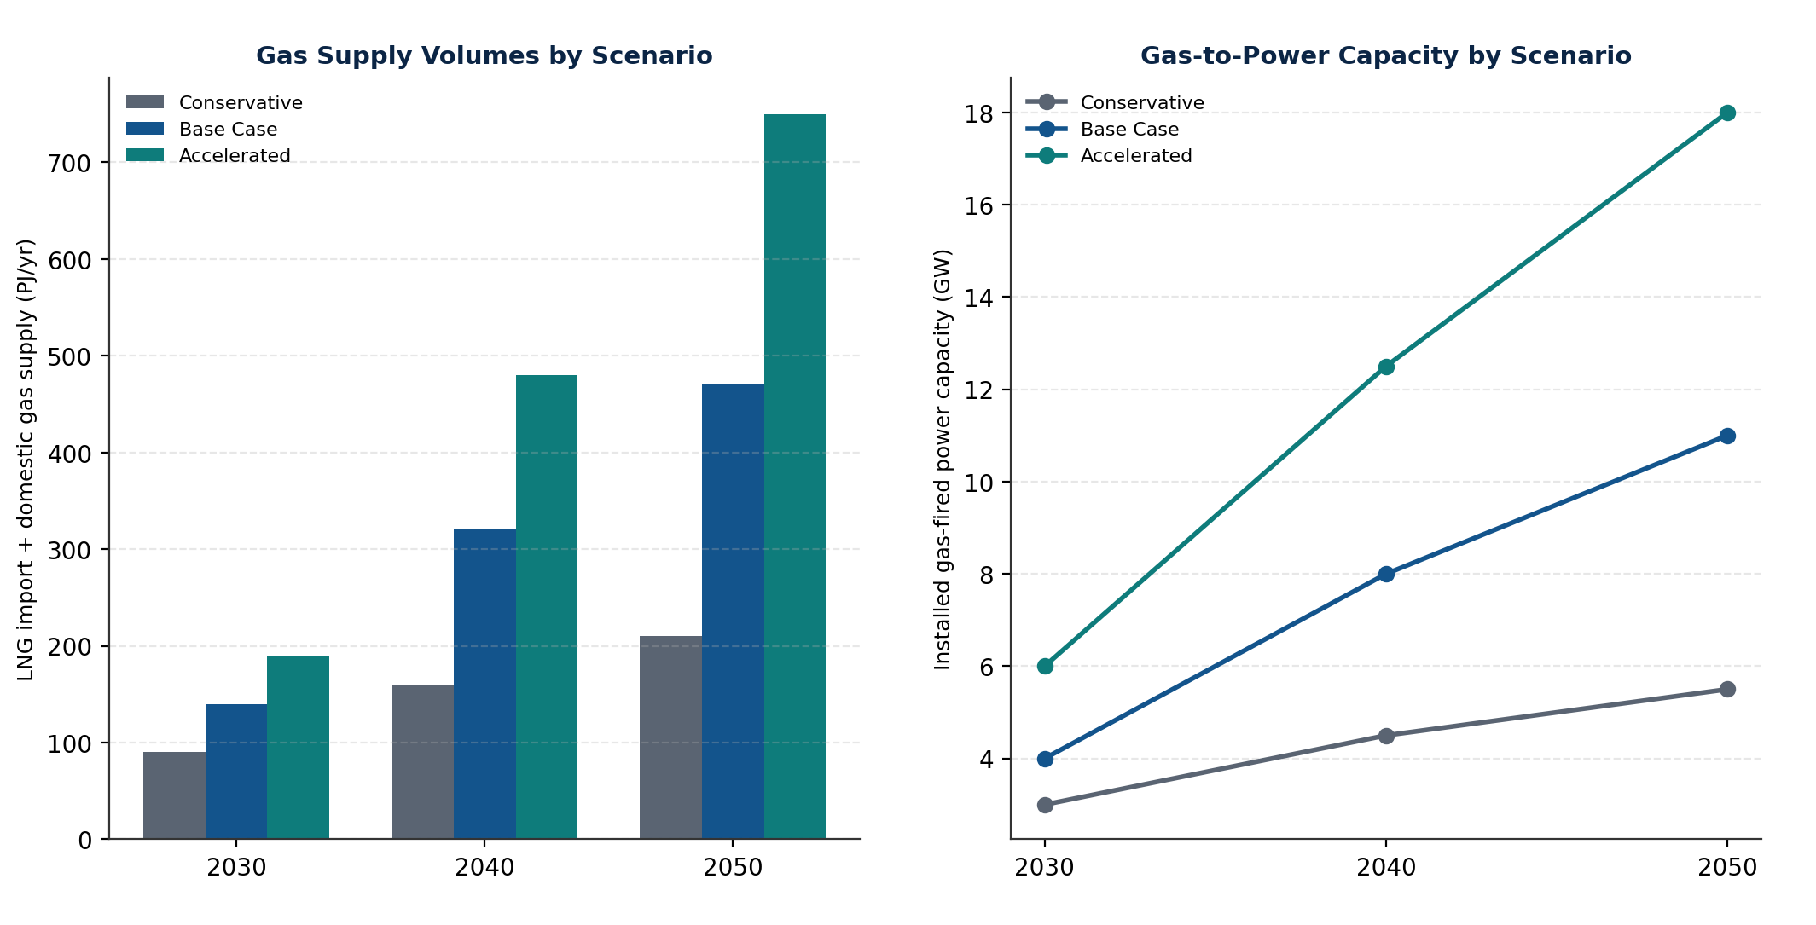
Figure 8. Scenario comparison dashboard gas supply volumes and gas-to-power capacity across Conservative, Base Case and Accelerated pathways, 2030/2040/2050.

Priority Recommendations
- 1. Treat the 2028 supply-decline date, not the more optimistic 2026 dates sometimes cited, as the binding planning constraint, and sequence Richards Bay FID and any complementary Mozambique-side import route accordingly.
- 2. Evaluate FSRU leasing/chartering as a parallel or interim track to the current dedicated-terminal design, given the multi-year schedule compression this model has demonstrated internationally.
- 3. Finalise UPRDA implementing regulations and the Gas Bill (B6-2026) on a fixed, published timeline, since regulatory uncertainty is a directly cited factor in prior project attrition (TotalEnergies' 11B/12B exit, Karpowership's FSRU collapse).
- 4. Establish an aggregated offtake or gas-trading mechanism — potentially state-anchored — to reduce single-buyer counterparty concentration risk and unlock financing for both Richards Bay Phase 2 and Block 11B/12B, directly addressing the price-negotiation failure that has twice stalled domestic gas commercialisation.
- 5. Prioritise closed-loop or hybrid FSRU regasification technology and rigorous, early-stage environmental authorisation processes, given that environmental objections have already defeated three prior South African FSRU proposals.
- 6. Pursue SADC regional integration opportunities (Matola, and longer-term Namibian gas) as risk-diversification instruments rather than as a substitute for direct South African import and domestic-production capacity.

