POSITIONING NATURAL GAS AS GHANA’S ENERGY TRANSITION FUEL

Executive Summary
Ghana is steadily transforming natural gas into the cornerstone of its energy transition strategy. While the country continues to produce crude oil from the Jubilee, TEN and Sankofa fields, policymakers are increasingly prioritising domestic gas utilisation to improve electricity reliability, reduce dependence on imported liquid fuels, lower generation costs and support industrialisation.

Domestic gas production from the Offshore Cape Three Points (OCTP) project and associated gas from Jubilee and TEN has significantly improved supply over the past decade. However, seasonal shortages, infrastructure bottlenecks and growing electricity demand continue to constrain the market.

Over the next decade, investments in offshore developments, pipeline expansion, LNG import capability and gas processing infrastructure will determine whether Ghana evolves into a regional gas hub or remains vulnerable to supply deficits.

Power Plants
Industry
Petrochemicals
Offshore Fields
(Jubilee, TEN, Sankofa)
Gas Processing Facilities
Transmission Pipelines
Economic Growth
Figure 1. Ghana's Natural Gas Value Chain

Ghana Natural Gas Snapshot

Indicator | Estimate
Proven Natural Gas Reserves | ~2.1 Tcf
Domestic Gas Production | 300–350 MMscfd
Daily Demand | 420–450 MMscfd
Gas Deficit | 70–120 MMscfd
Share of Electricity from Gas | ~70%
Main Producing Basins | Tano Basin, Cape Three Points
Major Import Source | Nigeria (WAGP)

Ghana’s Natural Gas Reserves
Ghana's natural gas endowment is commercially significant domestically because it underpins the majority of the country's thermal power generation. Ghana's gas resource base has been built up through a sequence of offshore discoveries:
- The associated gas of the Jubilee and Tweneboa-Enyenra-Ntomme (TEN) fields (operated by Tullow Oil)
- The non-associated gas of the Sankofa and Gye Nyame fields within the Offshore Cape Three Points (OCTP) block, operated by Eni.
Reserve estimates vary by source and vintage. Historic industry estimates place total proven and probable reserves at approximately 1.5–1.7 Tcf, including both discovered and appraised volumes, while the OCTP development alone was sanctioned on the basis of roughly 1.5 Tcf of gas-in-place and around 500 million barrels of oil-in-place, one of the few deep-water non-associated gas developments in Sub-Saharan Africa built specifically to serve a domestic market rather than export.

Field/Block | Operators | Resource Characteristics
Jubilee & TEN | Tullow Oil (operator); GNPC carried & participating interest; Kosmos Energy, Anadarko/Occidental legacy interests | Associated gas; ~2 Tcf targeted for monetisation over field life; gas re-injected historically, now increasingly processed for sales gas
OCTP — Sankofa & Gye Nyame | Eni (44.4%, operator); Vitol (35.6%); GNPC (20%) | Non-associated gas; ~1.5 Tcf gas-in-place; ~500 mmbbl oil-in-place; reserve life 15+ years at current offtake
Cape Three Points Block 4 | Eni-led exploration licence | Appraisal-stage; "significant" gas resources and associated condensate reported, not yet booked as reserves
Eban-Akoma prospect | Eni / Vitol / GNPC (OCTP partners) | 6New development concept tied back to existing OCTP facilities; submitted for government approval, late 2025

Ghana’s Demand and Supply Dynamics
Gas is the dominant fuel in Ghana's power system. Thermal generation almost entirely gas-fired, supplemented by light crude oil (LCO), diesel and heavy fuel oil (HFO) when gas is short, accounted for 66.1% of total generation in 2024/2025, against 33.1% from hydropower (Akosombo, Kpong and Bui) and under 1% from renewables.
System peak demand reached 4,338 MW in the 2025 projection (up 9.8% year-on-year), with total gas requirements for power generation alone projected at 151.4 TBtu (~134,000 MMscf) for 2025.

On the supply side, Ghana draws gas from three channels:
- Domestic offshore production (Jubilee/TEN and OCTP/Sankofa, together roughly 365–390 mmscfd)
- Pipeline imports from Nigeria via the West African Gas Pipeline (WAGP, contracted at a minimum of ~73 mmscfd, rising to 120 mmscfd depending on payment guarantees)
- Prospectively LNG imports once the Tema floating storage and regasification unit (FSRU) is commissioned.
The Energy Commission's own 2025 planning documents concede that combined domestic and minimum-import supply is insufficient to meet projected demand through the year, requiring supplementary liquid-fuel purchases estimated at US$2.02 billion for 2025 alone (of which US$1.165 billion is gas-related and the balance LCO, diesel and HFO).

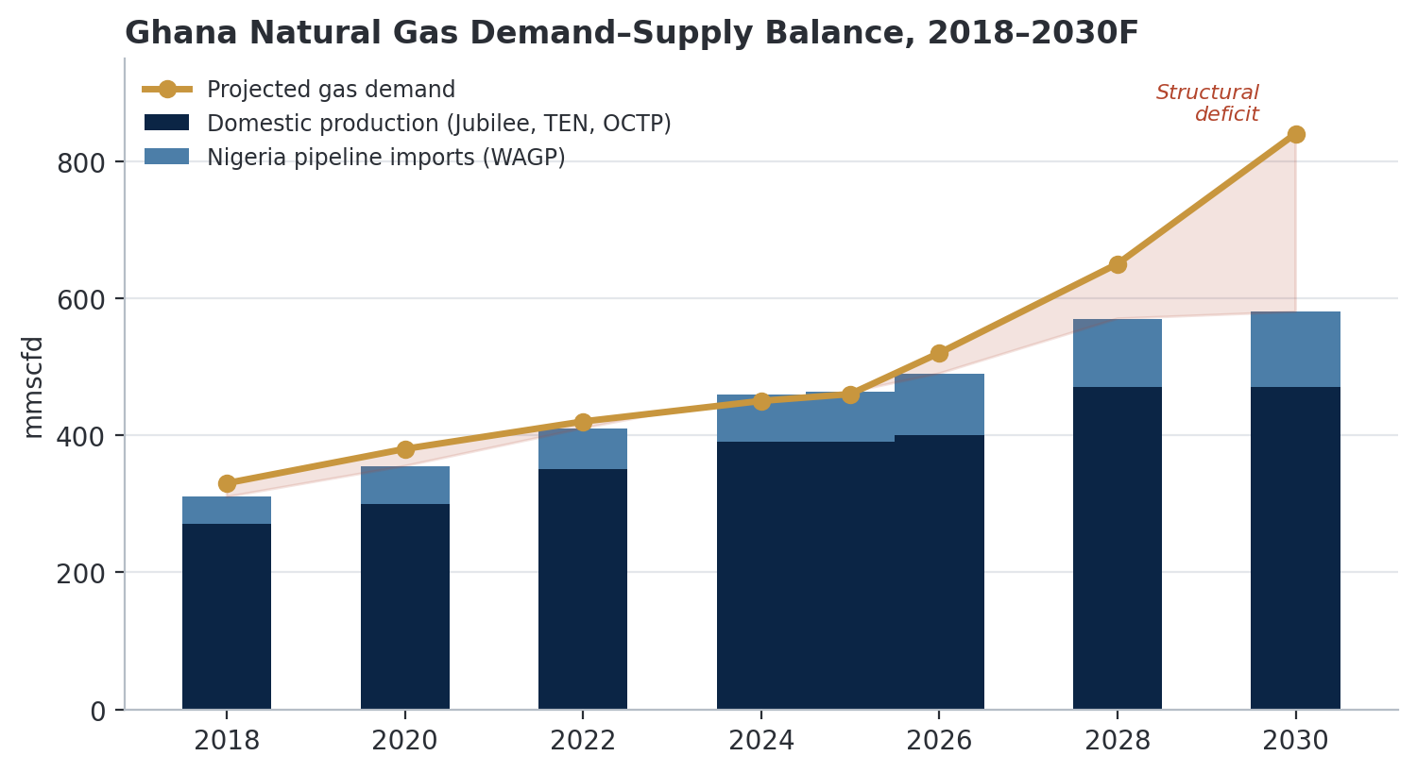
Figure 2. Ghana natural gas demand-supply balance, 2018–2030 (mmscfd).

Market Outlook
Ghana's gas market outlook over 2026–2030 is best characterised as structurally short but strategically active. Three developments will determine whether the supply gap narrows or widens further.
- The OCTP expansion
Under a term sheet signed on 11 May 2026 between the Government of Ghana, Eni, Vitol and GNPC, Sankofa/Gye Nyame gas sales volumes are set to rise 30% from 270 mmscfd to 350 mmscfd by 2028, via further development of the less-mature Gye Nyame field and FPSO compression upgrades. This is the single largest near-term lever on domestic supply and would raise OCTP's share of national demand to roughly 75%.
- LNG import readiness
The Tema FSRU terminal, backed by Helios Investment Partners and African Infrastructure Investment Managers with a Shell LNG supply contract for up to 225 mmscfd, was reported approximately 95% complete as of mid-2026 after repeated delays dating to 2017. GNPC has committed to operationalising the facility in 2026, though the Africa Centre for Energy Policy has flagged a contingent liability risk of up to US$820 million per year to GNPC if take-or-pay volumes are not matched by actual demand a material commercial risk for monitoring.
- Regional integration
At the June 2026 West Africa Gas Summit in Accra, WAPCo reported WAGP utilisation at roughly 60% of capacity at peak in 2025, implying meaningful spare pipeline capacity. Combined with over US$3.5 billion in announced capital commitments across upstream and midstream projects, Ghana is positioning itself as a prospective regional gas-trading and processing hub, though payment discipline and contract enforcement across the sub-region remain unresolved constraints on realising this ambition.

