INFRASTRUCTURE, MONETISATION TECHNOLOGY AND FOREIGN CAPITAL IN GHANA’S GAS SECTOR

Executive Summary
Ghana’s gas monetisation strategy is fundamentally domestic-market driven, with gas-to-power serving as the dominant monetisation pathway while LPG recovery, industrial consumption and prospective LNG regasification provide additional value streams. The sector combines strong state participation through GNPC and Ghana Gas with substantial foreign operatorship and capital from Eni, Vitol, Tullow Oil, Shell and international infrastructure investors.

The principal constraint is midstream infrastructure capacity. Atuabo Gas Processing Plant’s first train can process roughly 120–150 mmscfd, significantly below projected national gas demand, while the delayed GPP II and Tema LNG FSRU are expected to provide critical additional supply. This creates a near-term mismatch between Ghana’s growing gas-fired power demand and its ability to process and deliver sufficient domestic gas.

The immediate opportunity lies in expanding processing and transmission capacity, securing reliable gas supply to power and industrial users, and improving the utilisation of existing infrastructure.

In-Country Gas Business Operators
Ghana's gas sector operates on a concession model in which the state, through the Ghana National Petroleum Corporation (GNPC), holds carried and participating interests in upstream blocks operated by international oil companies, while a separate state entity, Ghana National Gas Company (GNGC), holds a legislated midstream monopoly over gathering, processing, transporting and marketing natural gas domestically. Power generation and gas offtake sit with the Volta River Authority (VRA) and a growing roster of independent power producers (IPPs).

Entity | Role | Ownership | Notes
GNPC | Upstream national oil company; carried & participating interests | 100% state-owned | 20% interest in OCTP; carried interest in Jubilee/TEN
GNGC | Midstream: gathering, processing (Atuabo), transport, LPG/NGL marketing | 100% state-owned | Operates Natural Gas Integrated Transmission System (NGITS); ~40% of national LPG supply
Eni Ghana E&P | Upstream operator, OCTP (Sankofa/Gye Nyame) | 44.4% of OCTP | Supplies ~70–75% of domestic gas; Italian IOC, present since 2009
Vitol | Upstream partner, OCTP; trading & offtake | 35.6% of OCTP | Global energy trading house (Rotterdam-founded; Geneva/Houston/London/Singapore hubs)
Tullow Oil | Upstream operator, Jubilee & TEN | Operator; equity partners incl. Kosmos, PetroSA, Ghana Oil legacy stakes | UK-listed independent; committed (with partners) to eliminate routine flaring
Volta River Authority (VRA) | Power generation; gas offtaker; WAGP shareholder | 100% state-owned | Operates TAPCO/TICO thermal plants at Aboadze; 16.3% WAGP stake
Karpowership, Amandi Energy, Sunon Asogli, AKSA, Genser, CENIT, Endeavor (Bridge Power) | Independent power producers (gas offtake) | Private / foreign-invested IPPs | Growing share of thermal capacity; several CCGT/OCGT plants on the Aboadze/Tema gas grid
GRIDCo / ECG | Transmission (GRIDCo) and distribution (ECG) | State-owned | Not gas-sector entities per se, but determine deliverability of gas-fired power to end users

Infrastructure and Pipeline Network
Ghana's gas infrastructure is anchored around the Western Corridor Gas Infrastructure Programme, built from 2011–2015 at a cost of roughly US$1 billion (China Development Bank-financed), comprising a 58–60 km offshore export pipeline from the Jubilee FPSO to the Atuabo Gas Processing Plant (GPP), the GPP itself, and an approximately 110–111 km onshore pipeline delivering sales gas to the VRA's Aboadze power enclave near Takoradi.

- Atuabo Gas Processing Plant (GPP Train 1)
Commissioned 2014/15, nameplate ~150 mmscfd, though effective throughput is often cited nearer 120 mmscfd; processes associated gas from Jubilee, TEN and (via tie-in) OCTP into lean sales gas, LPG, propane, butane, condensate and isopentane.

- Atuabo GPP Train 2 ("GPP II")
A second train targeting an additional 150 mmscfd (potentially expandable toward 350 mmscfd combined), at an estimated cost of US$700 million; an implementation committee was inaugurated in May 2025 and a 24-month delivery window has been targeted, though as of early 2026 civil-society monitors were still pressing for faster execution.

- Onshore transmission (NGITS)
The 110 km Atuabo–Aboadze trunk line plus lateral pipelines (e.g., the Esiama–Prestea lateral, completed 2017) extending gas to industrial users including ceramics manufacturers (Wangkang, Twyford, Jintao, Sentuo, Marco Polo) and the Sentuo Oil Refinery.

- West African Gas Pipeline (WAGP)
A 678 km regional pipeline (Chevron-operated; Chevron 36.7%, NNPC 25%, Shell 18%, VRA 16.3%, SoToGaz/SoBeGaz 4%) carrying Nigerian gas via Benin and Togo to Takoradi and Tema, with nameplate capacity variously cited at 200 mmscfd (expandable to 600 mmscfd) to 474 mmscfd; a 2019 reversal project enables east-flow from Takoradi to Tema to integrate with Ghana's own offshore gas.

- Tema LNG import terminal
A floating storage and regasification unit (FSRU) designed for up to 400 mmscfd (contracted Shell LNG supply of up to 225 mmscfd), under construction since 2017 and reported ~95% complete in mid-2026, backed by Helios Investment Partners and African Infrastructure Investment Managers.

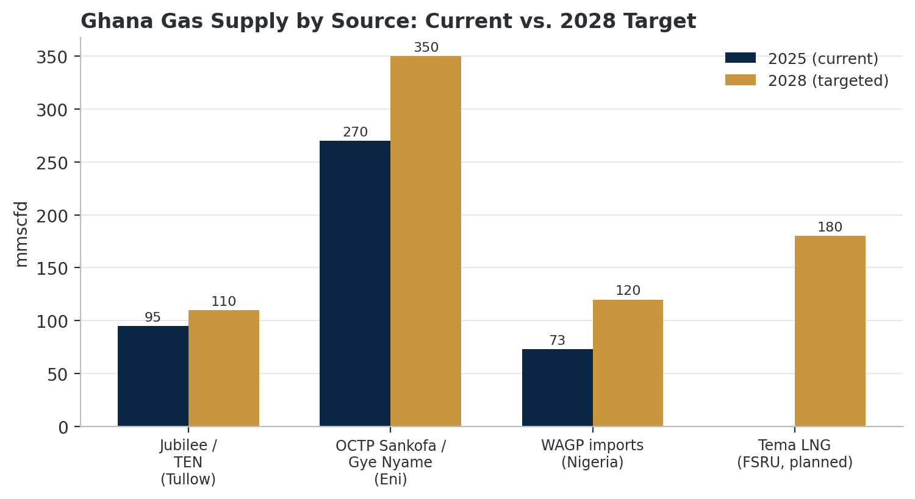
Figure 1 Ghana gas supply by source

Foreign Contribution to Ghana's Gas Market
Foreign capital and technical expertise are foundational to virtually every part of Ghana's gas value chain. On the equity side, Eni (Italy) and Vitol (Swiss-headquartered trading house) together hold 80% of OCTP, the single largest gas-supply asset in the country. Tullow Oil (UK-listed) operates Jubilee and TEN.

On the pipeline side, WAGP is majority foreign-owned and Chevron-operated. On project financing, the OCTP development (total project cost ~US$7.9 billion across its oil and gas phases) was supported by a US$500 million World Bank loan and the largest guarantee package in World Bank history at the time, reflecting the project's designation as a top development priority. The Tema LNG terminal is backed by pan-African/international private equity (Helios Investment Partners, African Infrastructure Investment Managers) with LNG supply contracted from Shell.

Foreign Party | Origin | Contribution
Eni | Italy | OCTP operator (44.4%); largest single source of domestic gas supply; committed to Sankofa expansion to 350 mmscfd by 2028
Vitol | Netherlands-founded / Swiss-based | OCTP partner (35.6%); global trading and marketing linkage for associated liquids and future export volumes
Tullow Oil | United Kingdom | Jubilee/TEN operator; committed (with partners) to a 2025–2026 drilling programme and flaring elimination
Chevron / Shell / NNPC | US / UK-Dutch / Nigeria | WAGP ownership and operation (Chevron-led); enables Nigerian gas imports
World Bank Group | Multilateral | US$500m loan plus large-scale guarantees underpinning the US$7.9bn OCTP development
Helios Investment Partners / AIIM | Pan-African private equity / infrastructure fund | Sponsor and financing of the Tema LNG FSRU terminal
Shell | UK / Netherlands | Contracted LNG supplier to the Tema terminal (up to 225 mmscfd)
China Development Bank / Chinese EPC | China | Original ~US$1bn financing and construction of the Western Corridor gas infrastructure (Atuabo GPP Train 1 and pipelines)

Ghana's Gas Monetization Technologies
Ghana's monetisation technology stack is conventional relative to global gas majors but well-matched to a market of its scale and domestically-oriented demand profile.

- Subsea production and FPSO processing
The John Agyekum Kufuor FPSO (Yinson-owned, Keppel-built) processes OCTP output at sea before export via a dedicated ~60 km pipeline to the Sanzule onshore receiving facility. The core production technology for non-associated gas monetisation.

- Onshore gas processing and NGL fractionation
The Atuabo GPP strips lean sales gas from raw associated/non-associated gas and fractionates natural gas liquids into propane, butane, condensate and isopentane, displacing imported LPG (currently ~40% self-sufficiency via GNGC) and supplying feedstock for a nascent domestic fertiliser and petrochemical ambition.

- Pipeline transmission and compression
Onshore trunk and lateral pipelines (NGITS) plus compressor stations (e.g., Sanzule, Atuabo Mainline) manage pressure and throughput across a network exceeding 150 km of onshore gas pipeline, integrated with the regional WAGP system.

- Gas-to-power generation
Combined-cycle (CCGT) and open-cycle (OCGT) gas turbines at Aboadze and Tema (VRA's TAPCO/TICO, plus IPPs including Sunon Asogli, Endeavor's Bridge Power, Karpowership, Amandi and AKSA) convert sales gas to electricity. The dominant monetisation route, consuming an estimated 90% of processed gas.

- LNG regasification (prospective)
The Tema FSRU will introduce ship-borne LNG import and regasification technology to Ghana for the first time, diversifying supply beyond pipeline-dependent domestic and Nigerian sources once commissioned.

You can make this section more analytical by showing how each risk affects Ghana’s gas monetisation pathway, energy security, and investment attractiveness, rather than simply naming the risks.

Risks

- Production Decline
Declining output from mature fields such as Jubilee, TEN and Sankofa-Gye Nyame could constrain the volume of gas available for domestic power generation, industrial users and LNG or other export-oriented projects. If upstream decline outpaces new field development, Ghana could face a growing gap between gas demand and domestic supply. This would increase reliance on imported gas or alternative fuels and weaken the economics of downstream gas infrastructure.

- Delayed Investments
The development of new upstream fields, processing facilities, pipelines and gas-based industrial projects requires significant capital and timely execution. Delays in final investment decisions, project approvals, financing or construction could create bottlenecks across the value chain.

- Regulatory Uncertainty
Changes in fiscal terms, licensing conditions, pricing frameworks, domestic gas obligations or government policies can affect the bankability of gas projects. Regulatory uncertainty may cause investors to delay final investment decisions or demand higher returns to compensate for perceived policy risk.

- Pipeline Disruptions
Ghana's gas monetisation strategy depends heavily on reliable transportation infrastructure linking offshore production to processing facilities, power plants and industrial consumers. Pipeline failures, maintenance issues, technical constraints or security incidents can interrupt gas flows and quickly translate into power-generation shortages and higher fuel costs. Because Ghana's electricity system relies significantly on gas-fired generation, persistent pipeline disruptions could undermine both energy security and industrial productivity.

Outlook

Ghana's gas outlook will ultimately depend on the speed, reliability and integration of infrastructure investment across the value chain. Sustained investment in upstream development, gas processing, pipelines, storage, power infrastructure and gas-based industries will be necessary to convert existing gas resources into reliable domestic energy supply and commercially viable regional exports.

If infrastructure development keeps pace with production and demand, Ghana can move beyond using gas primarily as a fuel for power generation toward a broader gas monetisation model encompassing industry, petrochemicals, LPG, LNG and regional gas trade. This would strengthen energy security while creating opportunities for industrialisation, reducing exposure to fuel imports and supporting economic diversification.

