OPTIMIZING TANZANIA'S GAS MONETIZATION PORTFOLIO ACROSS LNG, GAS-TO-POWER AND INDUSTRIAL VALUE CHAINS

Executive Summary
Tanzania stands closer than at any point in the past decade to converting its 57 Tcf natural gas resource base into a diversified, multi-pathway monetization portfolio. The $42bn Lindi LNG project, led by Shell and Equinor with ExxonMobil, Pavilion Energy, Medco Energi and TPDC, is in the final legal review stage of its Host Government Agreement (HGA) and Production Sharing Agreement (PSA), with signature targeted before mid-2026 and first LNG realistically expected around 2031–2032. Alongside this flagship export project, Tanzania is simultaneously scaling domestic gas-to-power capacity, planning a regional export pipeline to Uganda and Kenya, and courting early-stage interest in fertilizer and petrochemical investment a genuinely portfolio-based approach to gas monetization rather than a single-project bet.
This note assesses the comparative commercial and strategic merits of Tanzania's principal monetization pathways LNG exports, gas-to-power, industrial gas utilization, fertilizer/petrochemicals, and regional pipeline exports against the backdrop of a softening global LNG price environment, a still-developing domestic regulatory and financing architecture, and a domestic power sector being reshaped by the 2,115 MW Julius Nyerere Hydro power Project (JNHPP), which came fully online in April 2025 and has already displaced a meaningful share of gas-fired generation.
Key Finding
- Lindi LNG is Tanzania's single largest source of future economic value, but its scale ($42bn, ~10 Mtpa) and 2031–2032 first-LNG timeline mean it will not materially affect Tanzania's fiscal position before the early-to-mid 2030s — a decade-long gestation period the government must bridge with other monetisation strategies.
- The domestic gas-to-power market has weakened structurally in the near term: JNHPP's commissioning has already cut gas demand from TANESCO's thermal fleet, with Q2 2025 gas production down 24.5% year-on-year. This does not eliminate the long-term case for gas-fired capacity — Tanzania's own IRA target is 8,000 MW by 2030 and hydro is variable — but it does require Tanzania to actively cultivate demand elsewhere (industrial gas, CNG, fertiliser) to avoid stranding upstream capacity built for a purely domestic power market.
- A domestic market obligation clause under negotiation in the Lindi LNG HGA (reportedly 3–10% of gas reserved for local use) is a genuine point of commercial tension: it is essential to Tanzania's industrialisation ambitions but represents a live source of investor uncertainty in the pre-FID negotiations.
- Regional pipeline exports to Uganda and now, per PURA's 2026 announcement, potentially Kenya as well, represent a strategically underrated pathway: lower capital intensity than LNG, shorter lead times, and directly aligned with East African Community industrial gas demand growth (fertiliser, cement, steel, mining).
- Financing for Lindi LNG remains contingent on the HGA/PSA signature; once signed, a syndicate of export credit agencies and commercial lenders is expected to mobilise behind the project's IOC sponsors, though Tanzania's relatively thinner sovereign credit profile compared with peers implies continued reliance on foreign capital rather than domestic balance-sheet funding.

TANZANIA'S GAS POSITION
Tanzania holds an estimated 57 Tcf of recoverable natural gas resource, split between onshore/nearshore fields already in production (Songo Songo, Mnazi Bay, the newly tied-in Ntorya field) and the much larger deepwater offshore discoveries in Blocks 1, 2 and 4 (over 47 Tcf, operated by Shell, Equinor and ExxonMobil) that underpin the Lindi LNG project. This resource base is comparable in scale to Mozambique's Rovuma Basin and positions Tanzania, alongside Mozambique, as one of East Africa's two prospective LNG super-exporters a designation TPDC has explicitly embraced, describing Tanzania as poised to become Africa's next gas hub.
Tanzania's Fifth Five-Year Development Plan (FYDP IV) formalises this ambition with three explicit targets: unlocking further exploration potential across Tanzania's sedimentary basins; scaling domestic gas production and utilisation from roughly 320 MMscfd to 1,000 MMscfd onshore; and transforming Tanzania into Africa's leading gas exporter, with LNG export volumes targeted at 15 Mtpa and a regional gas trading hub supplying up to 3,500 MMscfd to East African Community (EAC) and Southern African Development Community (SADC) markets. These targets are aspirational relative to currently sanctioned capacity, but they signal a coherent government strategy spanning export, domestic, and regional pathways simultaneously, rather than sequential single-project development.
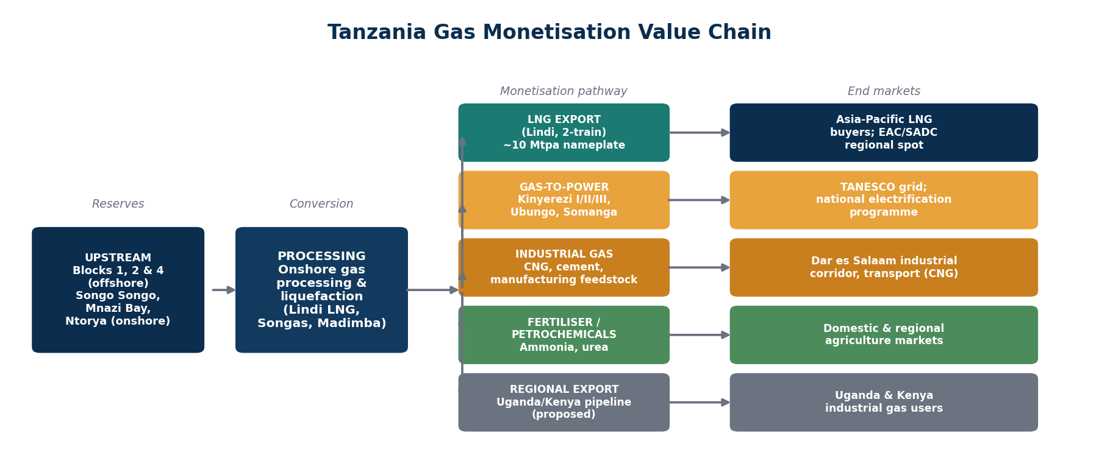
Tanzania gas monetization value chain, from upstream resource to end markets.

CRITICAL ASSESSMENT OF MONETIZATION PATHWAYS

1. LNG Exports — Lindi LNG
The Lindi LNG project (also referenced as the Likong'o-Mchinga LNG project) is a two-train, approximately 10 Mtpa liquefaction facility planned for Likong'o village near Lindi, on Tanzania's southern coast roughly 461km by road south of Dar es Salaam. It is designed to draw gas from Blocks 1 and 4 (Shell-operated) and Block 2 (Equinor/ExxonMobil-operated), which together hold an estimated 47 Tcf of recoverable offshore resource.
- Status (mid-2026): the HGA and PSA are in final legal review following the conclusion of substantive negotiations in mid-2025; signature is targeted before mid-2026, per Tanzanian government statements, after which FEED completion and FID would follow. Construction is expected to take four to five years, implying first LNG realistically around 2031–2032 even on an optimistic post-signature schedule.
- Commercial structure: the project includes a marine lease, land lease and security agreement, with the Tanzanian army designated to lead project security a materially different security model from Mozambique's foreign-troop-supported approach, reflecting Tanzania's comparatively more stable security environment.
- Unresolved negotiation point domestic market obligation: the government has sought to reserve an estimated 3–10% of produced gas for domestic utilisation, a demand that has historically been a friction point with investors concerned about the impact on export economics and contracted offtake volumes.
- Fiscal terms: specific tax incentives and rates are being finalised within the HGA/PSA text; the government has signalled willingness to grant preferential terms to secure FID, consistent with the pattern seen in Mozambique's earlier-generation LNG contracts.
LNG exports remain, on scale alone, Tanzania's dominant potential value-creation pathway. At a nameplate 10 Mtpa and a $42bn capital cost, Lindi LNG would approach half the capital intensity but a comparable per-tonne cost to Mozambique's Area 1 project, reflecting broadly similar offshore deepwater development conditions. However, the near-decade gap between now and first LNG means this pathway offers limited near-term fiscal or industrial benefit, reinforcing the case for parallel investment in faster-payback domestic pathways.

2. Gas-to-Power
Gas-fired generation has historically been the backbone of Tanzania's dispatchable power supply, anchored by the Kinyerezi complex (Kinyerezi I at 150MW, Kinyerezi II at 240MW, and the 185MW Kinyerezi I Extension approaching final commissioning) and the Songas-operated Ubungo plant (104MW), fed by the 535km Mtwara–Dar es Salaam pipeline. As of March 2026, Tanzania's installed gas-fired capacity stood at roughly 1,285 MW, approximately 28% of a 4,522 MW installed base.
- Structural headwind: the 2,115 MW Julius Nyerere Hydropower Project came fully online in April 2025 and now supplies 60.3% of installed capacity, materially reducing near-term reliance on gas-fired generation. Bank of Tanzania data show gas production fell 24.5% year-on-year in Q2 2025, driven largely by reduced TANESCO offtake at Songo Songo.
- Contractual friction: Orca Energy has filed arbitration claims against the Government of Tanzania and TPDC over the Songo Songo Gas-to-Electricity Project, alleging breaches including forced subsidised gas supply after July 2024 — an illustration of the commercial strain created by the shift toward hydro.
- Renewed pipeline: despite the hydro-driven near-term softening, TANESCO is progressing the 1,000MW Kinyerezi III project (feasibility update funded in the 2026/27 budget) on the premise that a hydro-heavy grid needs firm, dispatchable gas capacity to manage reservoir variability peak demand grew 15.2% year-on-year to 2,199 MW by February 2026, and the government targets 8,000 MW of installed capacity by 2030 under Vision 2050.
Gas-to-power's near-term economics have deteriorated relative to five years ago, but its long-term strategic rationale dispatchable, weather-independent capacity to complement a hydro-dominant grid remains intact. The pathway's investment case now depends more on grid-balancing and reliability value than on being the default first call on domestic gas.

3. Industrial Gas Utilization
Direct industrial use of gas compressed natural gas (CNG) for transport, process heat for cement and other manufacturing, and feed stock for light industry is a comparatively underdeveloped but strategically important pathway, particularly for the Dar es Salaam industrial corridor. Industrial and commercial gas users offer more price-stable, long-duration offtake than the now more volatile gas-to-power segment, and align directly with Tanzania's FYDP IV domestic utilisation target of scaling to 1,000 MMscfd onshore.
- CNG for transport offers meaningful import-substitution value given Tanzania's fuel import bill, though CNG refuelling infrastructure remains nascent outside Dar es Salaam.
- Industrial process heat (cement, glass, light manufacturing) is a natural complement to the government's broader industrialisation agenda and could absorb gas volumes freed up by reduced power-sector offtake.

4. Fertiliser and Petrochemicals
Fertiliser manufacturers have expressed interest in using Tanzania's offshore gas resources to produce ammonia and urea, positioning Tanzania alongside Uganda's planned Kabaale Industrial Park petrochemical hub as a potential East African fertiliser production centre. This pathway remains pre-FID and smaller in scale than LNG, but offers strong strategic alignment with regional agricultural demand and Tanzania's broader industrialisation goals, given East Africa's continued reliance on imported fertiliser.
- Ammonia/urea projects would likely require a dedicated, ring-fenced gas allocation distinct from both the LNG export stream and domestic power supply, reinforcing the importance of a clear, published domestic gas allocation policy.
- Regional demand pull is credible: fertiliser, cement and mining sectors across Tanzania, Uganda and Kenya have all seen rising industrial gas demand, per PURA's 2026 regional pipeline announcement.

5. Regional Pipeline Exports
Tanzania's Petroleum Upstream Regulatory Authority (PURA) announced in mid-2026 plans for a cross-border natural gas pipeline supplying both Uganda and Kenya — extending an existing bilateral Tanzania–Uganda pipeline initiative (a proposed 1,716km line from Dar es Salaam to Kampala, feasibility studies commenced in 2023) into a broader regional network. This pathway positions Tanzania as a long-term regional gas supplier rather than solely an LNG exporter to overseas markets.
- Uganda's intended end-uses span industry (notably steel), power generation, and displacement of wood/charcoal and road-transport fuels — a diversified demand base that reduces reliance on any single offtake sector.
- Technical and financing details (capacity, precise route, cost, timeline) remain undisclosed as of mid-2026, and the pipeline is best treated as a 2030s-horizon opportunity rather than a near-term monetisation lever.
- This pathway benefits from lower capital intensity and shorter development timelines than LNG, and from direct policy alignment with East African Community regional integration objectives, making it an attractive complement to the export-dominant Lindi LNG project.

COMPARATIVE ECONOMICS AND LONG-TERM VALUE
The table and charts below compare Tanzania's monetization pathways on capital intensity, indicative returns, and time-to-value. Figures are analyst-derived, calibrated to disclosed Lindi LNG costs, Tanzanian fiscal terms under discussion, and comparable East African and Mozambican gas monetisation projects; they are illustrative and intended for relative rather than absolute comparison.
Pathway | CAPEX | OPEX (annual) | NPV @10% | IRR | Time to first value | Relative risk
LNG exports (Lindi) | ~$42bn | $1.3–1.7bn | $3.0–7.8bn | 12–14% | ~6 yrs post-FID | High (schedule, price cycle)
Gas-to-power | $0.3–1.3bn | $0.1–0.2bn | $0.4–1.1bn | 9–11% | 2–4 yrs | Moderate (demand/hydro competition)
Industrial gas (CNG/direct use) | $0.4–0.8bn | $0.05–0.1bn | $0.2–0.6bn | 10–13% | 2–3 yrs | Low–moderate
Ammonia | $1.4–1.8bn | $0.15–0.2bn | $0.5–1.4bn | 12–14% | 4–5 yrs | Moderate (feedstock/offtake)
Urea / fertiliser | $1.2–1.6bn | $0.15–0.2bn | $0.4–1.1bn | 10–12% | 4–5 yrs | Moderate (fertiliser cycle)
Regional pipeline export | $3.5–4.2bn | $0.15–0.2bn | $0.3–0.8bn | 9–10% | 5–7 yrs | Moderate (cross-border coordination)
Comparative commercial metrics by monetization pathway (illustrative, analyst-derived, real terms).
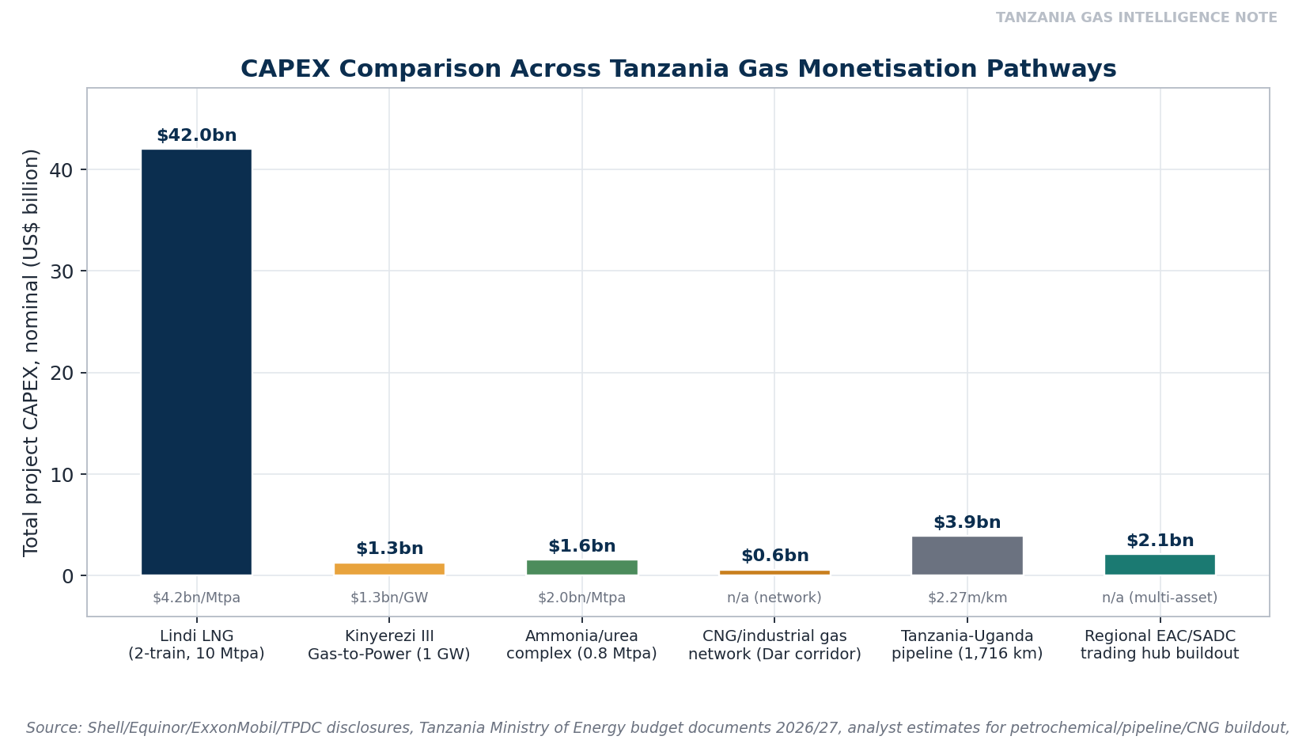
Figure 2. CAPEX comparison across Tanzania gas monetisation pathways.
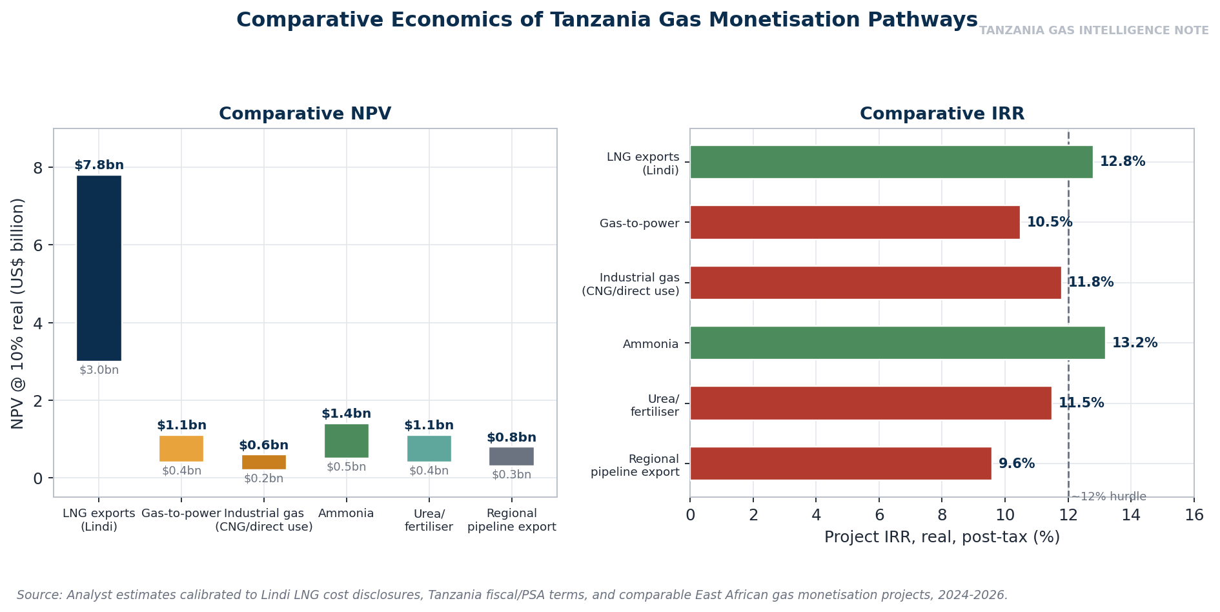
Figure 3. Comparative NPV and IRR across Tanzania gas monetization pathways.
Two conclusions follow. First, LNG exports remain the dominant source of absolute value by a wide margin, simply due to scale — no combination of domestic pathways can substitute for Lindi LNG's fiscal contribution once operational. Second, on a risk-adjusted, time-to-value basis, industrial gas utilisation and ammonia production offer the most attractive near-term propositions: shorter construction timelines, IRRs competitive with or exceeding LNG, and direct alignment with Tanzania's industrialisation agenda. Gas-to-power, historically the default domestic pathway, now screens as the weakest near-term option purely because JNHPP has structurally reduced near-term demand — though its long-run strategic value as grid-balancing capacity should not be discounted.
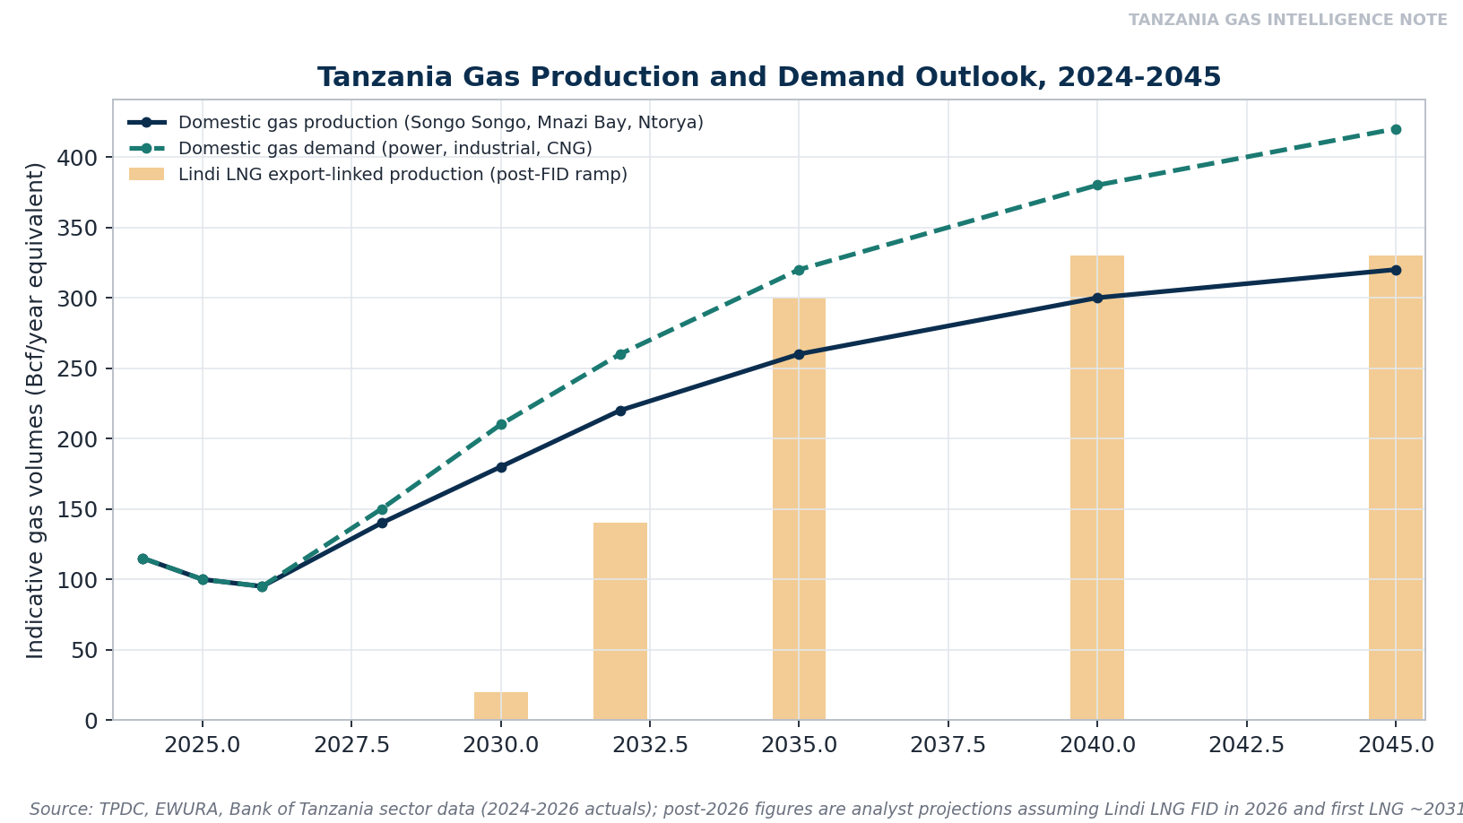
Figure 4. Tanzania gas production and demand outlook, 2024-2045 (indicative).
The production and demand outlook illustrates the core sequencing challenge facing Tanzania: domestic production has recently declined on weaker power-sector offtake, domestic demand is expected to recover only gradually as industrial and CNG use develops, and the large step-change in total gas production is not expected until Lindi LNG-linked output ramps from around 2031 onward. Managing this multi-year trough — keeping upstream fields commercially viable and avoiding further contractual disputes like the Orca Energy arbitration — is arguably as important to Tanzania's monetization success as the LNG project itself.

INFRASTRUCTURE, REGULATORY ENVIRONMENT AND FINANCING LANDSCAPE

Infrastructure
- The existing 535km Mtwara–Dar es Salaam pipeline, completed in 2015, remains the backbone connecting Mnazi Bay and Songo Songo gas to Dar es Salaam's power and industrial demand; the Ntorya field's tie-in to the Madimba processing plant, targeted for Q3 2026, will add incremental feed-gas to this corridor.
- Transmission grid expansion is proceeding rapidly alongside JNHPP's commissioning: the network grew 9% to 8,500km by March 2026, with major 400kV lines (Chalinze–Dodoma, Iringa–Mbeya–Tunduma–Sumbawanga) under construction, expanding the backbone needed to move both hydro and future gas-fired power to demand centres.
- Lindi LNG's Likong'o site will require substantial dedicated port, marine and logistics infrastructure, similar in scale to Mozambique's Afungi buildout, representing a major regional infrastructure investment in its own right beyond the liquefaction plant.
- The proposed Tanzania–Uganda (and potentially Kenya) pipeline remains at a pre-feasibility/consultant stage, with no confirmed route, capacity, or financing structure as of mid-2026 — the most significant infrastructure gap constraining the regional export pathway.

Regulatory Environment
- The Petroleum Upstream Regulatory Authority (PURA) and the Energy and Water Utilities Regulatory Authority (EWURA) share oversight of upstream licensing and midstream/downstream tariffs and standards respectively, providing a reasonably clear institutional structure, though the Lindi LNG HGA/PSA negotiation illustrates that fiscal and commercial terms for large-scale projects still require lengthy, case-by-case negotiation rather than following a standardised, published fiscal template.
- The domestic market obligation debate is the clearest current example of regulatory uncertainty affecting investment decisions: until the HGA/PSA is signed, the precise domestic gas reservation percentage and its commercial treatment remain unresolved, directly affecting both LNG project economics and the feedstock availability for future petrochemical investment.
- Local content requirements under discussion in the Lindi LNG negotiations mirror the pattern seen in Mozambique — labour and goods sourcing commitments that are politically essential but require careful sequencing against Tanzania's current technical and industrial capacity to avoid becoming a source of cost or schedule risk.

Financing Landscape
- Lindi LNG financing has not yet been structured pending HGA/PSA signature; based on the precedent of comparable East African LNG projects, a syndicate of export credit agencies (linked to sponsor home markets — Norway's GIEK, UK's UKEF, Japan's NEXI/JBIC via Pavilion/Medco-linked Asian capital, and potentially US EXIM given ExxonMobil's participation) alongside commercial project finance banks is the most probable structure.
- The Tanzanian government's 2026/27 energy budget explicitly targets mobilising $4.39bn of private capital, with 97.5% of the TZS 2.525 trillion energy budget directed to power and gas infrastructure — indicating strong domestic fiscal prioritisation of the sector even ahead of LNG FID.
- Chinese financing (via China Exim Bank and Sinosure) is already active in Tanzania's transmission and substation buildout, suggesting a similarly diversified financing base to Mozambique's may emerge for gas-sector infrastructure, blending Western ECA, Gulf, and Chinese capital.
- Multilateral development finance institutions (World Bank, African Development Bank) are more likely to engage on domestic gas-to-power, grid, and regional pipeline financing than on the IOC-led Lindi LNG project itself, consistent with their typical role in East African energy infrastructure.

Investment Pipeline
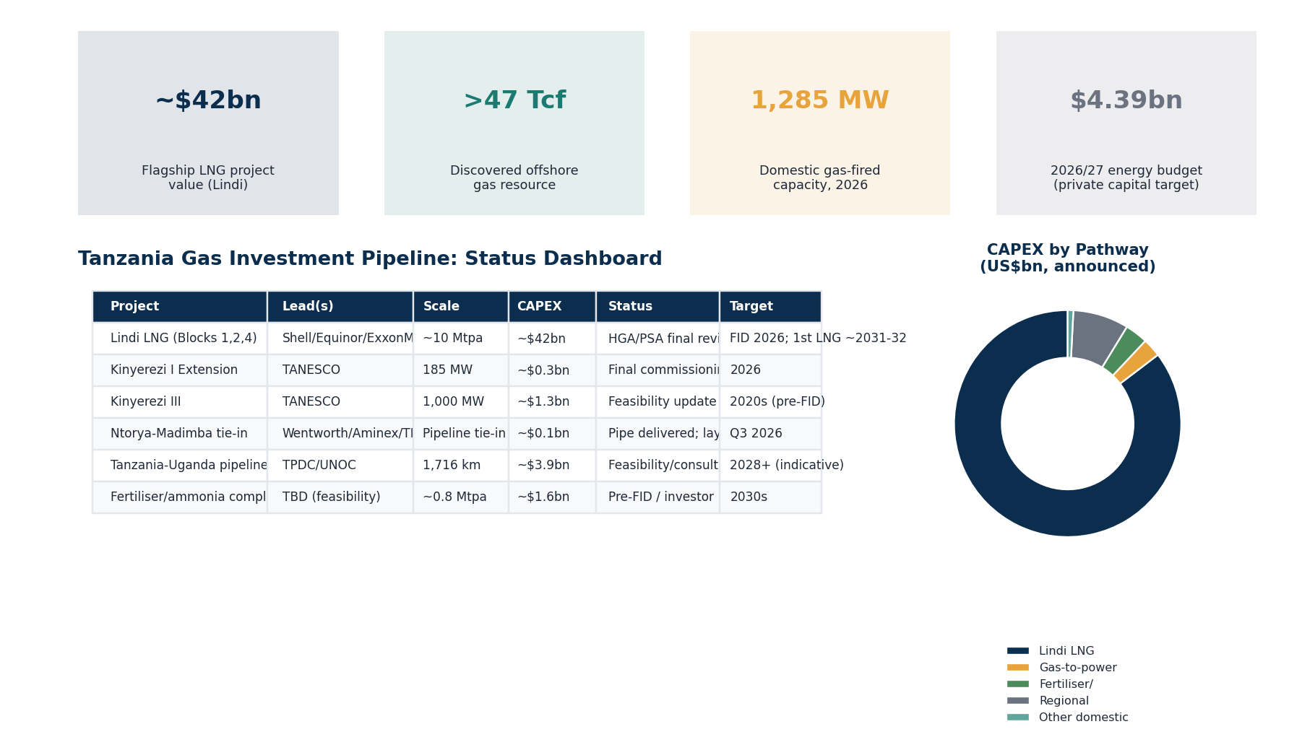
Figure 5. Tanzania gas investment pipeline: status dashboard.
The pipeline is heavily weighted toward Lindi LNG in capital terms (over 85% of disclosed/announced CAPEX across the portfolio), reflecting both the scale of the flagship project and the comparatively early stage of domestic and regional alternatives. This concentration is a structural vulnerability: with the bulk of announced capital contingent on a single project's FID and construction timeline, Tanzania's near-term investment narrative will inevitably track Lindi LNG's HGA/PSA signature and subsequent progress closely, even though the smaller-scale domestic and regional projects are individually further advanced in commercial terms (Kinyerezi I Extension nearing commissioning, Ntorya-Madimba tie-in construction underway).

KEY RISKS

Project Financing Risk
Until the HGA and PSA are formally signed, Lindi LNG financing cannot be structured, and repeated delays over the 2022–2026 period (multiple missed signature targets) illustrate genuine execution risk in translating negotiated terms into bankable agreements. Once signed, financing risk shifts toward the availability and terms of ECA and commercial bank capital in a global environment where lenders have shown increasing sensitivity to ESG, security, and country-risk factors for African LNG (as seen in Mozambique's UK Export Finance withdrawal).

Infrastructure Constraints
The absence of a developed regional pipeline network, the early stage of Likong'o port and marine infrastructure, and the ongoing need for substantial transmission grid expansion collectively mean that infrastructure — not resource availability — is Tanzania's binding constraint on faster monetisation across nearly every pathway assessed in this note.

Global LNG Market Dynamics
Lindi LNG's realistic first-cargo timeline of 2031–2032 places it well within the period global markets are expected to be absorbing the current wave of US, Qatari and other new LNG supply. The IEA and other market forecasters have consistently flagged a multi-year global LNG oversupply risk through the late 2020s and into the early 2030s. Tanzania's relative cost position — likely comparable to or slightly better than Mozambique's given a broadly similar offshore development profile — will need to be competitive against lower-cost Qatari and brownfield US Gulf Coast supply to secure durable long-term contracts rather than being relegated to spot/short-term sales at the back of the merit order.

Domestic Demand and Contractual Risk
The JNHPP-driven decline in gas-fired power offtake and the associated Orca Energy arbitration illustrate a specific and immediate risk: domestic gas contracts structured around a power-sector demand assumption that has since shifted can generate real commercial and legal disputes. Similar risk could recur if industrial or CNG demand fails to develop as quickly as hoped, or if the domestic market obligation allocation for Lindi LNG gas is not matched by genuine, bankable domestic offtake commitments.

Energy Transition Risk
As with other African LNG projects reaching first production in the early 2030s, Lindi LNG faces the medium-term risk that global gas demand growth — particularly in price-sensitive Asian markets — moderates faster than currently assumed under stated-policy scenarios, compressing the pricing environment for late-arriving supply. Methane intensity regulation (including the EU's methane import requirements from 2027) will also apply to Tanzanian cargoes bound for European buyers, requiring investment in measurement, reporting and mitigation infrastructure to preserve access to premium markets.

STRATEGIC OUTLOOK: THE NEXT TWO DECADES
- 2026-2028: HGA/PSA signature (targeted before mid-2026) followed by FEED and progression toward Lindi LNG FID; Kinyerezi I Extension and Ntorya-Madimba tie-in reach completion; continued grid expansion around JNHPP integration; feasibility work advances on the Tanzania-Uganda-Kenya regional pipeline.
- 2029-2032: Lindi LNG construction proceeds toward first LNG (~2031-2032); domestic gas demand recovery, driven by industrial gas and CNG expansion, helps rebalance upstream offtake away from pure power-sector dependence; Kinyerezi III potentially reaches FID as grid-balancing needs become clearer post-JNHPP integration.
- 2033-2038: Lindi LNG ramps toward full nameplate capacity, generating Tanzania's first substantial LNG fiscal receipts; government attention shifts toward converting revenue into domestic industrialisation, including potential ammonia/urea FIDs; regional pipeline construction could plausibly begin within this window if feasibility and financing align.
- 2039-2045: Tanzania's gas sector matures into the diversified portfolio envisioned under FYDP IV — LNG exports, a domestic industrial gas market, and regional pipeline supply operating in parallel; long-term success depends on how effectively the 2030s revenue window was used to build durable, diversified demand rather than leaving Tanzania re-exposed to a single global LNG price cycle at the point legacy fields begin to decline.

CONCLUSION
Tanzania's gas monetisation story in 2026 is defined less by resource scarcity than by sequencing and coordination challenges: a world-class offshore resource base awaiting a final commercial agreement, a domestic power market being reshaped by hydropower in ways that complicate near-term gas offtake, and a regional export ambition that remains at an early planning stage. None of these challenges is individually severe, but their combination means Tanzania's monetisation timeline is inherently multi-decade rather than a single near-term inflection point.
The most resilient strategy available to Tanzania is the portfolio approach the government appears to already be pursuing in principle under FYDP IV: securing the Lindi LNG HGA/PSA as the anchor investment, while deliberately cultivating industrial gas, fertiliser and regional pipeline demand to avoid over-reliance on a power sector now increasingly served by hydropower, and to bridge the multi-year gap before LNG-linked fiscal receipts materialise at scale. Investors, lenders and regional partners should treat the domestic market obligation negotiation and the pace of regional pipeline feasibility work — not the headline LNG project alone — as the key near-term signals of whether Tanzania can convert its resource endowment into the diversified, industrialising gas economy its own development plans envisage.

