BUILDING BANKABLE LNG PROJECTS, COMPETITIVE GAS MARKETS AND REGIONAL ENERGY INTEGRATION IN TANZANIA

EXECUTIVE SUMMARY
Tanzania stands at the most consequential inflection point in its energy sector's post-independence history. With approximately 47–57 trillion cubic feet (Tcf) of proven natural gas reserves and the $42 billion Lindi LNG Project at an advanced but still unresolved negotiation stage, the country is attempting a simultaneous triple transformation: becoming a global LNG exporter, a regional gas trading hub, and an industrialised economy powered by domestic gas utilisation.
However, the commercial window for this transformation is narrowing. The Host Government Agreement (HGA), the legal backbone of the LNG project, remains unsigned as of mid-2026 despite repeated government assurances that a deal would be concluded by June 2026. The Final Investment Decision (FID), originally targeted for 2025, has been pushed to 2028 at the earliest, with first LNG production now not expected before 2034 a cumulative delay of roughly 12–14 years from the project's original timeline.
Key findings:
- Bankability risk is elevated. Without HGA execution and fiscal terms certainty in 2026, the project risks losing its place in sponsor portfolios to lower-cost, faster-to-market alternatives.
- Global market timing is deteriorating. A wave of US and Qatari LNG capacity (~300 bcm/yr by 2030) will create oversupply and price compression just as Tanzania's project approaches FID.
- Domestic gas utilisation is a strategic hedge. Expanding domestic and regional demand reduces reliance on volatile LNG spot markets and builds the midstream infrastructure necessary for long-term hub status.
- Regional integration is the force multiplier. Cross-border pipelines to Kenya and Uganda, if executed, would transform Tanzania from a stranded-resource economy into East Africa's energy anchor.

1. PROJECT OVERVIEW & COMMERCIAL READINESS

1.1 The Lindi LNG Project: Scale and Structure
The Tanzania LNG Project also referred to as the Likong'o-Mchinga LNG Project is designed to monetise deepwater offshore gas discoveries through an onshore liquefaction and export facility at Likong'o, Lindi Region. The development targets more than 47 Tcf of recoverable natural gas, with a planned output capacity of 10 million tonnes per annum (MTPA) via two liquefaction trains. The project consortium comprises a roster of global gas majors:
- Equinor (Norway) – operator of Block 2 (>20 Tcf recoverable)
- Shell (UK) – operator of Blocks 1 and 4
- ExxonMobil (US) – minority partner in Block 2
- Pavilion Energy (Singapore)
- Medco Energi (Indonesia)
- TPDC (Tanzania Petroleum Development Corporation) – state NOC

The estimated total investment has escalated from an initial $30 billion to approximately $42 billion, reflecting inflation in engineering costs, extended timelines, and more rigorous environmental and social standards.

1.2 Commercial Readiness Assessment
Commercial readiness for a project of this scale requires four concurrent conditions: (1) resolved fiscal and legal terms; (2) completed front-end engineering and design (FEED); (3) secured long-term offtake agreements (SPAs); and (4) arranged project financing. As of mid-2026, Tanzania satisfies none of these conditions definitively.
Host Government Agreement (HGA): The HGA is the cornerstone legal instrument defining technical, commercial, legal, and fiscal terms. A framework agreement was signed in June 2022, and a more detailed HGA framework was agreed in May 2023. However, the government delayed signing the fully termed agreements in 2024, reportedly seeking changes to the financial terms reached in 2023. By January 2026, the government indicated that commercial discussions were concluded and only legal review by the Attorney General remained, with a target to sign before June 2026. As of June 2026, the HGA remains unsigned.
FEED Status: FEED and pre-FEED were expected to commence within three years of HGA signing. With the HGA unsigned since 2023, FEED has not advanced. This implies that even if the HGA is signed in H2 2026, FEED will require 24–36 months, pushing FID into 2028–2029 and first production into the early 2030s.
Offtake: No binding long-term SPAs have been disclosed. Tanzania has identified Asia as its primary target market, a logical choice given Indian Ocean access and growing Asian LNG demand. However, without firm offtake, project financing cannot close.
Financing: No financing structure has been finalised. The government has indicated it may sell gold reserves to fund its equity contribution, signalling fiscal strain.
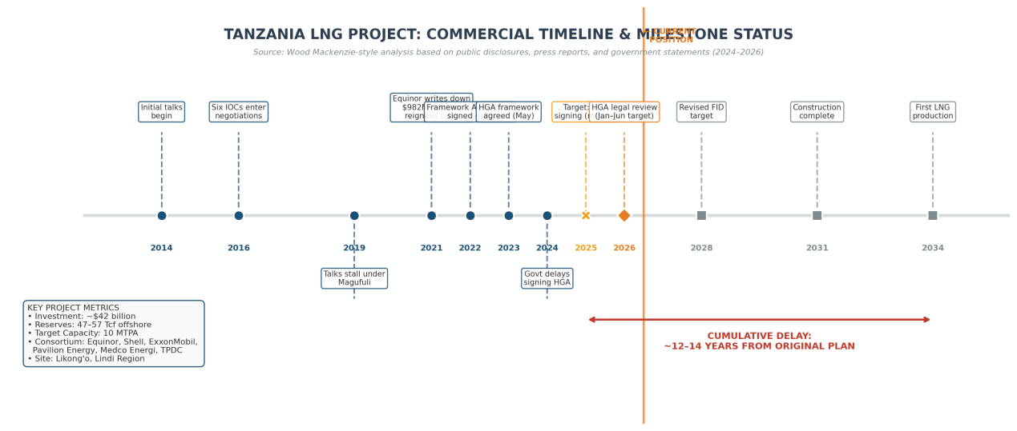

2. INVESTMENT ENVIRONMENT & FINANCING MODELS

2.1 Investment Climate Assessment
Tanzania's investment environment for hydrocarbons has improved markedly since the 2021 political transition but remains characterised by regulatory uncertainty and a legacy of adversarial state-resource relations. President Samia Suluhu Hassan's administration has pursued a more investor-friendly posture than her predecessor, yet the repeated delays in HGA execution have eroded confidence. The government's Fifth Licensing Round (2024–2025), offering 23 offshore and 3 Lake Tanganyika blocks, signals long-term commitment to sector expansion. However, the unresolved LNG terms cast a shadow over upstream exploration appetite. IOCs are unlikely to commit exploration capital to new blocks while the flagship project's fiscal framework remains unsettled.

2.2 Financing Structure & Capital Stack
Based on industry precedents for African LNG megaprojects and disclosed fiscal terms, the indicative financing structure for the Tanzania LNG Project would likely comprise:
Layer | Share | Source | Status
Sponsor Equity | ~30% | Equinor, Shell, ExxonMobil, partners | Committed in principle
Project Finance (Debt) | ~50% | International banks, ECAs, DFIs | Pending HGA and SPAs
DFI / ECA / Blended | ~15% | AfDB, IFC, NCMs, Korean/Japanese ECAs | Conditional on ESG compliance
TPDC / Government | ~5% | TPDC equity, potential gold reserve sale | Uncertain

The project's segmentation whether integrated, partially segmented, or fully segmented across upstream, pipeline, and LNG plant entities has significant tax implications. An integrated structure allows upstream cost recovery against higher-taxed upstream revenues, which companies generally prefer, while a segmented structure may offer the government greater future flexibility for third-party plant access. The debt-equity ratio is assumed at 70:30 under PSA terms. However, the extended timeline and global interest rate environment have increased the cost of capital. Development finance institutions (DFIs) and export credit agencies (ECAs) will likely require stringent environmental and social safeguards, including community resettlement frameworks, methane management plans, and local content compliance areas where Tanzania's institutional capacity remains underdeveloped.

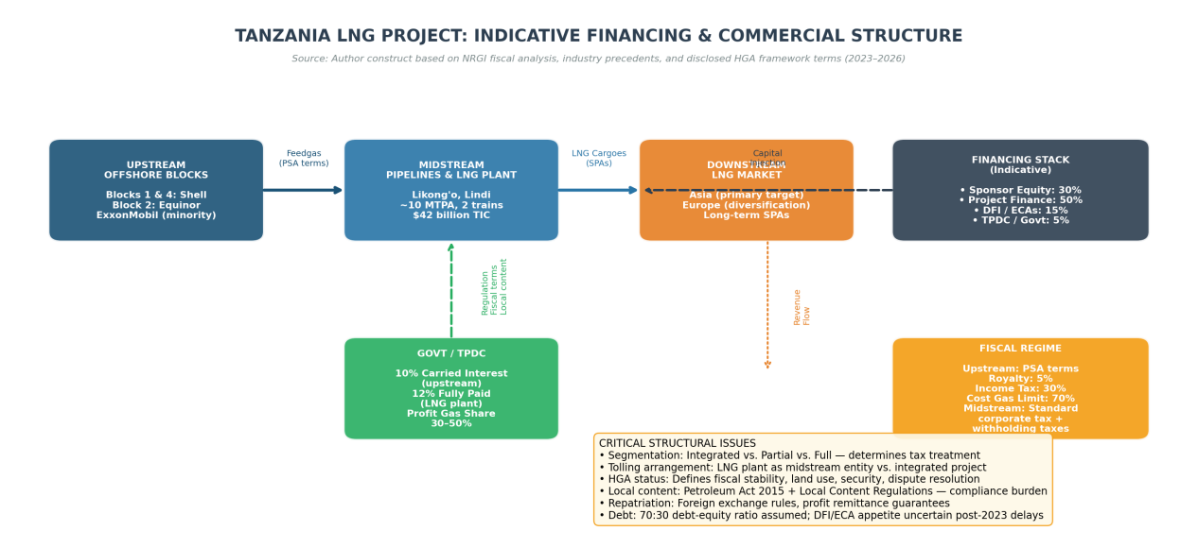

3. REGULATORY FRAMEWORK & FISCAL TERMS

3.1 Regulatory Architecture
Tanzania's oil and gas sector operates under a dual-regulator model:
- PURA (Petroleum Upstream Regulatory Authority) governs exploration, production, and upstream activities.
- EWURA (Energy and Water Utilities Regulatory Authority) oversees downstream and midstream operations, including pipeline tariffs and pricing.
- The Petroleum Act 2015 and subsequent amendments (Finance Act 2016, Written Laws Act 2017) provide the statutory foundation. However, the Local Content Regulations have created compliance burdens that investors view as ambiguous and potentially discriminatory.

3.2 Fiscal Regime
The fiscal terms for the LNG project are anchored in Production Sharing Agreements (PSAs) for the upstream blocks, with the LNG plant potentially subject to standard corporate income tax if structured as a midstream entity. Key terms include:

Instrument | Upstream | Midstream (LNG)
Royalty | 5% | —
Cost Gas Limit | 70% | —
Government Profit Gas Share | 30–50% | —
Income Tax | 30% | 30%
TPDC Equity | 10% carried (upstream) | 12% fully paid (LNG plant)
Dividend Withholding Tax | 10% | 10%
Interest Withholding Tax | 10% | 10%

The government's share of profit gas escalates with project profitability, creating a progressive fiscal structure. However, the lack of PSA disclosure limits independent verification of terms, and the government's stated intention to potentially renegotiate stricter terms introduces uncertainty.

3.3 Local Content & Institutional Risk
Local content requirements under the Petroleum Act 2015 mandate Tanzanian participation in goods, services, and labour. While strategically justified, the regulations have been criticised for lacking baseline capacity assessments, creating mandatory targets without feasibility studies, and granting excessive discretionary power to regulators. For the LNG project, local content compliance will be a major EPC contractor consideration. Given Tanzania's limited domestic oilfield services capacity, rigid local content rules could inflate costs and delay procurement.

4. DOMESTIC GAS MARKET DEVELOPMENT

4.1 Current State
Tanzania is already East Africa's largest natural gas consumer. Current onshore production stands at approximately 320 million standard cubic feet per day (MMSCFD), with domestic utilisation at roughly 290 MMSCFD. Natural gas accounts for 63% of the country's electricity supply mix, primarily from the Mnazi Bay, Songo Songo, and Kiliwani fields. The domestic gas distribution network is severely constrained at only 177.82 km, limiting industrial and residential access. Most industrial consumers in Dar es Salaam and surrounds rely on pipeline connections from the south, while hinterland industries and mines continue to use imported diesel and heavy fuel oil.

4.2 FYDP IV Targets & Strategic Pivot
Tanzania's Fifth Five-Year Development Plan (FYDP IV, 2026/27–2030/31) sets ambitious gas sector targets:
Indicator | Baseline (2024) | Target (2030/31) | Change
Onshore Gas Production | 320 MMSCFD | 1,000 MMSCFD | +213%
In-Country Utilisation | 290 MMSCFD | 800 MMSCFD | +176%
LNG Export (Lindi) | 0 MTPA | 15 MTPA | New
Regional Hub Supply | 290 MMSCFD | 3,500 MMSCFD | +1,107%
Gas Distribution Network | 177.82 km | 267 km | +50%
Gas Share of Electricity | 63% | 45% | −18 pp (diversification)

Notably, the government aims to reduce gas's share of electricity from 63% to 45%, reflecting the commissioning of the 2.1 GW Julius Nyerere Hydroelectric Power Plant. This creates a strategic pivot: gas is repositioned from baseload power to (1) hydropower backup, (2) industrial feedstock, and (3) export LNG.

4.3 Industrial & Virtual Pipeline Expansion
Several small-scale and virtual pipeline solutions are under development to truck compressed natural gas (CNG) or small-scale LNG to hinterland industries and mines. These projects are critical for absorbing domestic gas production growth and creating anchor demand ahead of large-scale LNG exports.
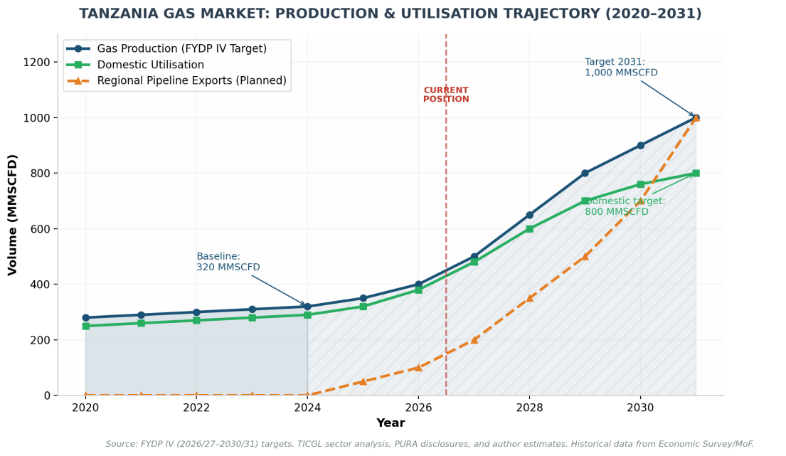

5. REGIONAL ENERGY INTEGRATION

5.1 The East African Gas Corridor
Tanzania's regional gas strategy has advanced from bilateral memoranda to concrete pipeline planning. In July 2026, PURA Director General Charles Sangweni announced plans for a single cross-border natural gas pipeline supplying both Uganda and Kenya. This follows earlier agreements to study a Dar es Salaam–Mombasa gas connection.
The proposed pipeline would build on Tanzania's existing 542 km Mtwara–Dar es Salaam Natural Gas Pipeline (commissioned 2015) and create one of East Africa's most significant regional energy links.

5.2 Regional Demand Dynamics
Kenya leads East Africa in geothermal power but remains heavily dependent on imported petroleum products for industry and transport. Natural gas demand from manufacturers, fertiliser producers, and potential gas-fired power projects could rise significantly if pipeline supply becomes available.
Uganda is industrialising around its petroleum sector (with the EACOP crude pipeline nearing completion) and has identified natural gas as a transition fuel for electricity, fertiliser, steel, and petrochemicals despite limited domestic gas reserves.
Rwanda, Burundi, and DRC represent longer-term demand centres but lack immediate pipeline connectivity.

5.3 Strategic Value of Regional Integration
For Tanzania, regional pipeline exports offer three strategic advantages:
- Revenue diversification: Reduces exposure to global LNG price volatility.
- Demand anchor: Creates baseload offtake that improves domestic upstream economics.
- Geopolitical leverage: Positions Tanzania as East Africa's indispensable energy hub, complementing its role in EACOP crude transit.

The Eastern Africa region currently has only three operational natural gas pipelines, all within Tanzania (825 km combined), and four planned or under-construction pipelines spanning 3,051 km, including three cross-border routes. However, no technical details capacity, route, financing, or timeline have been released for the Tanzania–Kenya–Uganda pipeline, indicating this remains a political commitment rather than a bankable project.

6. GLOBAL MARKET CONTEXT & COMPETITIVENESS

6.1 The Coming LNG Wave
The global LNG market is entering a period of profound transformation. Approximately 300 bcm/yr of new liquefaction capacity is expected to come online by 2030, driven primarily by the United States and Qatar, which together account for 70% of this expansion. In 2025 alone, more than 90 bcm/yr of LNG capacity reached FID—an all-time high for the US sector—including Louisiana LNG, Corpus Christi Train 8&9, CP2 Phase 1, and Rio Grande LNG Train 4&5. By the end of the decade, the US could supply around one-third of global LNG, up from ~20% in 2024.

6.2 Demand-Supply Balance & Price Trajectory
Global gas demand growth slowed to below 1% in 2025, with Asia Pacific demand expanding by less than 1%—the weakest growth since 2022. The IEA's base case projects global gas demand to increase by ~9% by 2030, but this may not absorb all incremental supply. A surplus of ~65 bcm could emerge in the base case, with forward curves indicating TTF prices declining from $12.31/MMBtu (2025 average) to ~$10.55 (2026) and ~$9.30 (2027).

6.3 Tanzania's Competitive Position
Tanzania's competitiveness in this environment is mixed:
Advantages:
- Proximity to Asia: Indian Ocean location reduces shipping distances versus Atlantic or US Gulf suppliers.
- Resource scale: 47–57 Tcf provides multi-decade reserve life.
- Consortium quality: Equinor and Shell bring technical excellence and marketing reach.
- Lower political risk than Mozambique: No Cabo Delgado-style insurgency.

Disadvantages:
- Timing: First production in 2034 places Tanzania at the tail end of the supply wave, potentially into a softer price environment.
- Cost structure: At $42 billion for 10 MTPA, unit capital costs are high (~$4.2 billion/MTPA) compared to Qatari expansion (~$1.5–2.0 billion/MTPA) or US brownfield projects.
- No offtake: Unlike Mozambique LNG (75% contracted pre-construction), Tanzania has no disclosed SPAs.
- Regulatory discount: Repeated delays have created a "Tanzania risk premium" in investor perceptions.

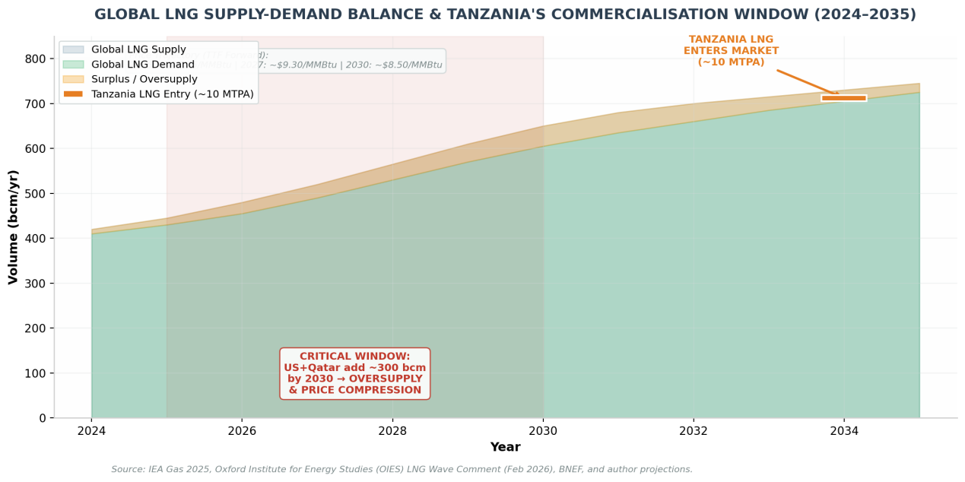

7. RISK ANALYSIS

7.1 Critical Risks (High Probability, High Impact)
- Regulatory / HGA Delays: The single greatest risk to the project. Each year of HGA delay pushes FID back, increases costs, and narrows the commercialisation window. The government's 2024 decision to revisit terms agreed in 2023 has damaged trust.
- Global LNG Oversupply (2027–2032): The US-Qatar supply wave will likely compress margins for new entrants. Tanzania's high capital intensity makes it vulnerable to lower long-term prices.
- Fiscal Terms Renegotiation: Government statements suggesting stricter fiscal terms post-HGA create expropriation risk. Investors require fiscal stability clauses spanning the project's 30-year life.

7.2 Elevated Risks
- Energy Transition & Demand Risk: By 2034, global decarbonisation policies may have structurally reduced Asian LNG demand growth. Japan and South Korea are already experiencing demand declines, and China's gas demand growth, while positive, is increasingly met by domestic production and Russian pipeline supply.
- Financing / Cost Overruns: At $42 billion, the project is among the most expensive LNG developments globally. Cost overruns of 20–30% are common in African megaprojects. With Tanzania's government selling gold reserves to fund infrastructure, sovereign financial stress is evident.
- Mozambique Competition: Mozambique's Rovuma Basin holds larger reserves (>100 Tcf) and has Eni's Coral FLNG already producing. TotalEnergies' Mozambique LNG (13 MTPA) and ExxonMobil's Rovuma LNG (18 MTPA), though delayed by security issues, could reach market before or concurrently with Tanzania, capturing Asian buyer attention.

7.3 Moderate Risks
- Local Content Compliance: Could inflate EPC costs and delay procurement if not managed pragmatically.
- Regional Pipeline Execution: Cross-border infrastructure in East Africa has a mixed record (EACOP is progressing but delayed). Financing and land acquisition for the Tanzania–Kenya–Uganda pipeline are unresolved.
- Domestic Demand Absorption: Without accelerated industrialisation, Tanzania may struggle to absorb 800 MMSCFD domestically by 2031.

CONCLUSION
Tanzania possesses the geological endowment, geographic position, and strategic intent to become a significant LNG exporter and East Africa's energy hub. Yet geology and geography are insufficient for bankability. The decade of delays since 2014 has transformed what should have been a first-mover advantage into a race against time against global LNG oversupply, against energy transition headwinds, and against investor fatigue.
The HGA signing in 2026 is the inflection point. If executed credibly, Tanzania can still attract the $42 billion investment, develop its domestic gas economy, and anchor regional integration. If delayed further, the project risks becoming a stranded ambition vast reserves left beneath the Indian Ocean while Mozambique, Qatar, and the United States capture the markets Tanzania once targeted.

