SENEGAL'S GAS MONETIZATION STRATEGY: INFRASTRUCTURE, DOMESTIC SUPPLY AND EXPORT GROWTH

EXECUTIVE SUMMARY
Senegal is in the early stages of converting a decade of offshore hydrocarbon discoveries into a functioning domestic gas economy. The centerpiece of this transition is the Réseau Gazier du Sénégal (RGS), an approximately 400 km national pipeline network valued at approximately €975M, designed to move gas from offshore production hubs to power plants, industrial zones, and eventually into the wider West African gas market via the 5,700 km African Atlantic Gas Pipeline. Full network operation is targeted for 2027, although as of mid-2026 only one of five segments , the Northern (GTA–Gandon) line has cleared construction approval.

INFRASTRUCTURE AND PIPELINE NETWORK
Senegal is constructing an approximately 400 km national gas pipeline network (Réseau Gazier du Sénégal) to unlock domestic gas monetization. The RGS network is explicitly designed to physically connect offshore production to Senegalese power plants and industrial users before any surplus gas is considered for wider regional or international sale. This is consistent with the country's broader "gas-to-power first" development doctrine, under which domestic energy security functions as the anchor demand that de-risks pipeline investment, with industrial and export markets layered on top once the core grid is operational.
The network comprises five segments at varying stages of maturity, together spanning roughly 400 km and representing close to €1 billion in planned investment.

Segment | Route | Length (km) | Capacity (Mscf/d) | Investment (€M) | Status
Northern (GTA-Gandon) | GTA hub → Gandon power plant | 85 | 300 | 275 | Construction approved May 2026
Green | Interconnection segment | 110 | 300 | 183 | Planned 2026 rollout
Blue | Mboro → Cap des Biches | 100 | 713 | 214 | Planned 2026 rollout
Orange | Sendou → Malicounda | 45 | 300 | 153 | Planned 2026 rollout
Red | Branch line | 17 | 150 | 150 | Planned 2026 rollout
TOTAL | Integrated National Grid | Approximately 400 | Up to 2.5 bcm/yr | ~€975M (~$1.15B) | Full operation target: 2027
The GTA-Gandon segment (85 km: 45 km offshore, 40 km onshore) will connect the GTA offshore terminal to a planned 250–300 MW gas-fired power plant at Gandon, near Saint-Louis. The full network aims to lower domestic electricity costs, reduce fuel import dependence, and feed industrial hubs.

Key Power Plant Conversions
Plant | Capacity | Status | Note
Bel Air | 335 MW | Conversion from heavy fuel oil to LNG underway | Existing thermal asset; conversion avoids new-build capital costs
Gandon  250–300 MW | 250–300 MW | New gas-fired facility planned | Fed directly by the Northern RGS segment
FONSIS tender | 500MW | International bidding deadline closed March 2026 | Awarded via competitive process; largest single planned gas-fired asset

FOREIGN CONTRIBUTION TO SENEGAL'S GAS MARKET
Senegal's gas sector development has attracted significant international investment across the value chain
Partner | Country | Contribution | Sector
BP | UK | GTA Operator ($4.8B Phase 1) | Upstream
Kosmos Energy | USA | GTA Partner (27%); ex-Yakaar operator | Upstream
Woodside Energy | Australia | Sangomar Operator ($4.7B) | Upstream
TotalEnergies | France | Downstream distribution leader | Downstream
China | China | Largest bilateral trade partner; infrastructure FDI | Investment
MCC/USA | USA | Second compact for energy sector strengthening | Development
EU/AFD | EU | Grid extension & pipeline finance | Finance
World Bank/AfDB | Multilateral | Policy, technical assistance, project finance | Finance
Turkey | Turkey | EPC contractors, construction | Construction

SENEGAL'S GAS MONETIZATION TECHNOLOGIES
Senegal is deploying multiple gas monetization technologies tailored to its offshore deepwater context and domestic development priorities. These technologies include:
1. Floating LNG (FLNG) — GTA Model
- The GTA project uses an innovative deepwater subsea → FPSO → FLNG architecture
- Gas extracted at 2,850m depth is pre-treated on the FPSO (~40 km offshore), then piped to the FLNG vessel (Gimi) at 10 km offshore for liquefaction
- Phase 1 capacity: 2.7 Mtpa; designed for 30–50 year field life
2. Gas-to-Power (CCGT/OCGT)
- Conversion of heavy fuel oil plants to natural gas
- New gas-fired capacity: Gandon (250–300 MW), FONSIS (500 MW tender)
- Target: Gas to make up 75% of installed capacity
3. Pipeline Transport & Regional Integration
- 400 km national grid with connection to African Atlantic Gas Pipeline
- Enables both domestic distribution and regional export
4. Gas-to-Industry (Fertilizer, Petrochemicals, Steel, Cement)
- Yakaar-Teranga Phase 2 planned to support downstream industrialization
- Estimated $5 billion needed for fertilizer, petrochemical, steel, and cement production
5. Domestic Market Obligations (DMOs)
- GTA Phase 1 allocates ~20–25% of output to domestic market
- Yakaar-Teranga prioritizes domestic supply over export

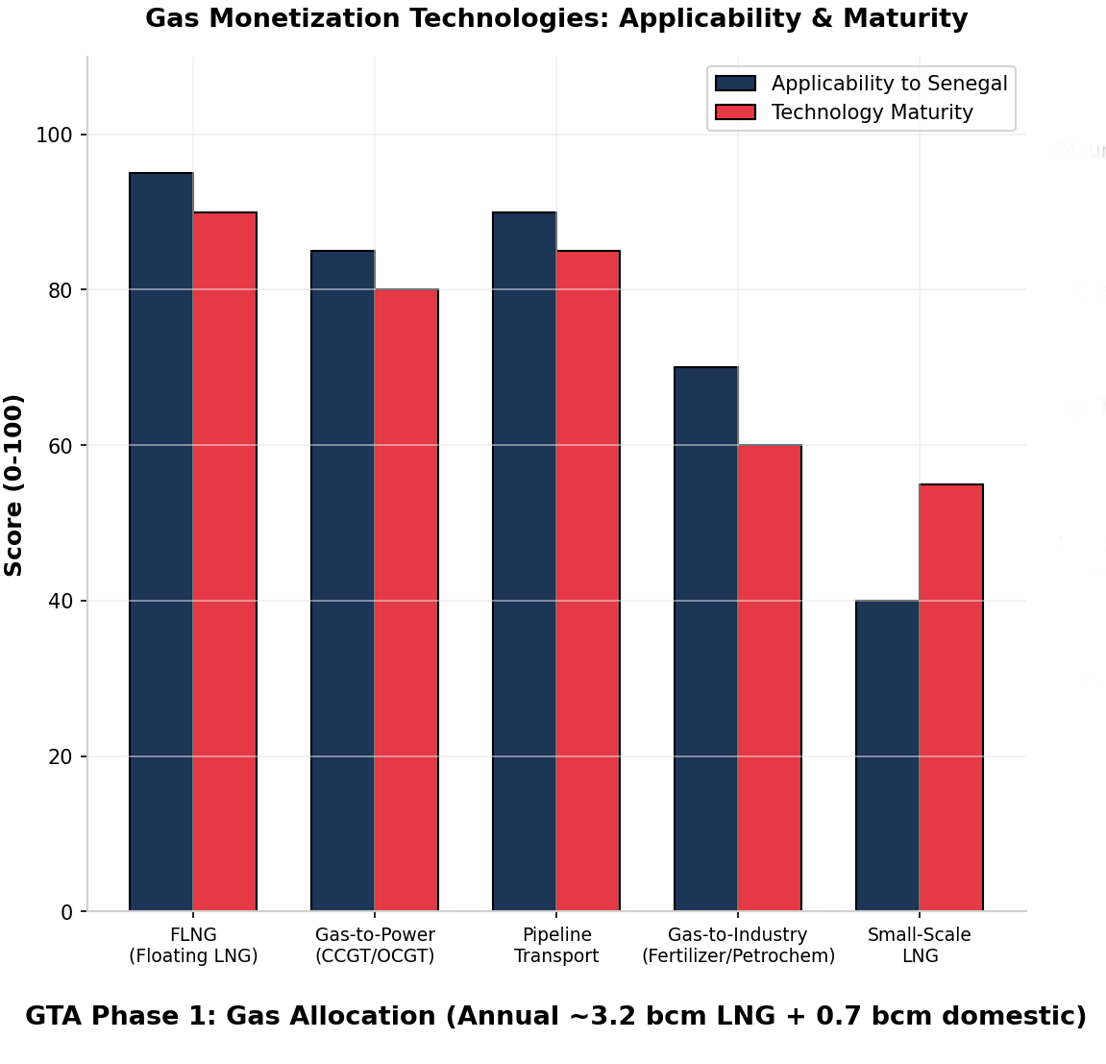
EXPORT AND DOMESTIC PROSPECTS
Export Prospects
Phase | Status | Volume
GTA phase 1 | Producing | Approximately 2.7 Mtpa LNG; fully contracted to BP via SPA
GTA Phase 2 | Pre-FID | Approximately+3.0 Mtpa; could roughly double capacity before 2030
GTA phase 3 | Long-term | Up to 10 Mtpa total production
Yakaar-Teranga | Planning | Export optionality retained, but domestic priority dominates

Risk Factors
- Global LNG price volatility and oversupply.
- State capacity constraints following Yakaar-Teranga nationalization.
- Security risks in the Sahel affecting cross-border infrastructure.
- Domestic market pricing below international netback levels.

CONCLUSION
Senegal's gas strategy represents a deliberate attempt to avoid the enclave economy pattern common to many first-generation hydrocarbon producers, where offshore wealth is extracted and exported with limited benefit to the domestic economy. By pairing GTA and Sangomar's upstream development with a purpose-built national pipeline network, binding Domestic Market Obligations, and an explicit gas-to-power target, the government has structured its policy framework to capture value at home before surplus gas is monetized abroad.

