SENEGAL’S ROLE IN WEST AFRICA'S EMERGING GAS ECONOMY

EXECUTIVE SUMMARY
Senegal is consolidating its position as one of West Africa's most significant new hydrocarbon producers, anchored by three offshore fields, Yakaar-Teranga, Greater Tortue Ahmeyim (GTA), and Sangomar that together represent over 40 Tcf of gas resource potential. The defining event of 2026 is the state's assumption of full control over Yakaar-Teranga. This is a watershed moment that shifts Senegal's largest undeveloped gas discovery from international-operator-led development to a fully state-led model with all the opportunity and risk that entails.

KEY DEVELOPMENTS
In April 2026, Senegal assumed full control of the Yakaar-Teranga field after Kosmos Energy's withdrawal, with the licence transferred exclusively to Petrosen and, notably, without financial compensation to Kosmos. This detail is significant because uncompensated transfers are relatively unusual in international upstream oil and gas, and typically signal either a negotiated exit under difficult commercial terms for the departing operator, a contractual mechanism triggered by specific licence conditions, or a deliberate policy choice by the host government to accelerate state control.
This shift carries several implications:
- Petrosen and the Senegalese state capture 100% of the field's economics going forward, rather than sharing them with an international partner potentially maximizing long-run fiscal and developmental benefit if the project is executed well.
- Petrosen inherits full responsibility for financing, technical execution, and project management on a field that will require an estimated multi-billion-dollar investment to develop (see Section 2), without the balance-sheet strength, technical track record, or project-financing relationships that an experienced IOC like Kosmos would have brought.

COUNTRY NATURAL GAS RESERVES
Senegal's offshore gas endowment is concentrated in three major fields, each at a different stage of maturity and under a different ownership structure, positioning it as one of West Africa's most promising new hydrocarbon producers.
Key Reserve Holdings (2026):
Field | Location | Recoverable Reserves | Operator | Status
Yakaar-Teranga | Cayar Offshore Profond, north of Dakar | ~25 Tcf (708 bcm) | Petrosen (100%) — state-controlled since April 2026 | Pre-development; FEED phase initiated
Greater Tortue Ahmeyim (GTA) | Maritime border with Mauritania | ~15 Tcf (shared 50/50) | BP (60%), Kosmos (27%), Petrosen (10%), SMHPM (7%) | Phase 1: Operating since Q1 2025
Sangomar | Offshore Senegal | ~0.6 Tcf gas component | Woodside Energy | Operating since June 2024

- Yakaar-Teranga
Yakaar-Teranga stands out globally, at roughly 25 Tcf, it ranks among the largest undeveloped gas discoveries anywhere in the world in recent years. Two technical characteristics make the field particularly attractive:
- Negligible CO₂ content many gas fields require costly carbon capture or reinjection systems to manage high CO₂ concentrations, Yakaar-Teranga's near-absence of this problem substantially simplifies processing design.
- Minimal impurities
This reduces the capital intensity of gas treatment facilities and shortens the path to sales-quality gas.

- GTA
GTA is a frontier project from an engineering standpoint. It straddles the Senegal–Mauritania maritime border at water depths reaching 2,850 metres, placing it among the deepest offshore gas developments in the world and spans an estimated 1,400 billion cubic metres of gas resource across a 33,000 km² area, with a production life projected at 30–50 years. The scale of the resource area alone (larger than the country of Belgium) suggests significant further exploration and development upside beyond the currently sanctioned Phase 1.

- Sangomar
While primarily an oil development, Sangomar's associated gas component (~0.6 Tcf) is comparatively modest next to Yakaar-Teranga and GTA, but its significance lies in being already operating since June 2024, giving Senegal early, tangible offshore production experience and cash flow ahead of its two larger gas projects reaching full development.
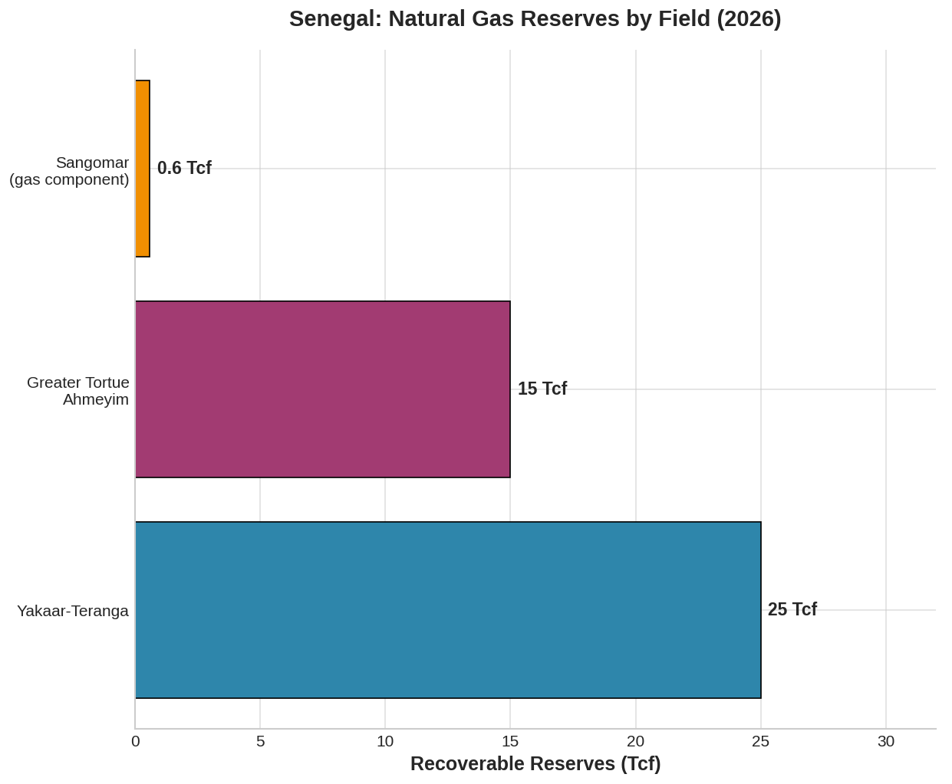

COUNTRY DEMAND AND SUPPLY DYNAMICS
Senegal's electricity generation has historically been dominated by imported petroleum products, making it one of Africa's highest-cost power markets. Generation costs range from 34–38 US cents/kWh, while consumers pay roughly 24 cents/kWh, the difference covered by government subsidies reaching CFA 280 billion ($455 million) in 2023.

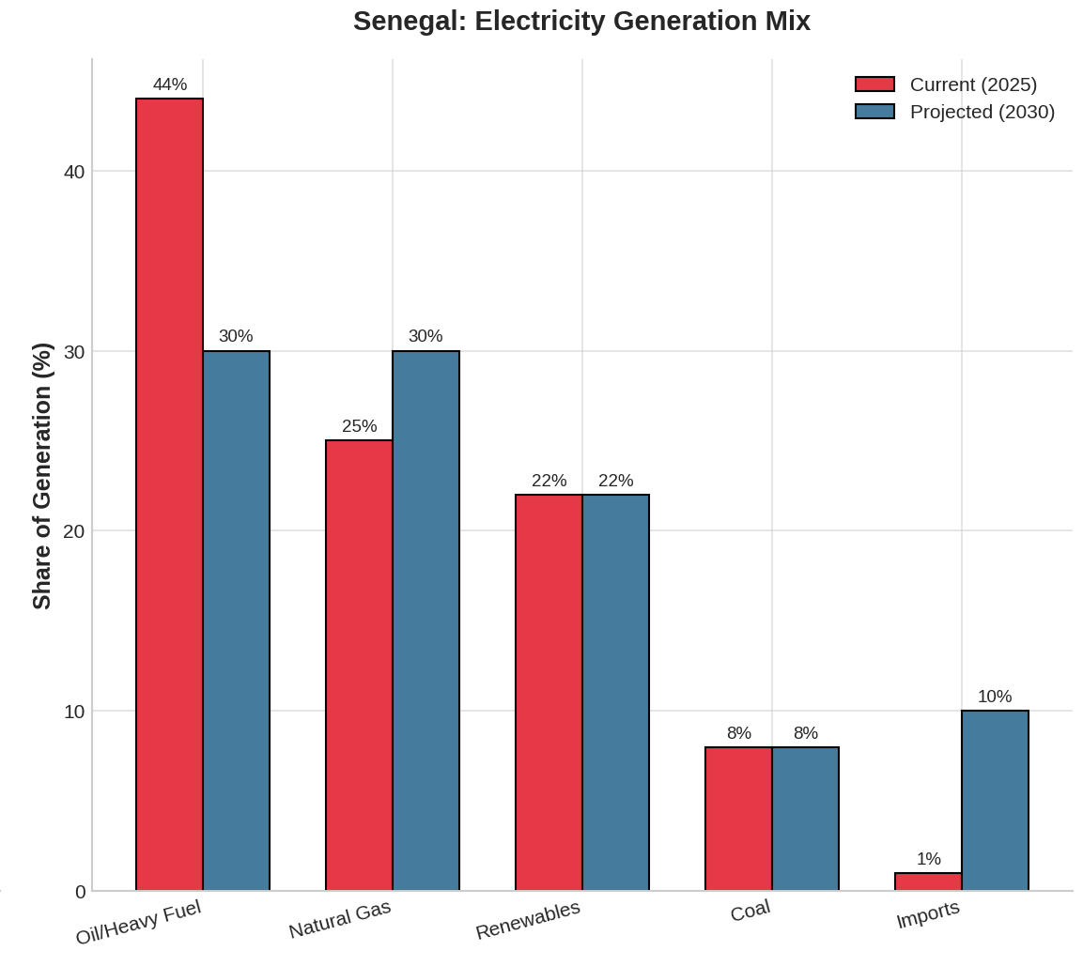

Electricity Access & Demand Growth
- 2024: 84% national electricity access (universal in urban areas, 66% rural)
- Target: Universal access by 2029
- Demand growth: ~8% annually through 2030

Power Generation Mix Transformation
Source | Current (2025) | Projected (2030)
Oil/Heavy Fuel | 44% | 30%
Natural Gas | 25% | 30%
Renewables | 22% | 22%
Coal | 8% | 8%
Imports | 1% | 10%
The share of natural gas in electricity production is expected to rise from less than 1% in 2025 to about 30% by 2030, reflecting the rapid introduction of gas into a system historically dominated by fuel oil.

MARKET OUTLOOK
Africa supplied 34.7 million tonnes of LNG in 2024, with sub-Saharan Africa contributing 26.9 Mt. Senegal-Mauritania's GTA project has now joined the ranks of established exporters. However, global LNG supply is forecast to increase sharply through 2030, driven by the U.S. and Qatar, potentially pushing Asian and European benchmark prices below $6/MMBtu by the late 2020s.

Conclusion
Senegal's emergence as a gas frontier economy is now entering a more complex second phase. The country's underlying resource endowment is exceptional by any regional or even global standard. Yakaar-Teranga alone ranks among the largest undeveloped gas discoveries found anywhere in recent years, and GTA's ultra-deepwater engineering places Senegal at the frontier of offshore gas technology.

