The Strategic Capital Split: Data Reconnaissance vs. Hard Capital Commitments in Freetown’s Deepwater

Executive Summary
Sierra Leone's offshore sector is mid-way through a deliberate two-stage capital funnel:
- A wave of low-cost, non-binding reconnaissance permits designed to re-risk a basin that produced no commercial discovery across five licensing rounds.
- A smaller but growing set of binding, capital-committing exploration licences.
The most significant recent development is Shell's April 2026 reconnaissance agreement, covering approximately 20,600 km² of offshore acreage. The programme includes advanced geological and geophysical surveys, basin modelling and petroleum-systems analysis. Crucially, Shell has stated that the agreement does not itself represent a commitment to proceed with exploration drilling.
This follows Eni's November 2025 reconnaissance agreement covering five deepwater blocks and approximately 6,790 km². Eni's programme similarly represents a technical evaluation stage rather than a full exploration investment decision.
At the same time, Marginal Energy has moved further down the investment ladder. Its 2026 Petroleum Licence Agreement covers approximately 6,800 km², with the company committing more than US$225 million during the exploration phases. This is materially different from reconnaissance: the programme includes seismic work, advanced geoscience and drilling commitments.

Key Figures
- 27,384 km² acreage under non-binding reconnaissance permits (Eni + Shell, 2025–2026 wave)
- 6,800 km² acreage under the sole binding PSC signed in the current wave (Marginal Energy)
- $225M+ disclosed exploration spend commitment, the only hard capital number in the current cycle
- 8 wells / 0 commercial discoveries, the legacy record the current strategy is designed to overturn
- 6th licensing round and first deepwater well in a decade both targeted for 2026

The Basin Context
Geological Potential vs. Exploration History
Sierra Leone's offshore basin sits on the Equatorial Atlantic Margin, a region that has delivered world-class discoveries in Guyana, Suriname, and Namibia. Early interpretations suggest up to 30 billion barrels of recoverable oil potential, though these figures remain contingent on drilling confirmation.
Despite this potential, Sierra Leone's exploration track record has been sobering:

Metrics | Figure
Wells Drilled (since 1980s) | 8
Commercial Discoveries | 0
Licensing Rounds Completed | 5 (2002–2022)
Last Drilling Campaign | 2016

This underperformance created a data deficit that deterred major capital commitments. The Petroleum Directorate of Sierra Leone (PDSL) response has been to front-load data investment, acquiring new 3D seismic, reprocessing legacy datasets, and commissioning independent basin-wide studies to ensure investors are not starting from zero.

Regulatory Streamlining
A critical enabler of the capital split strategy has been regulatory reform. PDSL Director General Foday Mansaray has reduced the upstream approval timeline from years to approximately 30–40 days, stripping away red tape while maintaining "three non-negotiable pillars": contractual structure, royalty framework, and state participation.

The Strategic Capital Split
- Track 1: Data Reconnaissance
Data reconnaissance encompasses seismic data acquisition, geological and geophysical (G&G) studies, petrophysical analysis, basin modeling, and petroleum systems analysis. In frontier deepwater basins globally, this phase typically represents 10–20% of total pre-production capital, yet it determines the viability of the remaining 80–90%.
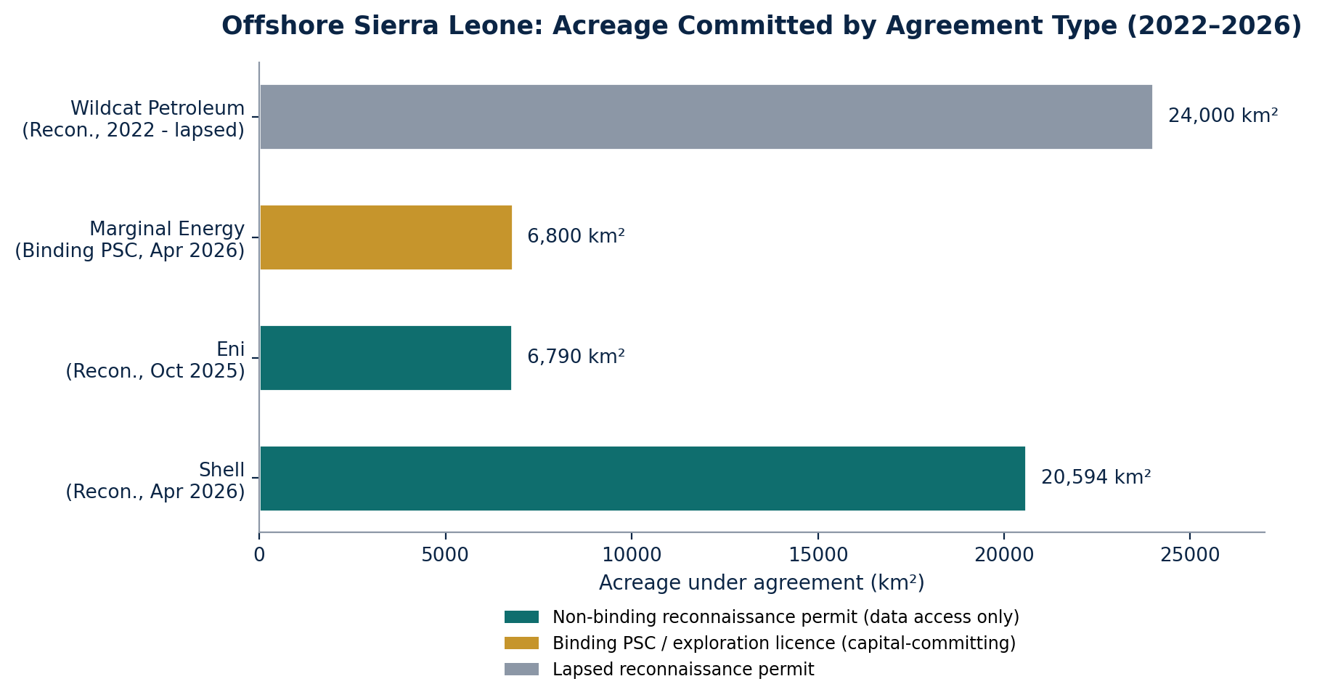
Figure 1 Acreage engaged offshore Sierra Leone by counterparty and agreement type, (2022–2026).

Shell's reconnaissance agreement does not authorize drilling. It is a foundational, data-driven framework that could lead to future licensing rounds and exploration campaigns, depending on study results.
This is a deliberate capital-light entry strategy for a major IOC, allowing Shell to evaluate ~20,000 km² of acreage at a fraction of the cost of a single deepwater exploration well.

Current Data Reconnaissance Commitments in Sierra Leone

Operators | Agreement Type | Blocks | Area (Km²) | Data Commitment | Estimated Cost
Shell | Reconnaissance Permit | 19 (incl. G-112, G-114, G-133) | ~20,594 | Seismic interpretation, basin modeling, petroleum systems analysis, structural trap mapping | $10–15M
Eni | Reconnaissance Permit | 5 (G-113, G-129, G-130, G-131, G-132) | ~6,790 | Advanced seismic data evaluation, technical studies | $8–12M
PDSL (Government) | Multi-client seismic | Multiple | Basin-wide | 3D seismic acquisition (Pre-Stack Time Migration), legacy data reprocessing | $15–20M
TGS / GeoPartners | Multi-client library | Northern offshore | ~15,000+ | Sierra Leone Fusion 3D PSDM 2025, MC3D surveys | $20–30M

- Track 2: Hard Capital Commitments
Hard capital commitments involve drillship contracts, exploration well drilling, appraisal campaigns, and eventually field development. These commitments are irreversible, long-duration, and high-risk. A single deepwater exploration well in West Africa can cost 80–120 million, with ultra-deepwater wells exceeding 150 million.
In April 2026, Nigerian independent Marginal Energy Limited signed a $225 million offshore petroleum license agreement covering five blocks (G-145, G-146, G-147, G-160, G-161) across approximately 6,800 km². The Sierra Leonean state retains a 10% carried interest in oil and 5% in gas during exploration and development, with an option to acquire up to an additional 9% paid interest once production begins.
The agreement includes:
- Structured exploration period: Up to seven years
- Minimum work program: 3D seismic acquisition, advanced geoscience studies, and drilling commitments
- Exploration spending: Expected to exceed $225 million
This represents the first binding hard capital commitment in Sierra Leone's offshore sector in recent years. The capital split within Marginal Energy's program is estimated as follows:

Expenditure Category | Estimate Allocation | % of Total
3D Seismic Acquisition & Processing | $35M | 16%
Geoscience Studies & Interpretation | $15M | 7%
Exploration Drilling (2–3wells) | $140M | 62%
Support Vessels, Logistics, HSE | $25M | 11%
Contingency & Admin | $10M | 4%
Total | $225M | 100%

Comparative Analysis: Sierra Leone vs. Peer Frontier Basins

Basin/Country | Data Reconnaissance Phase | Hard Capital Phase | Total Pre-FID Investment | Key Differentiator
Sierra Leone | $60M (2025–2027E) | $550M+ (2027–2030E) | ~$610M | Government-funded multi-client seismic de-risks blocks before licensing
Namibia (Orange Basin) | $200M+ (2020–2024) | $2B+ (2024–2028E) | ~$2.2B | Major IOCs (TotalEnergies, Shell) self-funded seismic; rapid drilling follow-through
Guyana (Stabroek) | $150M+ (2012–2015) | $15B+ (2015–2030) | ~$15B+ | ExxonMobil operated; exceptional reservoir quality reduced appraisal needs
Senegal (MSGBC) | $80M+ (2014–2016) | $1.5B+ (2016–2023) | ~$1.6B | Cairn Energy/SNE discovery triggered rapid capital reallocation
Mozambique (Rovuma) | $300M+ (2006–2010) | $20B+ (2010–2028E) | ~$20B+ | Eni/Anadarko; massive gas reserves justified LNG development capital

Why the 15:85 Split is Rational
The 15% data reconnaissance / 85% hard capital split reflects:
- Asymmetric Information Value
High-quality seismic data reduces geological uncertainty by 30–50%, directly improving drilling success rates. In frontier basins, this can be the difference between a 15% and 30% commercial success rate.
- Capital Efficiency
A $15M seismic survey across 20,000 km² costs less than 15% of a single exploration well but de-risks multiple drillable prospects.
- Optionality Preservation
Reconnaissance agreements (Shell, Eni) preserve capital flexibility. Operators can exit after data evaluation without sunk drilling costs.
- Government Cost Sharing
PDSL's investment in multi-client seismic ($15–20M) effectively subsidizes operator data costs, improving project economics.

Key Investment Risks

Risk Category | Specific Risk | Capital Impact
Geological | Basin may lack viable reservoir/seal pairs | Data reconnaissance reduces dry hole risk
Commercial | Global oil price volatility; $60–70/bbl Brent forecast | Hard capital commitments remain viable at lower prices
Operational | Drillship availability; rates $400K+/day | Rig costs = 45% of well budget; timing critical
Regulatory | Fiscal terms instability; contract renegotiation risk | Predictability attracts long-dated hard capital
Political | Election cycles; resource nationalism | Balanced state participation
Environmental | Deepwater drilling opposition; ESG pressures | Compliance costs embedded in hard capital

Recommendations for Investors
- Leverage recon permits or licence multi-client datasets for low-cost optionality ahead of the next round.
- Engage FA Oil farm-out or monitor Marginal Energy progress; evaluate 6th-round deepwater packages.
- Combine reconnaissance exposure (Shell/Eni-style) with selective hard-commitment co-investment to balance risk/reward in this high-upside frontier.

